Capital Region PRISM Invasive Species Fact Sheet
Winter Creeper (Euonymous fortunei)
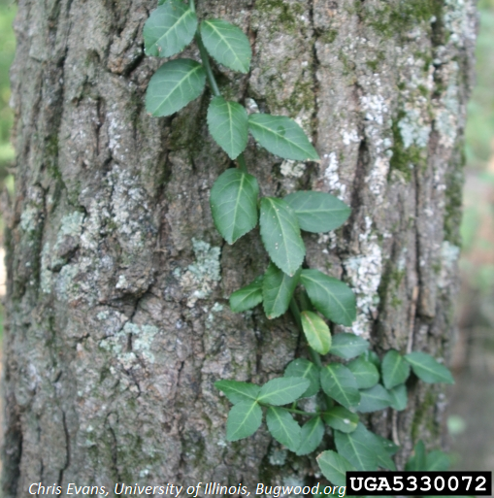
Background: You have probably seen this plant used in landscaping much to the same effect as any number of groundcovers with variegated leaves. Like those other invasive ground covers, it creates a carpet that smothers native plants.
Description: This vine is evergreen, keeping its color throughout every season. It gradually becomes woody with age but is most often somewhat thin and herbaceous. It is shade tolerant and reproduces through vine growth and by seeds that are spread by animals and water movement. Its leaves are glossy, simple, and entire. They have light venation and grow in opposite formation.
Flowering: Flowers are small and usually not present, though when found are a green-white color. The plant appears to be more likely to produce flowers when growing vertically in vine form, rather than horizontally across the forest floor.
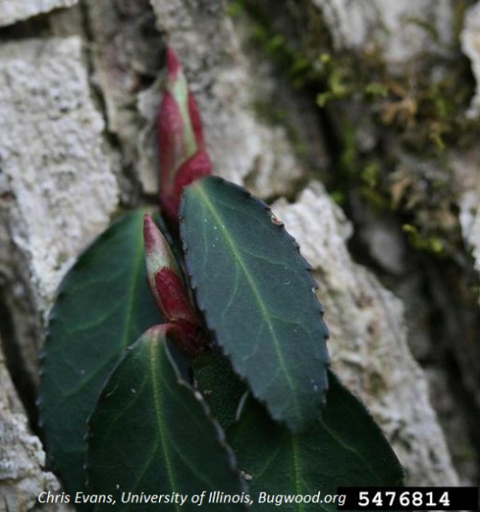
Look-alikes: Partridge berry (native) and invasive species Common Periwinkle both have similar growth and leaf shape to Wintercreeper.
Control Methods:
Manual/Mechanical: Young plants can be hand-pulled, but mature plants are more difficult to control manually. Repeated pulling may be needed. Dispose of plants in sanitary landfill or solarize in a black bag on site and then dispose of.
Smothering the plant is also an option by placing tarp or cardboard over plants and then filling over top with mulch.
Chemical: Cut-stem method can be used as well as a foliar application of appropriate herbicides. Contact your local PRISM for more information on herbicides.

