Capital Region PRISM Invasive Species Fact Sheet
Yellow Garden Loosestrife (Lysimachia vulgaris)
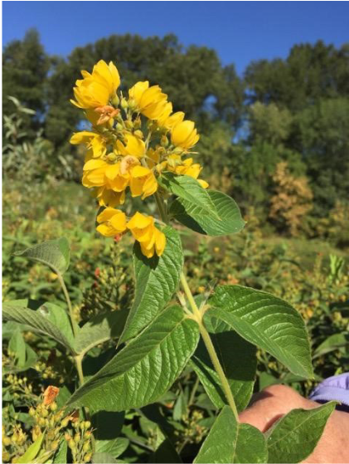
Background: This plant appears to be a less-common version of Purple Loosestrife (though not related) and grows most often in wetland habitats. It most often spreads via rhizomes beneath the soil but also by seed. The rhizomes can spread up to 10 feet in open water. This plant most likely was introduced via the landscaping industry and has a continued use in the field.
Description: Growing up to one meter tall, this species has opposite or whorled leaves. The leaves are lanceolate to ovate in shape. The stems have a soft pubescence to them. The leaf edges are entire and leaf shape is simple.
Flowering: The flowers grow in an inflorescence of yellow, five-petaled flowers that come out in June-September.
Look-alikes: Purple Loosestrife (Invasive, Tier 4) looks somewhat like Yellow Garden Loosestrife, though the common names suggest the difference that can be found in flower color. It looks extremely similar to Large Yellow Loosestrife though it has smaller flowers that grow along the entire stem, not just on the ends.
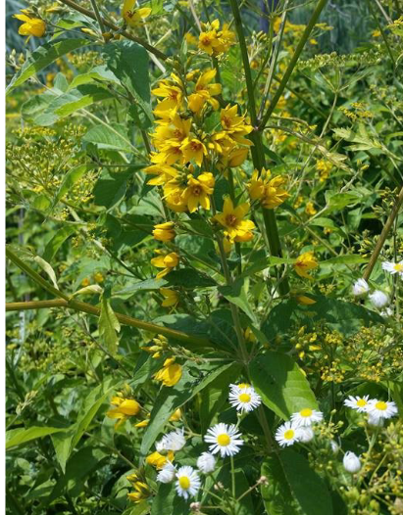
Control Methods:
Manual/Mechanical: Manual control is not very feasible due to the rhizome this plant possesses. But small infestations or single plants can be dug out if control is repeated. Cutting will prevent seeding but not eradicate. Bag and dispose of plant material in landfill.
Chemical: Herbicides can be effective. Contact your local PRISM for more information on herbicide use. It is your responsibility to fully understand the laws, regulations and best practices required to apply pesticides in a responsible manner.

