Capital Region PRISM Cornell Cooperative Extension Saratoga County
Partnership for Regional 50 West High St. Invasive Species Management Ballston Spa, NY 12020
www.capitalregionprism.org (518) 885-8995

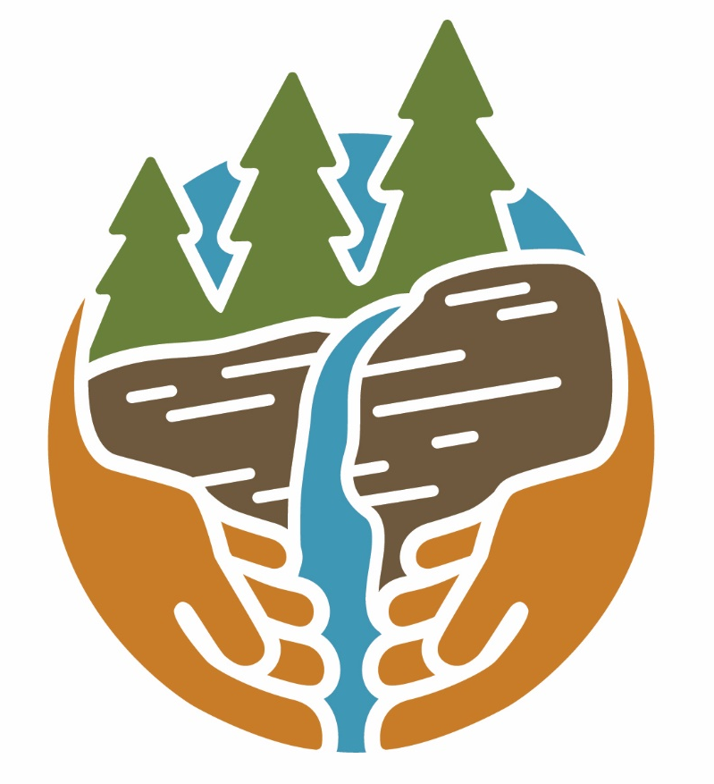

Capital Region PRISM Treatment Report

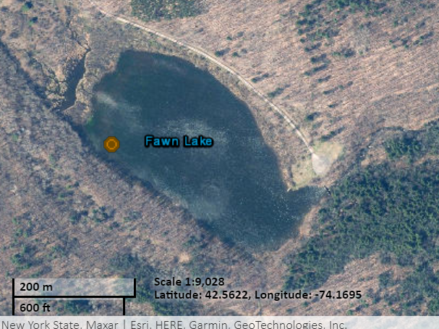
Site Information
Date: August 21th, 2022
Site Name & Address: Fawn Lake
Fawn Lake Rd., Berne, NY, 12023
Property Owner: NYS Department of Environmental Conservation, Region 4 Schenectady Office | (518) 357-2154 | Wildlife.r4@dec.ny.gov
Coordinates: 42.562381, -74.167665
Project Leader: Pamela Aprilliano – AIS Watercraft Launch Steward Supervisor
Email: pca46@cornell.edu
iMapInvasives User ID: 8406
Team Members: Caleb Lines (Watercraft Launch Steward)

Project Information
Target Species: Water chestnut (Trapa natans)
First year of treatment? No
Size of infestation: <10 Sq. ft. (trace distribution at west side of the lake)
Treatment Method (please be specific): Mechanical/Manual – Hand Pull
% Completed: 100%
Amount removed: (# bags, # plants, # mature, # seedlings): <1 contractor bag, <10lbs removed
Time spent on removal: .5 hours
Is follow-up needed? Fawn Lake will be surveyed on an annual cycle for water chestnut and other potential AIS.
Were treatments uploaded to IS Tracker and iMapInvasives? Yes
iMapInvasives Treatment Record: 26259

Photos of the Project:
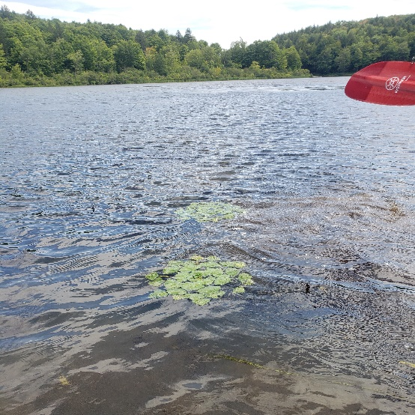

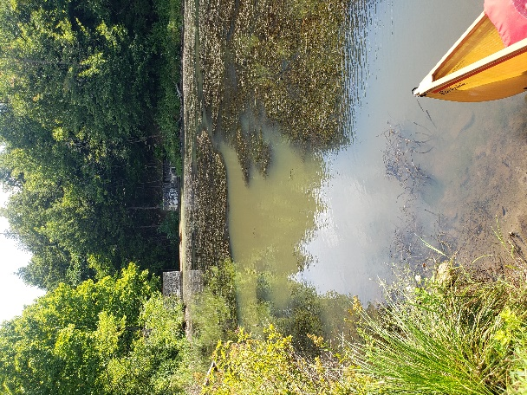
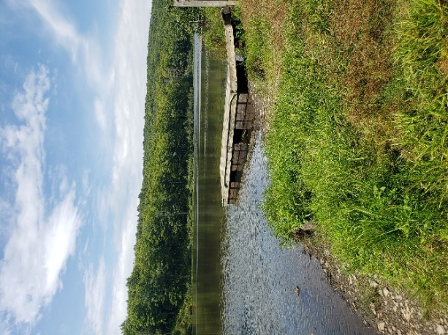

The New York State Department of Environmental Conservation provides financial support to The Capital Region PRISM via the Environmental Protection Fund
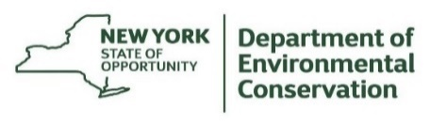
The New York State Department of Environmental Conservation provides financial support to The Capital Region PRISM via the Environmental Protection Fund

