Garlic Mustard
Alliaria petiolate

Identification
Garlic mustard is a 2-3ft tall biennial plant. In its early stage of life, garlic mustard is a small basal rosette with toothed edges. As it matures, it grows a thin stalk with alternating, triangular, toothed leaves. When the leaves are crushed, they release a garlic like odor which is how it got its name. In late summer, garlic mustard loses its leaves but remains as a stalk throughout the winter.
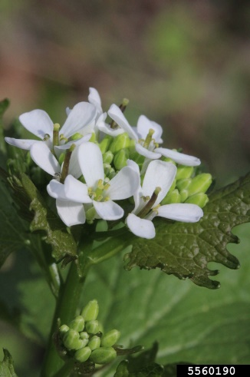

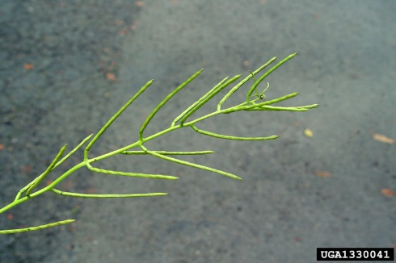

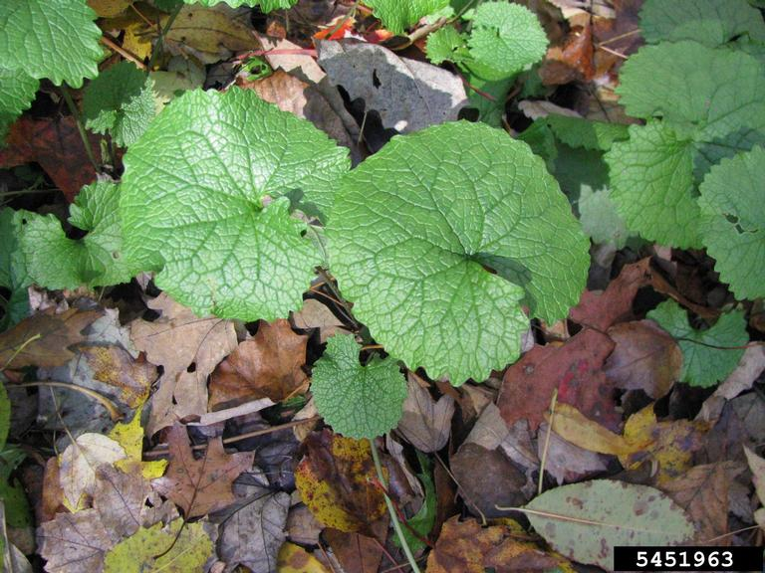

Reproduction
In early spring, garlic mustard develops and umbel of small white flowers at the top of the stalk. When the leaves fall off in late summer, the stalk develops long seed pods called siliques. They appear light green at first but change to a light brown color and papery texture in the fall. Each plant can hold thousands of seeds. The seeds are black and are easily spread by wind, water, and animals. They also remain viable in the soil for up to seven years.

Habitat
Garlic mustard is found in moist, shaded areas in forests, flood plains, and edge habitat.

Threat
Garlic mustard has the ability to invade very high quality old growth forests which can reduce biodiversity and decrease the quality of the habitat. It also has allelopathic compounds that inhibit the growth of native plants in the seed bank.
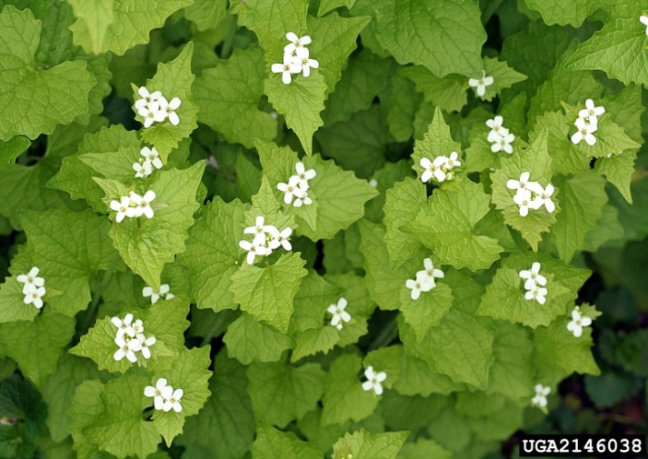

Integrated Pest Management for

Garlic Mustard
Due to the threat garlic mustard has to the environment, it is important to tackle infestations to reduce the size and prevent the spread. An integrated pest management approach combines strategies in order to safely and efficiently eradicate populations and prevent the formation of new populations.

Practices to Avoid:
- AVOID REMOVAL WHEN IN SEED. Removing garlic mustard while it is in seed can help spread the infestation rather than solve it. The seeds also remain viable in the soil for about five years, so it is important to remove garlic mustard before the seeds form.
- DO NOT LEAVE PULLED OR CUT PLANTS ON THE GROUND. Garlic mustard has the capability of going into seed even when the root or stalk is damaged. Because of this it is important to bag any pieces of garlic mustard that are removed and leave them to solarize for 10 days.

Manual and Mechanical Control
Cutting and pulling garlic mustard is one of the most effective methods at reducing population size and spread. It is important to pull adult plants before they go into seed to prevent seed dispersal. Pulling is easiest when the soil is wet, typically just after rainfall. Cutting off the seed heads has also been shown to be effective at contributing to mortality. When pulling or cutting, make sure any fragments are placed in plastic bags and left to solarize for 10 days before disposal.

Biological Control
There are currently no approved methods for biological controls in the United States.

Herbicide Control
If the infestation is too large to remove by manual or mechanical means, herbicide may be used as a last resort. The best management practices when applying chemical herbicides to treat an infestation should be follower to limit the effects on the environment. Please consult an expert or contractor when applying herbicides. Please read and follow herbicide product labels are required by law. Seek out proper local, state, and federal permitting when applying herbicides.

Herbicide Treatment for Homeowners/Private Landowners

Time of Year: July-November (when other plants are dormant)

Example Chemical(s) to Use: Read all Product Labels as Required by Law
Product names are listed as examples, and not as endorsement or recommendation. The suitability and details for specific use of these products are provided through their labels.
Chemical  (Products containing) | Time of Year | Application Technique | Notes
Glyphosate (Roundup, Rodeo) | Late Fall | Foliar Spray | - Non-selective  - Best to perform in warm yet dry weather
If there is water present near the infestation, a permit from the DEC is required. For more information regarding aquatic pesticide permitting, please contact the nearest DEC Regional Office: Division of Environmental Permits at (518) 357-2069 or visit: http://www.dec.ny.gov/permits/209.html.

Timeline of Action

For More Information Seek out the Cornell Guidelines for Pesticide Use:
The Cornell Guidelines offer the latest information on topics such as pest management, crop production, and landscape plant maintenance. Each title in the series is updated by Cornell University researchers and Extension specialists and is designed as a practical guides. https://www.cornellstore.com/books/cornell-cooperative-ext-pmep-guidelines

