Capital Region PRISM Treatment Report

Site Information
Date: 6/4/2020
Site Name & Address: Grafton Lakes State Park 254 Grafton Lakes State Park Way, Cropseyville, NY 12052
Property Owner: NYSOPRHP
Latitude: 42.785777 Longitude: -73.458075
Project Leader: Mary Downey Email: nlc64@cornell.edu (Nicole)
Team Members: Nicole Campbell (PRISM), CJ Bortnick (Parks)
iMapInvasives User ID: 7176

Project Information
(Copy this section and fill out for each species)

Target Species: Japanese Barberry (Berberis thunbergii)
First year of treatment? Yes
Size of infestation: 1.5acres
Treatment Method (please be specific): Drove the truck in to the area where Japanese Barberry was previously detected and we flagged the outer border of the infestation to ensure we removed all satellite infestations. We used weed wrenches and loppers to trim branches then remove as much of the root system as possible to prevent re-infestation. All parts of the plants were bagged then brought to a dumpster to be disposed of in a landfill.
% Completed: 100%
Amount removed (# bags, # plants, # mature, # seedlings): 19 bags, ~80 individual plants
Time spent on removal: 3 hours
Is follow-up needed? Yes- Post-treatment monitoring recommended for next 2-5 years, follow-up removals likely
Were treatments uploaded to iMapInvasives? Yes
Photos and maps of the project:
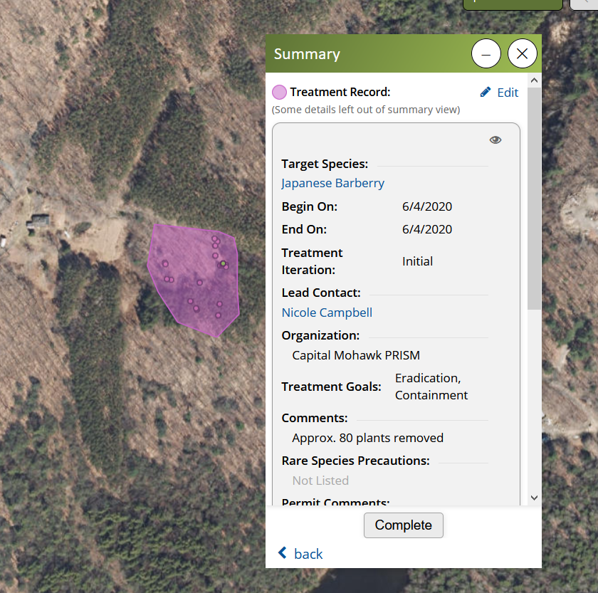
Photo of the treatment area at Grafton Lakes State Park along the Granville Hicks beltway, many plants
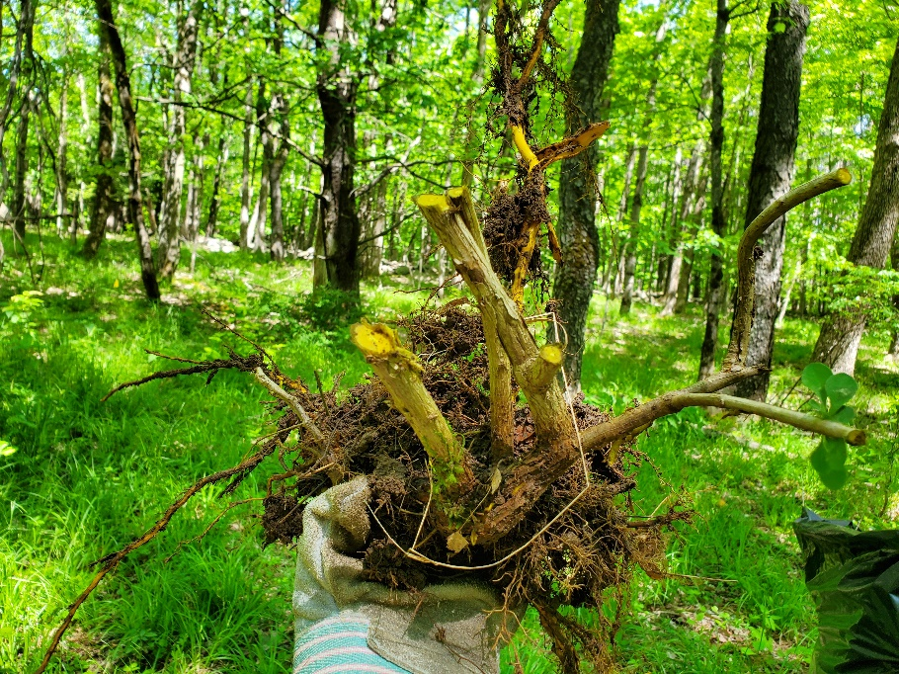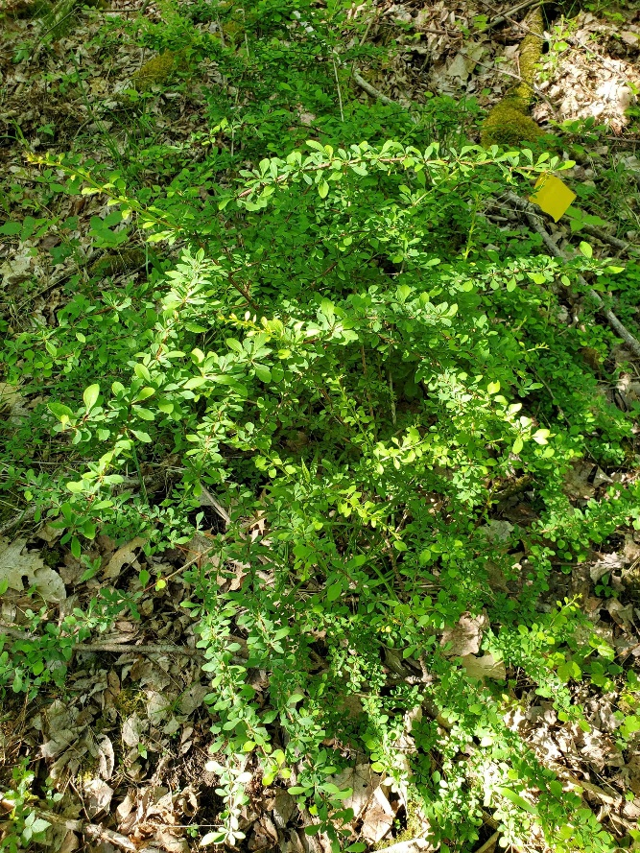
Photo of a flagged Japanese barberry plant at Grafton Lakes State Park that was removed during the project.
Photo of stumps and root system of a Japanese barberry plant removed at Grafton Lakes

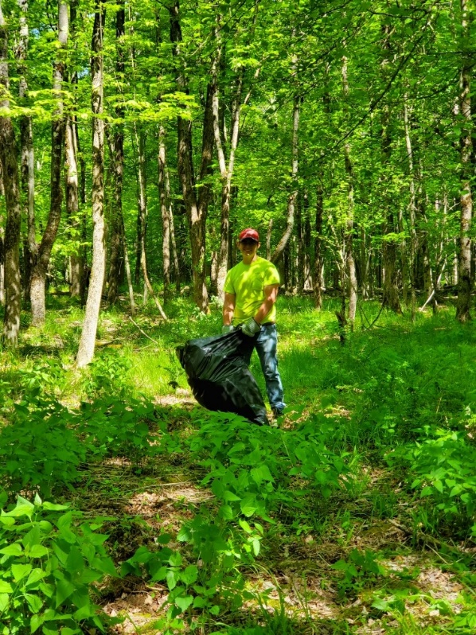
Photo of CJ, a Parks employee, filling a bag with Japanese barberry.
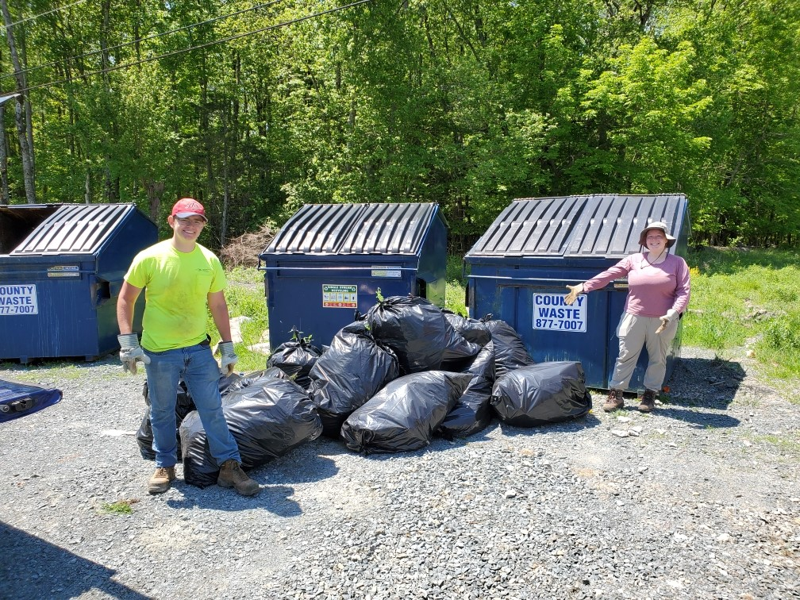
Photo of Mary and CJ with 19 bags of Japanese barberry that was removed

