Capital Region PRISM Cornell Cooperative Extension Saratoga County
Partnership for Regional 50 West High St. Invasive Species Management Ballston Spa, NY 12020
www.capitalregionprism.org (518) 885-8995

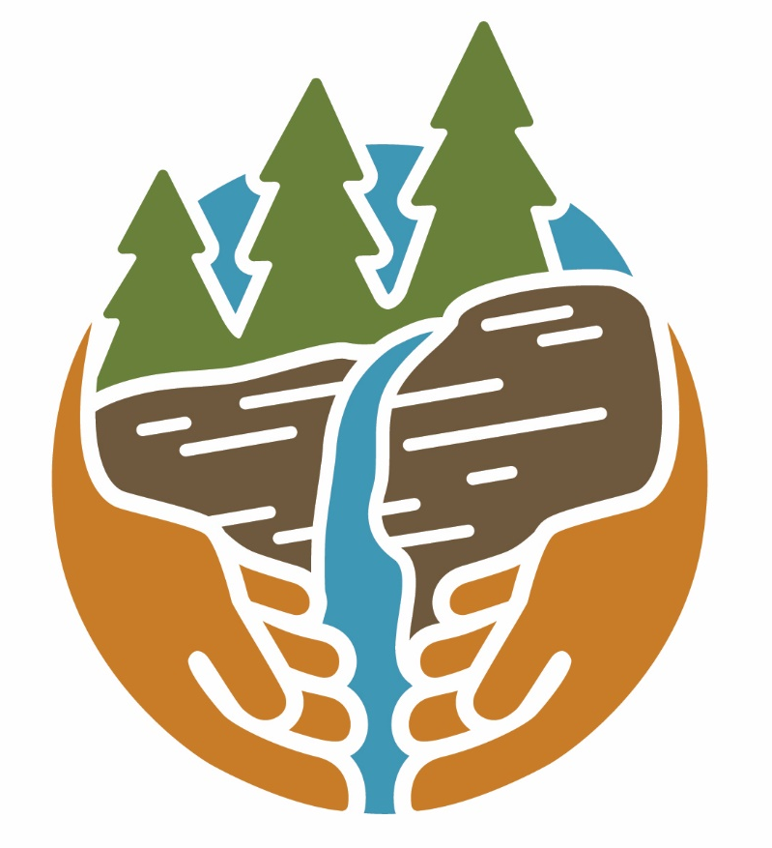

Capital Region PRISM Treatment Report

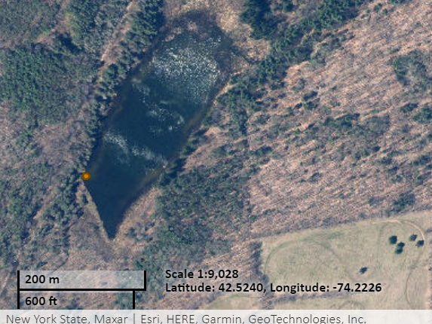
Site Information
Date: August 21th, 2022
Site Name & Address: Gulf Rd Ext Spillway
221-7 Gulf Rd Exd, Middleburgh, NY 12122
Property Owner: NYS Department of Environmental Conservation, Region 4 Schenectady Office | (518) 357-2155 | Wildlife.r4@dec.ny.gov
Coordinates: 42.5240, -74.2227
Project Leader: Pamela Aprilliano – AIS Watercraft Launch Steward Supervisor
Email: pca46@cornell.edu
iMapInvasives User ID: 8406
Team Members: Caleb Lines (Watercraft Launch Steward)

Project Information
Target Species: Water chestnut (Trapa natans)
First year of treatment? Yes
Size of infestation: <10 Sq. ft. (trace distribution at water access site near beaver dam)
Treatment Method (please be specific): Mechanical/Manual – Hand Pull
% Completed: 100%
Amount removed: (# bags, # plants, # mature, # seedlings): <1 contractor bag, <10lbs removed
Time spent on removal: .5 hours
Is follow-up needed? Yes. Will perform follow-up next year
Were treatments uploaded to IS Tracker and iMapInvasives? Yes
iMapInvasives Treatment Record: 26260

Photos of the Project:

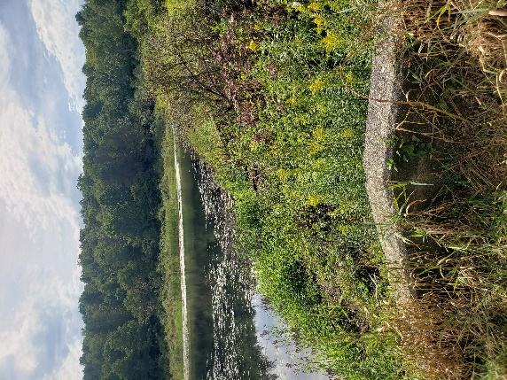
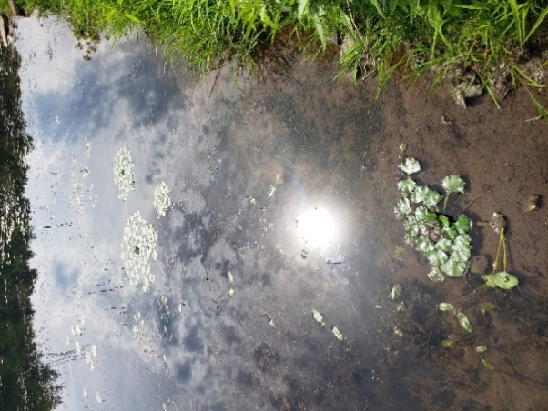
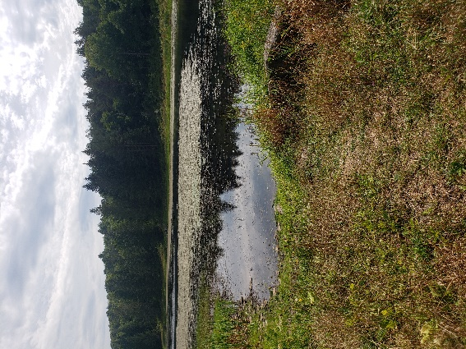

The New York State Department of Environmental Conservation provides financial support to The Capital Region PRISM via the Environmental Protection Fund

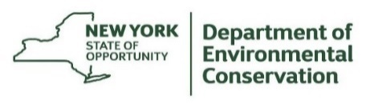
The New York State Department of Environmental Conservation provides financial support to The Capital Region PRISM via the Environmental Protection Fund

