HANNACROIX PARK PRESERVE INVASIVE SPECIES SURVEY 2019:

Anna Kuhne, Lauren Mercier, and Kelsey Stevens

Introduction: In July of 2019, the Terrestrial Invasive Species interns, from Siena College, and the education and outreach coordinator went to look for early detection invasive species throughout the Capital-Mohawk PRISM. The Siena interns, Anna Kuhne and Kelsey Stevens, focused on terrestrial invasive plant surveys at highly susceptible and valuable habitats throughout the PRISM region. The following is an abridged summary of some of the findings of the survey throughout the Hannacroix Park Preserve. The PRISM works throughout 11 counties around the capital region to detect, prevent, and control invasive species.

Project Description: Surveying terrestrial invasive plants in the park
Dates: July 3rd, 2019
Participants: Capital Mohawk Prism, Cornell Cooperative Extension, NYS DEC, and the New Baltimore Conservancy
Point of Contact: The New Baltimore Conservancy: newbaltconservancy@gmail.com
County: Greene County, New York

Locations and Species Identified:
Hannacroix Park Preserve (The New Baltimore Conservancy): Scouting was done on the trails of the Hannacroix Park Preserve, including the parking lot, Laverne Irving Trail, Red Loop Trail, North Trail, Laverne Irving Spur Blue Trail, Paper Mill Trail, and the Hudson River Interpretive Trail.
Invasive Species Present at Hannacroix Park Preserve:
Common Name | Scientific Name | Locations (GPS) | Growth Type | Phenology
Common Reed | Phragmites australis | 42.46102  -73.78951 | Herbaceous | Vegetative
Tree of Heaven | Ailanthus altissima | 42.46219  -73.79217 | Tree | Vegetative
Japanese Barberry | Berberis thunbergii | 42.46296  -73.79631 | Shrub | Vegetative
Oriental Bittersweet | Celastrus orbiculatus | 42.4614  -73.79503 | Vine | Vegetative
Mugwort | Artemisia vulgaris | 42.46221  -73.79237 | Herbaceous | Vegetative
Honeysuckle | Lonicera spp. | 42.46258  -73.79408 | Shrub | Vegetative
Burning Bush | Euonymus alatus | 42.46319  -73.79729 | Shrub | Vegetative
Multiflora Rose | Rosa multiflora | 42.46153  -73.79003 | Shrub | Past Seed
Elongate Hemlock Scale | Fioinia externa | 42.46342  -73.79786 | Pest | N/A
Purple Loosestrife | Lythrum salicaria | 42.46157  -73.79027 | Herbaceous
Common Buckthorn | Rhamnus cathartica | 42.46319  -73.79684 | Tree | Vegetative
Norway Maple | Acer platanoides | 42.46388  -73.79182 | Tree | In Seed (Samaras)
Narrow Leaf Bittercress | Cardamine impatiens | 42.46221  -73. 79942 | Herbaceous | In Seed
Dame’s Rocket | Hesperis matronalis | 42.46109  -73.78985 | Herbaceous | In Flower
Privet | Ligustrum spp. | 42.46287  -73.7952 | Shrub | Vegetative
Creeping Jenny; Moneywort | Lysimachia nummularia | 42.46236  -73.79683 | Herbaceous | Vegetative
Japanese Stiltgrass | Microstegium vimineum | 42.45909  -73.80061 | Herbaceous | Vegetative
Black Locust | Robinia pseudoacacia | 42.46001  -73.78755 | Tree | Vegetative
Colts Foot | Tussilago farfara | 42.46224  -73.79988 | Vine | Vegetative
Common Periwinkle | Vinca minor | 42.4616  -73.80015 | Herbaceous | Vegetative
Garlic Mustard | Alliaria petiolate | 42.46222  -73.79225 | Herbaceous | Vegetative

Dominant Native Plants: Virginia creeper, sugar maple, cotton wood, quaking aspen
Native Community Types: Forested, creek-side
Treatment Method: N/A

Summary of Work Completed:
  - Scouting for invasive terrestrial plant species
Recommendations for the Future: Continue scouting

Contact Anna Kuhne at av13kuhn@siena.edu, Lauren Mercier at lnm47@cornell.edu, or Kelsey Stevens at kao04stev@siena.edu for any questions regarding this report.
Figure 1: Map of the points taken at the Hannacroix Park Preserve in Greene County.
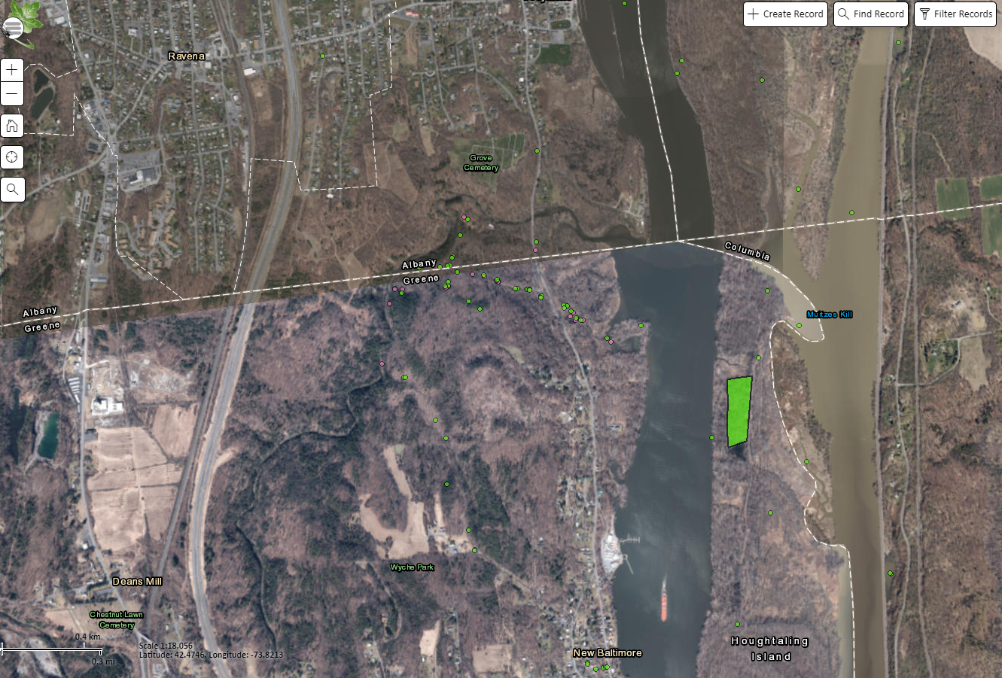

Figure 2: Japanese Barberry (Berberis thunbergii) at Hannacroix Park Preserve on the North Trail.
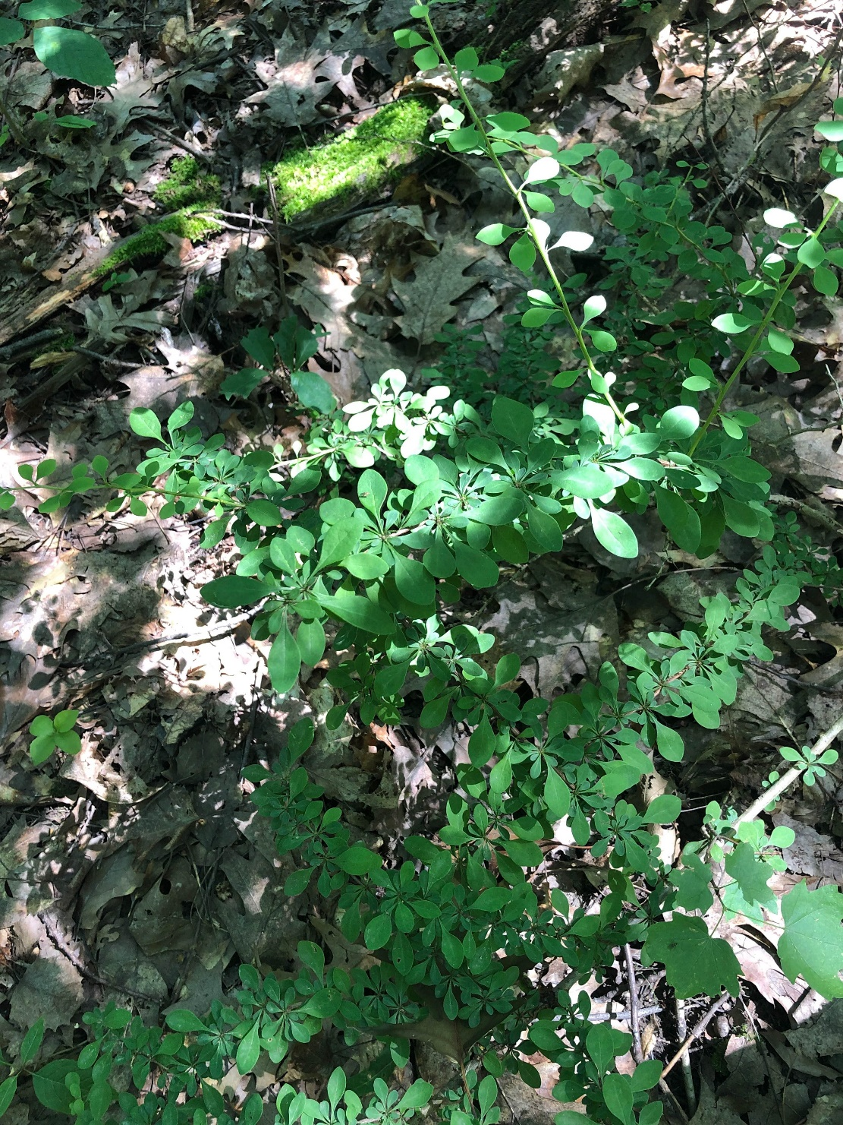\

Figure 3: Honeysuckle (Lonicera spp) at Hannacroix Park Preserve on the Laverne Irving Trail.
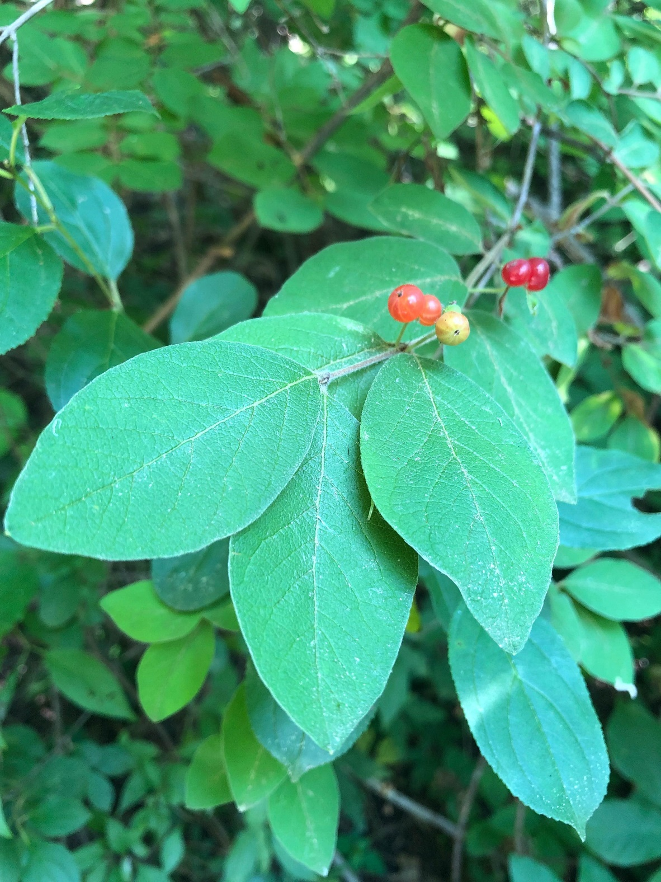

Figure 4: Common periwinkle (Vinca minor) at the Hannacroix Park Preserve on the Laverne Irving Trail closer inbetween theLaverne Irving Spur Blue Trail and the Paper Mill trail.
