HUDSON CROSSINGS INVASIVE SPECIES SURVEY 2019:

Spencer Barrett, Anna Kuhne, and Kelsey Stevens

Introduction: : In June of 2019, the Terrestrial Invasive Species Coordinator, Spencer Barrett, worked with two interns, from Siena College, to look for early detection invasive species throughout the Capital-Mohawk PRISM. The Siena interns, Anna Kuhne and Kelsey Stevens, focused on terrestrial invasive plant surveys at highly susceptible and valuable habitats throughout the PRISM region. The following is an abridged summary of some of the findings of the survey throughout Rockwood State Forest. The PRISM works throughout 11 counties around the capital region to detect, prevent, and control invasive species.

Project Description: Survey of terrestrial invasive plants in the park along trails and edge of property.
Dates: June 12th, 2019
Participants: Capital Mohawk PRISM/Cornell Cooperative Extension
Point of Contact: Kate Morse, Park Director. (kmorse@hudsoncrossingspark.org)
County: Saratoga County

Locations and Species Identified:
Hudson Crossings: Scouting was done on the trails of the Hudson Crossings Park which started at the play garden adjacent to the parking lot and looped around the edge of the island, ending again at the play garden.
Invasive Species Present at Hudson Crossing Park:
Common Name | Scientific Name | Locations (GPS) | Growth Type | Phenology
Norway Maple | Acer platanoides | 43.11285  -73.57717 | Tree | Vegetative
Garlic Mustard | Alliaria petiolata | 43.11723  -73.57505 | Herbaceous | Seed
Mugwart | Artemisia vulgaris var. vulgaris | 43.12212  -73.58584 | Herbaceous | Vegetative
Narrowleaf Bittercress | Cardamine impatiens | 43.11301  -73.57715 | Herbaceous | Vegetative
Canada Thistle | Cirsium arvense | 43.11306  -73.57711 | Herbaceous | Vegetative
Poison Hemlock | Conium maculatum | 43.12116  -73.58487 | Herbaceous | Flowering
Crown Vetch | Coronilla varia | 43.11756  -73.58079 | Herbaceous | Vegetative
Pale Swallow-wort | Vincetoxicu, rossicum | 43.12212  -73.58582 | Herbaceous | Flowering
Burning Bush | Euonymus alatus | 43.11617  -73.5764 | Shrub | Vegetative
Ground Ivy | Glechoma hederacea | 43.11343  -73.57788 | Vine | Some flowering and some vegetative
Dame’s Rocket | Hesperis matronalis | 43.11267  -73.5771 | Herbaceous | Flowering
Yellow Arch-angel | Lamiastrum galebdolon | 43.11803  -73.57954 | Herbaceous | Vegetative
Oriental Bittersweet | Celastrus orbiculatus | 43.11329  -73.57778 | Vine | Vegetative
Knapweed (species unknown) | Centaurea spp | 43.12232  -73.58596 | Herbaceous | Vegetative
Black Locust | Robinia pseudoacacia | 43.11566  -73.5792 | Tree | Vegetative
Honeysuckle (species unknown) | Lonicera spp | 43.11299  -73.5771 | Shrub | Seed
White Mulberry | Morus alba | 43.11251  -73.57718 | Tree | Vegetative
Japanese Knotweed | Reynoutria japonica var, japonica | 43.11723  -73.57509 | Herbaceous | Vegetative
Common Buckthorn | Rhamnus cathartica | 43.11373  -73.57794 | Tree | Vegetative
Multiflora Rose | Rosa multiflora | 43.11422  -73.57629 | Shrub | Some flowering some vegetative

Dominant Native Plants: Jewelweed, sugar maple, oak spp.
Native Community Types: Mixed hardwood forest.
Treatment Method: None
Summary of Work Completed:
  - Surveyed Invasive Terrestrial Plants
  - Came across Yellow Arch-angel
  - Saw four female Northern Map Turtles in the large field in the middle of the Hudson Crossing Park. These turtles are an S3 vulnerable level, threatened by invasive species such as the red slider turtle. These turtles were laying their eggs in the field. Additional wildlife included Eastern Cottontails, Double-Crested Cormorants, Woodchucks, and Eastern Chipmunks.

Recommendations for the Future:
- Stop mowing practices in the field during the months of June/July where the Map turtles were found to allow the eggs to safely develop and hatch, as well as being aware of when those eggs hatch. Map turtles are characterized as an S3 (Vulnerable) species in New York State, meaning that their populations are slightly declining and having their eggs safely develop is of great importance. Four nests were found during the surveying on June 12th.
- Be on the lookout for additional points of Pale Swallowwort on park property and take measures to prevent this species from spreading. In addition to competing with native species, it’s often said that this species is extremely bad for the Monarch Butterfly, which would make an additional educational hook to get people to try and remove this small patch at Eagle Point. This species is wind-dispersed and being present in the middle of the river offers an easy point for these seeds to spread further up and down river.
- Monitor and possibly attempt to remove the Yellow Arch-angel population. While this species does not spread virulently through seed, the patch will continue to expand vegetatively and will become less easy to remove in the future

Figure 1: Map detailing total area covered as well as invasive species population data entered during the visit to Hudson Crossings Park. Pale Swallowwort is found at the furthest north point of the park.
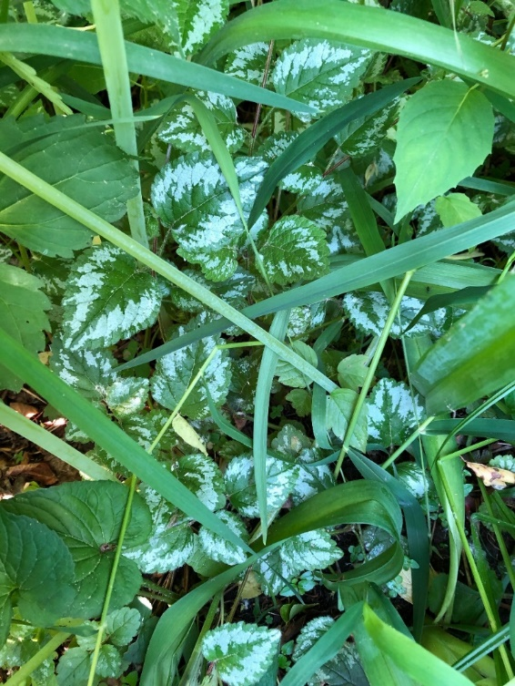
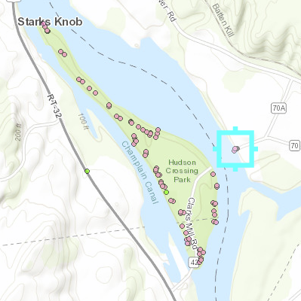
Figure 2: Yellow Arch-Angel population found adjacent to the Hudson River in the northwest area of Hudson Crossings Park.

Figure 3 Northern Map Turtles found nesting in the center of Hudson Crossings Park in the field area. This is an S3 vulnerable species statewide and three nests were found in the field with one more turtle likely preparing to make a nest next to the woodchip pile. Flagging these nest areas could help mowers avoid those areas if mowing cannot be avoided.
