HUYCK PRESERVE INVASIVE SPECIES SURVEY 2019:
Emily Caboot, Anna Kuhne, Lauren Mercier, and Kelsey Stevent

Type of Work Performed: Manual removal of false spiraea, and burning bush at the Huyck Preserve

Date: August 6th and 9th , 2019

Address: E.N. Huyck Preserve, 5052 Delaware Turnpike, Rensselaerville, NY 12147
County: Albany County
Latitude and Longitude: 42.515448, -74.140219
Website: https://www.huyckpreserve.org/

Lead Contact Information for Project: Anne Rhoads 518-813-5583 Anne@huyckpreserve.org

Site Owner Contact Information: Anne Rhoads 518-813-5583 Anne@huyckpreserve.org

Project Description: Continued, work that had previously been started that week by the Huyck Preserve team, to manually remove false spiraea for eradication. The patch was about 800 plants in total, that day we removed over 50. Later in the week a single burning bush was manually removed on site.

Invasive Species Present at Huyck Preserve:
Common Name | Scientific Name | Locations (GPS) | Growth Type | Phenology | Distribution/ Abundance
False Spiraea | Sorbaria sorbifolia | 42.54297  -74.16654 | Herbaceous | Vegetative | Monoculture
Burning Bush | Euonymus alatus | 42.51837  -74.14406 | Shrub | In seed | Single plant surrounded by seedlings

Capital Mohawk PRISM Strongly Recommends Uploading Points into https://www.imapinvasives.org/
Native Community Types: Forest
Dominant Native Plants Present: Jack in the pulpit, sugar maples
Summary of Work Completed:
  - Continuation of digging up the false spiraea to eventually eradicate the patch

Recommendations for the Future: Continue removal until the patch has been eradicated. In the future return for surveys to look for any new sprouts.
Contact the Capital Mohawk Prism http://www.capitalmohawkprism.org/

Figure 1. Map of points taken at the location. The false spiraea is the pink dot on the map.
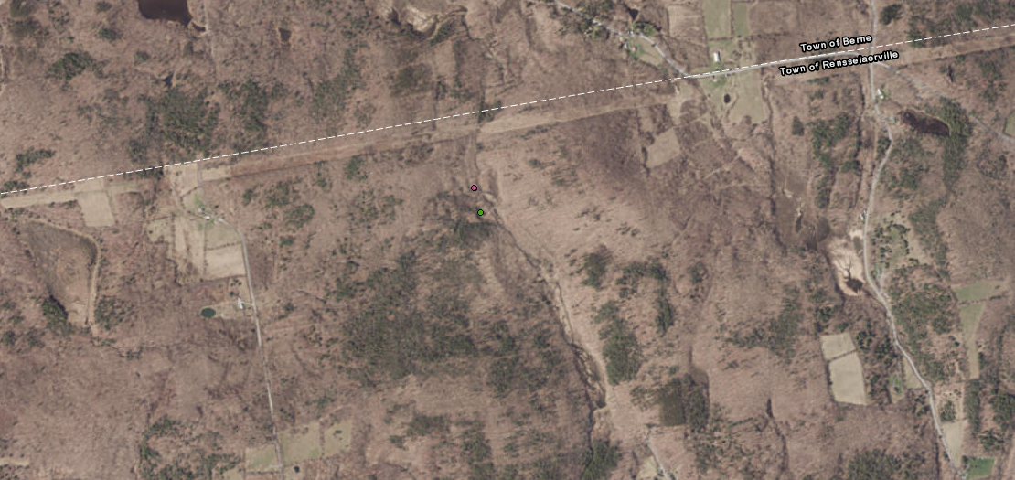

Figure 2. False spiraea at the Huyck Preserve
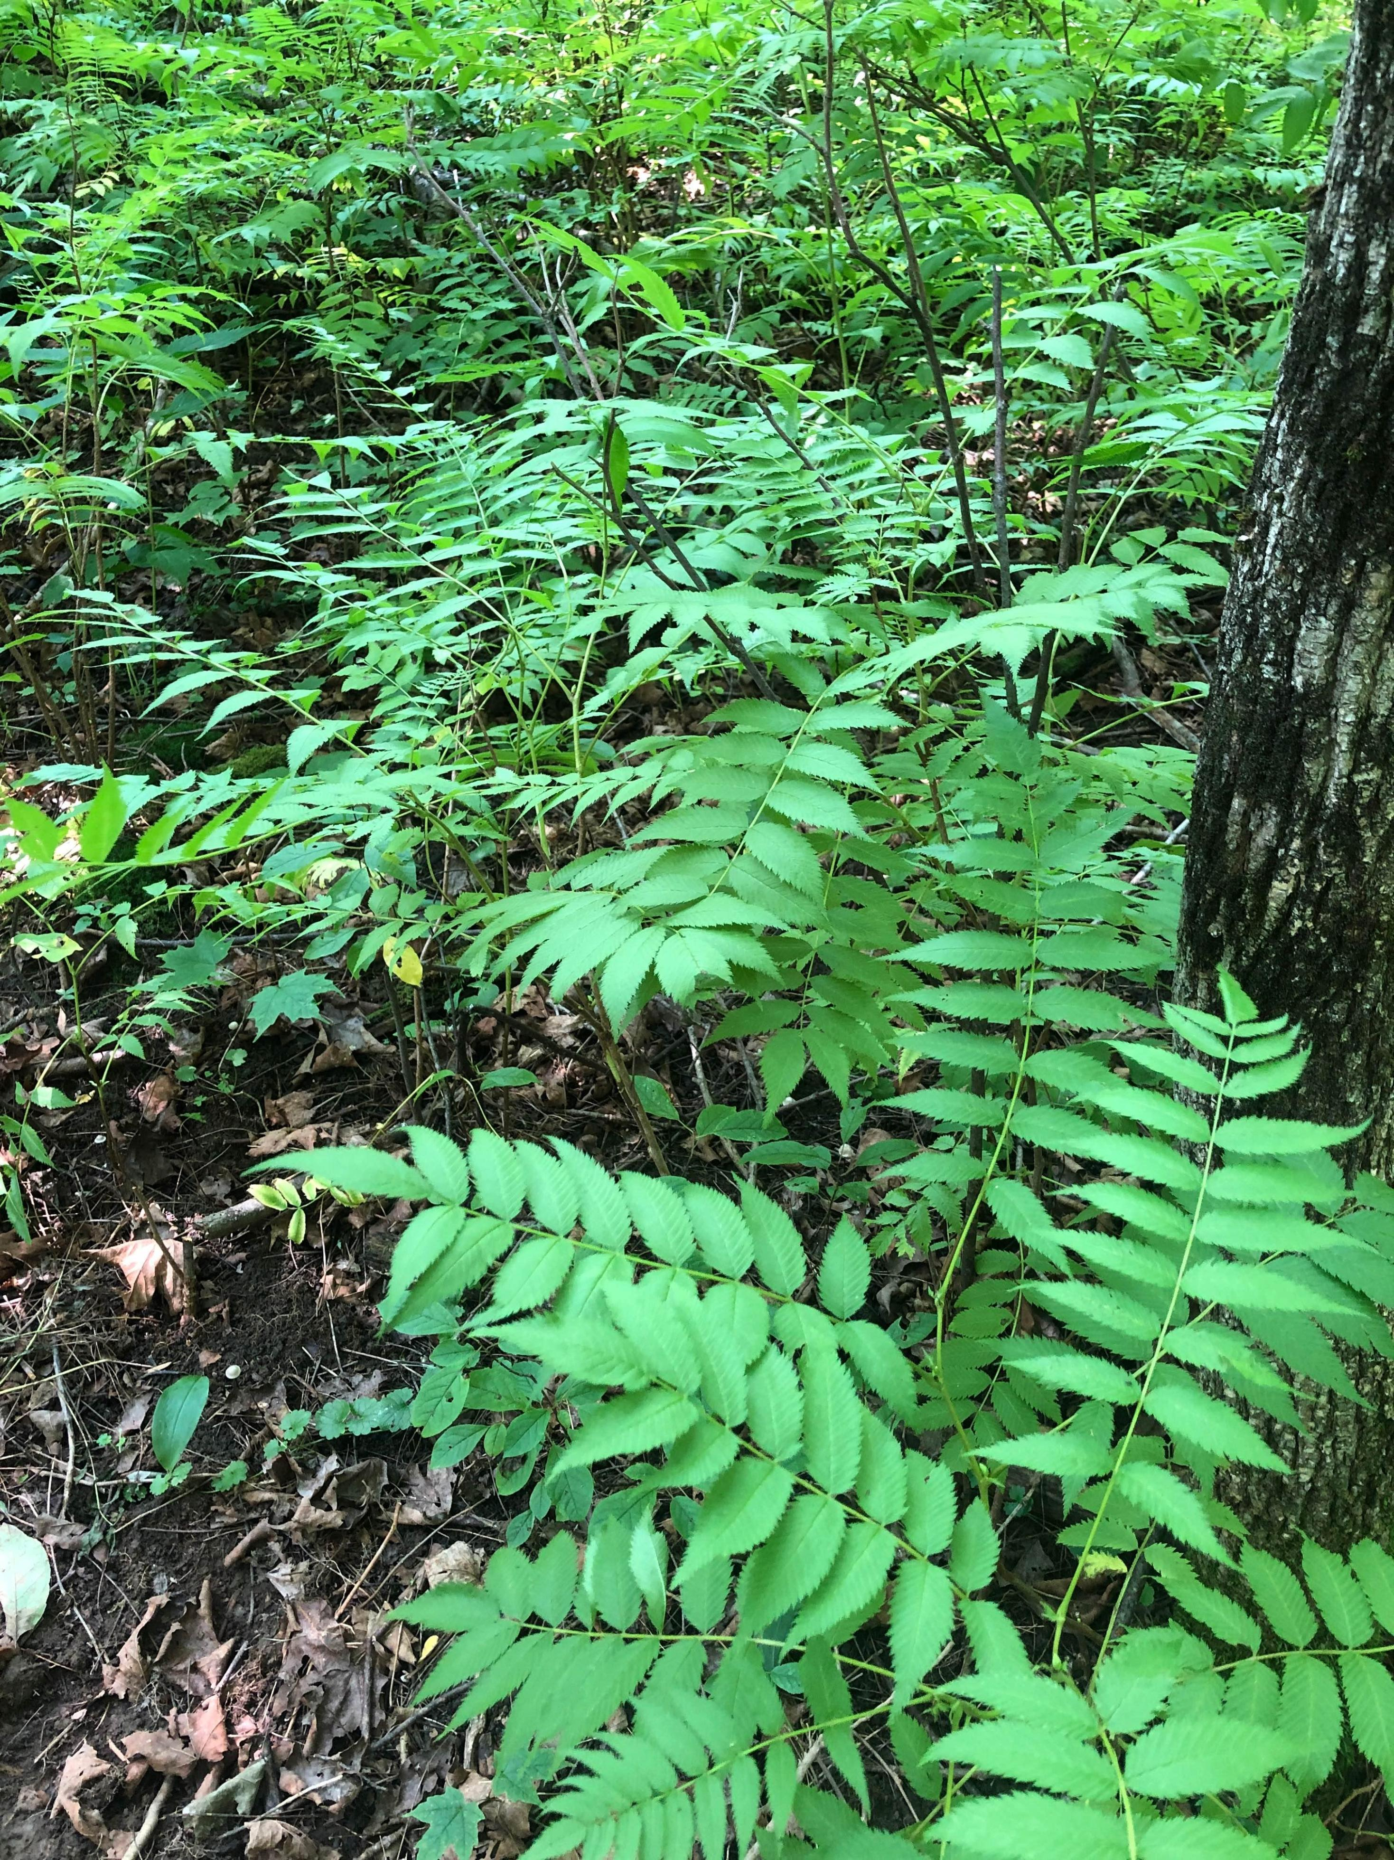

Figure 3. Map of points taken at the Huyck Preserve. The two pink points in the box are for the single burning bush shrub that was manually removed.
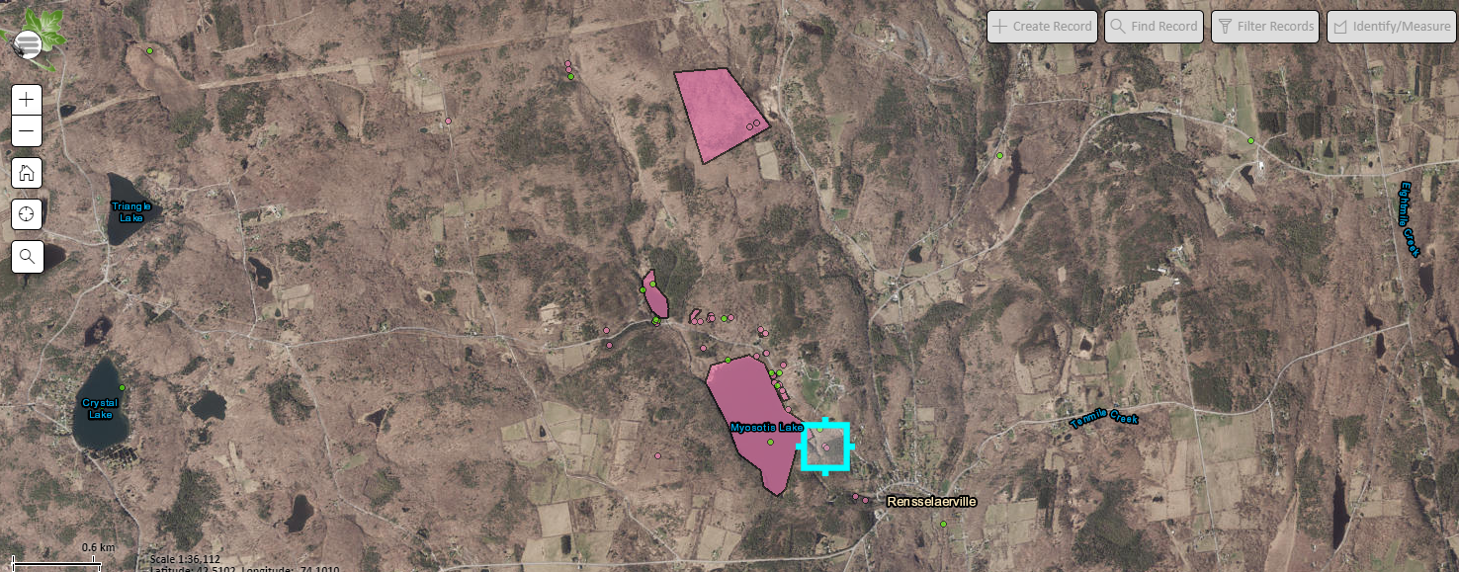
Figure 4. The burning bush that was manually removed.
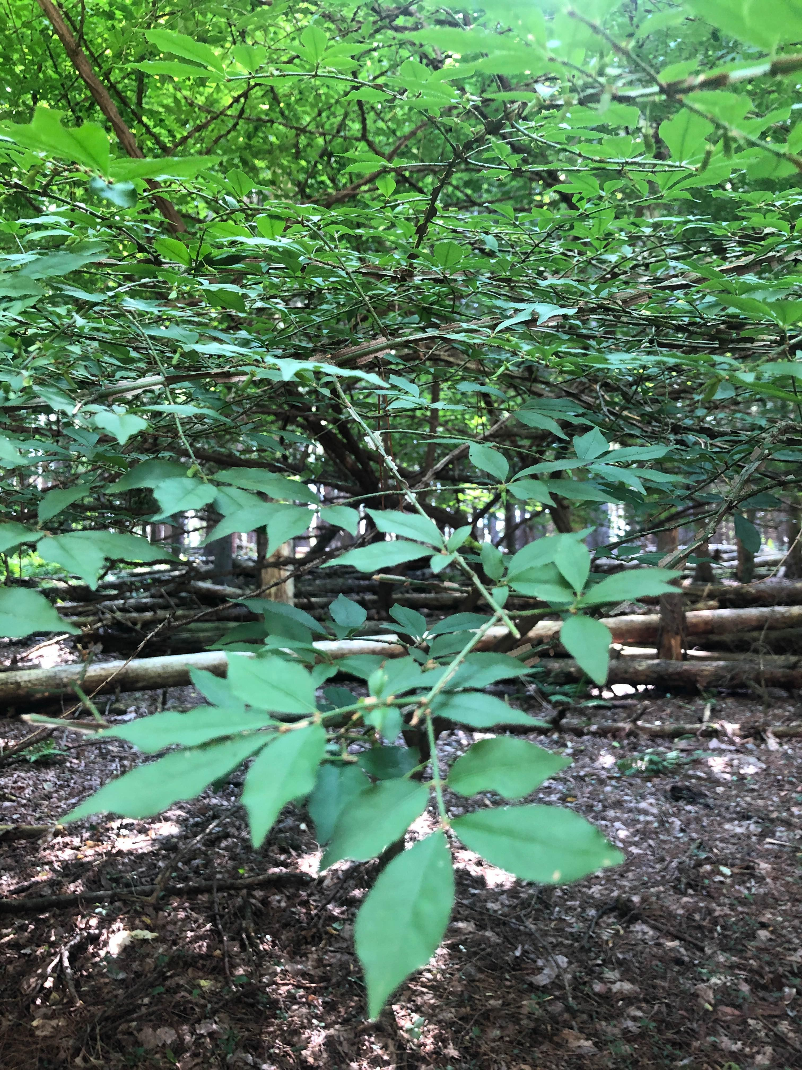

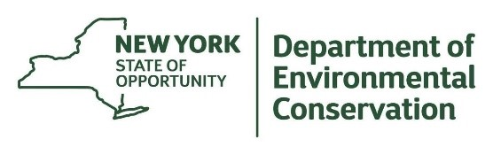
The New York State Department of Environmental Conservation provides financial
support to The Capital Mohawk PRISM via the Environmental Protection Fund.

