Capital Region PRISM Treatment Report

Site Information
Date: 7/14/2020
Site Name & Address: The Edmund Niles Huyck Preserve, Inc. 5052 Delaware Turnpike, Rensselaerville, NY 12147
Property Owner: The Edmund Niles Huyck Preserve, Inc.
Latitude: 42.53915 Longitude: -74.15101
Project Leader: Garrett Chisholm Email: garrett@huyckpreserve.org
Team Members: Nicole Campbell, Lauren Henderson, Kristopher Williams
iMapInvasives User ID: 18757

Project Information
(Copy this section and fill out for each species)

Target Species: Pale Swallow-wort (Cynanchum rossicum)
First year of treatment? Yes
Size of infestation: 1.71 acres
Treatment Method (please be specific): The large infestation of Pale Swallow-wort on the hillside of the Loop 1 Trail at the Huyck Preserve was cut back to ground level using weed trimmers starting from the top of the hill and ending at the stone wall at the base of the hill. Isolated populations of Pale Swallow-wort were hand pulled. Both the large infestation and isolated populations were left on-site to decompose.

% Completed: 100%
Amount removed (# bags, # plants, # mature, # seedlings): NA
Time spent on removal: 4 hours
Is follow-up needed? Yes
Were treatments uploaded to iMapInvasives? No
Photos and maps of the project:
Treatment area walked in Survey123:
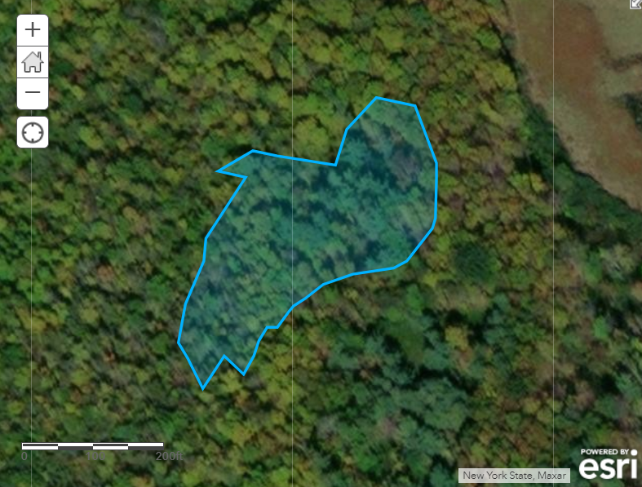

Map of Pale Swallow-wort points created in ArcGIS PRO:
