Can a Pacific Northwest silverfly save eastern hemlocks in New York State?
The Huyck Preserve in Rensselaerville, NY is leading the way in finding out

It’s called biological control, and it means putting a natural predator near its prey as a way of managing a pest. Think lady bugs killing aphids, or deer mice eating gypsy moths. Now, an Upper Hudson Valley nature preserve is a testing ground for two species of silverflies that might help save native hemlock populations.

The Edmund Niles Huyck Preserve, a 2,000+ acre nature preserve, accredited land trust, and biological research station in Rensselaerville, NY is working closely with the New York Hemlock Initiative (NYSHI) at Cornell University to implement biological control of the hemlock woolly adelgid (HWA), a destructive pest of eastern hemlock trees that was introduced in Virginia in the early 1900s. Since that time, HWA has killed millions of hemlocks from northern Georgia to Nova Scotia.

The Huyck Preserve is a partner in the Capital Region PRISM (Partnership for Regional Invasive Species Management), a nonprofit quasi-governmental agency hosted by the Cornell Cooperative Extension of Saratoga County and funded through the NYS Department of Environmental Conservation via the Environmental Protection Fund. In 2018, the Huyck Preserve began work on its first invasive species management and monitoring plan, and Capital Region PRISM became a significant resource for protecting the lands and waters of the Preserve from the harmful effects of invasive species including forest pests like hemlock woolly adelgid. With support from Capital Region PRISM and advice from the NYSHI, the Huyck Preserve undertook its first chemical treatment of HWA in 2020. HWA has continued to spread across the nearly 350 acres of hemlocks at the Huyck Preserve, and last fall Capital Region PRISM and the NYSHI approached the Huyck Preserve with a proposal to release HWA biocontrol agents as a second tool in the fight to save the Preserve’s important trees. This spring, the NYSHI released two species of silverflies, Leucopis argenticollis and Leucopis piniperda. These tiny flies are native to the Pacific Northwest of the United States and are specialist predators of HWA. In other words, they only feed on HWA and are at very low risk of causing ecological problems. The silverflies feed on HWA eggs as larvae and are some of their most numerous predators on the western hemlocks of the Pacific Northwest.

This year’s release is part of a long-term study coordinated by the three organizations, and future monitoring will determine the success of establishment of silverfly and control of HWA. Only time will tell if the release of a small number of silverflies (compared to the vast infestation of HWA at the Preserve) is successful. Will the silverflies thrive in this environment? Will they suppress the HWA population enough that hemlock trees will survive? This spring’s release is one of the first in the Capital Region. Although systemic insecticide treatment is currently the most effective method in managing HWA, long-term, landscape-scale conservation of hemlocks will likely depend on biological control. Eastern hemlock is New York’s third most common tree species and is a foundation species in our forests. Hemlock trees are important for maintaining healthy wildlife habitat and fresh water resources, and their loss would drastically change our landscape.

For more information visit these sites:
- www.capitalregionprism.org
- https://blogs.cornell.edu/nyshemlockinitiative/
- www.huyckpreserve.org

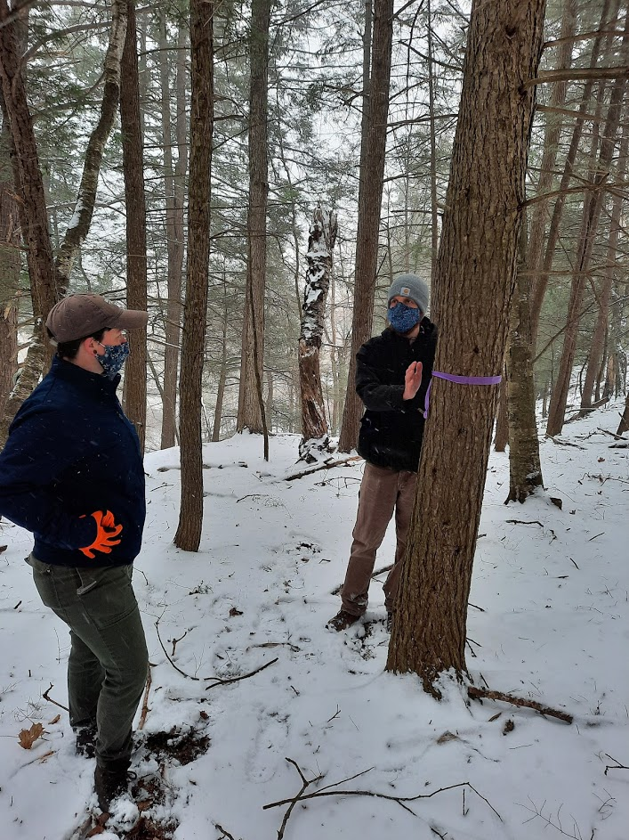
Nicholas Dietschler, Research Technician with the NYS Hemlock Initiative at Cornell University (R), and Nicole Campbell, Terrestrial Invasive Species Coordinator for the Capital Region Partnership for Regional Invasive Species Management (L), discuss plans to release silverflies at the Huyck Preserve in Rensselaerville in an effort to combat invasive hemlock woolly adelgid.
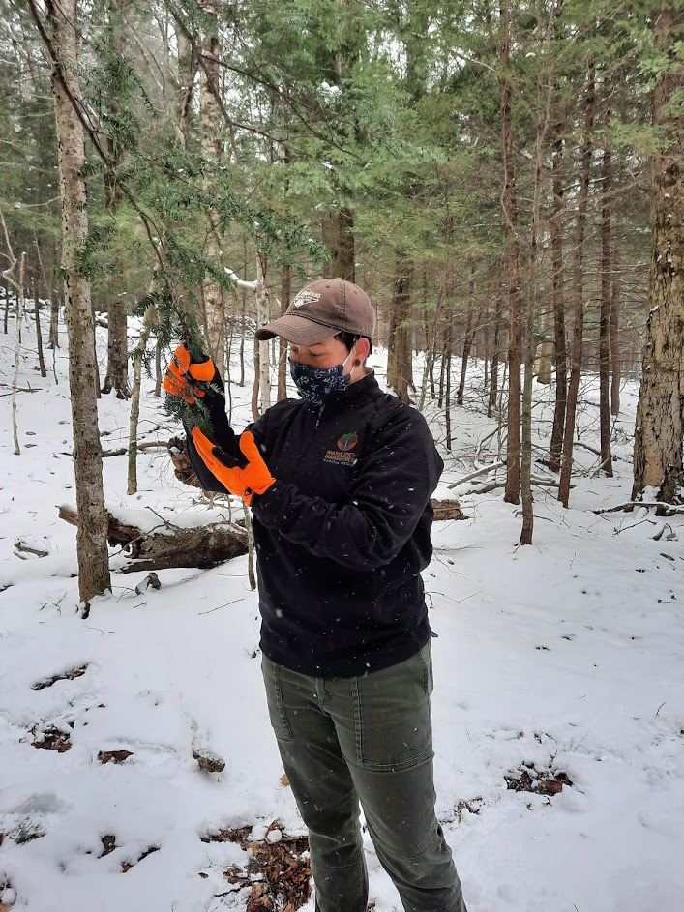
Nicole Campbell, Terrestrial Invasive Species Coordinator for the Capital Region Partnership for Regional Invasive Species Management, inspects a hemlock infested with hemlock woolly adelgid at the Huyck Preserve in Rensselaerville.
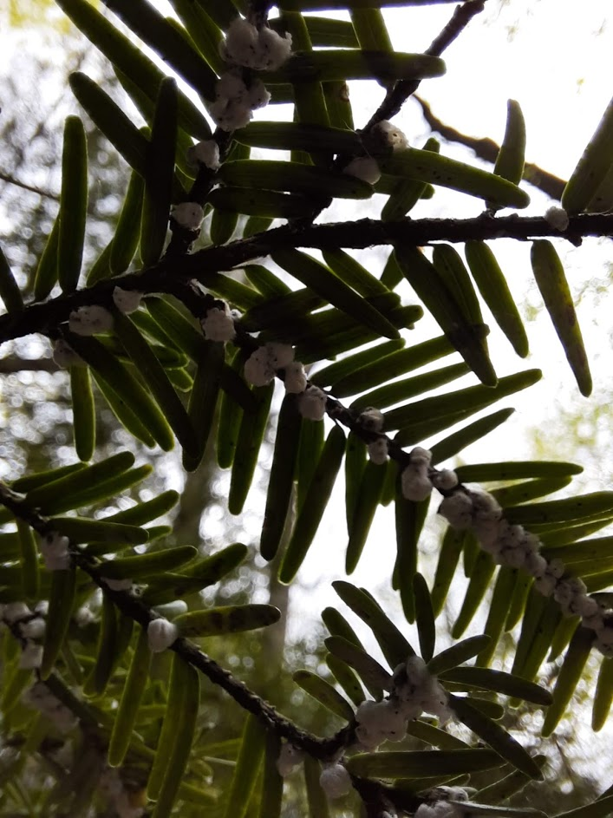
Telltale woolly masses from hemlock woolly adelgid on an eastern hemlock tree

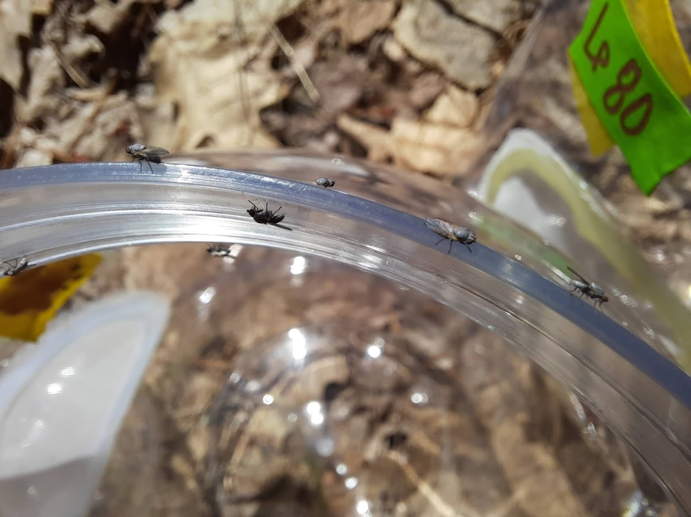
Leucopis piniperda was released in a hemlock stand infested with invasive hemlock woolly adelgid at the Huyck Preserve in Rensselaerville as part of a biological control study aimed at conserving hemlocks.

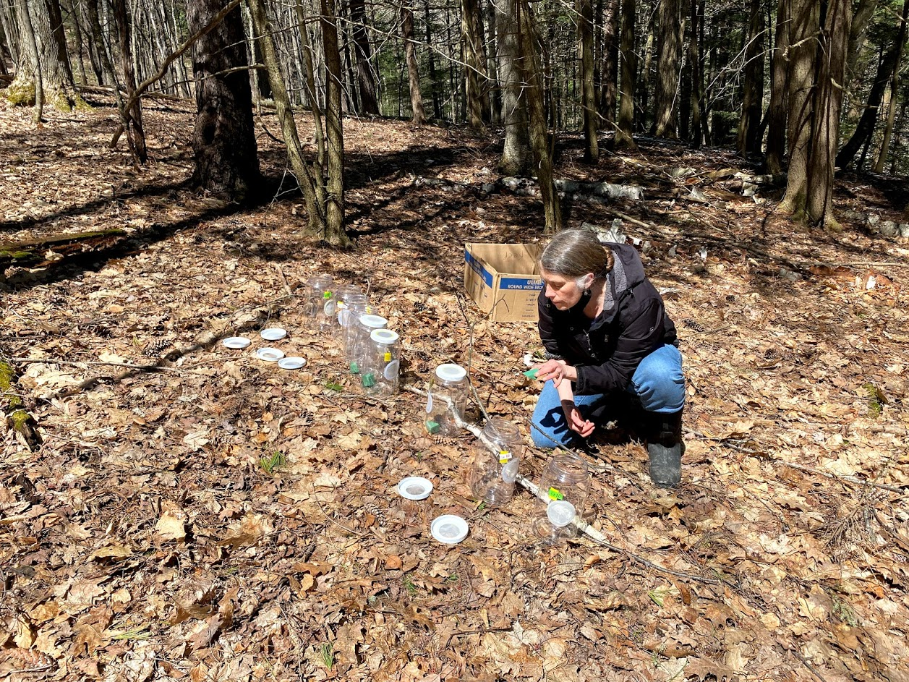
Huyck Preserve Executive Director Anne Rhoads, Ph.D. releases silverflies in a hemlock stand infested by invasive hemlock woolly adelgid.
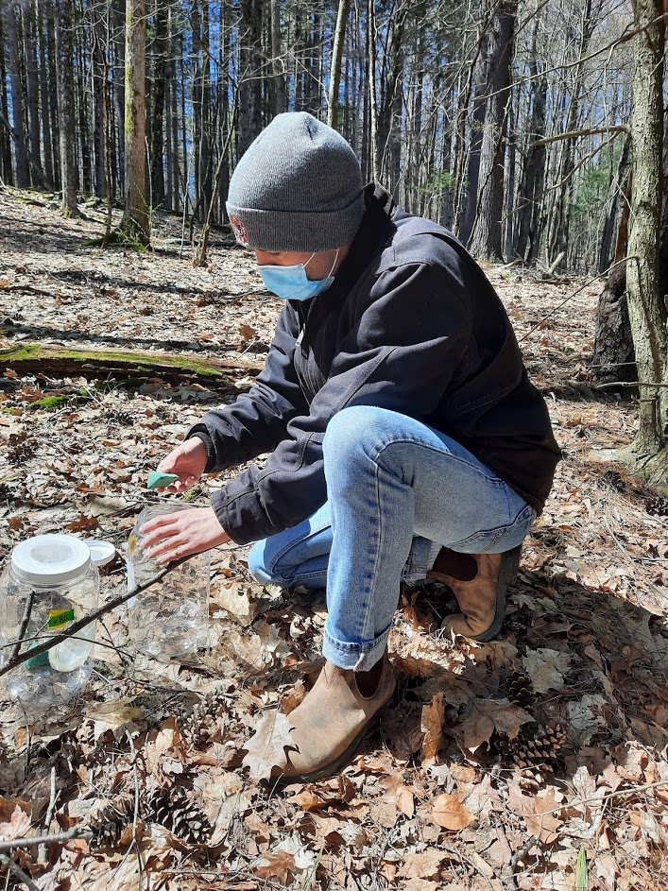
Huyck Preserve Stewardship Coordinator Garrett Chisholm releases Leucopis piniperda in a hemlock stand infested with invasive hemlock woolly adelgid at the Huyck Preserve in Rensselaerville.

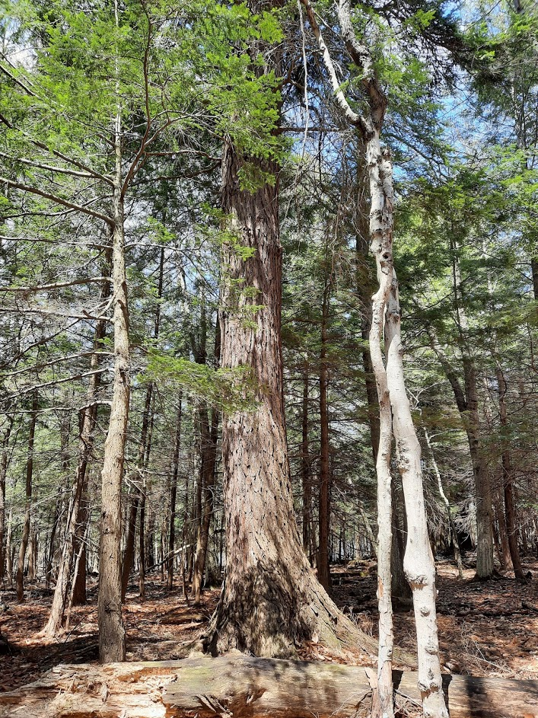
An example of the hemlock trees at the Huyck Preserve that the Preserve, Capital Region PRISM, and the NYSHI hope to protect from invasive hemlock woolly adelgid with the help of biological control

