Capital Region PRISM Cornell Cooperative Extension Saratoga County
Partnership for Regional 50 West High St. Invasive Species Management Ballston Spa, NY 12020
www.capitalregionprism.org (518) 885-8995

Page 1

Capital Region PRISM Survey Report

Purpose:
The Invasive Species Survey Report will provide an overview and help guide invasive species treatments, baseline site composition, post-monitoring, and restoration at a specific site over time. A single survey report should not be written for an entire site, but a specific project. A site could have multiple reports. If there are multiple reports within a site, consult with the Capital Region PRISM about potentially preparing a more robust survey report.

To be submitted to Capital Region PRISM following the completion of partner, individual, or PRISM-led survey for review. This form can be found onlineas "Field Survey Report Template" at www.capitalregionprism.org/reports.html or with a request. Please consult the Capital Region PRISM if there are any questions at (518)-885-8995. Please capture and collect data using iMapInvasives: www.nyimapinvasives.org. The online software platform and associated mobile application is free and open sourced.

Section 1: Survey Summary
This section provides an overview of the site, contact information, etc. Once complete, save your report and submit the form via email to a member of the Capital Region PRISM team. Feel free to include supporting documents in your submission.

To determine site value, we recommend using the iMapInvasives Prioritization Model which can be found on the PRISM website at https://www.capitalregionprism.org/ny-invasive-species-prioritization-map.html The prioritization model will allow you to assess your sites ecologic value based on a few factors. Evaluate the comprehensive score or the ecological score to determine if your site is a high priority site that will will help us determine if the location and infestation falls into our priority objectives for future management. If it is not a high priority site, we still encourage you to complete invasive species surveying as the site maybe culturally and socially of value to the public.

Section 2: Survey Result Summary
The survey summaries section will contain the tables and maps generated from your survey efforts. The biologic surveys will assist the Capital Region PRISM in our efforts to identify emerging species to be able to more effectively manage infestations and the spread of populations. Please fill out the provided table and insert screen shots of iMapInvasives maps.

Section 3: Summary of Recommendations
The recommendation section contains treatment calendars and post-season summaries. Most sites need to be revisited annually to document successes/failures, identify any changes needed, and update future treatment calendars.

Section 1: Survey Summary

Date: 10/22/21
Site Name Address: Indian Meadows Park Glenville, NY 12010
County: Schenectady
Latitude and Longitude: 42.884080, -73.940637
Property Owner Contact: N/A
Lead Contact for Survey: Sam Schultz
Phone and Email: (518) 885-8995 (ext. 2211), ss986@cornell.edu
Overall Site Size: 186 acres

Site Description: Provide existing conditions of the site, current land use, landscape elements, etc.

This 186-acre Town of Glenville Park is the Town's largest and most popular day use facility. A number of recreational facilities are located within the park, offering a variety of year-round activities including: cross-country skiing and snowshoe trails, two ice skating rinks, sledding hill, tennis and basketball courts, baseball, softball and soccer fields, park pavilion, playground, story trail and restroom facilities.

Large tracts of open field within the park are managed for wildlife preservation and bird habitat. The Greenway Trail connects Indian Meadows to Andersen Park. Participants can hike, snow shoe or cross-country ski the trail.

Survey Techniques: Provide a clear and concise description of the work to be conducted, target species, and any survey methods used.

Survey was conducted along trails surrounding iMap record for Porcelain berry. Site where record was reported was surveyed as well. The point was off-trail and GPS point is assumed to be inaccurate.

Did you identify this site through the iMapInvasives Prioritization Model? If yes- Did it score high in either ecological or comprehensive value? What other reason is present for conducting the survey?
No, porcelain berry is a tier 2 within the Capital Region PRISM and therefore can still be eradicated within our boundaries.

Section 2: Survey Result Summary

Common Name | Scientific Name | GPS Location
Porcelain berry | Ampelopsis brevipedunculata | Not detected

Growth Type: (T)Tree, Shrub, Vine, Ground Cover, Herbaceous, Riparian, Pest, Animal (A)Submerged, Floating, Emergent,
Riparian, Pest, Animal

Phenology: Flowering, Leaf unfolding, fruit ripening, leaf color change, dormant, swarming, spawning, emergence (insects), migrating, in seed

Distribution/Abundance: Sparse, Dense Patches, Dominant, Single Clump, Single Plant

Map: Develop a map of the survey area that has any iMapInvasives points and/or searched, polygons to delineate infestation extent. Multiple maps may be added for multiple species or locations. Different mapping formats are welcome but iMap Invasive delineations are preferred,

- Insert Survey Map(s):

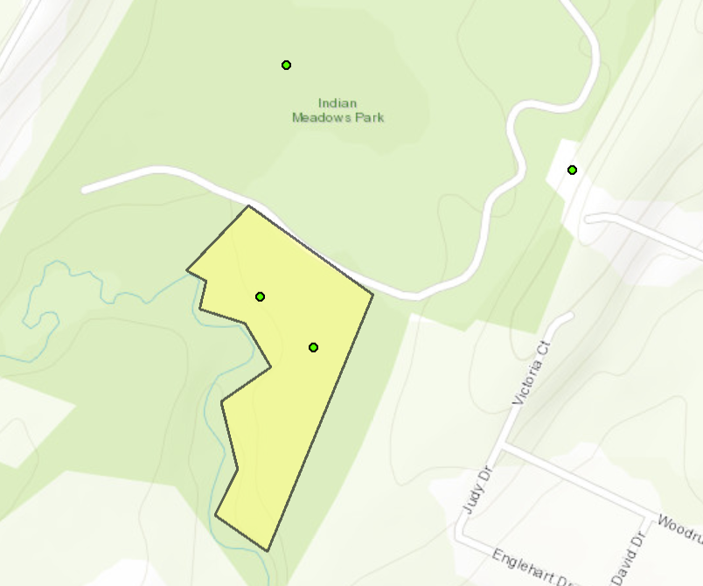
Not-Detected Region #: 20126

Section 3: Summary of Recommendations
This page provides recommendations of any treatment methods, monitoring methods, and restoration efforts based on the survey.

Treatment: Describe briefly any recommendations for future treatment methods, why they are recommended, and any alternatives to consider. Please use abundance and site-specific factors in your treatment recommendation. Optional: Attach or reference BMP guidance document. Consider state and local permitting requirements.
No treatment is recommended at this time since the reported species was not detected at this location.

Post- Survey Monitoring: Briefly explain the monitoring procedure, when it will occur, and who will complete it. Consider the phenology of species when suggesting time-lines. If a control such as eradication, suppression, and exclusion is selected will a management plan be drafted? If a plan is needed please contact the CR-PRISM Office for a template of post treatment Invasive Species Management Plan.
Capital Region PRISM staff will follow up with another survey at this location next year to determine if porcelain berry is present. It is suggested to survey in September to have a higher likelihood of detection if reported species is present. There are two entrances into this trail, use the one closer to the end of the road, do not enter at the entrance near the parking lot, your walk will be much longer to record point.

