Japanese Angelica Tree Treatment, Spring 2019: Ballston Spa, Saratoga County
Prepared by Spencer Barrett
Japanese Angelica Tree (Aralia elata) has a single known population in CapMo and has been in close proximity to the PRISM for a number of years now, making it a Tier 2 species. This species is a serious threat in the Lower Hudson PRISM as well as New Jersey, and has been popping up in new PRISMs in recent years. Alarmingly, this plant appeared in Ballston Spa, NY, more than 54 miles from the next closest reported location next to Otsego Lake.
Associated iMap Invasives Records: (Obs: #530790, Treatment: #14189)

Discovered by CapMo staff, this population of Aralia is present in Wiswell Park in the center of the village of Ballston Spa. Wiswell Park is managed by the Ballston Spa Department of Public Works. After contact was established with DPW, Jeff G. was very responsive, meeting with Spencer Barrett, Terrestrial Coordinator for CapMo on-site and evaluating the population. He approved the work verbally, stating that a DigSafe ticket should be filed due to the population’s close proximity to the wall of Front Street Deli, and that would serve as notification to his office. Spencer agreed to re-plant the break in the hedge that the removal would re-open and Dustin Lewis of the Saratoga Soil and Water Conservation District agreed to supply the tree for restoration of the site.
Totals: In one visit, Spencer removed four stems of Japanese Angelica Tree over an area of approximately 30 square feet. In addition to the removal of this pest plant, Spencer and Gwendolyn Temple planted a spruce tree to fill the newly exposed gap in the hedgerow.

Suggestions for the Future:
With this project, as with most invasive species removal projects, it is recommended that post-treatment monitoring occur to evaluate the success of the eradication effort. Aralia is known to re-grow from root fragments, which may be left in the soil.
From the village perspective, the plantings at Wiswell Park are hardy and provide a variety of colors at different time of year. From an ecological perspective, the plantings are a possible source of invasive species to natural areas around the village, especially the Kaydeross corridor which is located down the hill from the park. Burning Bush, Bishop’s Goutweed, and Miscanthus are featured plants in the park and is recommended that native alternatives are sought to further enhance the park. The species to focus on first would be Miscanthus, which is currently a Tier 2 species in the PRISM. Hopefully both groups see this project as a success and improvement for the park. Thank you to the partners that assisted with this small but meaningful project.

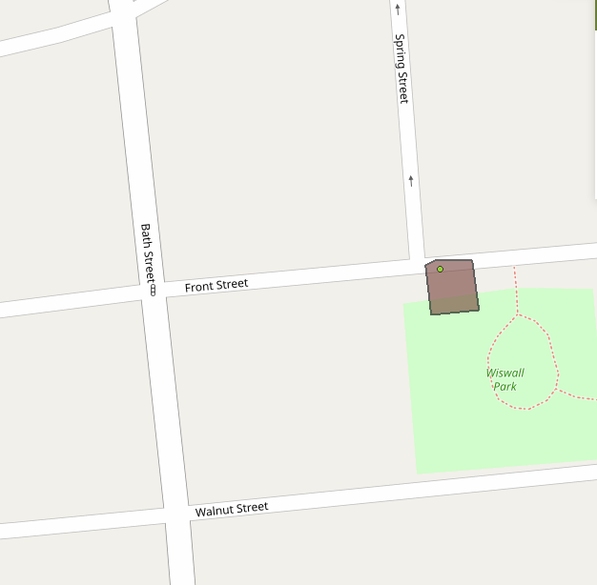Figure 1: The infestation polygon from iMap Invasives. Plants were located at the very northwestern edge of the park, adjacent to the brick wall of the neighboring building. Four stems were manually removed. The observation point and treatment polygon are slightly off from the actual location.

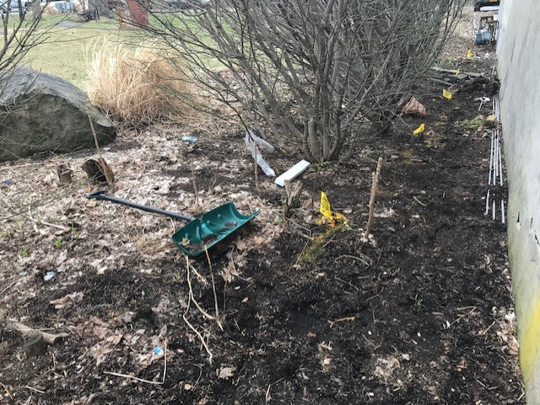
Figure 2: A before and after shot of the Japanese Angelica tree treatment site. Pictures were taken before leaf-out. Yellow lines and flags notate a natural gas line delineated by DigSafe NY.
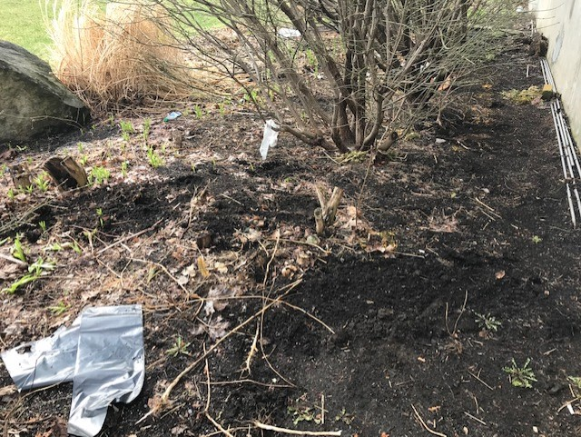
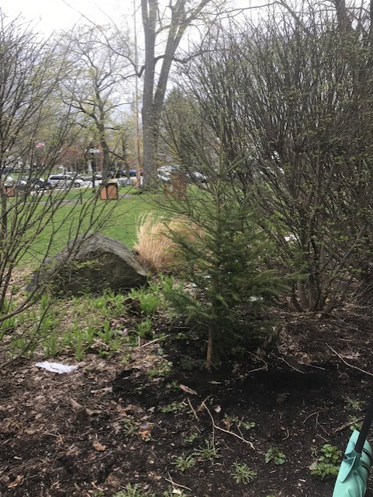
Figure 3: Final picture of the site, complete with new spruce tree provided by Saratoga Soil and Water Conservation District that provides the same benefits a thorny plant to block people walking through the gap.

