Japanese Barberry
Berberis thunbergii

Identification
Japanese barberry is a deciduous shrub that grows to an average height of 2ft. It has small, smooth edged, oval leaves that grow in clusters on the stem. Cultivated Japanese barberry has reddish-purple leaves throughout the summer, while the wild-type has green leaves until the fall when they turn red. The stem is brown in color and has sharp thorns at each node.

Reproduction
In May, Japanese barberry will develop clusters of drooping yellow flowers. The flowers have six petals and hang from the bottom of the stem. By July, the Japanese barberry forms clusters of small, red, oval fruits that persist until the winter. The seeds are spread primarily by birds, but the plant can also spread through root fragments and rhizomes.

Habitat
Japanese barberry is typically found in well drained, partially shaded forests, fields, and roadsides. It is also was commonly used as an ornamental plant in gardens, but is currently a prohibited plant in New York.
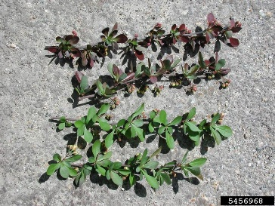

Threat
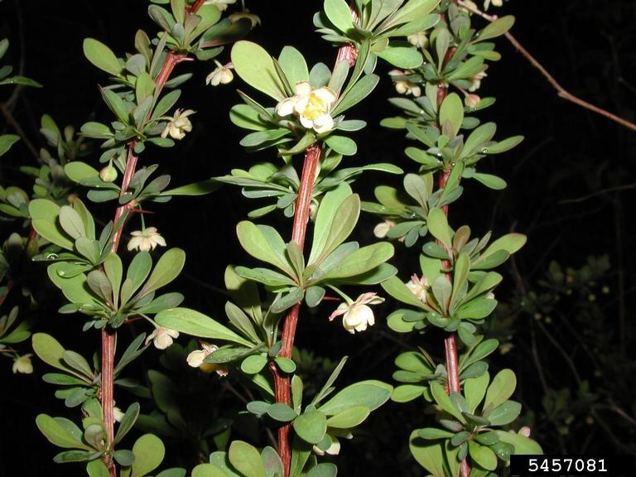
The fast growth and ease of spread of Japanese barberry allows it to outcompete native shrubs. It can also alter the soil composition and does not serve as a food source to livestock or other herbivores. In addition, it is a breeding ground for deer ticks which carry Lyme disease.

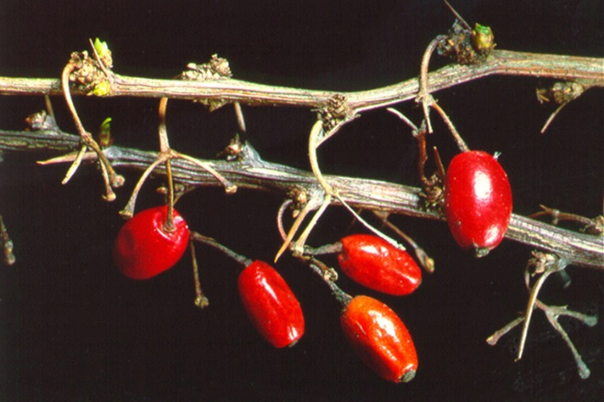

Integrated Pest Management for

Japanese Barberry
Due to the threat of Japanese barberry to local ecosystems, it is important to reduce the size and limit the spread of existing populations. Invasive species are controlled through prevention, eradication, containment and suppression. An integrated pest management (IPM) approach should be adopted to control unwanted species. The integrated approach is a combination of manual, mechanical, biological and chemical controls. IPM requires post treatment monitoring and treatment over a period of several years, leading to more successful outcomes (https://nysipm.cornell.edu/about/defining-ipm/).

Practices to Avoid
- AVOID MOWING AND CUTTING. Mowing and cutting are not useful tools for Japanese barberry because they will trigger re-sprouting. These methods can be used as a way to initially reduce the biomass but it is best to follow up with pulling or herbicide treatment.
- AVOID REMOVAL WHEN IN FRUIT. It is best to remove Japanese barberry before it goes into fruit to avoid seed dispersal. If you do remove it when it is in fruit, be sure to place the pieces into a bag and leave it to dry for at least two weeks before disposal.

Manual and Mechanical Control
Japanese barberry is fairly easy to remove by hand due to the shallow root system. It is important to wear protective clothing and gloves to prevent getting stuck by a thorn. This is the best method of control for small populations and should ideally be performed in the spring season when the ground is moist. Cutting and mowing can be used in conjunction with pulling or herbicide treatments, but are not considered effective methods on their own.

Biological Control
There are currently no approved biological control methods for Japanese barberry.

Herbicide Control
For large and mature infestations of Japanese barberry that cannot be manually removed, herbicide is a useful tool. It is very important however to be educated on the proper chemicals and techniques for applying herbicide to limit the effects on the environment. Please consult an expert or certified applicator when applying herbicides. Read and follow herbicide product labels as required by law. Seek out proper local, state, and federal permitting when applying herbicides.

Herbicide Treatment for Homeowners/ Private Landowners

Time of Year: April-May or September-November

Example Chemical(s) to Apply: Read All Product Labels as Required by Law
Product names are listed as examples, and not as endorsement or recommendation. The suitability and details for specific use of these products are provided through their labels.
Chemical  (Products containing) | Timing | Application Technique | Notes
Glyphosate (Roundup, Rodeo) | April- May or September-October | - Foliar spray  - Cut-stump | - Non-selective so best to apply before other plants bud and after other plants die back  - Avoid cut-stump in spring when sapping
Triclopyr (Garlon 3A) | April-September | - Foliar spray  - Cut-stump | - Selective  - Avoid cut-stump in spring when sapping
If there is water present near the infestation, a certified applicator or a permit from the DEC is required. For more information regarding aquatic pesticide permitting, please contact the nearest DEC Regional Office: Division of Environmental Permits at (518) 357-2069 or visit: http://www.dec.ny.gov/permits/209.html.

Timeline of Action

For more information, seek out the Cornell Guidelines for Pesticide Use:
The Cornell Guidelines offer the latest information on topics such as pest management, crop production, and landscape plant maintenance. Each title in the series is updated by Cornell University researchers and Extension specialists and is designed as a practical guide. https://www.cornellstore.com/books/cornell-cooperative-ext-pmep-guidelines
CAUTION: DO NOT HANDLE WILD PARSNIP WITHOUT PERSONAL PROTECTIVE EQUIPMENT.

Native Replacements
After removing or treating Japanese Barberry, it is important replace the disturbed area with native species to help restore the ecosystem and prevent new invasive species from appearing. Leaving a living seed bank in the treated area or spreading native seeds in will help the cultural/biodiversity and re-establishing native plants. More information about native plants, shrubs and trees can be found:

Alternatives to Ornamental Invasive Plants “A Sustainable Solution for New York State”
- https://nysipm.cornell.edu/sites/nysipm.cornell.edu/files/shared/documents/NYSIPM-alt-inv.pdf

NYSDEC Native Plant Factsheets
- https://www.dec.ny.gov/docs/lands_forests_pdf/factnatives.pdf

Lady Bird Johnson Native Flower Database
- https://www.wildflower.org/plants/

Westchester Community College Native Plant Center
- https://www.sunywcc.edu/about/npc/

Definitions:
Manual Control: a technique to remove small infestations. Some examples of manual control is hand-pulling, mulching, burning, digging, and removal of the entire plant, portions of a plant, nests, egg masses, or other life stages. This type of control is only economically feasible for small infestations.
Herbicide Control: a technique which uses chemicals to remove or decrease the population of a species. Herbicides are usually one of the last choices for control as they are usually expensive and have adverse effects to the environment. There are different methods to apply an herbicide. Some examples are: foliar spray, basal bark, bundle and cut, and cut-stump treatment.
Biological Control: a technique where an animal, insect, fungi or disease is used to manage a large invasive species population. This control species is studied intensively to see if there could be any negative effects for native species.
Foliar Spray: method of herbicide control where the chemical is sprayed directly on the leaves. Sprayers can be hand held, on a backpack or mounted on a vehicle. If a plant has a waxy surface, a surfactant may be needed to allow the herbicide to work.
Selective herbicides: a type of herbicide which kills specific groups of plants but not others. For examples, a selective herbicide may kill broadleaf plants, like dandelions, but not grasses.
Non-selective herbicides: a type of herbicide which kills all types of plants. When using this herbicide, any plant that is sprayed will be effected.
DISCLAIMER
Please note that neither Cornell Cooperative Extension of Saratoga County nor any representative thereof makes any representation of any warranty, express or implied, of any particular result or application of the information provided by us or regarding any product. If a product is involved it is the sole responsibility of the User to read and follow all product labeling instructions and to check with the manufacturer or supplier for the most recent information. Nothing contained in this information should be interpreted as an express or implied endorsement of any particular product or criticism of unnamed products. With respect to any information on pest management the User is responsible for obtaining the most up-to-date pest management information. The information we provide is no substitute for pesticide labeling. The User is solely responsible for reading and following manufacturer’s labeling and instructions.

The New York State Department of Environmental Conservation provides financial support
to The Capital Mohawk PRISM via the Environmental Protection Fund.

