Japanese Knotweed
Fallopia japonica

Identification
Japanese knotweed is a perennial shrub that can grow up to 15ft tall. The stem is hollow and has purple spots spread throughout. It has large, broad triangular leaves that come to a sharp point at the end. They grow from internodes in an alternating pattern along the stem.

Reproduction
In the summer months, around June to September, Japanese knotweed develops spikes of small white flowers. The flowers are unisexual and develop into a brown, papery fruit containing three-sided shiny brown seeds. The majority of the seeds are non-viable, so the primary form of reproduction is through rhizomes and fragmentation. The rhizomes can reach up to 20m horizontally from the tap root. Seeds and fragments are easily transported by water, wind, and human interaction.
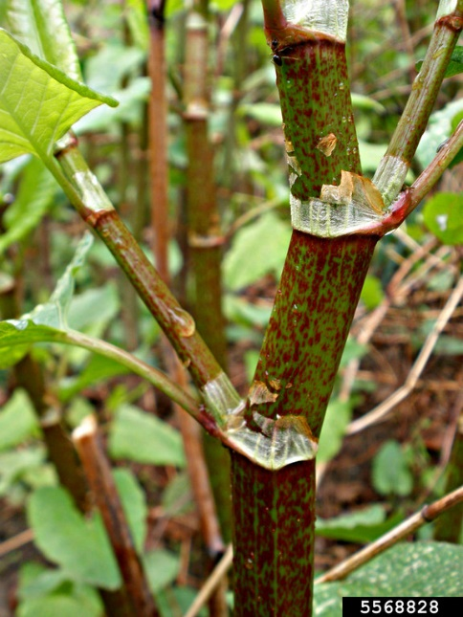

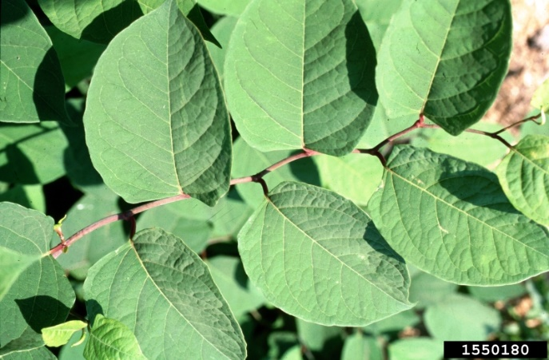

Habitat
Japanese knotweed thrives in disturbed areas such as roadways, right of ways, river banks, and waste facilities. It is also tolerant of a variety of soil and light conditions.

Threat
Japanese knotweed grows very quickly and spreads easily, causing it to form dense, widespread stands. These stands crowd out native vegetation and can increase erosion, especially in riparian areas
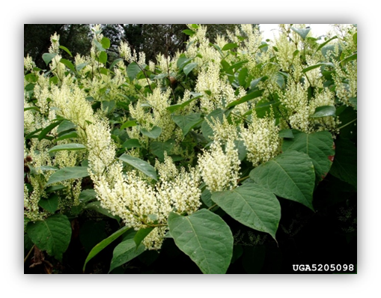

Integrated Pest Management for

Japanese Knotweed
Due to the threat of Japanese knotweed to local ecosystems, it is important to reduce the size and limit the spread of existing populations. Invasive species are controlled through prevention, eradication, containment and suppression. An integrated pest management (IPM) approach should be adopted to control unwanted species. The integrated approach is a combination of manual, mechanical, biological and chemical controls. IPM requires post treatment monitoring and treatment over a period of several years, leading to more successful outcomes (https://nysipm.cornell.edu/about/defining-ipm/).

Practices to Avoid
- DO NOT MOW. Mowing will create fragments which are easily spread by equipment that can start new populations.
- DO NOT HAND PULL LARGE INDIVIDUALS. Pulling large individuals of Japanese knotweed is relatively ineffective due to the extensive network of rhizomes and the intense amount of physical labor required.
- DO NOT APPLY HERBICIDE BEFORE FLOWERING. Waiting until the plant has flowered will be the most effective due to the nutrient storage being moved up the stem rather than underground in the roots.

Manual Control
Cutting and pulling small and young populations may be effective if performed in June, right before flowering. This will help reduce the size of the individual and reduce the amount of flowering spikes that can produce seeds. Any cut or pulled material should be bagged and left to solarize for at least three weeks before disposal. If small plants are pulled up, they should be replaced with a native alternative in order to prevent any new growth from fragments or the seed bank.

Biological Control
There is currently ongoing research on various biological control methods for Japanese knotweed. Aphalaris itadori is a psyllid that has been extensively tested in the UK but has not been approved for widespread use in the United States yet.

Herbicide control
Herbicides are typically the last resort for management, but in the case of Japanese knotweed it is the most effective. Knowing what chemicals to use and when to apply them is critical for having a lasting impact on Japanese knotweed infestations. Please consult an expert or certified applicator when applying herbicides. Read and follow herbicide product labels as required by law. Seek out proper local, state, and federal permitting when applying herbicides.

Herbicide Treatment for Private Landowners

Time of Year: July-October

Example Chemical(s) To Use: Read All Product Labels as Required By Law
Product names are listed as examples, and not as endorsement or recommendation. The suitability and details for specific use of these products are provided through their labels.
Chemical  (Products containing) | Timing | Application Technique | Notes
Glyphosate  (Rodeo, Glyphomate 41) | July-October | - Foliar Spray  - Stem Injection (between 2nd and 3rd node) | - Non-selective  - Kills foliage quickly but requires recurring application
Imazapyr (Arsenal, Polaris) | July-October | - Foliar Spray | - Non-selective  - Long soil life but most effective
Triclopyr  (Triclopyr 3, Garlon 3A) | July-October | - Foliar Spray  - Cut-Stem | - Selective  - Targets foliage but not very effective on rhizomes  - Often used as follow up
If there is water present near the infestation, a permit from the DEC is required. For more information regarding aquatic pesticide permitting, please contact the nearest DEC Regional Office: Division of Environmental Permits at (518) 357-2069 or visit: http://www.dec.ny.gov/permits/209.html

timeline of Action

For More Information Seek out the Cornell Guidelines for Pesticide Use:
The Cornell Guidelines offer the latest information on topics such as pest management, crop production, and landscape plant maintenance. Each title in the series is updated by Cornell University researchers and Extension specialists and is designed as a practical guides. https://www.cornellstore.com/books/cornell-cooperative-ext-pmep-guidelines

Native Replacements
After removing or treating Japanese knotweed, it is important to reseed or plant the disturbed soils with native species common in the geographic area. Replanting will help restore the ecosystem and prevent old infestations from re-establishing. Consider using stress tolerant plants in harsh environments that are best suited to a given site. If pre-existing native plants are present on site, protect these species from harm, during management. The surrounding native species can then be used to aid in the heathy reestablishment of the area. More information about native plants, shrubs and trees can be found:

Alternatives to Ornamental Invasive Plants “A Sustainable Solution for New York State”
- https://nysipm.cornell.edu/sites/nysipm.cornell.edu/files/shared/documents/NYSIPM-alt-inv.pdf

NYSDEC Native Plant Factsheets
- https://www.dec.ny.gov/docs/lands_forests_pdf/factnatives.pdf

Lady Bird Johnson Native Flower Database
- https://www.wildflower.org/plants/

Westchester Community College Native Plant Center
- https://www.sunywcc.edu/about/npc/

Definitions:
Manual Control: a technique to remove small infestations. Some examples of manual control is hand-pulling, mulching, burning, digging, and removal of the entire plant, portions of a plant, nests, egg masses, or other life stages. This type of control is only economically feasible for small infestations.
Herbicide Control: a technique which uses chemicals to remove or decrease the population of a species. Herbicides are usually one of the last choices for control as they are usually expensive and have adverse effects to the environment. There are different methods to apply an herbicide. Some examples are: foliar spray, basal bark, bundle and cut, and cut-stump treatment.
Biological Control: a technique where an animal, insect, fungi or disease is used to manage a large invasive species population. This control species is studied intensively to see if there could be any negative effects for native species.
Foliar Spray: method of herbicide control where the chemical is sprayed directly on the leaves. Sprayers can be hand held, on a backpack or mounted on a vehicle. If a plant has a waxy surface, a surfactant may be needed to allow the herbicide to work.
Cut-stump treatment: method of herbicide control where the stem is cut, near the base of the plant, and an herbicide is applied. Water-based herbicides should be applied immediately following the stem cut while oil-based can be applied later. The herbicide can be applied use a sprayer or sponge/paint brush.
Selective herbicides: a type of herbicide which kills specific groups of plants but not others. For examples, a selective herbicide may kill broadleaf plants, like dandelions, but not grasses.
Non-selective herbicides: a type of herbicide which kills all types of plants. When using this herbicide, any plant that is sprayed will be effected.
DISCLAIMER
Please note that neither Cornell Cooperative Extension of Saratoga County nor any representative thereof makes any representation of any warranty, express or implied, of any particular result or application of the information provided by us or regarding any product. If a product is involved it is the sole responsibility of the User to read and follow all product labeling instructions and to check with the manufacturer or supplier for the most recent information. Nothing contained in this information should be interpreted as an express or implied endorsement of any particular product or criticism of unnamed products. With respect to any information on pest management the User is responsible for obtaining the most up-to-date pest management information. The information we provide is no substitute for pesticide labeling. The User is solely responsible for reading and following manufacturer’s labeling and instructions.

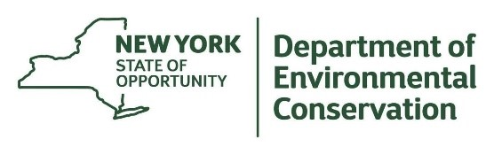
The New York State Department of Environmental Conservation provides financial support
to The Capital Region PRISM via the Environmental Protection Fund.

