Type of Work Performed: Follow Up Survey

Date: 8.27.2019

Address: 131 Daniels Road off Route 9 (Maple Ave) Greenfield New York 12833.
Access Road is a shared easement take the right hand gravel road.
County: Saratoga
Latitude and Longitude: 43.10868; -73.7883
Website: https://www.dec.ny.gov/lands/104708.html

Lead Contact Information for Project: Kristopher Williams kbw44@cornell.edu

Site Owner Contact Information: DEC Region 5 Warrensburg Office: (518) 897 1200 info.r5@dec.ny.gov
Other: http://saratogamtb.org/daniels-road/

Project Description:

Daniel’s Road State Forest owed by the NYS DEC is used primarily by mountain bike enthusiast. The access road to the State Forest is a shared with private landowner through an easement. The trail network throughout the forest is maintained by Saratoga Mountain Bike Association. The parking area and access road is infested with Japanese Stilt grass.
- The State Forest is a high priority conservation area with a moderately high comprehensive score.
Japanese Stiltgrass, which before the 2018 season was not known to occur anywhere in Saratoga County, was found in the parking lot and up and down the access road to the site. The stiltgrass also spreads off onto adjacent properties, notably the landing area for logging, further complicating treatment options for this population.
- A large potential spread threat exist with the high use activity of mountain biking in the area.

Invasive Species Present:
Common Name | Scientific Name | Locations (GPS) | Growth Type | Phenology | Distribution/ Abundance
Japanese Stilt Grass | Microstegium vimineum | 43.1057: -73.7907 | Herbaceous | Not in Seed as of 8.27.2019 | Linear Edge of Road 1.2 miles

NYSIS Threat Ranking Very High: 85
- http://nyis.info/wp-content/uploads/2018/01/f8fe1_Microstegium.vimineum.NYS_.pdf
iMap Records www.imapinvasives.org
- Presence # 1029636
- Searched Area: 1045007

Recommendations:
- Complete IPMDAT Decision Analysis Management Tool
- Evaluate the threat the Microstegium vimineum presents
- Contact all landowners involved
- Informational and educational signage
- Garnish support with interns, SMBA, Stick Force Teams
- Proceed with removal
  - Manual and mechanical before the plant goes into seed
  - Chemical and Burn Treatments May Not Be a feasible option with type and land use restrictions.
  - Revisit site 7 years

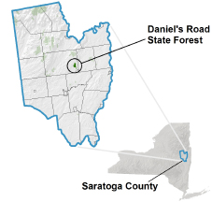

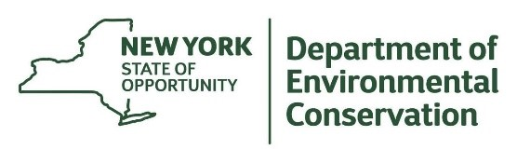
The New York State Department of Environmental Conservation provides financial
support to The Capital Mohawk PRISM via the Environmental Protection Fund.

