Capital Region PRISM Treatment Report

Site Information
Date: 9.14.2020
Site Name & Address: Daniels Rd. State Forest
Property Owner: State
Coordinates 43.104939°N, 73.794805°W
Project Leader: Kristopher Williams, Nicole Campbell
Email: kbw44@cornell.edu iMapInvasives User ID: 9274

Team Members:
Lauren Mercier

Project Information
(Copy this section and fill out for each species)

Target Species: Japanese Stiltgrass (Microstegium vimineum)
First year of treatment? No – 2nd
Size of infestation: ~6.5 acres linear infestation
Treatment Method (please be specific):

- Manual removal of stiltgrass, pulling the plants up especially in areas where native plants are dominant to avoid non-target species removal. Weed whacking of dense stiltgrass patches along road to suppress infestation for potential hand-pulling next year.

% Completed: 90
Amount removed (# bags, # plants, # mature, # seedlings):
Time spent on removal: 3 hours
Is follow-up needed? Yes
Were treatments uploaded to iMapInvasives? Yes

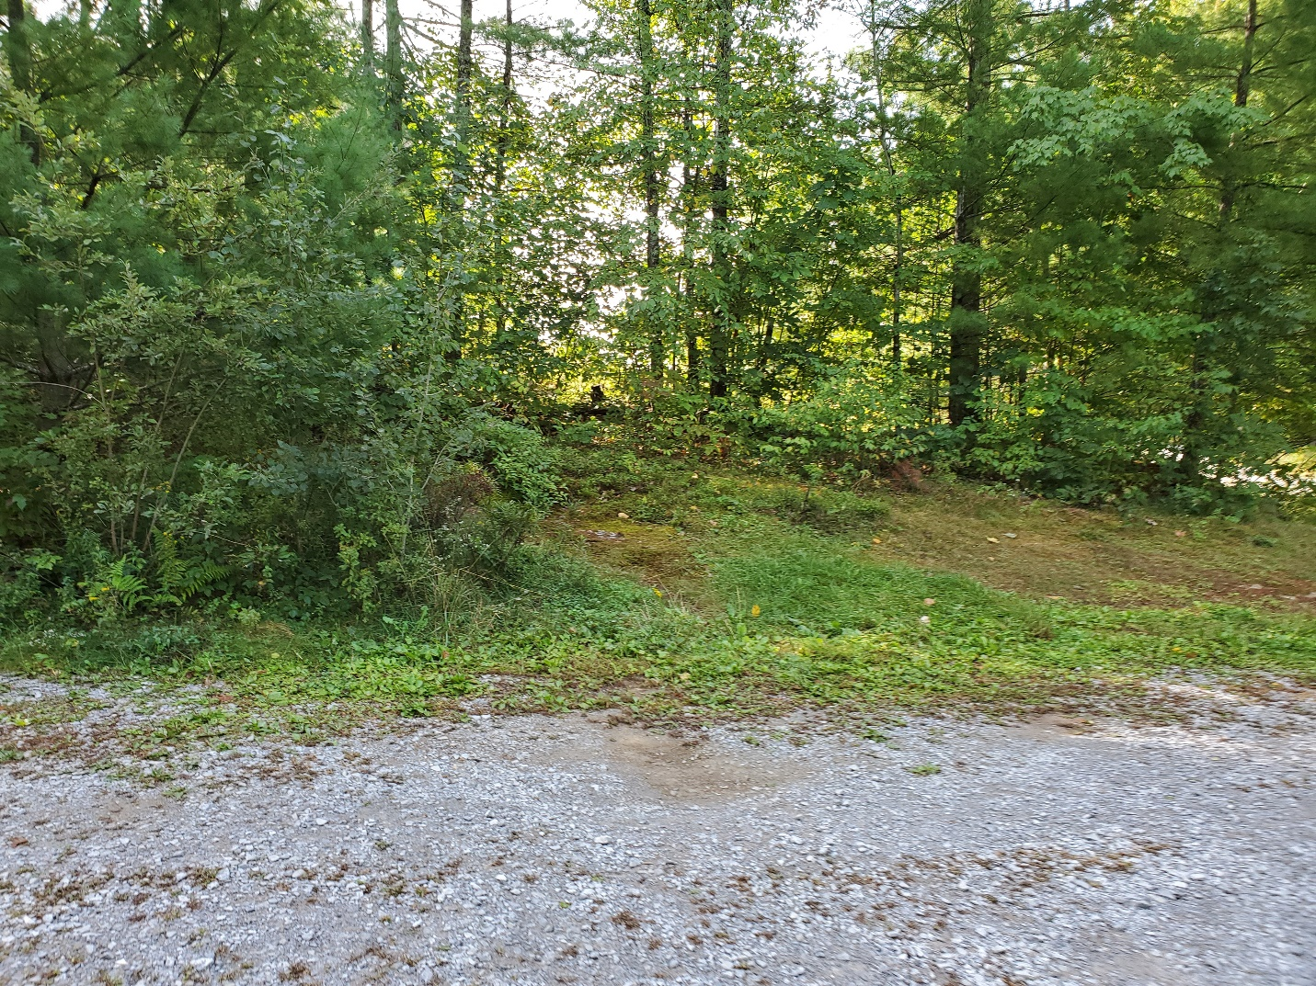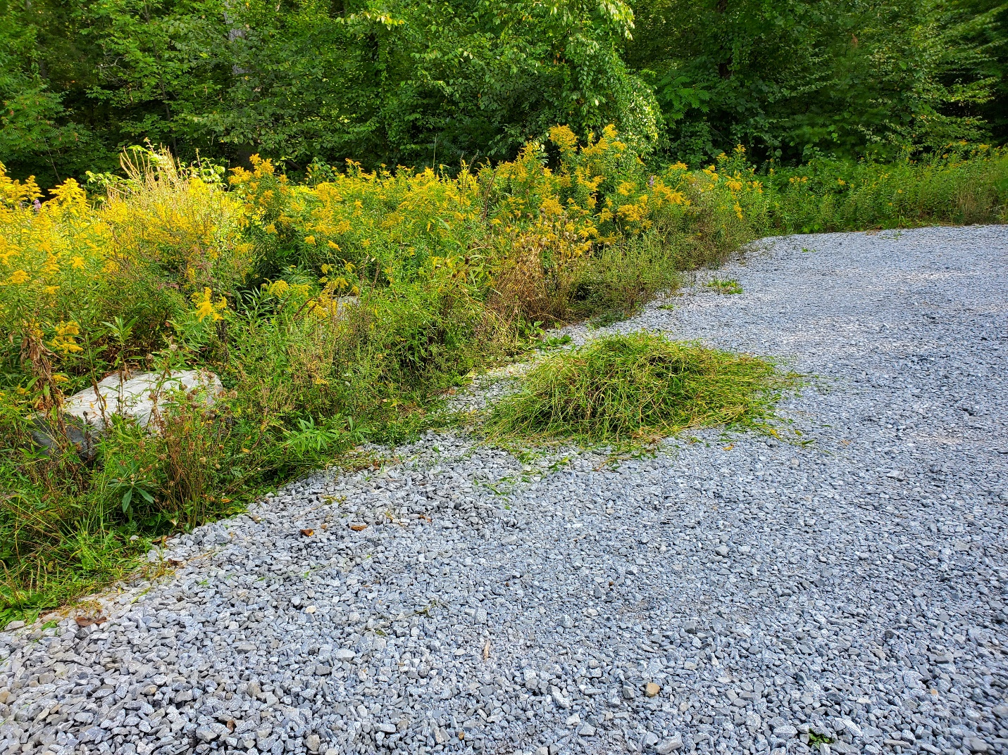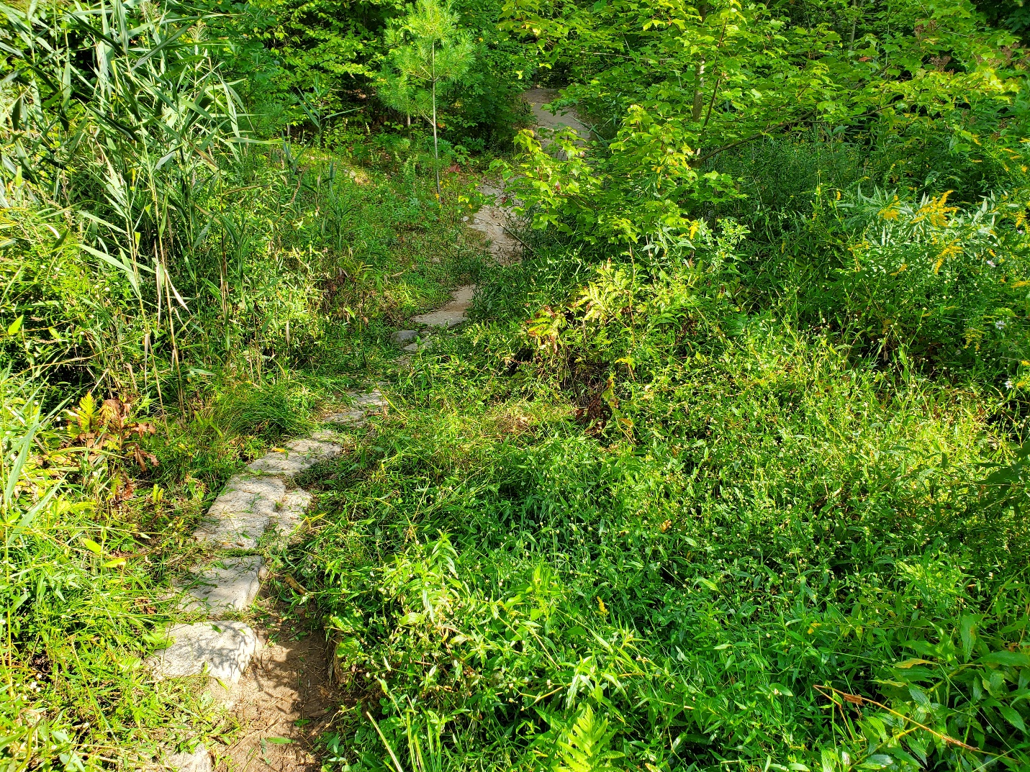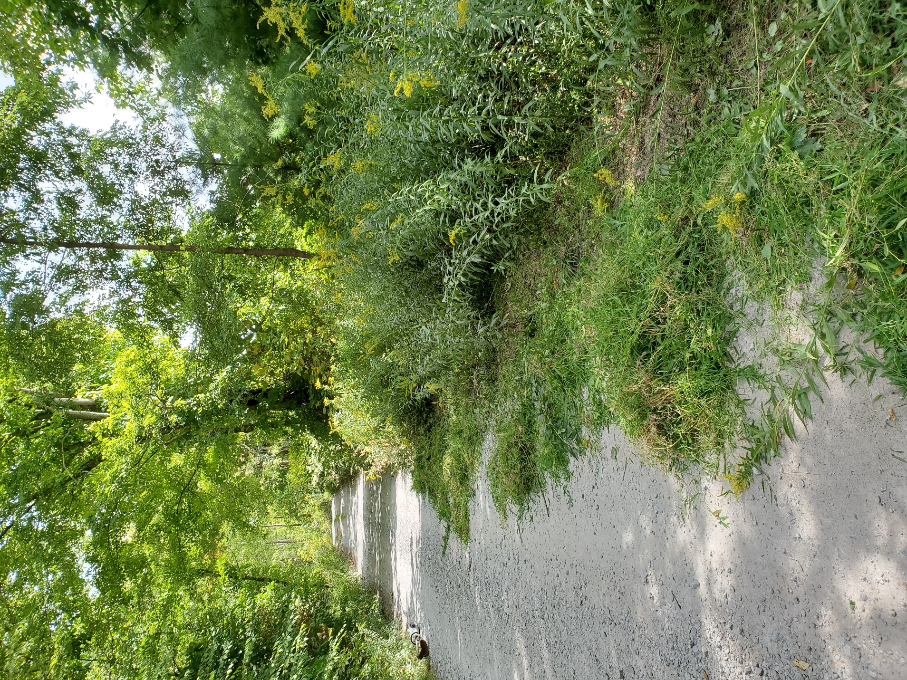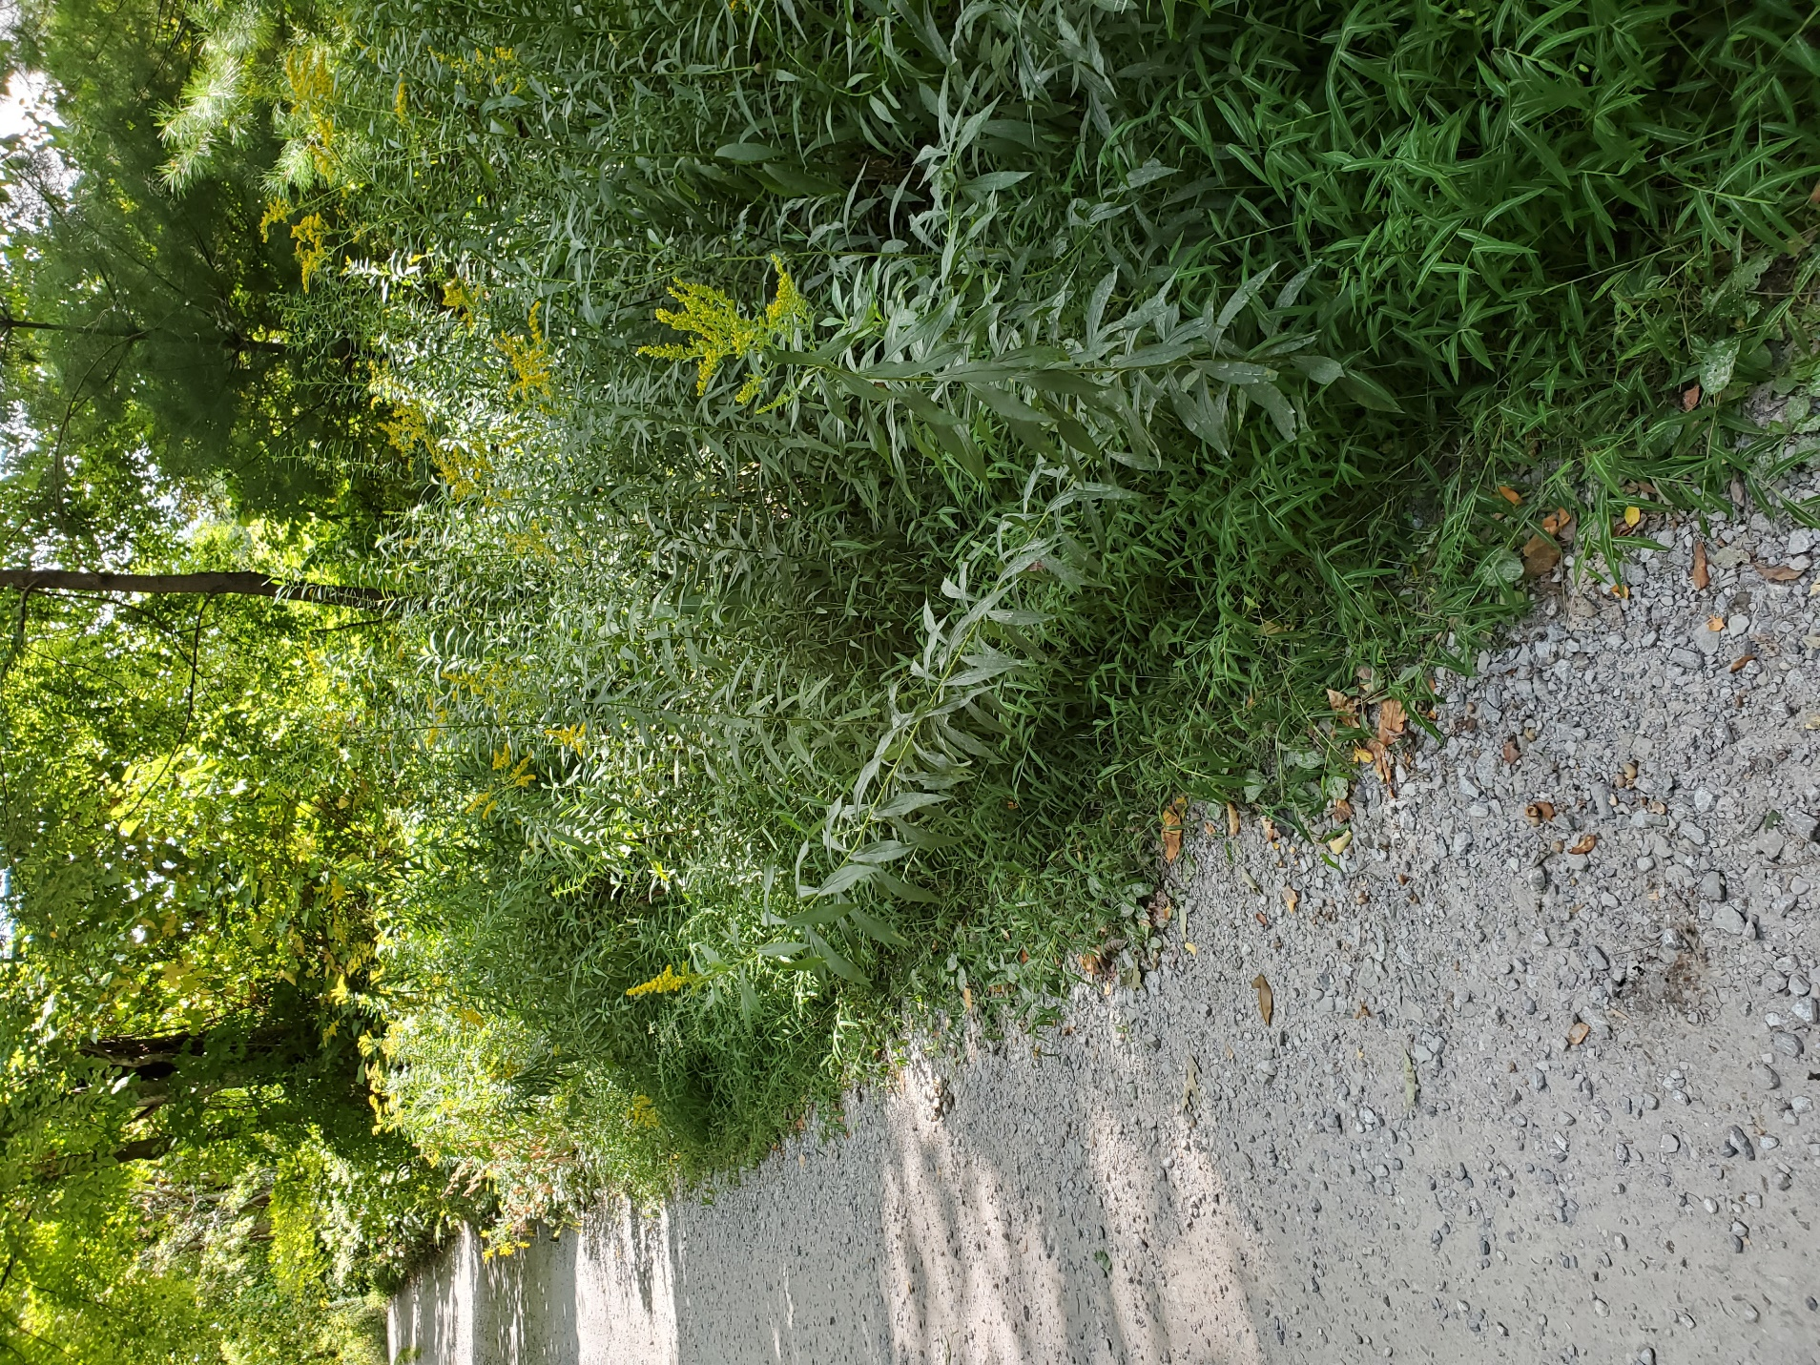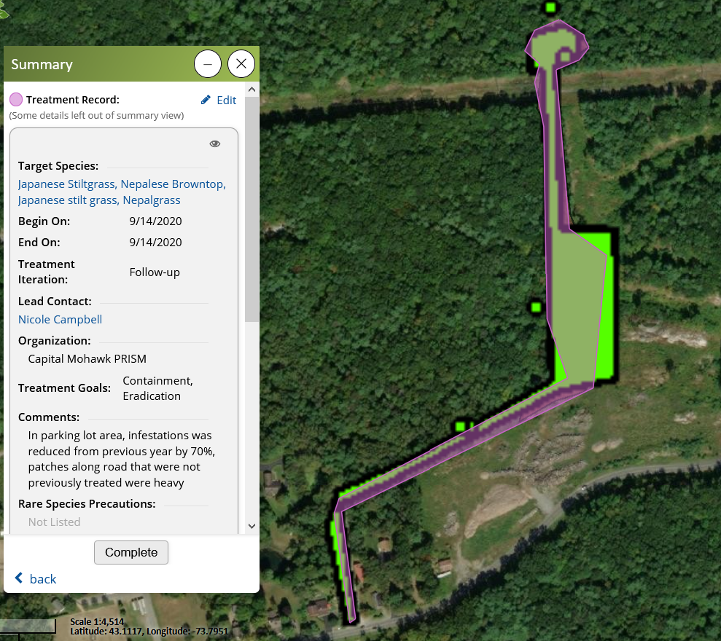Photos and maps of the project:

