Capital Region PRISM AIS Survey Report
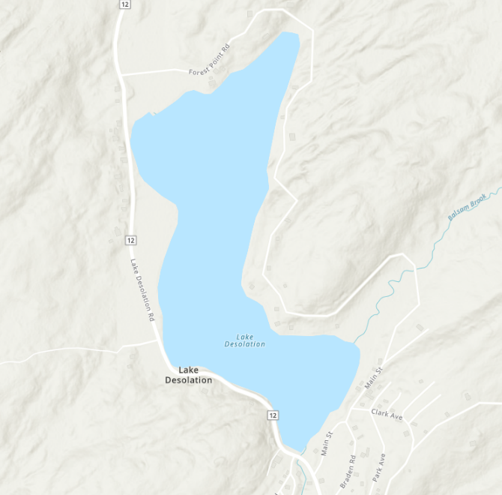
Date(s): July 12th, 2022
Site Name: Lake Desolation
Site Size: 66.6 acres
Waterbody Perimeter: 2 miles
Mean Depth: --
GPS Location: 43.132363, -73.970551
Physical Address: 498 Lake Desolation Rd, Middle Grove, NY 12850
Town: Lake Desolation
County: Saratoga

Property Owner Contact: Tinney’s Tavern
Primary Contact: Tinney’s Tavern (518) 450-1066
Secondary Contact: N/A

Survey Leader: Hannah Coppola
Phone: (518) 886-8995
Team Members: Kristopher Williams (PRISM Coordinator), Ben Caligari (Seasonal Technician)
iMapInvasives User ID: 21052, 9274, 19154

Section 1: Survey Summary
On July 12th, 2022 the Capital Region PRISM conducted an aquatic survey on Lake Desolation located in Saratoga County. The survey focused on early detection of Tier 1 and 2 aquatic invasive species. Upon completion of the survey it was determined that no aquatic invasive species were observed. A species of pink hardy waterlily was found, and is recommended for removal after acquiring permissions in 2023.

Site Description
Lake Desolation is a 66.6-acre waterbody located in Saratoga County, NY. The waterbody substrate is sand and muck with a bottom cover of macrophytes.
Lake Desolation is a privately-owned waterbody with no public boat launch present. Private residences boarder the waterbody. Tinney’s Tavern is the only restaurant present, and own a private beach area.

Survey Techniques
Entire waterbody, top water
- Top-side (visual)
- Rake toss

NYS Invasive Species Prioritization Model
Lake Desolation is located near an area with a medium-high comprehensive score on the NYS Invasive Species Prioritization Model. Close by is the Lake Desolation State Forest Conservation Easement. Locations with high comprehensive scores have high ecological significance, a high risk of spread of invasives into the area, and high value according to their protected status. Early detection is important in these locations to ensure timely management of new infestations if detected.
NYS Invasive Species Prioritization Model
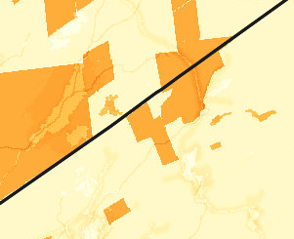

Lake Desolation

Does this site contain previously treated infestations?
No

Section 2: Survey Result Summary

Aquatic Invasive Species Presence
None. Hardy Lily Species under review of exact species. Possible cultivar of native white waterlily (Nymphaea odorata).

Native Species Presence
- Clasping Leaf Pondweed (Potamogeton perfoliatus)
- Bladderwort (Utricularia spp)
- Flat-leaved Bladderwort (Utricularia intermedia)
- Spadderdock (Nuphar variegate)
- Little Floating Heart (Nymphoides chordata)
- Eel Grass (Vallisneria americana)
- Robbin’s Pondweed (Potamogeton robbinsii)
- Watershield (Brasenia schreberi)

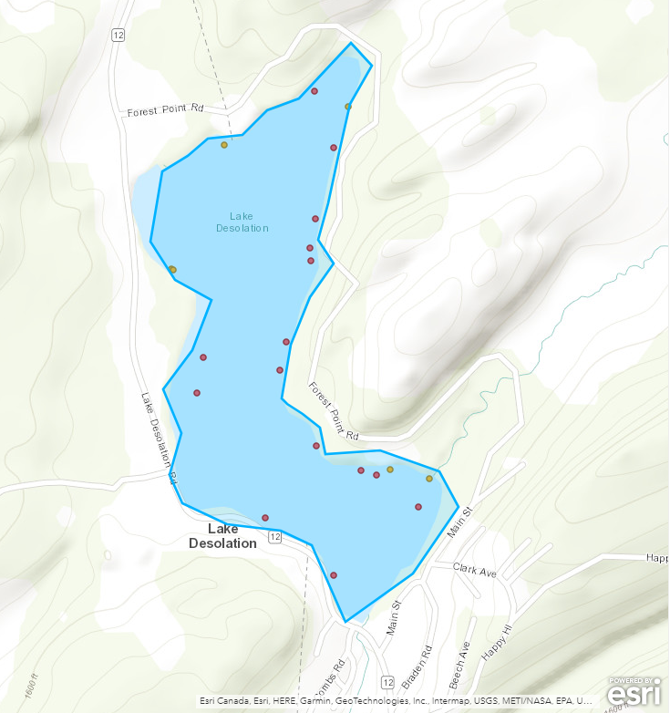
Map
Red indicates Rake Toss Locations

Orange indicates Species Detected Outside of Rake Toss

Section 3: Summary of Recommendations

Prevention
Prevention efforts are recommended to reduce the chance of new aquatic invasive species introductions into Lake Desolation. The private access to the lake helps prevent unwanted species being introduced through reduction of visitors.
- Ensuring clean, drain, dry practices are being followed when transporting watercraft from one waterbody to another is also recommended.
- Identifying and reporting any suspected aquatic invasive species is encouraged to ensure early detection.
- Rental property owners on Lake Desolation can take steps to educate their renters on the threats of aquatic invasive species and how they can prevent the spread into the waterbody they are visiting
- Private property owners can take prevention measures by avoiding plantings of potential invasive aquatic species.

Management
Removal of the suspected hardy lily is recommended. Permissions will be sought after in 2023.

Post-Survey Monitoring
Lake Desolation is not considered a Priority Waterbody in the Capital Region PRISM and will not be surveyed on a regular schedule. The Capital Region PRISM plans to visit this location in 2023 after acquiring permissions, with the goal of removing the known population of suspected hardy waterlily.

Will an Invasive Species Management Plan be created?
- Not at this time.

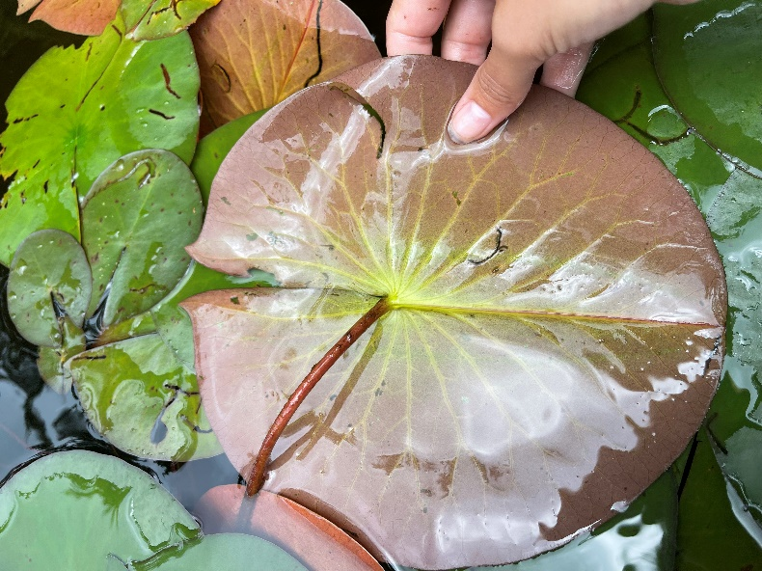
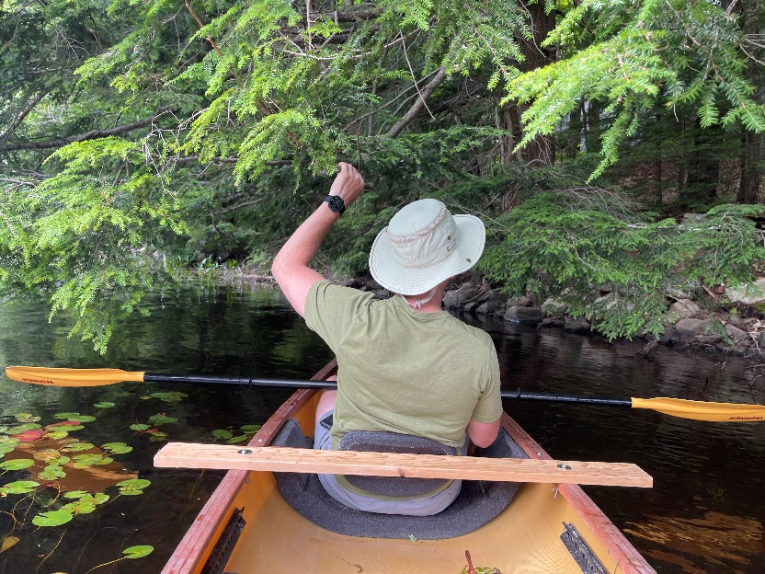
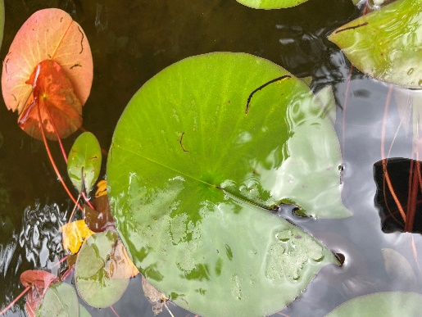
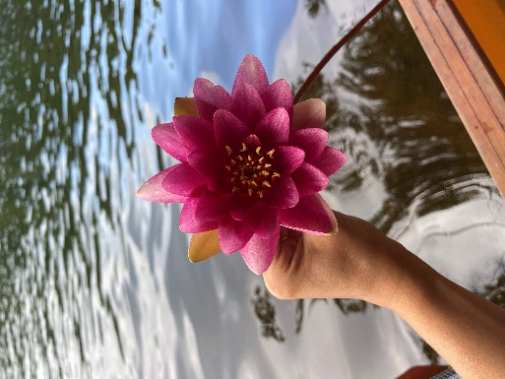
Photos

The New York State Department of Environmental Conservation provides financial support to The Capital Region PRISM via the Environmental Protection Fund.

