LEWIS A. SWYER PRESERVE INVASIVE SPECIES SURVEY 2019:
Anna Kuhne and Kelsey Stevens
Type of Work Performed: Terrestrial invasive species surveying

Date: August 2nd, 2019

Address: 1599 NY-9J, Stuyvesant, NY 12173
County: Columbia County
Latitude and Longitude: 42.417891, -73.76069
Website: The Nature Conservancy

Lead Contact Information for Project: Anna Kuhne and Kelsey Stevens, Capital Mohawk PRISM

Site Owner Contact Information: The Nature Conservancy

Project Description: Surveying for terrestrial invasive species was done and points for the species were uploaded on to iMapInvasives.

Invasive Species Present at Lewis A. Swyer:
Common Name | Scientific Name | Locations (GPS) | Growth Type | Phenology | Distribution/ Abundance
Emerald Ash Borer | Agrilus planipennis | 42.41416  -73.77242 | Pest | N/A | Record from 2016
Yellow Iris | Iris pseudacorus | 42.41282  -73.77331 | Herbaceous | Vegetative | Linearly Scattered
Tartarian Honeysuckle | Lonicera tatarica | 42.41695  -73.77203 | Shrub | N/A | Record from 2004
Creeping Jenny | Lysimachia nummularia | 42.41645  -73.797 | Herbaceous | Vegetative | Sparse
Multiflora Rose | Rosa multiflora | 42.4129  -73.77503 | Shrub | Vegetative | Dense
Oriental Bittersweet | Celastrus orbiculatus | 42.41686  -73.76888 | Vine | Vegetative | Sparse
Chicory | Cichorium intybus | 42.41779  -73.6923 | Herbaceous | Flowering | Dense at parking lot
Bull Thistle | Cirsium vulgare | 42.41785  -73.76904 | Herbaceous | Flowering | Sparse in parking lot
Wild Carrot | Daucus carota | 42.41781  -73.76928 | Herbaceous | Flowering | Dense in parking lot
Glossy buckthorn | Frangula alnus | 42.41679  -73.76895 | Tree | In seed | Sparse in parking lot
Honeysuckle | Lonicera spp | 42.41291  -73.77504 | Shrub | In seed | Dense
Birdfoot Deervetch | Lotus corniculatus | 42.41696  -73.76893 | Herbaceous | Flowering | Sparse near parking lot
Purple Loosestrife | Lythrum salicaria | 42.41699  -73.76889 | Herbaceous | Flowering | Dense
Common Buckthorn | Rhamnus cathartica | 42.41784 | Tree | Vegetative | Dense in parking lot
Japanese Stiltgrass | Microstegium vimineum | 42.41587  -73.77208 | Herbaceous | Vegetative | Linearly Scattered

Capital Mohawk PRISM Strongly Recommends Uploading Points into https://www.imapinvasives.org/
Native Community Types: Wetland and forest
Dominant Native Plants Present: American Hog Peanut
Summary of Work Completed:
  - Surveying for terrestrial invasive plant species
Recommendations for the Future: Continue surveying the site
Contact the Capital Mohawk PRISM http://www.capitalmohawkprism.org/

Figure 1. Map of points taken in Lewis A. Swyer Preserve in Saratoga County.
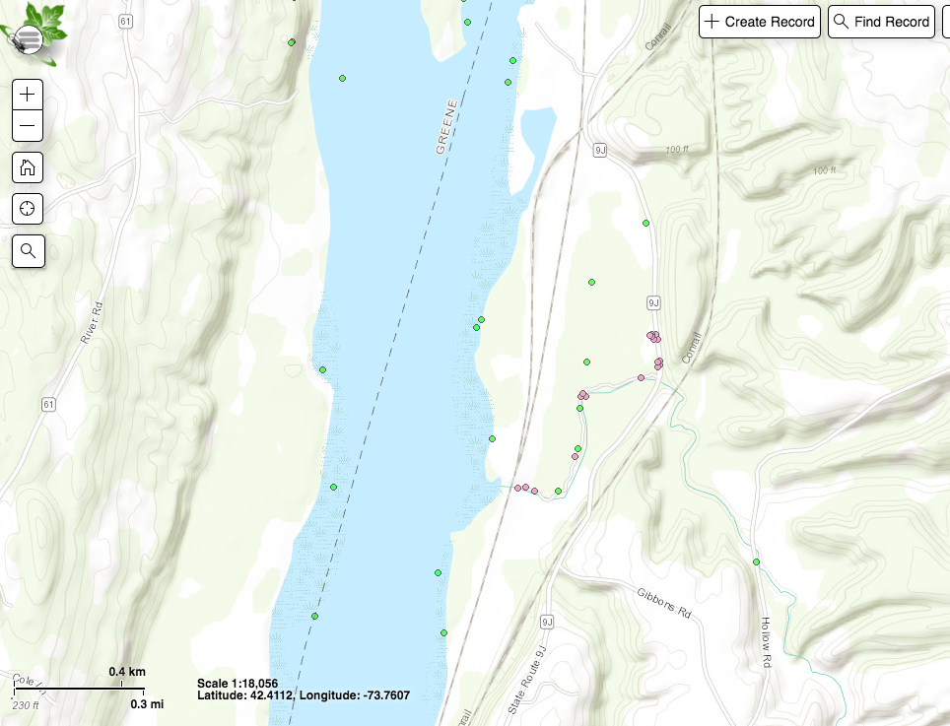

Figure 2. Honey Suckle at Lewis A. Swyer Preserve in Colombia County, NY.
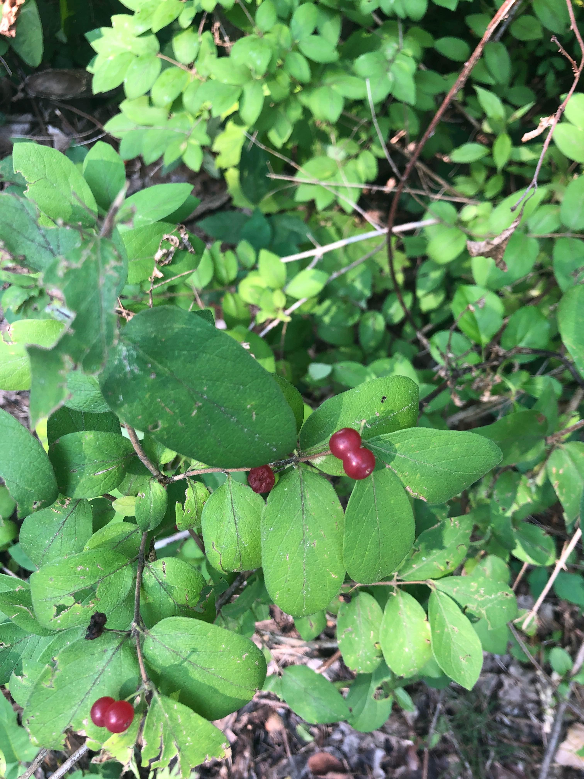

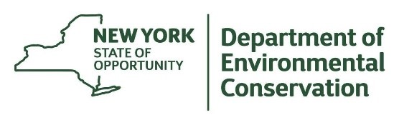
The New York State Department of Environmental Conservation provides financial
support to The Capital Mohawk PRISM via the Environmental Protection Fund.

