Type of Work Performed: Treatment of Mile-a-minute weed

Date: 8/5/2019

Address: 56 Game Farm Rd. Delmar, NY 12054
County: Albany
Latitude and Longitude: 42.608676°N, 73.889757°W
Website: https://www.dec.ny.gov/education/1835.html

Lead Contact Information for Project: Anik Gibeau

Site Owner Contact Information: Five Rivers Environmental Education Center

Project Description:
Eradication treatment of Mile-A-Minute weed a high threat invasive species. A 6 person crew resurveyed along Vlomankill trail at the Five Rivers DEC Environmental Center to assess and ongoing small but serious infestation of the plant identified in 2018. Source of materials may have been brought in by contaminated soil or crusher run rock used to make train and culvert improvements.
- Removed ~25 plants – 2 plants were mature (1m tall) with no seeds or flowers, the rest were seedlings
- All plants were found <1.5m off trail under Coltsfoot and most in an area that receives sunlight

Invasive Species Present at (SITE NAME): Five Rivers Vlomankill Trail
Common Name | Scientific Name | Locations (GPS) | Growth Type | Phenology | Distribution/ Abundance
Mile-a-minute weed | Persicaria perfoliata | Uploaded in Imap | Vine | Early state emergence no flower or seed | Scattered  10- 15% coverage in area surveyed
Mugwort | Artemesia vulgaris |  | Herbaceous
Japanese Barberry | Berberis thunbergii |  | Shrub
Coltsfoot | Tussilago farfara |  | Herbaceous
Multiflora Rose | Rosa multiflora |  | Shrub

Native Community Types: Hemlock Beech Maple Forest
Dominant Native Plants Present: Joe Pye Weed and Riparian Plants
Summary of Work Completed:
  - Treatment – manual removal
Recommendations for the Future:
Plants seed anytime from June to the first frost so the area should be checked regularly. If any plants are found, contact:
Anik Gibeau at Five Rivers Environmental Education Center (518) 475-0291 Anik.Gibeau@dec.ny.gov

“Five Rivers IS Surveying Project” on iMapInvasives
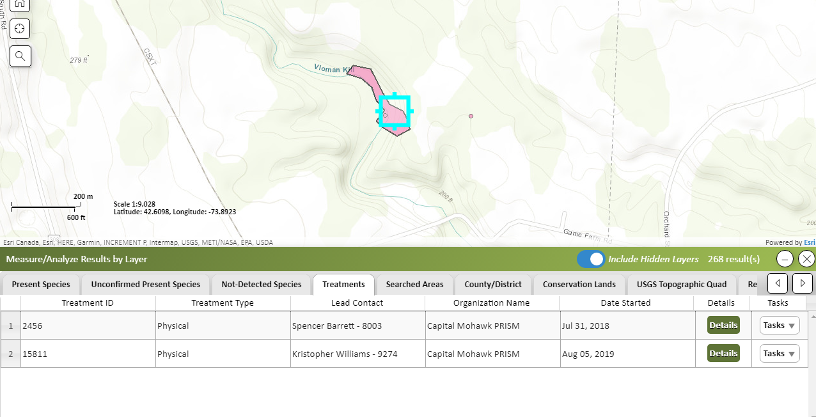

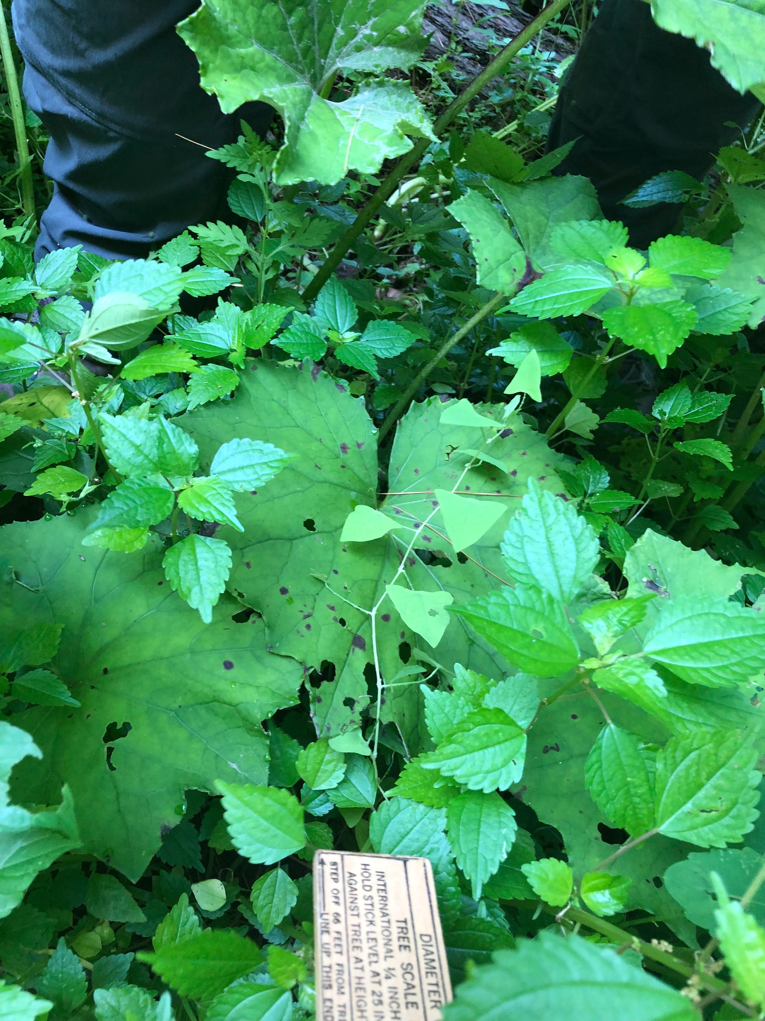
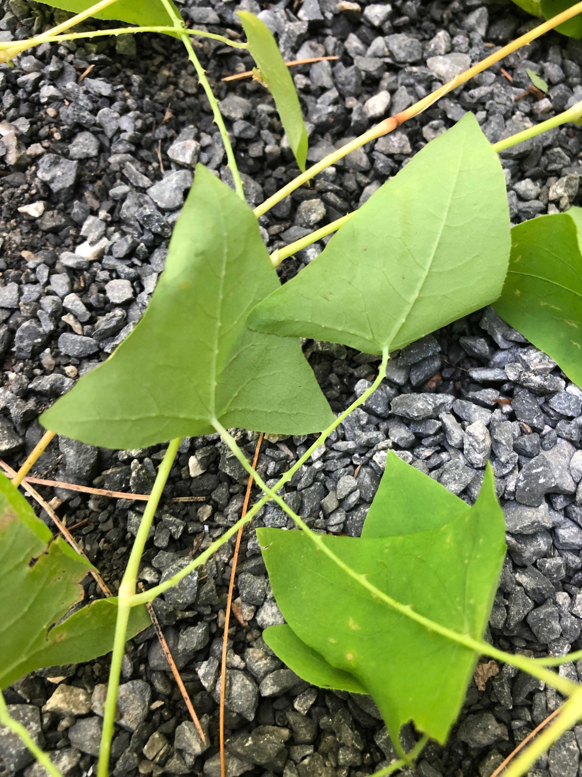
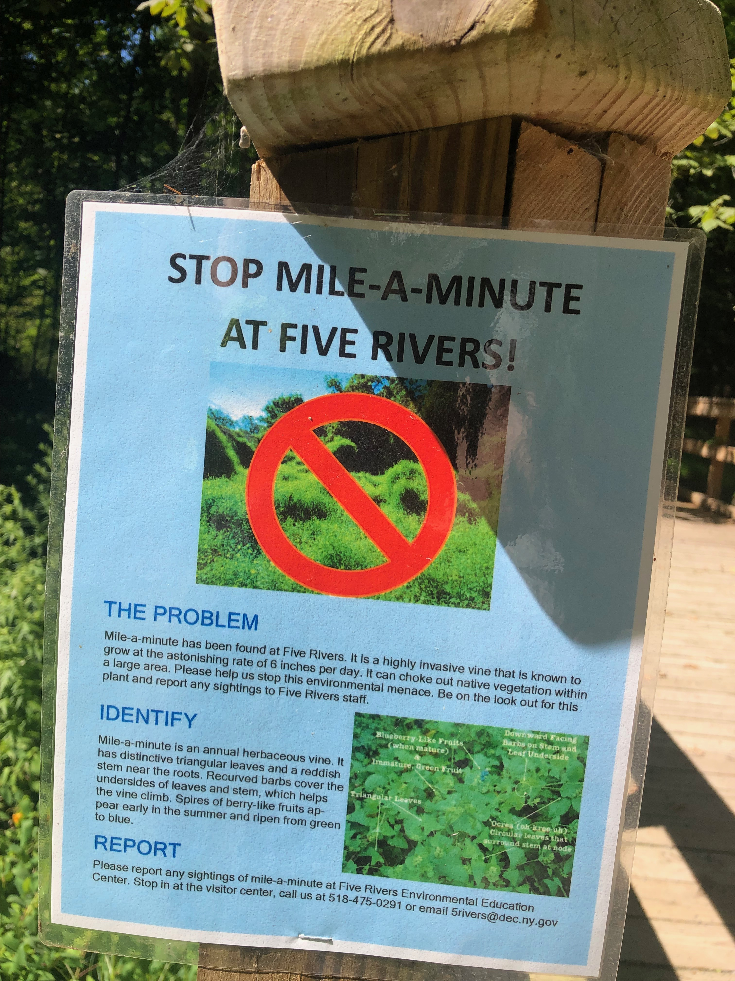
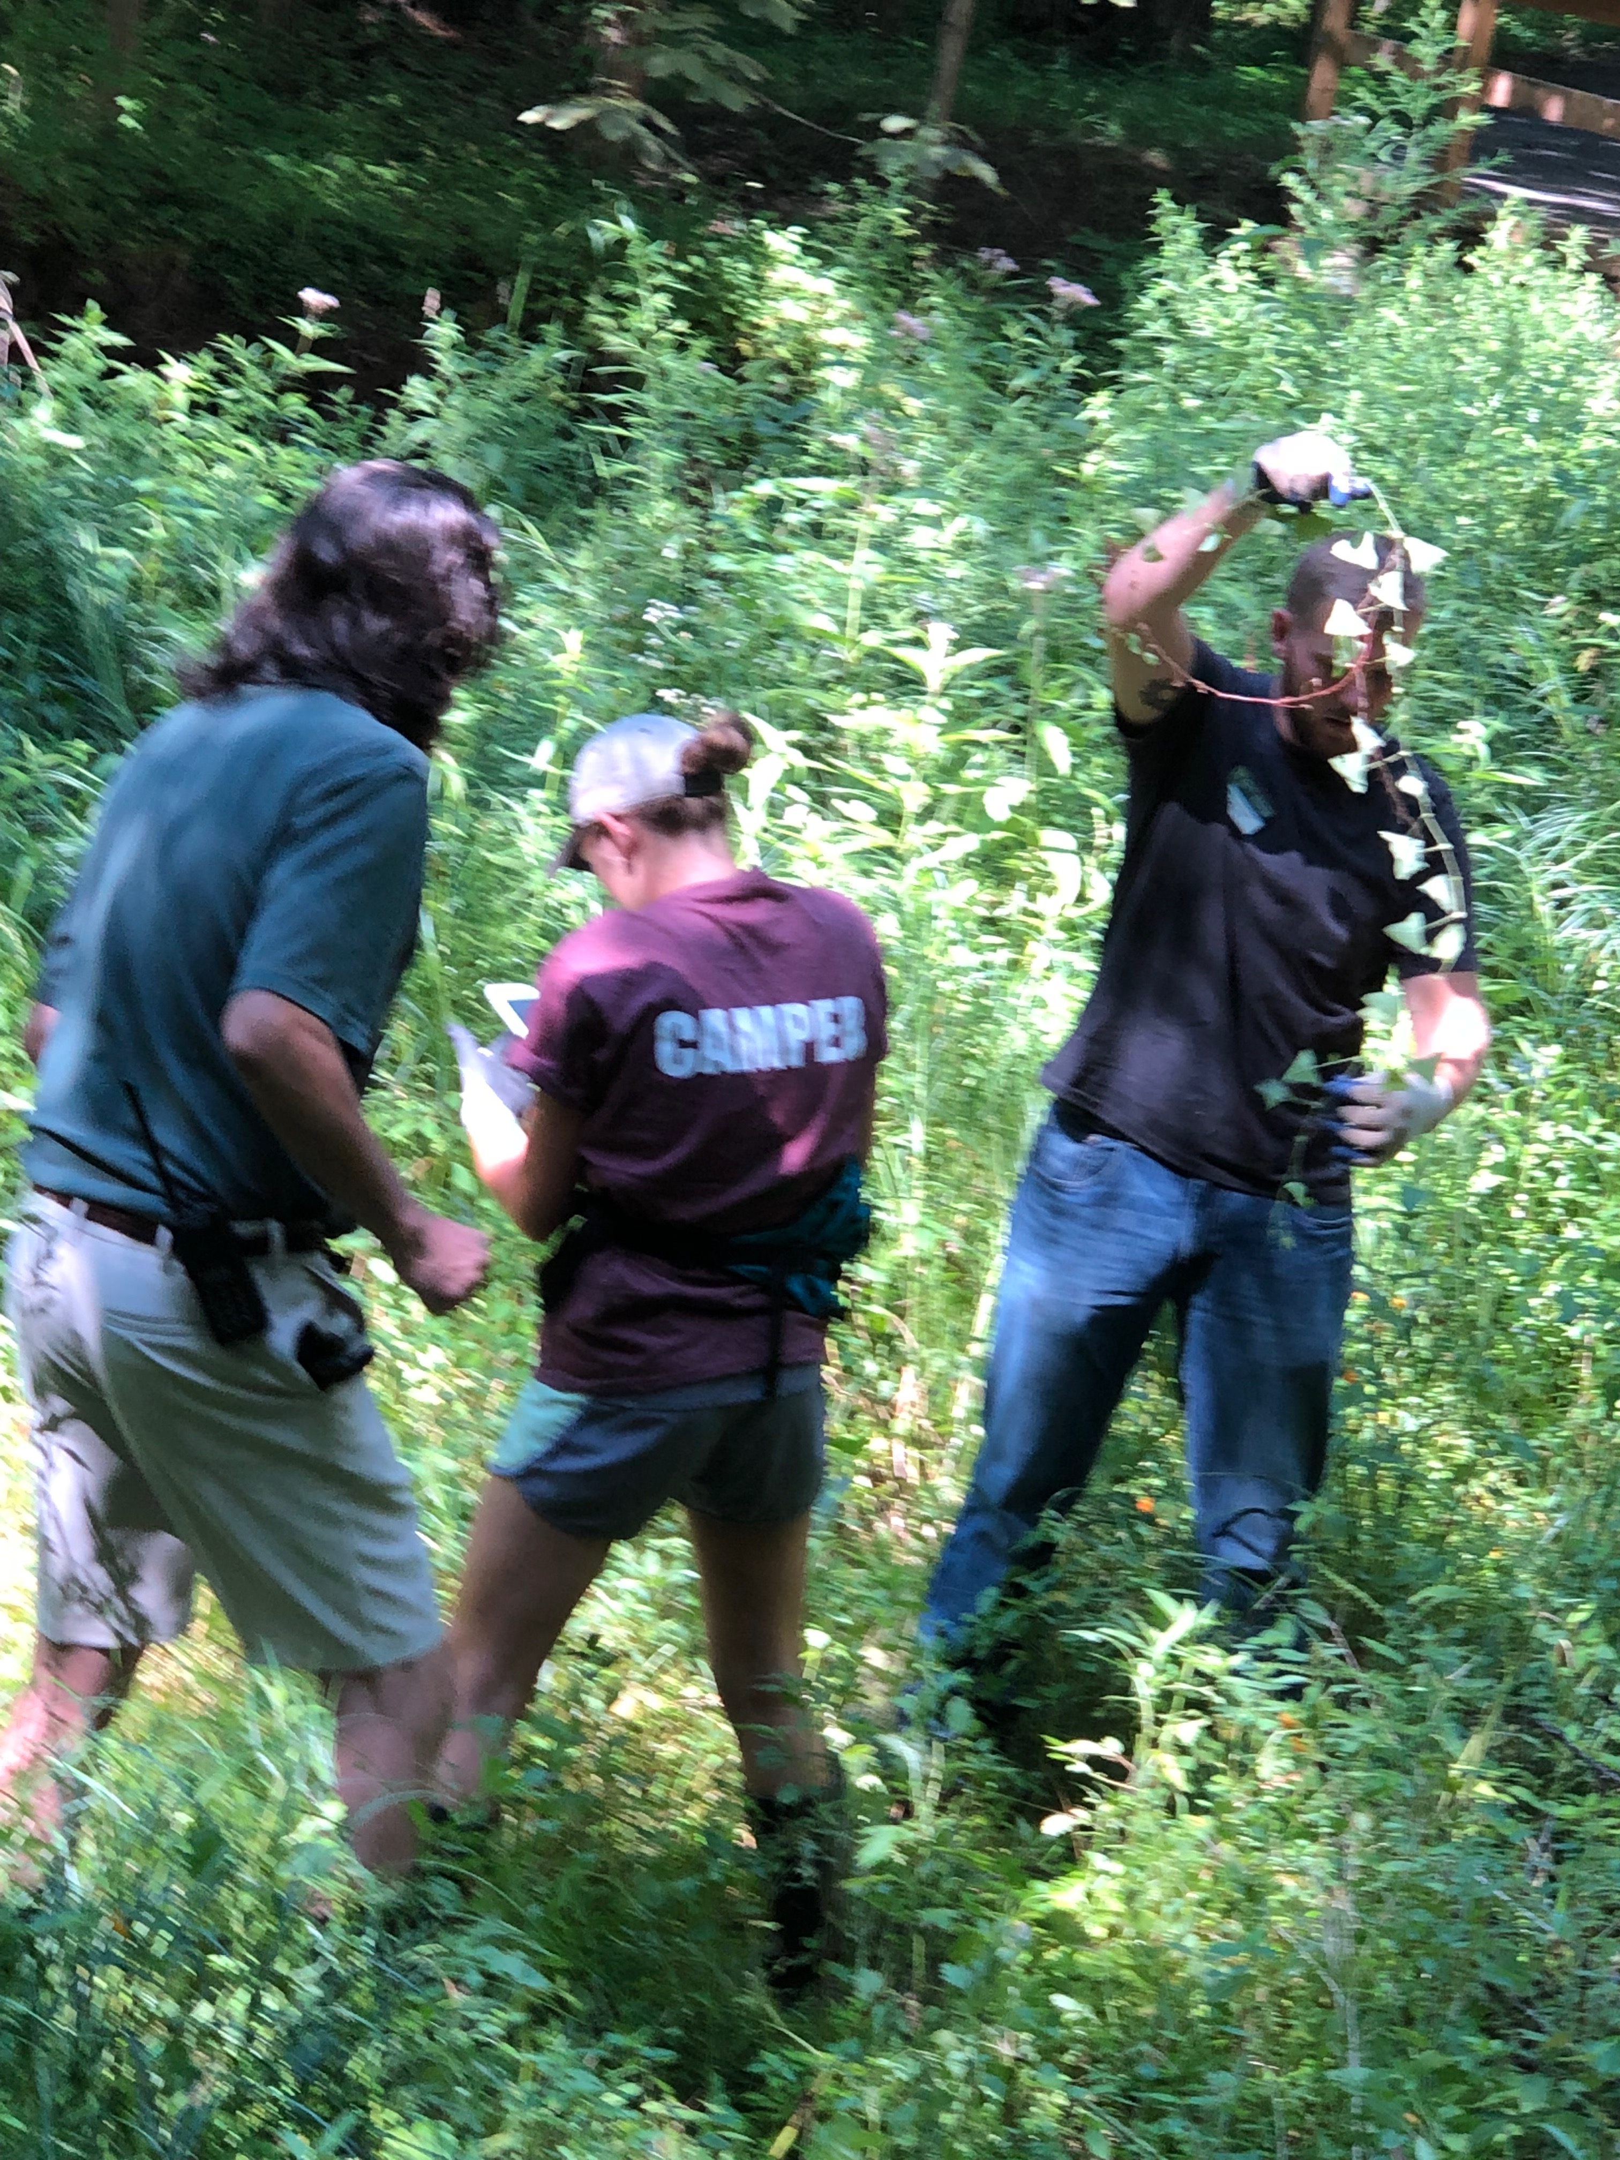

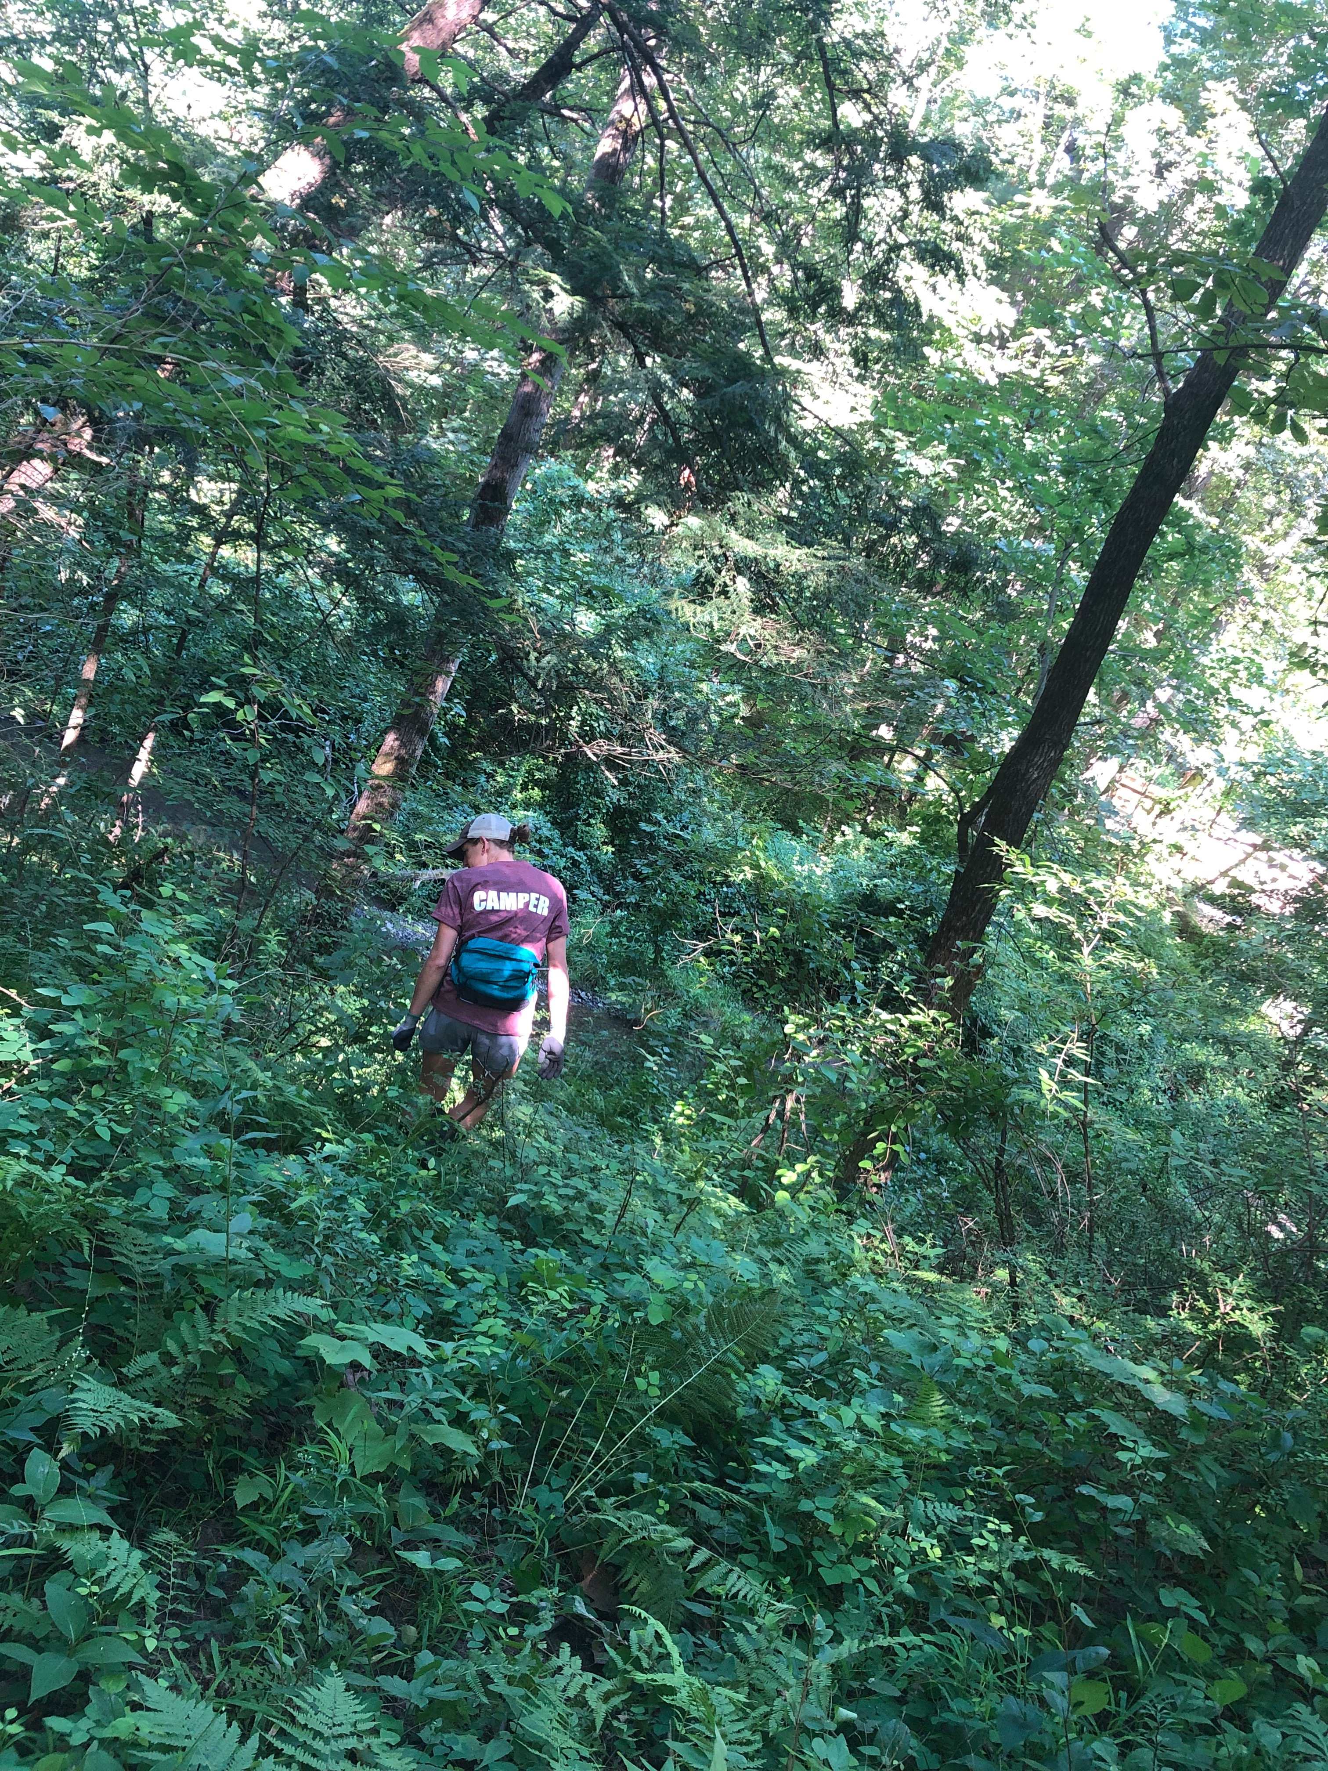
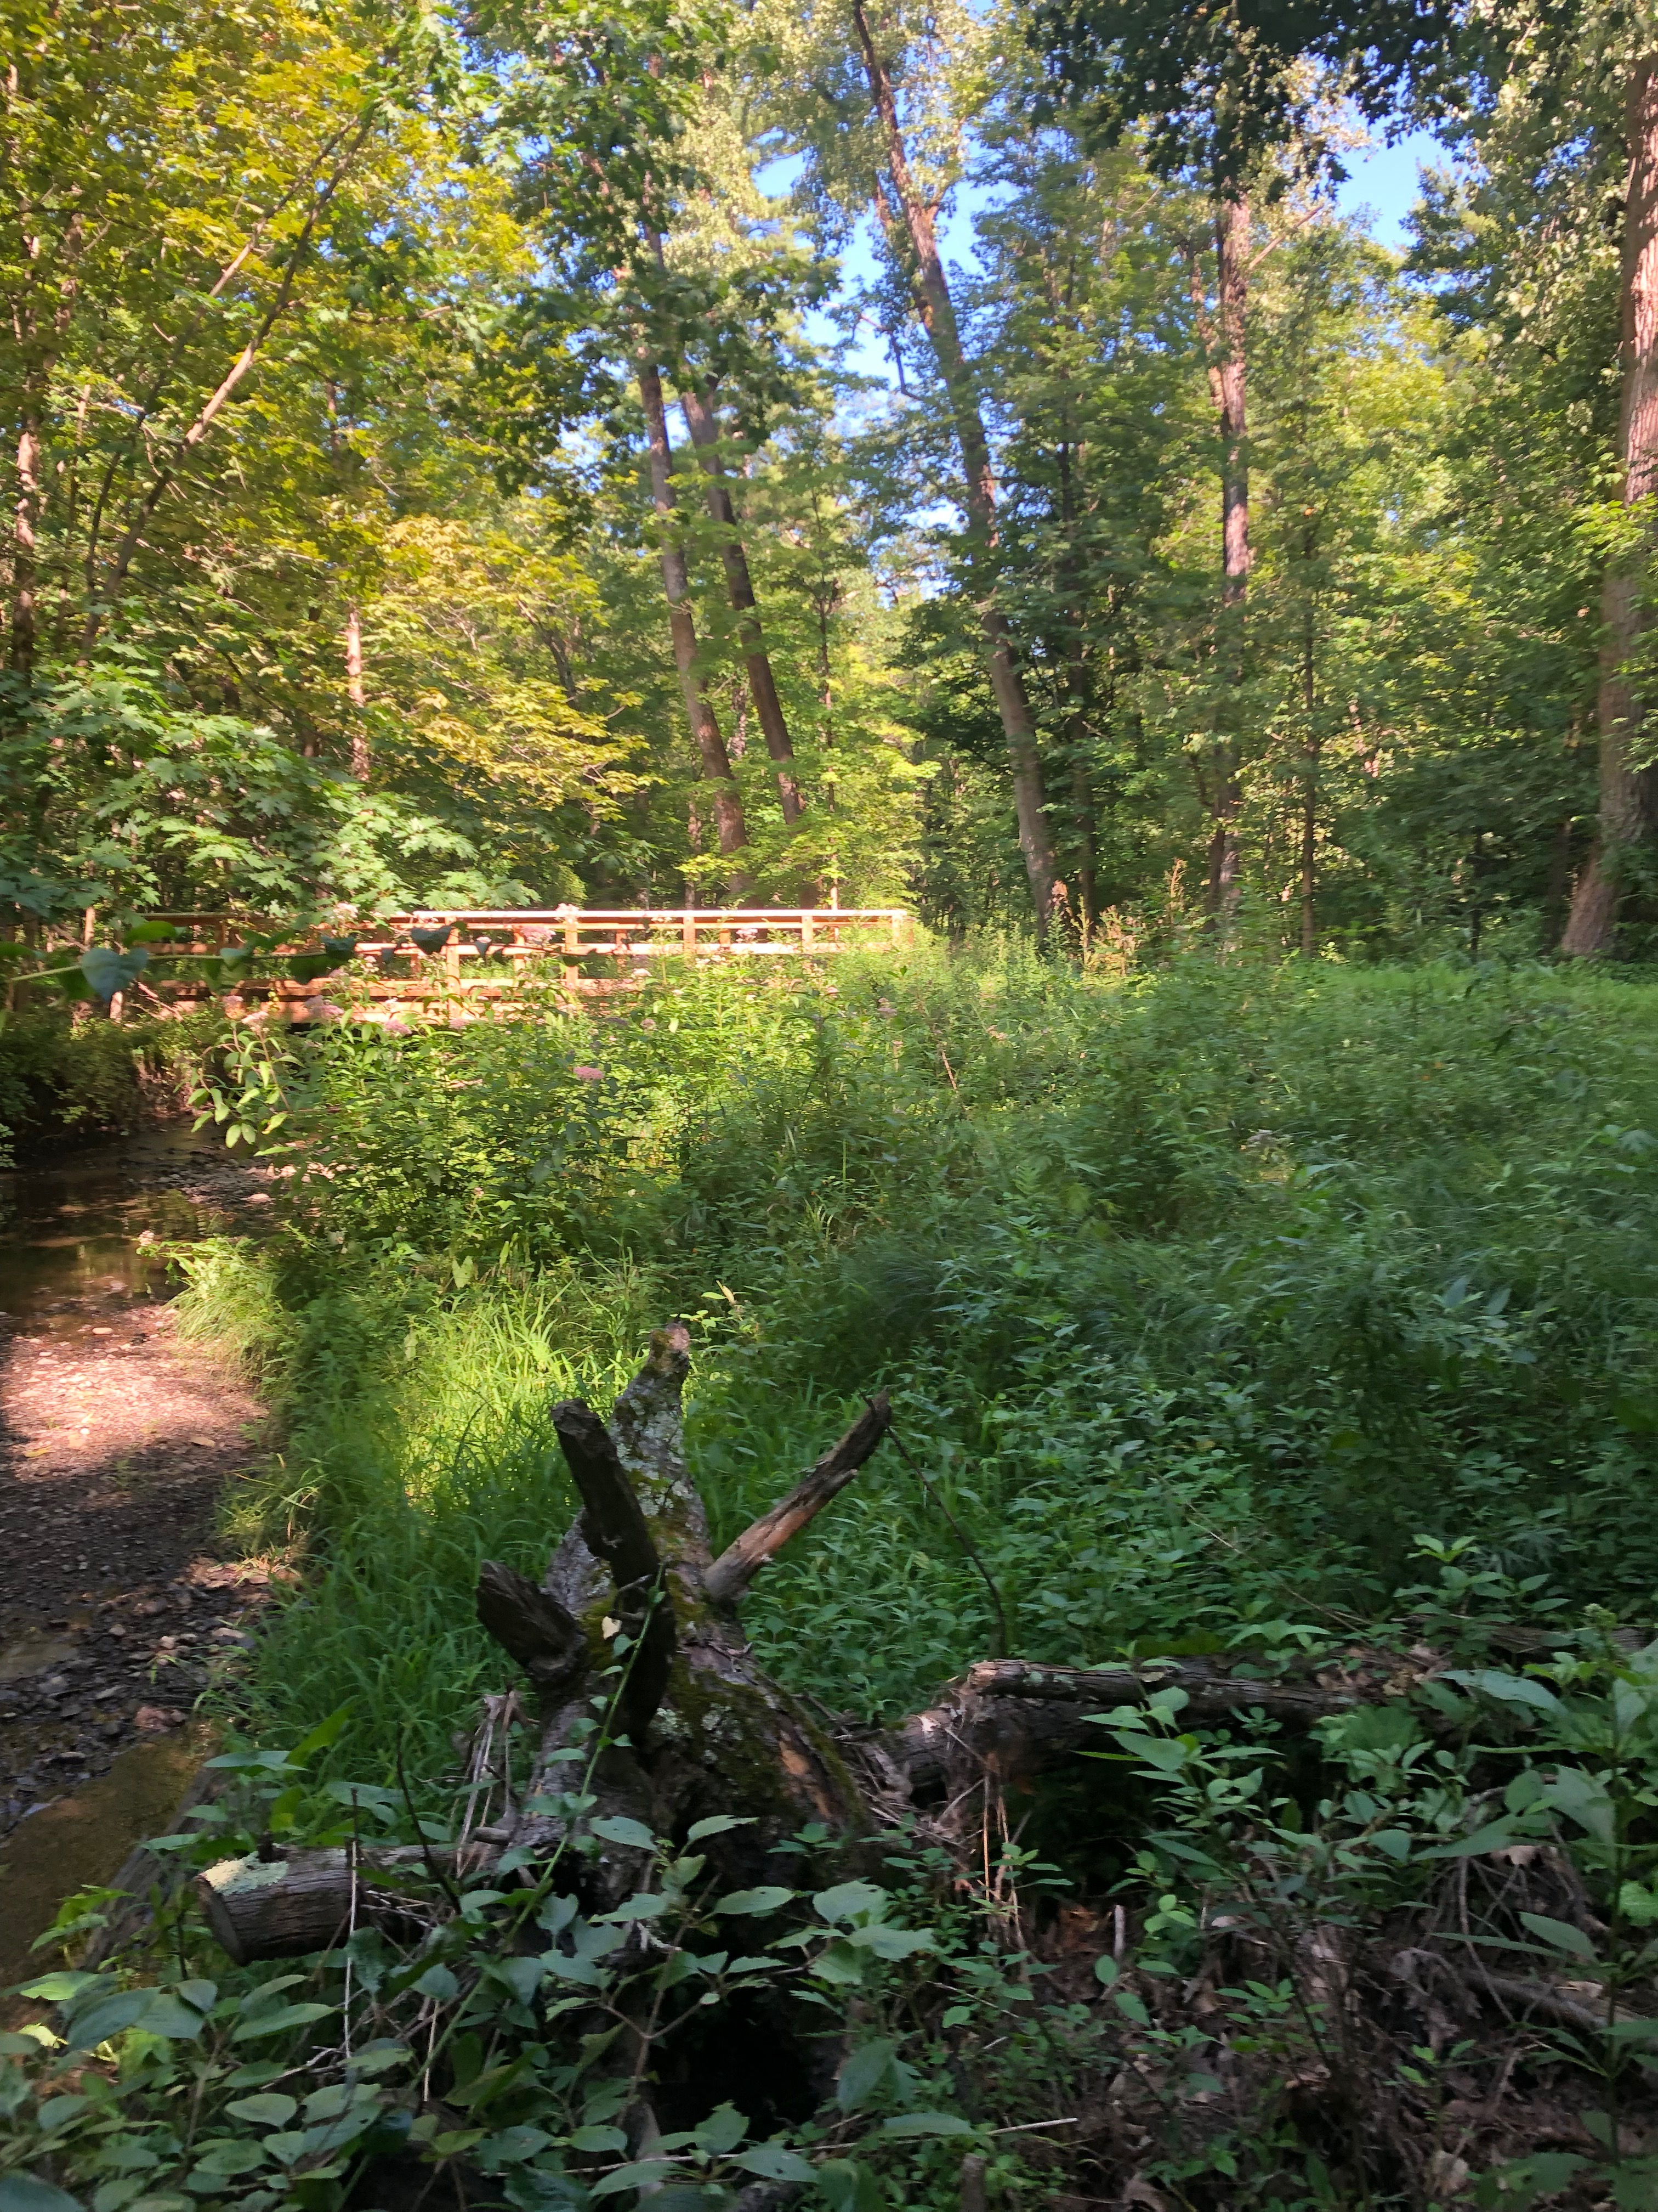

The New York State Department of Environmental Conservation provides financial
support to The Capital Mohawk PRISM via the Environmental Protection Fund.

