Mile-a-Minute Treatment, Summer 2018: Capital Region
Prepared by Spencer Barrett

Mile-a-Minute Vine has not been reported in the Capital Region before this year, but has been in close proximity to the PRISM for a number of years now. This virulent species is known for its quick reproductive rate, aggressive pursuit of sunlight, and extremely rapid growth in the span of a single season. Alarmingly, this plant appeared more than 50 miles from the next closest reported location in Woodstock, NY, popping up at Five Rivers Environmental Education Center. Contacted by the staff at Five Rivers, Cap/Mo PRISM staff delineated the known infestation and manually removed all Mile-a-Minute they discovered through hand-pulling. The following is a summary of all work that took place at Five Rivers Environmental Education Center during the 2018 Field Season.

Visit #1:
On 7/31/18, Spencer Barrett, Terrestrial Invasive Species Coordinator for the PRISM, Kristopher Williams, PRISM Coordinator, and interns Lily-Anne Trainor and Elizabeth Jamison traveled to Five Rivers to evaluate the reports of Mile-a-Minute Vine that they had gotten from staff at the center. Quickly upon arriving, they were joined by Alex, who was the original discoverer of the population and showed the team where the plants could be found along the Vlomankill trail. At this time, the population spread down the hill immediately following the start of the trail, across the bridge spanning the creek, and down the north fork of the trail following the junction at the bottom of the hill. While Kristopher met with Gina Jack, Director of Five Rivers, staff hand-pulled the area that can be seen in Figure 1 below. The team pulled 332 stems, all of which were vegetative. The plant appeared to follow a line, sprouting from what appeared to be fresh fill material which is believed to be the source of the seeds. The plant was especially vigorous on the west side of the trail, though there were stems that were removed on the east side as well.
The online treatment report for the work done this day can be viewed on iMap Invasives. (Obs: NY-452713U, Treatment: NY-100858U-T)

Visit #2:
Spencer Barrett and Gwendolyn Temple, Aquatic Invasive Species Coordinator for the PRISM, manned a table during the 2018 Five Rivers Fall Festival on September 15th. During this time, Spencer took the opportunity to check back on the Mile-a-Minute population to see if there were stems that were missed either due to size, the roots not being completely removed, or that were hidden beneath the Colt’s Foot that also grows in the same section of the trail. During his visit, he pulled an additional eight stems that were not removed during the first visit to the site, including one that was in immature fruit. In August, it was clear that the plant had kept growing, as stems that were not visible during the first visit became visible at a later date.
Totals: In two visits, the Terrestrial staff of the Capital-Mohawk PRISM removed 340 stems of Mile-a-Minute over an area of .8 acres. In addition to the removal of this pest, Elizabeth Jamison produced a flyer with information on the plant for display at the Environmental Education Center.

Suggestions for the Future:
July seemed to be a good time to begin management activity as the plants that were pulled did not grow back. August and September makes a good follow-up date if needed as the plants that were not immediately visible during the first visit were seen on the second visit. Additionally, the fruit that was growing was still immature at this point. PRISM staff should visit Five Rivers around those times during the next year to ensure continual control of this voracious plant pest.
On the Five Rivers side, during the spring and summer, monitoring of other places in the preserve where construction has occurred in the last one or two years should take place. Seasonal staff would be well served by being instructed on how to identify Mile-a-Minute, as well as additional emerging invasive plants that have been seen on the property such as Japanese Hops and Beefsteak Plant. If requested, PRISM staff could do an invasive species training for seasonal staff of the preserve, or training materials could be provided.

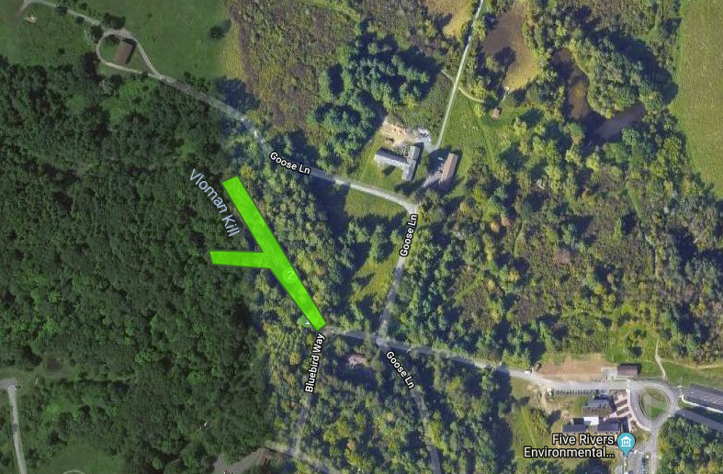
Figure 1: The infestation polygon from iMap Invasives. Plants were thickest on the southern, downhill section of the trail on the west side, though they were scattered on both sides throughout the polygon.

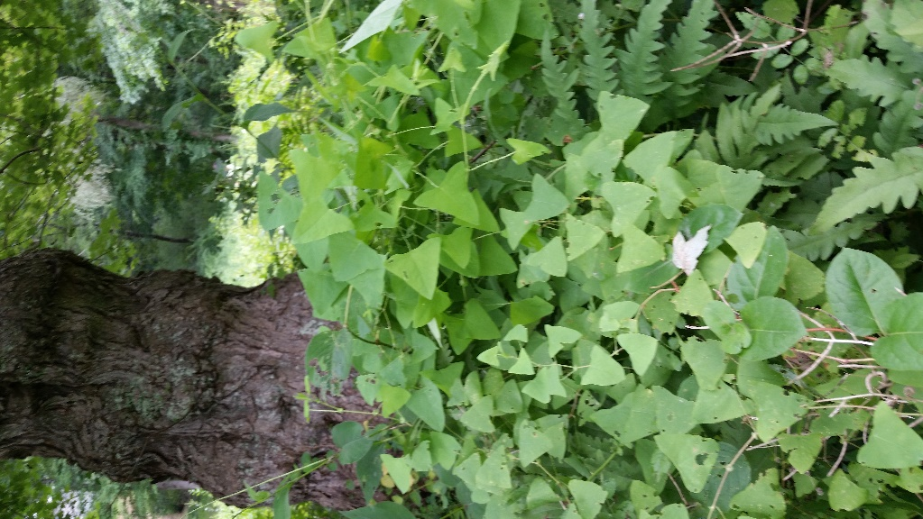
Figure 2: A photo illustrating the color variation among a single population of Mile-a-Minute. Also visible is the thorny, red stem which can be used to identify the plant.

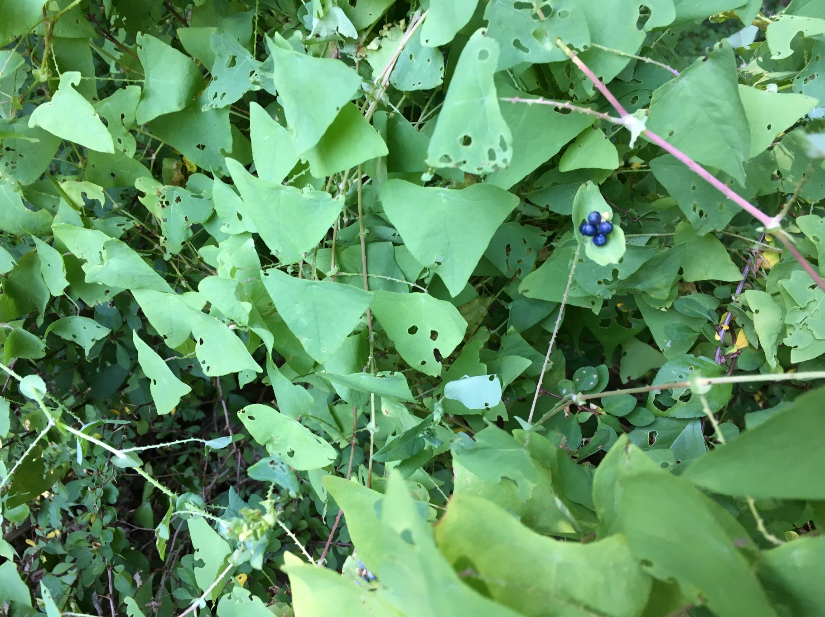
Figure 3: This photo illustrates the mature fruit of the vine, along with the circular ocrea that the fruit grows from. When infestations are more established, biocontrol weevils can be employed to eat Mile-a-Minute, which can be seen in the circular holes in the plant below.

