MOREAU LAKE STATE PARK INVASIVE SPECIES SURVEY 2019:

Anna Kuhne, and Kelsey Stevens

Introduction: In July of 2019, the Terrestrial Invasive Species interns, from Siena College went to look for early detection invasive species throughout the Capital-Mohawk PRISM. The Siena interns, Anna Kuhne and Kelsey Stevens, focused on terrestrial invasive plant surveys at highly susceptible and valuable habitats throughout the PRISM region. The following is an abridged summary of some of the findings of the survey throughout Moreau Lake State Park. The PRISM works throughout 11 counties around the capital region to detect, prevent, and control invasive species.

Project Description: Surveying terrestrial invasive plants in the park
Dates: June 9th, 2019
Participants: Capital Mohawk Prism, Cornell Cooperative Extension, and NYS DEC
Point of Contact: (518) 793-0511
County: Saratoga County

Locations and Species Identified:
Moreau Lake State Park ((518) 793-0511): Scouting was done at the parking lots, campsites, and roadsides surrounding Moreau Lake
Invasive Species Present at Moreau Lake State Park: This table presents species that have been identified in the area in the past and present including both terrestrial and aquatic invasive species.
Common Name | Scientific Name | Locations (GPS) | Growth Type | Phenology
Common Reed | Phragmites australis | 43.22702  -73.71087 | Herbaceous | Vegetative
Norway Maple | Acer platanoides | 43.22762  -73.71018 | Tree | Vegetative
Japanese Barberry | Berberis thunbergii | 43.22984  -73.70655 | Shrub | Vegetative
Oriental Bittersweet | Celastrus orbiculatus | 43.23382  -73.71549 | Vine | Vegetative
Honeysuckle | Lonicera spp | 43.22707  -73.71064 | Shrub | In Seed
Garlic Mustard | Alliaria petiolate | 43.22519  -73.7044 | Herbaceous | In Seed
Mugwort | Artemisia vulgaris var. vulgaris | 43.22669  -73.70838 | Herbaceous | Vegetative
Chinese Mystery Snail | Cipangopaludina chinesis | 43.227733  -73.71264 | Animal | N/A
Crown vetch | Coronilla varia | 43.22995  -73.71553 | Herbaceous | Flowering
Autumn Olive | Elaeagnus Umbellata | 43.23929  -73.70802 | Shrub | Vegetative
Burning Bush | Euonumus alatus | 43.2322  -73.71469 | Shrub | Vegetative
Purple Loosestrife | Lythrum salicaria | 43.22694  -73.7109 | Herbaceous | Vegetative
Eurasian Water-milfoil | Myriophyllum spicatum | 43.23124  -73.71195 | Aquatic | Vegetative
Reed Canarygrass | Phalaris arundinacea | 43.24627  -73.71006 | Herbaceous | Vegetative
Japanese Knotweed | Reynoutria japonica | 43.2251  -73.70447 | Herbaceous | Vegetative
Common Buckthorn | Rhamnus cathartica | 43.23354  -73.71527 | Herbaceous | Vegetative
Black Locust | Robinia pseudoacacia | 43.23897  -73.70726 | Herbaceous | Vegetative
Multiflora Rose | Rosa multiflora | 43.2336  -73.70581 | Shrub | Vegetative
Climbing Nightshade | Solanum dulcamara | 43.23647  -73.70914 | Vine | Flowering (Found in August 2018)
Tufted Vetch | Vicia cracca | 43.24627  -73.71006 | Herbaceous | Flowering (Found in August 2018)
Common Periwinkle | Vinca Minor | 43.23104  -73.71525 | Herbaceous | Vegetative
Wisteria | Wisteria spp | 43.22615  -73.70819 | Vine | Vegetative
Crown Vetch | Coronilla varia | 43.22704  -73.70857 | Herbaceous | Flowering
Common St. Johnswort | Hypericum perforatum | 43.23372  -73.71567 | Herbaceous | Flowering
Birdfoot Deervetch | Lotus coriculatus | 43.2338  -73.71427 | Herbaceous | Flowering
Creeping Jenny; Moneywort | Lysimachia nummularia | 43.22809  -73.70858 | Herbaceous | Vegetative
Japanese Stiltgrass | Microstegium vimineum | 43.22693  -73.71074 | Herbaceous | Vegetative
White Poplar | Populous alba | 43.22809  -73.71446 | Tree | Vegetative
Showy Vetch | Vicia grandiflora | 43.22965  -73.70691 | Herbaceous | Vegetative

Dominant Native Plants: Sugar maple, princess pine, ground cedar, hemlock, oak
Native Community Types: Aquatic (lake/wetland) and forested
Treatment Method: N/A
Summary of Work Completed:
  - Surveying for invasive terrestrial and aquatic species
Recommendations for the Future: Continue surveying and possible removals of invasive species that may become / are a high priority (i.e. wisteria and/or Japanese knotweed)

Contact Anna Kuhne at av13kuhn@siena.edu, , or Kelsey Stevens at kao04stev@siena.edu for any questions regarding this report.

Figure 1: Map Map of the points taken Moreau Lake State Park in Saratoga County.

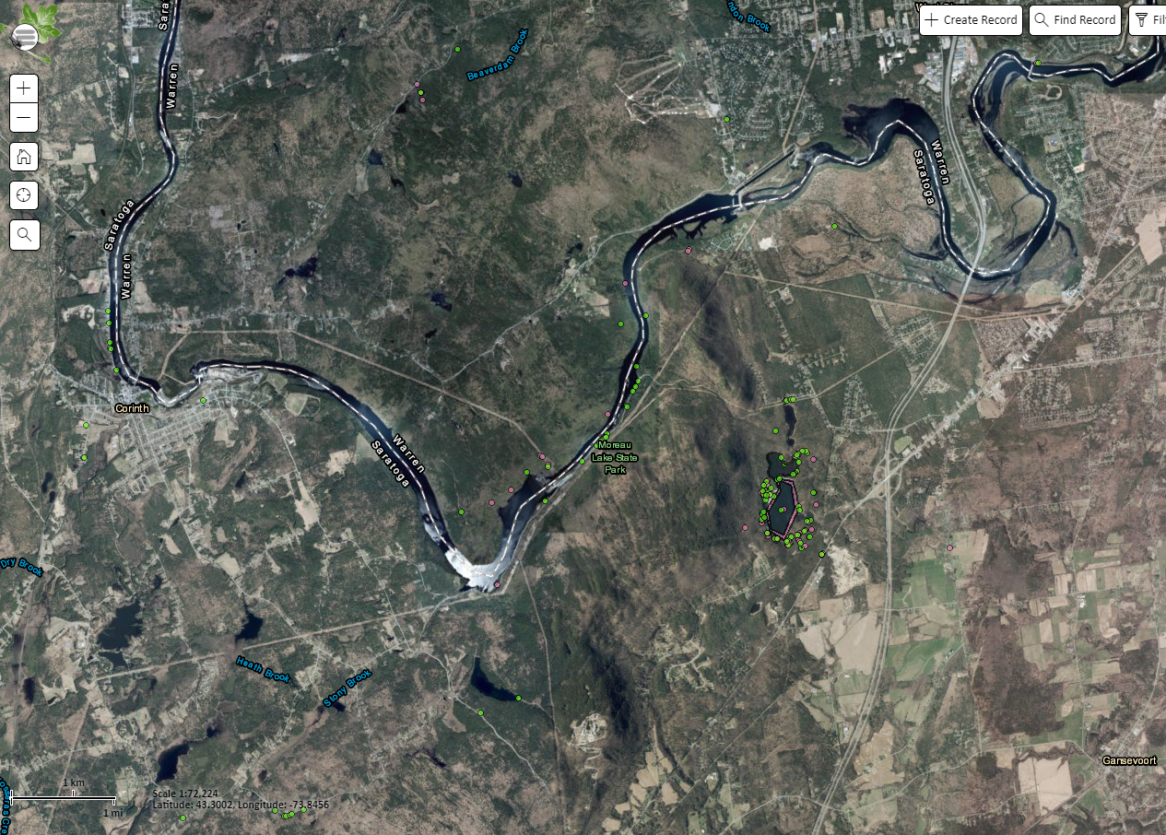

Figure 2. neysuckle (Lonicera spp) at Moreau Lake State Park at the parking lot to the beach and Nature Center.
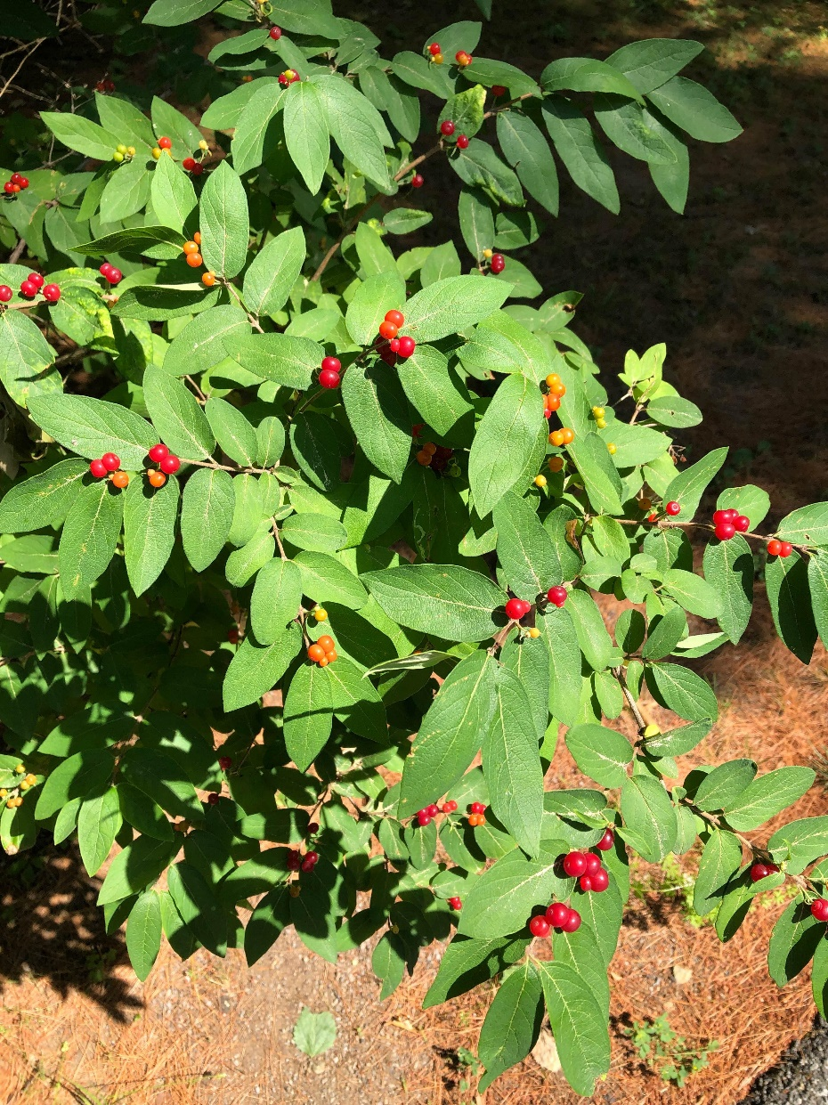
Figure 3. Common Reed, Phragmites (Phragmites australis) near the boat launch and maintenance area of the southernmost tip of Moreau Lake.
