Multiflora Rose
Rosa multiflora

Identification
Multiflora rose is a perennial shrub that can reach heights of up to 15 ft and can span 13 ft in width. The stems, or canes, grow in an arching pattern and are capable of wrapping around trees and other surfaces. The reddish-green stems also have curved thorns running along the entire plant. It has alternate, compound leaves that are a dark green color. The leaflets are toothed and have very symmetrical veins.

Reproduction
Between May and June the multiflora rose develops clusters of white or pink flowers with yellow centers. Later in the summer, the flowers will develop into small, red fruits that will remain through winter. The seeds are very small and are contained within sharp spicules. Once released, they can remain viable in the soil for up to 20 years. Stem tips and root fragments are also capable of forming new plants.
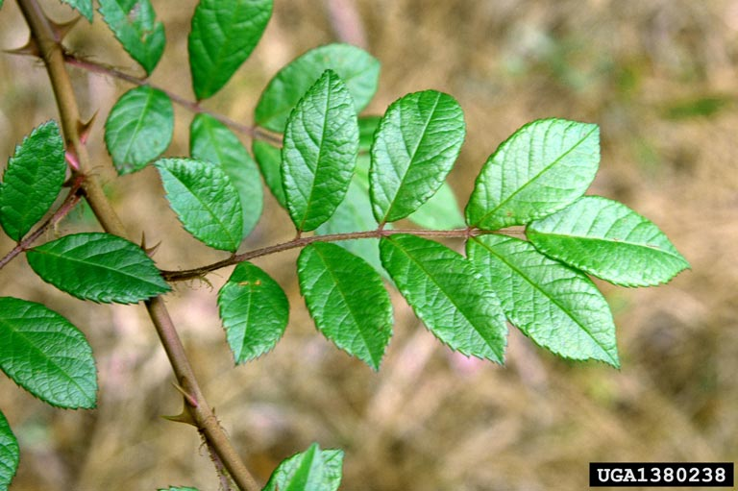

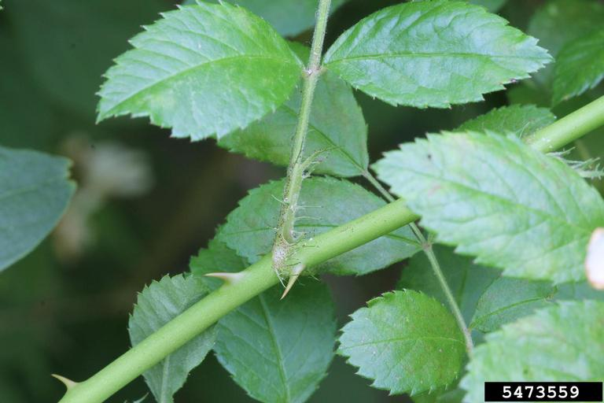

Habitat
Multiflora rose is commonly found on forest edges, right-of-ways, fields, and swamp edges. It is tolerant of a range of light, water, and soil conditions, thus making it a very strong invader.

Threat
This plant grows very quickly and is easily spread, which causes a loss of biodiversity and decreased habitat quality for other species. Many wild animals avoid feeding on the multiflora rose due to the sharp thorns that cover the stems. The thorns are also a threat to humans that may come in contact with them on hiking trails or even backyards.
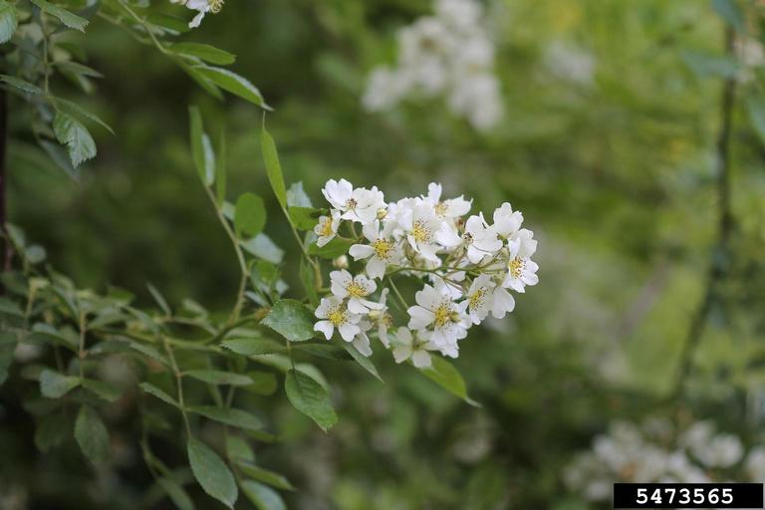

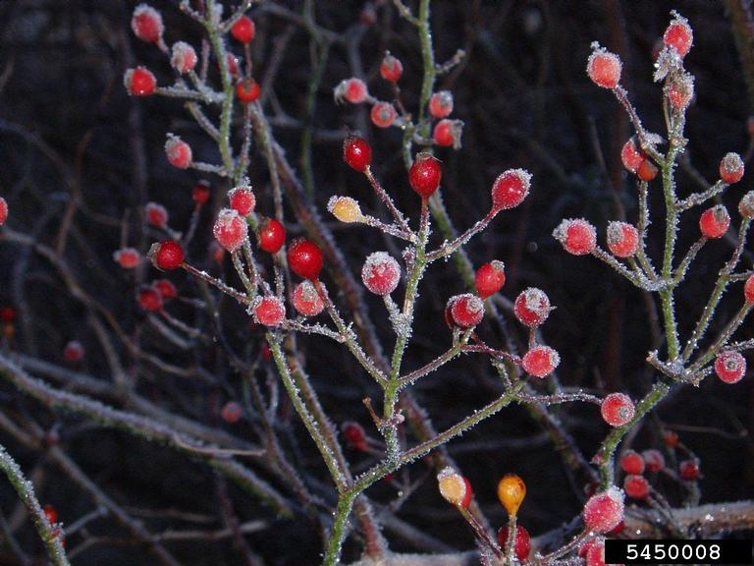

Integrated Pest Management for

Multiflora Rose
Due to the threat of multiflora rose to local ecosystems, it is important to reduce the size and limit the spread of existing populations. Invasive species are controlled through prevention, eradication, containment and suppression. An integrated pest management (IPM) approach should be adopted to control unwanted species. The integrated approach is a combination of manual, mechanical, biological and chemical controls. IPM requires post treatment monitoring and treatment over a period of several years, leading to more successful outcomes (https://nysipm.cornell.edu/about/defining-ipm/).

Practices to Avoid
- DO NOT PLANT MULTIFLORA ROSE. Despite its beauty, the multiflora rose is a prohibited species in New York, meaning it is illegal to knowingly sell, purchase, or introduce the plant.
- AVOID LEAVING FRAGMENTS. When removing multiflora rose, it is important to remove the entire root system because any fragments left have the ability to form new infestations.

Manual and Mechanical Control
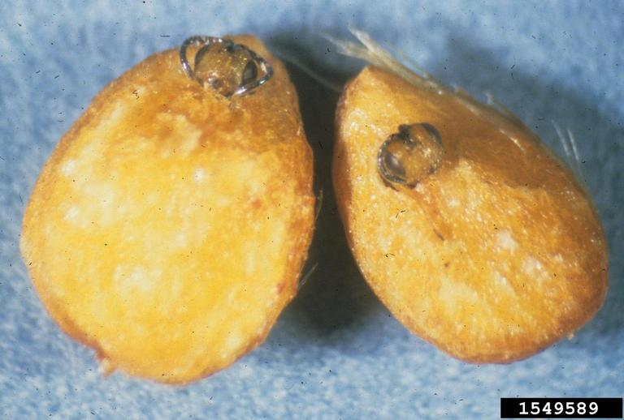
Young and small populations of multiflora rose are frequently pulled by hand or dug out. Cutting or mowing of larger populations about four times a year for three years has been effective at killing off the plant as well. Excavating equipment can be used to remove multiflora rose. Wear gloves and other personal protective equipment to avoid being pricked by the thorns. Any plant material cut or pulled should be placed in black bags and left in the sun for at least two weeks before disposal or landfilled.
European Rose Chalcid

Biological Control
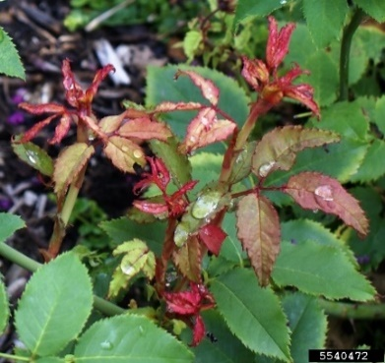
There are two biological control methods currently being studied to help reduce populations of multiflora rose. Rose-rosette disease is a native virus spread by mites and the European rose chalcid is a wasp that infests the seeds. However, both methods effect native rose bushes as well, so further research is required.
Rose-rosette Disease

Herbicide Control
Herbicide is typically the last resort when it comes to integrated pest management. For large populations of multiflora rose it has been very successful at reducing population size and preventing the spread. It is very important when applying herbicides to be aware of the most effective time of year and chemicals to use in order to reduce the adverse effects on the environment. Please consult an expert or certified applicator when applying herbicides. Read and follow herbicide product labels as required by law. Seek out proper local, state, and federal permitting when applying herbicides.

Herbicide Treatment for Homeowners/ Private Landowners

Time of Year: July to September (Growing Season)

Example Chemical(s) to Use: Read all Product Labels as Required by Law
Product names are listed as examples, and not as endorsements or recommendations. The suitability and details for specific use of these products are provided through their labels.
Chemical  (Products Containing) | Timing | Application Technique | Notes
Glyphosate (Roundup, Rodeo) | July-September or dormant season in winter months | - Cut-Stump  - Foliar Spray | - Non-selective  - Cut-stump dormant application preferred to prevent non-target effects
Triclopyr (Garlon 3A, Garlon 4) | July-September | - Cut-stump | - Apply right after cutting on a dry day to avoid run-off
Fosamine (Krenite) | July-September | - Foliar Spray | - Selective  (only effects woody plants)  - Die off not apparent until following summer
If there is water present near the infestation, a permit from the DEC is required. For more information regarding aquatic pesticide permitting, please contact the nearest DEC Regional Office: Division of Environmental Permits at (518) 357-2069 or visit: http://www.dec.ny.gov/permits/209.html.

Timeline of Action

For More Information Seek out the Cornell Guidelines for Pesticide Use:
The Cornell Guidelines offer the latest information on topics such as pest management, crop production, and landscape plant maintenance. Each title in the series is updated by Cornell University researchers and Extension specialists and is designed as a practical guides. https://www.cornellstore.com/books/cornell-cooperative-ext-pmep-guidelines

Native Replacements
After removing or treating multiflora rose, it is important to reseed or plant the disturbed soils with native species common in the geographic area. Replanting will help restore the ecosystem and prevent old infestations from re-establishing. Consider using stress tolerant plants in harsh environments that are best suited to a given site. If pre-existing native plants are present on site, protect these species from harm, during management. The surrounding native species can then be used to aid in the heathy reestablishment of the area. More information about native plants, shrubs and trees can be found:

Alternatives to Ornamental Invasive Plants “A Sustainable Solution for New York State”
- https://nysipm.cornell.edu/sites/nysipm.cornell.edu/files/shared/documents/NYSIPM-alt-inv.pdf

NYSDEC Native Plant Factsheets
- https://www.dec.ny.gov/docs/lands_forests_pdf/factnatives.pdf

Lady Bird Johnson Native Flower Database
- https://www.wildflower.org/plants/

Westchester Community College Native Plant Center
- https://www.sunywcc.edu/about/npc/

Definitions:
Manual Control: a technique to remove small infestations. Some examples of manual control is hand-pulling, mulching, burning, digging, and removal of the entire plant, portions of a plant, nests, egg masses, or other life stages. This type of control is only economically feasible for small infestations.
Herbicide Control: a technique which uses chemicals to remove or decrease the population of a species. Herbicides are usually one of the last choices for control as they are usually expensive and have adverse effects to the environment. There are different methods to apply an herbicide. Some examples are: foliar spray, basal bark, bundle and cut, and cut-stump treatment.
Biological Control: a technique where an animal, insect, fungi or disease is used to manage a large invasive species population. This control species is studied intensively to see if there could be any negative effects for native species.
Foliar Spray: method of herbicide control where the chemical is sprayed directly on the leaves. Sprayers can be hand held, on a backpack or mounted on a vehicle. If a plant has a waxy surface, a surfactant may be needed to allow the herbicide to work.
Selective herbicides: a type of herbicide which kills specific groups of plants but not others. For examples, a selective herbicide may kill broadleaf plants, like dandelions, but not grasses.
Non-selective herbicides: a type of herbicide which kills all types of plants. When using this herbicide, any plant that is sprayed will be effected.
DISCLAIMER
Please note that neither Cornell Cooperative Extension of Saratoga County nor any representative thereof makes any representation of any warranty, express or implied, of any particular result or application of the information provided by us or regarding any product. If a product is involved it is the sole responsibility of the User to read and follow all product labeling instructions and to check with the manufacturer or supplier for the most recent information. Nothing contained in this information should be interpreted as an express or implied endorsement of any particular product or criticism of unnamed products. With respect to any information on pest management the User is responsible for obtaining the most up-to-date pest management information. The information we provide is no substitute for pesticide labeling. The User is solely responsible for reading and following manufacturer’s labeling and instructions.

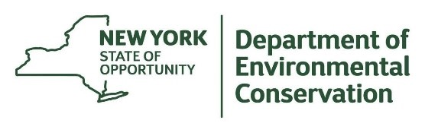
The New York State Department of Environmental Conservation provides financial support
to The Capital Mohawk PRISM via the Environmental Protection Fund.

