Survey for Joint-head Arthraxon (Arthraxon hispidus) Murderers Creek

Date: 8.30.19

Address: Athens Boat Launch 10 N Washington St, Athens, NY 12015
Off County Route 385, North of Athens NY
OPRHP Property 518-732-0187

County: Green

Latitude and Longitude: 42.27799 ° -73.80389 °

Lead Contact Information for Project: Kristopher Williams CMP Coordinator

Site Owner Contact Information: OPRHP Property 518-732-0187
Sleepy Hollow Lake Owners Association 518.731.3175 https://sleepyhollowlake.org/
Survey Description:

At the moment there was no observation of joint-head arthraxon (Arthraxon hispidus) on the shore line of Murderers Creek or the access road from Sleepy Hollow Road down to the footwall of the Sleepy Hollow Reservoir. The clasping leaf of the joint-head carpet grass may possibly have been miss identified for Japanese Stiltgrass. If the Arthraxon is present it is not detectable at current levels in anticipated shoreline regions of Murderers Creek. The Athens boat launch was also surveyed. Please note the iMap Invasive Search Area Record below.

The presence of Japanese Stiltgrass was found at the survey site. Note the IMap Invasive presence and search area record below. The stiltgrass in this location has become entrenched and appears to have been introduced via unclean access road gravel during reservoir outflow and access road improvements. Due to the nature of the tidal flux and difficulty in accessing Murderers Creek it is unlikely for this population to ever be eradicated from the site. The outflow from the reservoir is surrounded by private property. Transects through private holdings would occur down steep embankments and mudflats at the base of the creek.

Other Notes: It may be possible that the Japanese Stiltgrass displaced the Joint-Head Carpetgrass. The presence of Japanese Stiltgrass at this location is the third possible occurrence of this invasive in the Capital Mohawk PRISM where gravel was brought in for access road improvement. The occurrence may have been unintentionally introduced by the unclean fill. The Stiltgrass is found along the roadside edges and decreases in abundance and or density as you transect away from the road and stream banks. The seeded veggitation from the Stiltgrass follows the hydrologic flow down the access road into Murderers Creek.

Invasive Species Detected or Non-Detected:
Common Name | Scientific Name | Locations (GPS) | Growth Type | Phenology | Distribution/ Abundance
Small Carpetgrass; Joint-head | Arthraxon hispidus | 42.27799 ° -73.80389 ° | Non-detectable Grass | N/A | Not Detected
Japanese Stiltgrass | Microstegium vimineum | 42.27799 ° -73.80389 ° | Grass | Vegetative not in seed | Detected
Non-Detect: Small Carpetgrass; Joint-head Detect: Japanese Stiltgrass

- iMap Invasive Searched Area Record: #1045971 iMap Invasive Searched Area Record: #1046039
- iMap Invasive Not-Detected Record: #8181 iMap Invasive Presence Record: #1030608

Recommendations for the Future:
- The private property to the north of Murderers Creek should be accessed in a perpendicular transect to check if there is an infestation of Arthraxon hispidous in a woodland meadow next to the stream.
- The legislature needs to pass a law for fill to be certified clean when used in ecologically sensitive areas.

Identification:
Appearance: The plant stands to 1.5 ft. (0.5 m) tall with oval to lance-shaped leaves.

- Leaves are 1-3 in. (2.5-7.6 cm) long, 0.2 in. (0.5 cm) wide and have heart shaped bases. The margins of the leaves have conspicuous hairs.
- Flowers bloom in early fall and are contained in 1 to several, 1-3 in. (2.5-7.6 cm) long spikes.Fruit is a caryopsis.
- Ecological Threat Arthraxon hispidus is an annual grass that was introduced into the United States, either accidentally or by immigrants, from Japan and eastern Asia. Arthraxon hispidus inhabits wet areas such as stream banks, flood plains and shorelines.
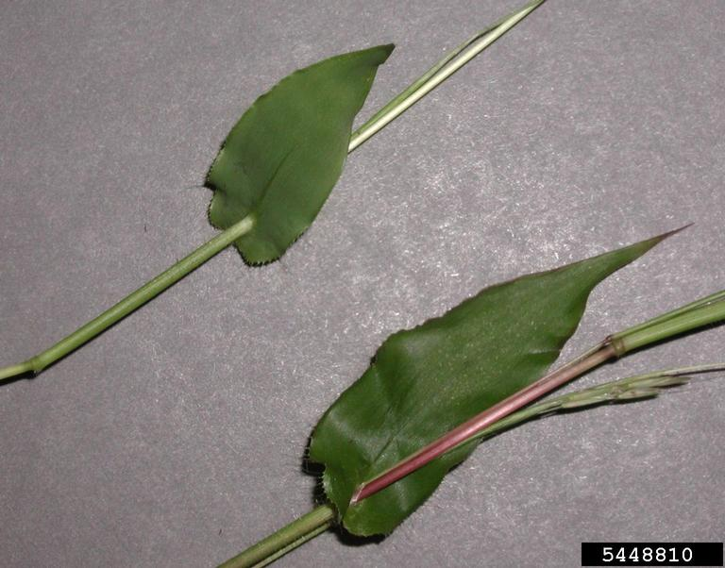
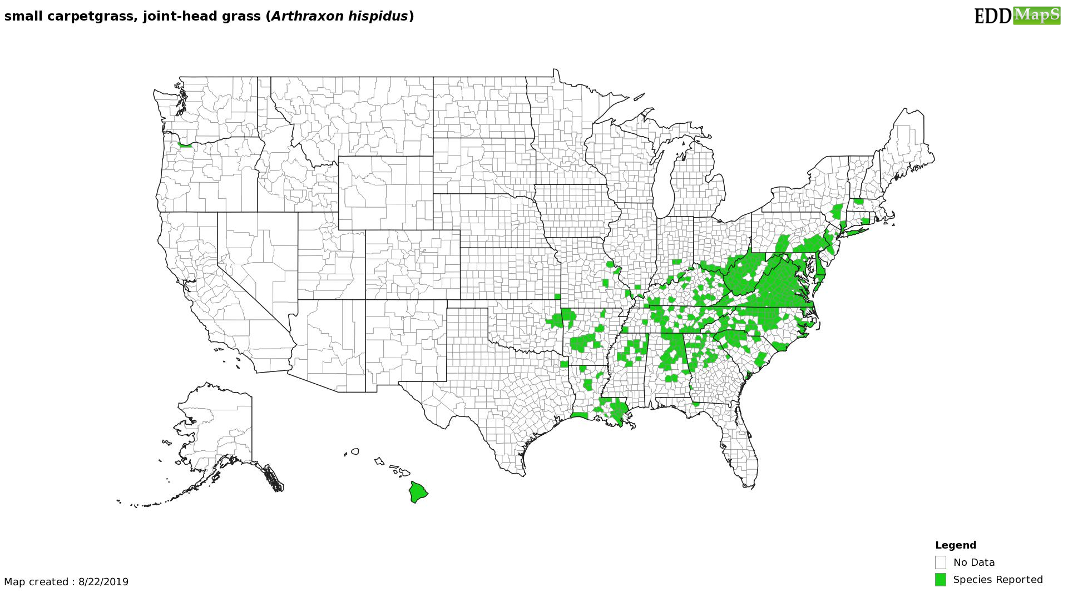

The New York State Department of Environmental Conservation provides financial
support to The Capital Mohawk PRISM via the Environmental Protection Fund.

