NEPAL SMARTWEED IN MOREAU LAKE STATE PARK INVASIVE SPECIES SURVEY 2019:
Anna Kuhne and Lauren Mercier

Type of Work Performed: Survey for Nepal Smartweed along

Date: July 31st, 2019

Address: Spire Falls Rd, ganesvoort, NY, 12831
County: Saratoga County
Latitude and Longitude: 43.24058, -73.74556
Website: https://parks.ny.gov/parks/150

Lead Contact Information for Project: Lauren Mercier, Capital Mohawk PRISM

Site Owner Contact Information: New York State Parks, Recreation, and Historic Preservation

Project Description: A survey for Nepal smartweed was done along Spire Falls Road where a small patch of the plant was found. The Nepal Smartweed – single patch found on the side of the road that is not adjacent to the water. The patch could be easily removed manually.

Invasive Species Present at (SITE NAME):
Common Name | Scientific Name | Locations (GPS) | Growth Type | Phenology | Distribution/ Abundance
Nepal Smart Weed | Persicaria nepalensis | 43.24058  -73.74556 | Herbaceous | Flowering | Single patch

Capital Mohawk PRISM Strongly Recommends Uploading Points into https://www.imapinvasives.org/
Native Community Types: Wetland
Dominant Native Plants Present: Sugar Maple, Hemlock, Oak
Summary of Work Completed:
  - Survey for Nepal Smartweed – a terrestrial invasive species
Recommendations for the Future: Remove the single patch manually with gloves and shovels.
Contact the Capital Mohawk Prism http://www.capitalmohawkprism.org/

Figure 1. Map with the Nepal Smartweed point.
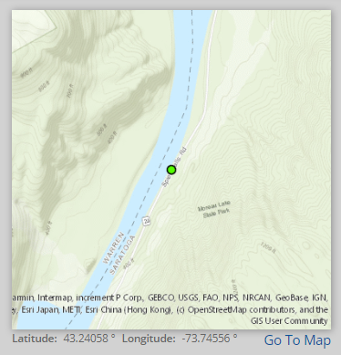

Figure 2. Nepal Smartweed found on Spire Falls Road in Ganesvoort, New York in Saratoga County.
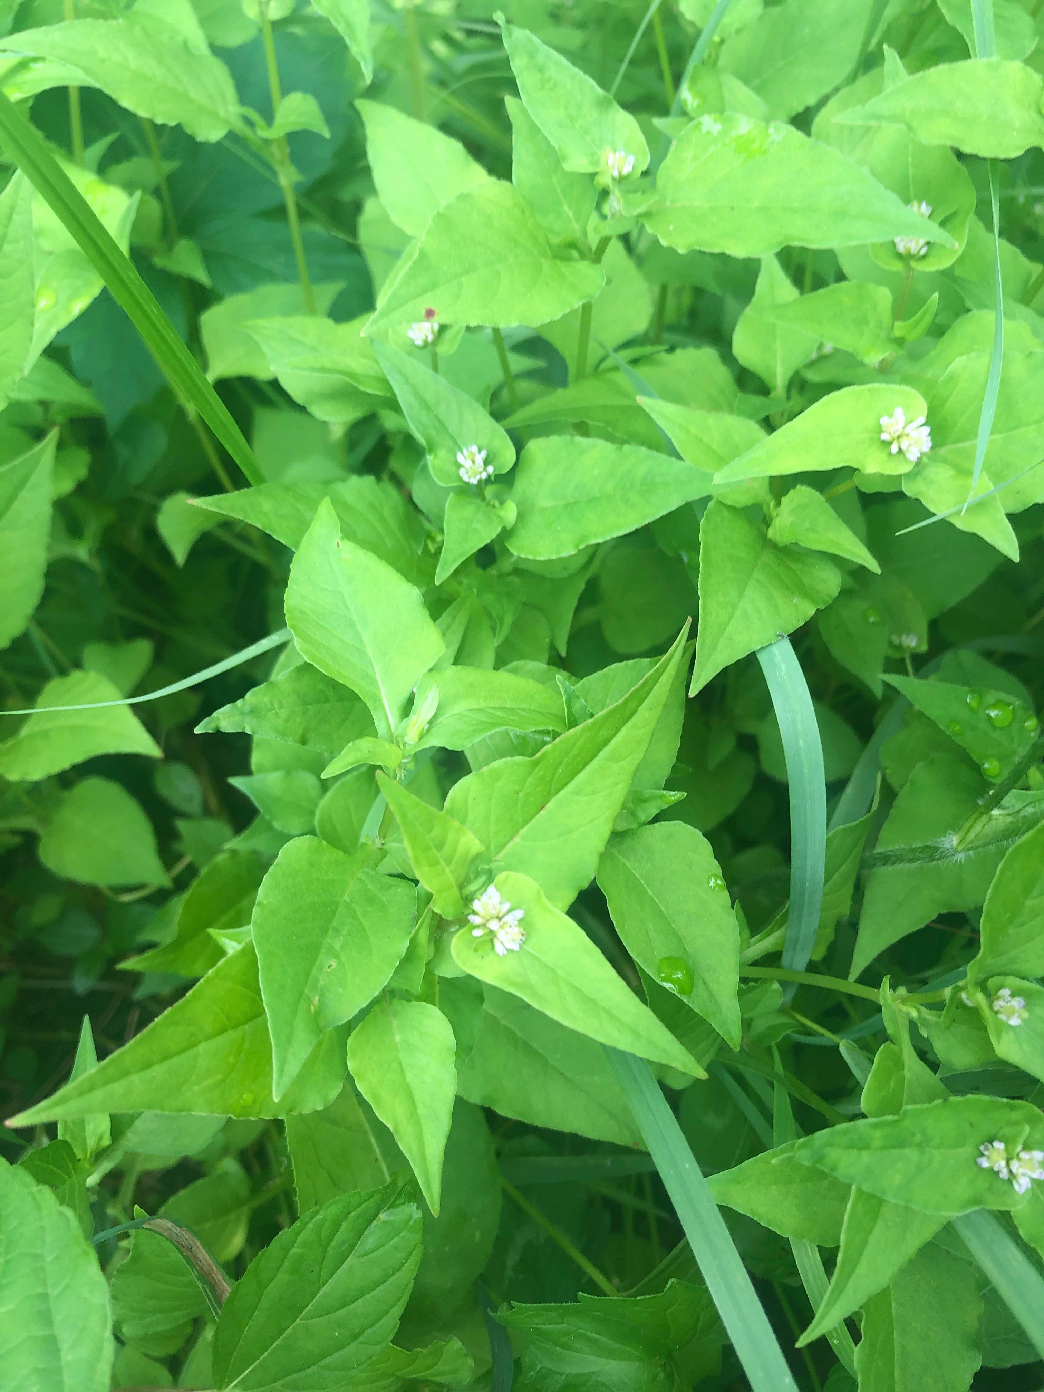

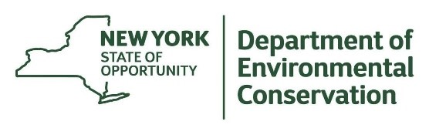
The New York State Department of Environmental Conservation provides financial
support to The Capital Mohawk PRISM via the Environmental Protection Fund.

