Oriental Bittersweet
Celastrus orbiculatus

Identification
Oriental bittersweet is a woody vine that can grow up to 60 feet tall and 4 inches diameter. The stem is green when it is young then matures to have a smooth brown bark with the leaves that grow alternately. The leaves are glossy, finely toothed, and are very round in young plants but become more egg-shaped as the plant matures. The roots have a very distinct orange color.

Reproduction
Between May and June, Oriental bittersweet forms clusters of small greenish-white flowers. By mid-summer the bittersweet develops green fruits that eventually turn yellow. In the fall and winter, the yellow capsule will open to reveal red berries. The berries are eaten by birds which helps spread the seeds. The roots also form suckers and rhizomes that allow it to spread horizontally.
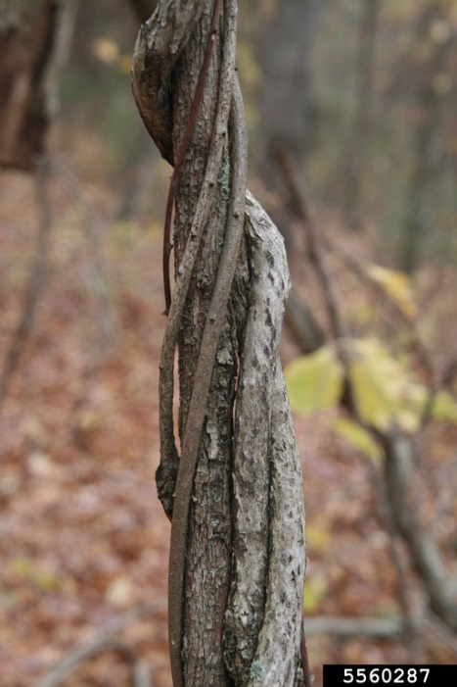

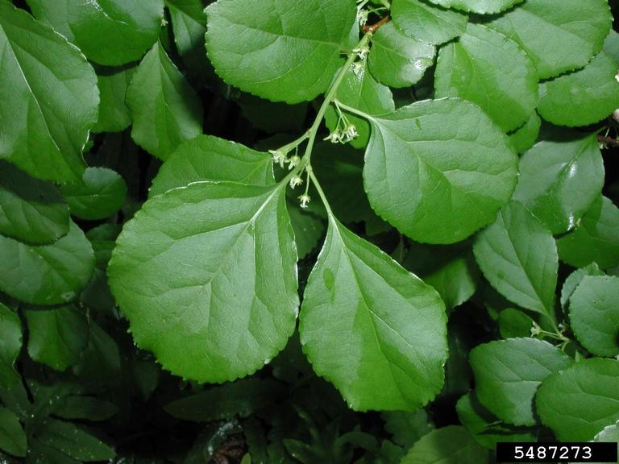

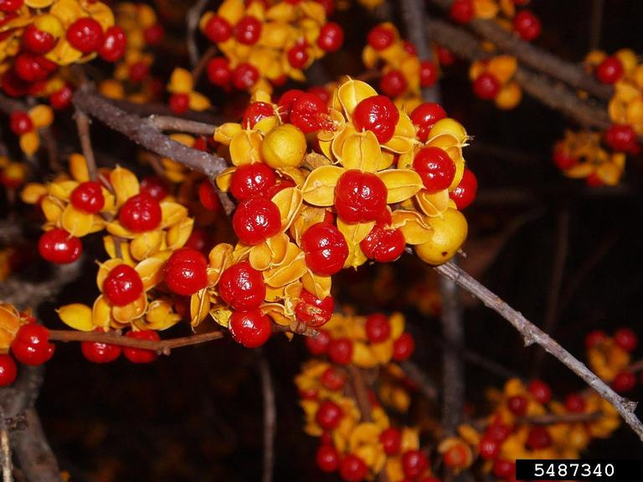

Habitat
Oriental bittersweet is found in a variety of habitats including fields, roadsides, and even urban settings. Although it prefers sunny areas, oriental bittersweet is fairly shade tolerant allowing it to invade forests as well.

Threat
The rapid growth and spread of oriental bittersweet allows it to shade out native plants as well as choke out the trees and other plants it uses to climb. If it grows large enough it can cause damage to the limbs and branches of trees. The weight can even cause the tree to fall, which can cause property damage and injury people.

Integrated Pest Management for

Oriental Bittersweet
Due to the threat of oriental bittersweet to local ecosystems, it is important to reduce the size and limit the spread of existing populations. Invasive species are controlled through prevention, eradication, containment and suppression. An integrated pest management (IPM) approach should be adopted to control unwanted species. The integrated approach is a combination of manual, mechanical, biological and chemical controls. IPM requires post treatment monitoring and treatment over a period of several years, leading to more successful outcomes (https://nysipm.cornell.edu/about/defining-ipm/).

Practices to Avoid:
- Manually or mechanically cutting oriental bittersweet without multiple treatments.
- Applying herbicides at the incorrect time of the year. Spring and fall applications are best for cut-stump treatments, and foliar sprays before flowering. Consult the product label before using an herbicide.

Manual and Mechanical Control
Young and small individuals of oriental bittersweet can be pulled, ideally before the plant goes into fruit. However, once the vine grows larger and higher up, it become far more difficult to remove by hand. Repeated cuttings and grubbing of the root system will eventual deplete the plant of its energy stores. Monitor and repeat removals annually as needed. Large diameter stems one inch or bigger typically die in the first year. Smaller stems require annual attention 3-5 years. If the plant cuttings has gone into fruit, be sure to bag the fragments and fruits to prevent seed dispersal.

Biological Control
There are currently no approved biological control methods for oriental bittersweet.

Herbicide Control
For large and mature infestations of oriental bittersweet, that cannot be manually removed, herbicide is a useful tool. The best management practices when applying chemical herbicides to treat an infestation should be followed to limit the effects on the environment. Please consult an expert or certified applicator when applying herbicides. Read and follow herbicide products labels as required by law. Seek out proper local, state, and federal permitting when applying herbicides. If you cut oriental bittersweet without the intention of applying a follow up herbicide, the vine is able to re-sprout and can continue to spread. A cut stump type of treatment method is a recommended practice. When the plant is storing energy into its root system brushing a small amount of herbicide on cut stems can be an effective treatment.

Herbicide Treatment for Private Landowners

Time of Year: May to September (Before Fruit)

Example Chemical(s) to Use: Read All Product Labels as Required by Law
Product names are listed as examples, and not as endorsement or recommendation. The suitability and details for specific use of these products are provided through their labels.
Chemical  (Products containing) | Time of Year | Application Technique | Notes
Glyphosate (Roundup, Rodeo) | May to September | - Foliar spray  - Cut-stump | - Best to apply when temperatures > 40°F  - Non-selective
Triclopyr  (Garlon 3A, Garlon 4) | May to September | - Foliar spray  - Cut-stump | - Best to apply when temperatures > 60°F  - Selective
If there is water present near the infestation, a permit from the DEC is required. For more information regarding aquatic pesticide permitting, please contact the nearest DEC Regional Office: Division of Environmental Permits at (518) 357-2069 or visit: http://www.dec.ny.gov/permits/209.html.

Timeline of Action

For More Information Seek out the Cornell Guidelines for Pesticide Use:
The Cornell Guidelines offer the latest information on topics such as pest management, crop production, and landscape plant maintenance. Each title in the series is updated by Cornell University researchers and Extension specialists and is designed as a practical guides. https://www.cornellstore.com/books/cornell-cooperative-ext-pmep-guidelines

Native Replacements
After removing or treating oriental bittersweet, it is important to reseed or plant the disturbed soils with native species common in the geographic area. Replanting will help restore the ecosystem and prevent old infestations from re-establishing. Consider using stress tolerant plants in harsh environments that are best suited to a given site. If pre-existing native plants are present on site, protect these species from harm, during management. The surrounding native species can then be used to aid in the heathy reestablishment of the area. More information about native plants, shrubs and trees can be found:

Alternatives to Ornamental Invasive Plants “A Sustainable Solution for New York State”
- https://nysipm.cornell.edu/sites/nysipm.cornell.edu/files/shared/documents/NYSIPM-alt-inv.pdf

NYSDEC Native Plant Factsheets
- https://www.dec.ny.gov/docs/lands_forests_pdf/factnatives.pdf

Lady Bird Johnson Native Flower Database
- https://www.wildflower.org/plants/

Westchester Community College Native Plant Center
- https://www.sunywcc.edu/about/npc/

Definitions:
Manual Control: a technique to remove small infestations. Some examples of manual control is hand-pulling, mulching, burning, digging, and removal of the entire plant, portions of a plant, nests, egg masses, or other life stages. This type of control is only economically feasible for small infestations.
Herbicide Control: a technique which uses chemicals to remove or decrease the population of a species. Herbicides are usually one of the last choices for control as they are usually expensive and have adverse effects to the environment. There are different methods to apply an herbicide. Some examples are: foliar spray, basal bark, bundle and cut, and cut-stump treatment.
Biological Control: a technique where an animal, insect, fungi or disease is used to manage a large invasive species population. This control species is studied intensively to see if there could be any negative effects for native species.
Foliar Spray: method of herbicide control where the chemical is sprayed directly on the leaves. Sprayers can be hand held, on a backpack or mounted on a vehicle. If a plant has a waxy surface, a surfactant may be needed to allow the herbicide to work.
Cut-stump treatment: method of herbicide control where the stem is cut, near the base of the plant, and an herbicide is applied. Water-based herbicides should be applied immediately following the stem cut while oil-based can be applied later. The herbicide can be applied use a sprayer or sponge/paint brush.
Selective herbicides: a type of herbicide which kills specific groups of plants but not others. For examples, a selective herbicide may kill broadleaf plants, like dandelions, but not grasses.
Non-selective herbicides: a type of herbicide which kills all types of plants. When using this herbicide, any plant that is sprayed will be effected.
DISCLAIMER
Please note that neither Cornell Cooperative Extension of Saratoga County nor any representative thereof makes any representation of any warranty, express or implied, of any particular result or application of the information provided by us or regarding any product. If a product is involved it is the sole responsibility of the User to read and follow all product labeling instructions and to check with the manufacturer or supplier for the most recent information. Nothing contained in this information should be interpreted as an express or implied endorsement of any particular product or criticism of unnamed products. With respect to any information on pest management the User is responsible for obtaining the most up-to-date pest management information. The information we provide is no substitute for pesticide labeling. The User is solely responsible for reading and following manufacturer’s labeling and instructions.

The New York State Department of Environmental Conservation provides financial support
to The Capital Region PRISM via the Environmental Protection Fund.

