PECK HILL STATE FOREST INVASIVE SPECIES SURVEY 2019:

Spencer Barrett, Anna Kuhne, and Kelsey Stevens

Introduction: : In June of 2019, the Terrestrial Invasive Species Coordinator, Spencer Barrett, worked with two interns, from Siena College, to look for early detection invasive species throughout the Capital-Mohawk PRISM. The Siena interns, Anna Kuhne and Kelsey Stevens, focused on terrestrial invasive plant surveys at highly susceptible and valuable habitats throughout the PRISM region. The following is an abridged summary of some of the findings of the survey throughout Rockwood State Forest. The PRISM works throughout 11 counties around the capital region to detect, prevent, and control invasive species.

Project Description: Surveying terrestrial invasive plants in the park
Dates: June 7th^{th}, 2019
Participants: Capital Mohawk Prism, Cornell Cooperative Extension, and NYS DEC
Point of Contact: DEC Regional Office, Region 5
County: Fulton County

Locations and Species Identified:
Peck Hill State Forest (DEC Region 5 Office): Scouting was done on the trails of the Hudson Crossings Park which started at the play garden adjacent to the parking lot.
Common Name | Scientific Name | Locations (GPS) | Growth Type | Phenology
Elongate Hemlock Scale | Fiorinia externa | 43.08307  -74.44365 | Pest | Pest
Glossy Buckthorn, European Buckthorn | Frangula alnus | 43.08323  -74.44196 | Tree | Vegetative
Common Buckthorn | Rhamnus cathartica | 43.08314  -74.44258 | Tree | Vegetative
Multiflora Rose | Rose multiflora | 43.08307  -74.4495 | Shrub | Vegetative

Dominant Native Plants: Hemlock, sugar maple, princess pines, ground cedar, pink lady slippers (not as dominant but present).
Native Community Types: Marsh
Treatment Method: None

Summary of Work Completed:
  - Surveyed for invasive terrestrial plants, found mostly buckthorn
  - Surveyed for hemlock wooly adelgid and possibly found some on a marshy trail close to the water on a trail that is not wheel chair accessible.

Recommendations for the Future: Return for an HWA survey and take a sample for testing

Contact Spencer Barrett at spncrbrrtt@gmail.com for any questions regarding this report.

Figure 1: Possible HWA found at 19ºN, 43º5’3” N, 74º26’54” W in Gloversville, NY at 1410ft elevation on the second loop close to the marsh on a trail that is not accessible by wheelchair.
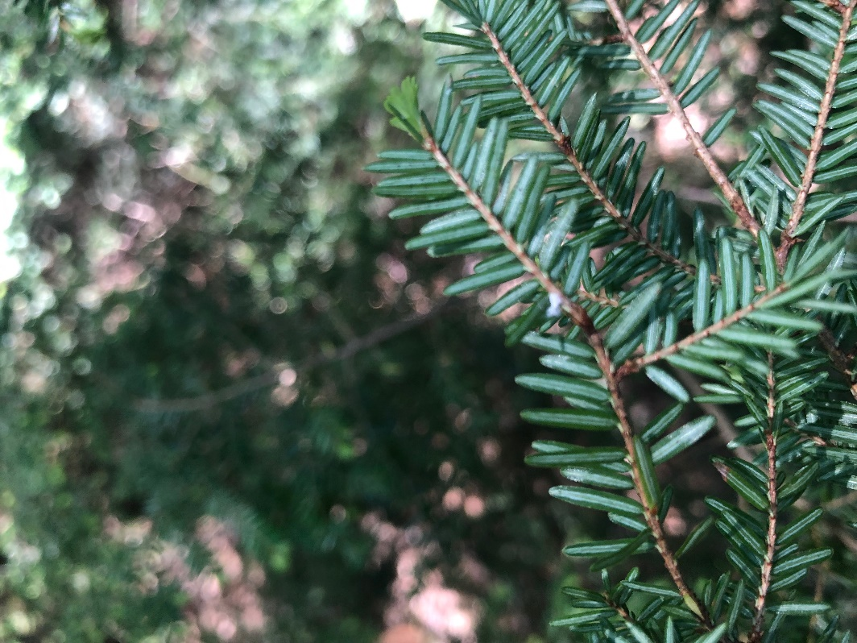

Figure 2: Map of Peck Hill State Forest and Willie Wildlife Marsh from June 7th, 2019.
