Type of Work Performed: Treatment Japanese Angelica Tree (Aralia elata )

Date: Monday Sept 23rd 2019

Address: The Pine Hollow Arboretum 34 Pine Hollow Road, Slingerlands, NY 12159 Phone: (518) 992-2033
County: Albany
Latitude and Longitude:
Website: https://www.pinehollowarboretum.org/

Lead Contact Information for Project: Sandra Brousseau sandrabr2@live.com
Site Owner Contact Information: The Pine Hollow Arboretum

Project Description and Summery of Work Completed:

Pine Hollow Arboretum, a partner of the Capital Mohawk PRISM, agreed to treat and eradicate in-house with a certified applicator Japanese Angelica Tree (Aralia elata). The arboretum had a specimen of the invasive tree Aralia elata that had colonized to approximately a tenth of an acre. The Aralia had gone to flower this season but the park manager cut the flower heads off prior to a basal bark treatment. The Aralia elata was an intentional planting. Approximately 45 stems where treated. The specimens where no larger than 1.5 inches in diameter.

Invasive Species Present and Treated:
Common Name | Scientific Name | Locations (GPS) | Growth Type | Phenology | Distribution/ Abundance
Japanese Angelica Tree | Aralia elata | 42.63211 ° -73.85449 ° | Tree less than 1.5 inch diameter | Vegetative Saplings | Sparse Colonial Species

Capital Mohawk PRISM Strongly Recommends Uploading Points into https://www.imapinvasives.org/
- Searched Area Record:#1050064
- Treatment Record:#16998
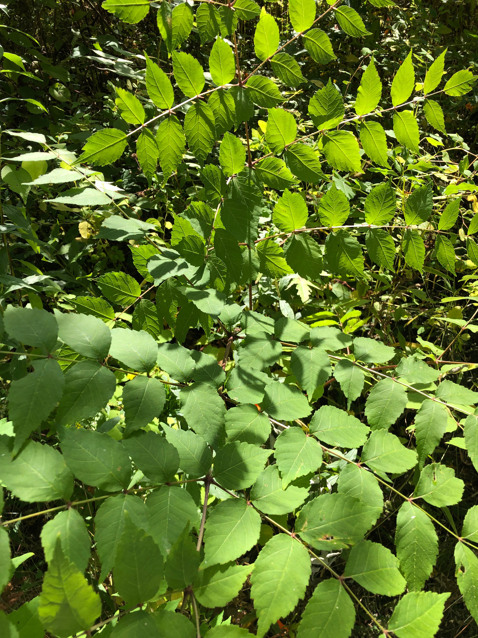

Recommendations for the Future: Monitor and retreat as needed.

The New York State Department of Environmental Conservation provides financial
Support to The Capital Mohawk PRISM via the Environmental Protection Fund.

