Purple Loosestrife
Lythrum salicaria

Identification
Purple loosestrife is an herbaceous, perennial plant that has a distinctive spike of purple flowers between June and September. It has a square shaped stem that is covered in hairs and has sword shaped leaves between 5 cm and 14 cm long.

Reproduction
Purple loosestrife flowers between June and September and each plant can produce up to 2.5 million seeds. The seeds are dispersed by wind, water, and human activity.

Habitat
This flower inhabits wet soils, typically in marshy or swampy area, but it can also survive in roadside ditches. It is tolerant of a variety of light and nutrient conditions, but thrives in moist, organic soils.
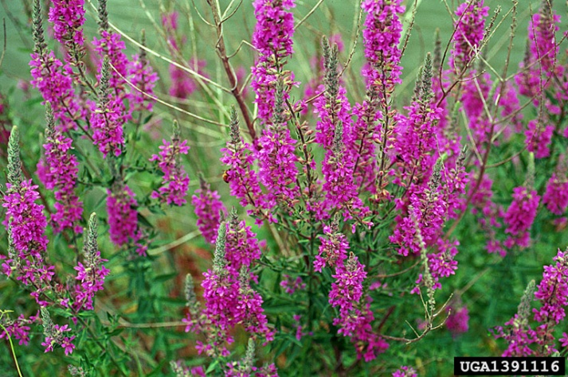

Threat
Purple loosestrife grows in dense stands, creating monocultures that decrease biodiversity and the quality of the habitat. It can also change the hydrological composition of wetlands.
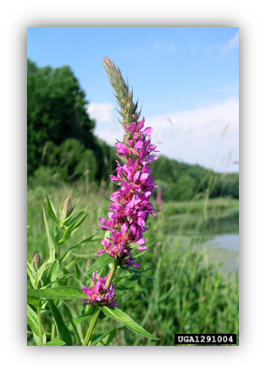

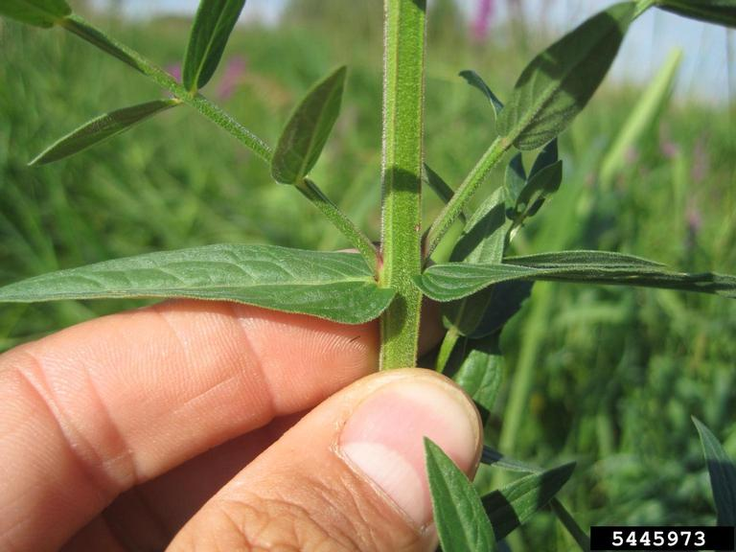

Integrated Pest Management for

Purple Loosestrife
One of the main challenges of managing purple loosestrife infestations is the fact that it grows near water. This makes accessing the full stands fairly difficult and excludes common forms of terrestrial management like mowing. Because of this, it is important to tackle infestations of purple loosestrife using a combination of approaches in order to control and mitigate the problem.

Practices to Avoid:

DO NOT wait until the plant is mature. If you notice purple loosestrife before it goes into flower or before it is mature, remove it as soon as possible. Waiting until it flowers gives the plant the opportunity to spread over 2 million seeds.

DO NOT mow. Mowing will create fragments that have the ability to start new populations.

Manual and Mechanical Removal
The two most effective methods for small infestations is removing the flower and removing the entire plant. By removing the flower, it prevents the plant from going to seed. It has been found effective removing the seed head, flower when seeds have been produced. This still decreases the amount of seed left for the following season. The second method, plant removal, is best performed when the soil is damp. This makes it easier to remove the entire root system. Remaining root fragments can regrow. All plant material should be placed in a plastic bag and left in the sun for at least 3 weeks before disposal. Soil that is disturbed should be packed down to prevent purple loosestrife seeds from germinating.

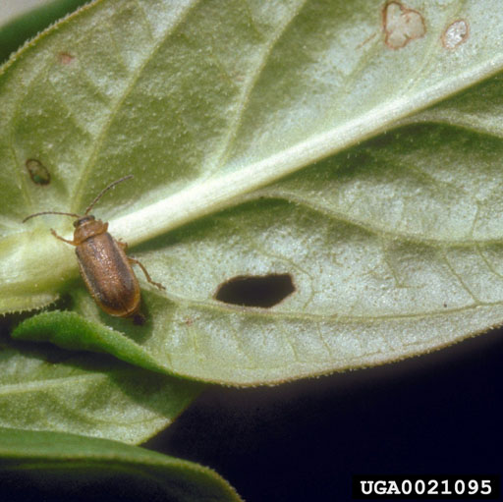
Biological Control
The beetle, Galerucella spp., has been approved by New York State as a biological control for purple loosestrife. The beetle consumes the leaves making it hard for the plant to complete plant processes. Galerucella spp. is able to survive New York’s winter and only feed on the loosestrife. This control method should be used for large infestations and releasing the beetles require extensive monitoring to ensure the population is surviving as well as managing the purple loosestrife.
To obtain a colony of Galerucella spp. beetles, visit http://www.dec.ny.gov/docs/wildlife_pdf/plbioctrlpermit.pdf or contact your Regional DEC Office for more details.

Herbicide Treatment
Herbicides should only be applied to large infestations where all other methods have failed. Treatments should be administered before seed set, typically around May or June, and require frequent monitoring and reoccurring treatments to effectively control. If considering this method of treatment for a terrestrial environment (land), please read and follow herbicide product labels as required by law. If considering this method for wetland or near an aquatic environment, please consult a professional and seek out proper local, state, and federal permitting when applying herbicide.

Herbicide Treatment for Private Landowners

Time of Year: May-June for intact plants, June-September when used in combination with cutting or pulling

Example Chemical(s) to Use: Read all Product Labels as Required by Law
Chemical  (Products containing) | Timing | Application Technique | Notes
Triclopyr  (Triclopyr 3, Garlon 3A) | May-September | Foliar Spray | - Can be used in aquatic areas with permit  - Little soil activity
Glyphosate  (Rodeo, Roundup) | May-September | Foliar Spray | - Non-selective, so good for mixed invasive stands  - Can be used in aquatic areas with permit
If the purple loosestrife infestation in question is near water, a certified applicator or permit from the DEC is required. For information regarding permitting and regulations, please contact the DEC Division of Environmental Permits at (518)357-2069 or visit: http://dec.ny.gov/permits/209.html, https://www.dec.ny.gov/chemical/8530.html

Native Replacements
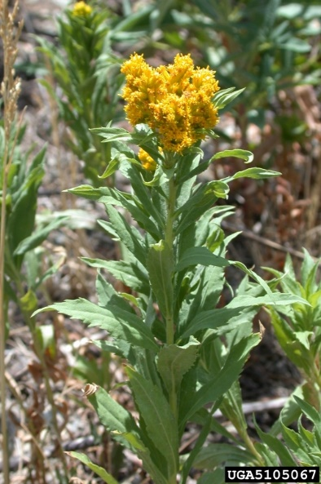
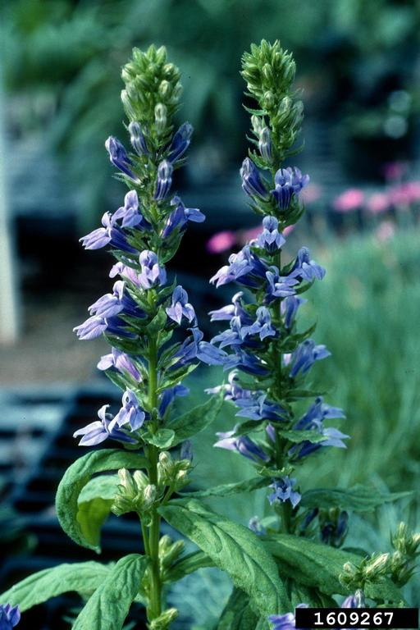
After removing or treating purple loosestrife infestations, it is important replace the disturbed area with native species to help restore the ecosystem and prevent new invasive species from appearing. Leaving a living seed bank in the treated area or spreading native seeds in will help the cultural/biodiversity and re-establishing native plants. Here are a few options for replacements.

Great Blue Lobelia
(Lobelia siphilitica)
Canadian Goldenrod
(Solidago canadensis)

For more options please visit: http://www.dec.ny.gov/docs/lands_forests_pdf/factnatives.pdf
The New York State Department of Environmental Conservation provides financial support
to The Capital Mohawk PRISM via the Environmental Protection Fund

