Reist Sanctuary and Kelly Adirondack Center (2019)

Field Manger Kristopher Williams:

Project Description: Educational Field Walk and Removal of Invasive Species
Dates: May 11th 2019
Participants: Kristopher Williams Capital Mohawk PRISM / Kelly Adirondack Center at Union College /
Union College Environmental Club / Hudson Mohawk Bird Club
Introduction:
The Reist Sanctuary is a 111 acre wood located in the Town of Niskayuna and has a joint parking area with the Kelly Adirondack Center of Union College. The property house a research library for the Adirondack Region of New York State and offers an educational room and museum dedicated to Paul Schaefer a pioneer in early park conservation. The parking area is a main vector for the introduction of invasive species that threaten the preserve. The primary target goal for the day was to eliminate an infestation of invasive9s) in a Highly Probable Area which will lead to the protection a vulnerable vernal pool and bird habitat. The secondary goal of the outing today was to educate stakeholders in the Library, Preserve and Students of Union College regarding the threat that invasive species present to the preserve.

Site Owner & Point of Contact:
The Kelly Adirondack Center 897 St. David’s Lane Niskayuna, NY 12309
Margie Amodeo Coordinator Union College (518)388-7000 amodeom@union.edu
Hudson Mohawk Bird Club Betsy Sandberg bsandberg782@gmail.com Reist Preserve Manager

County: Schenectady
Invasive Species Present at Reist Sanctuary
Common Name | Scientific Name | Locations (GPS) | Growth Type | Phenology | Target/Treatment
Burning Bush | Euonymus alatus | 42.78946 -73.88221 | Shrub | Monoecious  High Seed Production / Bird | 2019-2020 ?
Japanese Knotweed | Polygonum cuspidatum | 42.78946 -73.88221 | Shrub | High Seed Production / Fragmentation | 2020?
Honeysuckle Spp. | Lonicera spp. | 43.2335 -73.7141 | Shrub | High Seed / Production / Bird | Manual Removal
Common Buckthorn | Rhamnus cathartica | 42.7893 -73.88211 | Tree |  | Manual Removal
Japanese Barberry | Berberis thunbergii | 42.78929 -73.88211 | Shrub | High Seed Production / Bird | 2019 -2020 ?
Garlic Mustered | Alliiaria petiolata | 42.78937 -73.88226 | Forb | Seed | Removed / Monitor

Dominant Native Plants: Conifer Mixed hardwoods

Native Community Types:
56 species of Fern, Club Moss, Horsetail, Moss, Liverwort and Lichen 280 Species, 77 families) of Gymnosperm, Dicot and MonocotR. S. Mitchell and G. C. Tucker (1997) list 3,483 higher plants for New York State. The Sanctuary thus hosts 8% of the NYS higher-plant Flora. https://www.hmbc.net/resources/Documents/MiscPDF/Reist_Flora.pdf

Geology
The site's geology is underlain by a clay bed. This is covered by coarse glacial sand that has gathered into dunes and swells. Consequently, the site is quite wet in the spring, with vernal pools in the low areas. But the high ground quickly drains, carrying nutrients away, leaving, dry, nutrient poor soil. In the south end, the property becomes rather swampy, with cattails and other water-loving plants. Thus, vegetation on the site varies greatly from the soggy lowland to the dry high ground. Since the coarse sandy soils are rather poor, trees and other vegetation tends to grow slowly and remain small in size.

Treatment Method: Mechanical/ Manual Removal
Summary of Work Completed:
  - Educational Woods Walk w/ Invasive Ecology
- 15 Direct Contacts /Participants
  - Grounds and Head Trail Removal
    - 30 Honeysuckle (ssp.) Stumps 10 Yards of Biomass
    - Oriental Bittersweet 5 Yards Biomass
    - Garlic Mustered 1 yard Biomass
    - Common Buckthorn 3 Trees
Recommendations for the Future:
- Restore the site with native forbs and sedges. Hydric soils
-pine –whichhazel -iris

- Sites will be monitored bi-annually by Museum and Environmental Club
- Winged euonymus parking lot hedge should be removed by Union College Grounds Crew
- Half Acre- Japanese Knot Weed Infestation should be subject to a knotweed injection program. Recommendations to the Park Manager were made on how to acquire funding for such a project.
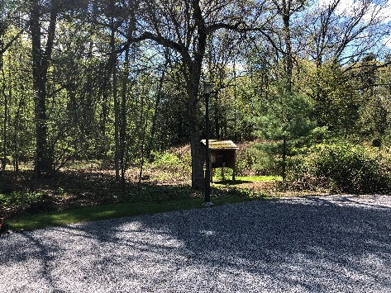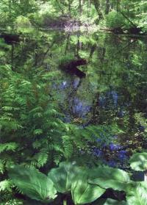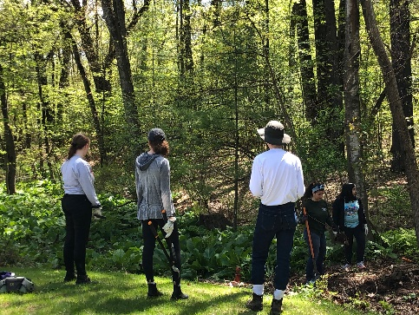
Highly Probable Area Cleared Vernal Pool Volunteirs

The Kelly Adirondack Center 897 St. David’s Lane Niskayuna, NY 12309

