Capital Region PRISM AIS Lake Survey Report

Date: June 16th 2020

Site Name: Rockwood Lake

Site Size: 75 acre(s)

GPS Location of Site/Parking lot: 43.0659, -74.5074

County: Fulton

Town: Johnstown

Property Owner Contact(s) NYS DEC Region 5 Northville Office (518) 863- 4545; [info.R5@dec.ny.gov](mailto:info.R5@dec.ny.gov)

Brookfield Power Company

Survey Leader: Kristopher Williams

Phone: 518.321.0189

Email:kbw44@cornell.edu

iMapInvasives User ID:9274

Summary

On June 16th 2020 the Capital Region PRISM conducted a HWA Lake Survey and AIS Training Survey on Rockwood Lake in Fulton County. The Lake is shared by APIPP and the Capital Region PRISM. A meandering rake toss method was conducted along the edge of the shoreline to survey for AIS. Approximately 35 Rake tosses were conducted along with visual inspection of the surface and subsurface in the littoral zone. No rake tosses were conducted by the dam. The shallow water bays contained dense population of Variable Leaf Watermilfoil. Curly Leaved Pond Weed is new and emerging in one location. Please note the estimated presence polygons and data table below for specific points as posted in iMap.

Aquatic Invasive Species Infestation

* Variable Watermilfoil; Broadleaf Watermilfoil *Myriophyllum heterophyllum* is found in the majority of shallow loamy bays. The extent of the variable leaf watermilfoil is dense to very dense in identified polygons boarding on a monoculture (see map on the second page).

Very High Threat Ranking <http://nyis.info/wp-content/uploads/2018/01/90efb_Myriophyllum.heterophyllum.NYS_.pdf>

* Curly-leaved Pondweed; *Potamogeton crispus* is new and emerging in the lake with a small infestation.

High Threat Ranking <http://nyis.info/wp-content/uploads/2018/01/7223b_Potamogeton.crispus.NYS_.pdf>

Site Description:

Rockwood State Forest is an 856-acre property located near the village of Rockwood. It contains access to Rockwood Lake, as well as several miles of trails and old logging roads. The state land is used for water quality protection, recreation, wildlife habitat and timber production.

* [Wildlife Management Unit:](https://www.dec.ny.gov/outdoor/8302.html) 5J & 6R
* [Rockwood State Forest Map (PDF)](https://www.dec.ny.gov/docs/lands_forests_pdf/maprockwoodsf.pdf)
* <https://www.dec.ny.gov/lands/107041.html>

Access to Rockwood Lake is accessible from route 10 in Fulton County NY using a power company access point easement. Hand launch of small personal watercraft is permitted. There is no bathymetry maps that I can find showing the depths of the lake for AIS surveying. Caroga Creek from the North Flows into the lake and continues south. The lake spans two PRISMS

Survey Techniques:

* *Meandering rake tosses with in the Littoral Zone (Approximately 35)*
* *Visual Inspection of Surface and Subsurface*

iMapInvasives Prioritization Model:

The area is ranked moderately/high on the prioritization model comprehensive score attribute with a fairly shaded coloring on the heat map. The vector of transition exist and the region is surrounded by protected and natural areas.

* <https://www.arcgis.com/home/webmap/viewer.html?webmap=57d30ff9bff7426c8950d90b0ba43bba&extent=-81.0352,39.2503,-70.2686,45.8067>

Does this site contain previously treated infestations? If yes- What species? NO.

Map:

Develop a map of the survey area that has any iMapInvasives points and searched polygons included to clearly define infestation extent. Multiple maps may be added for multiple species or locations.

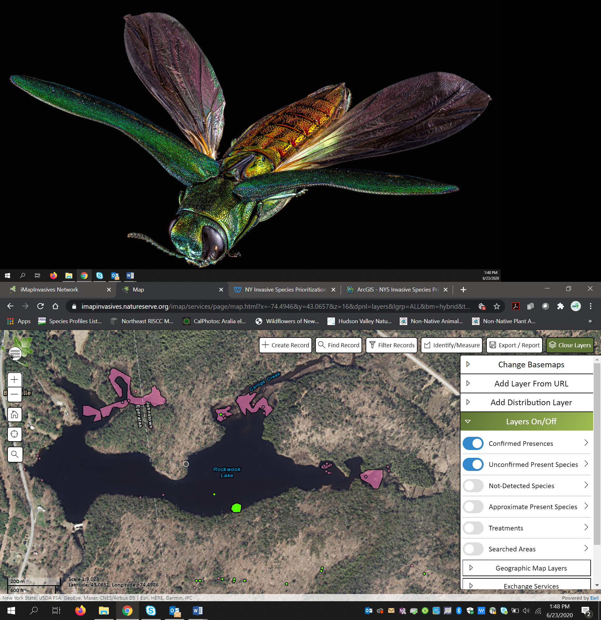

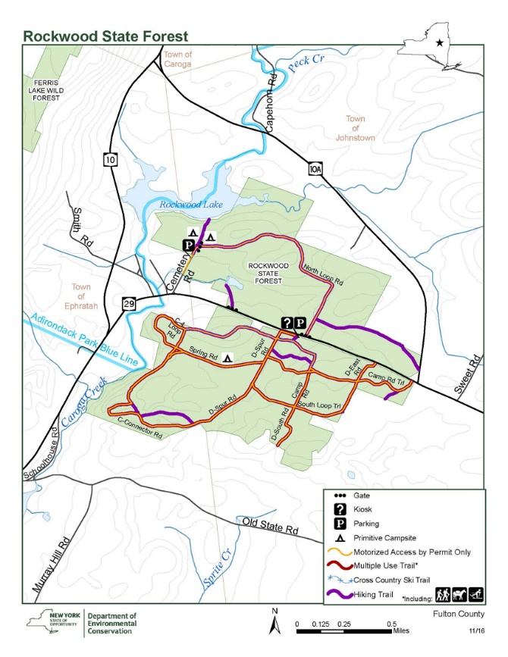

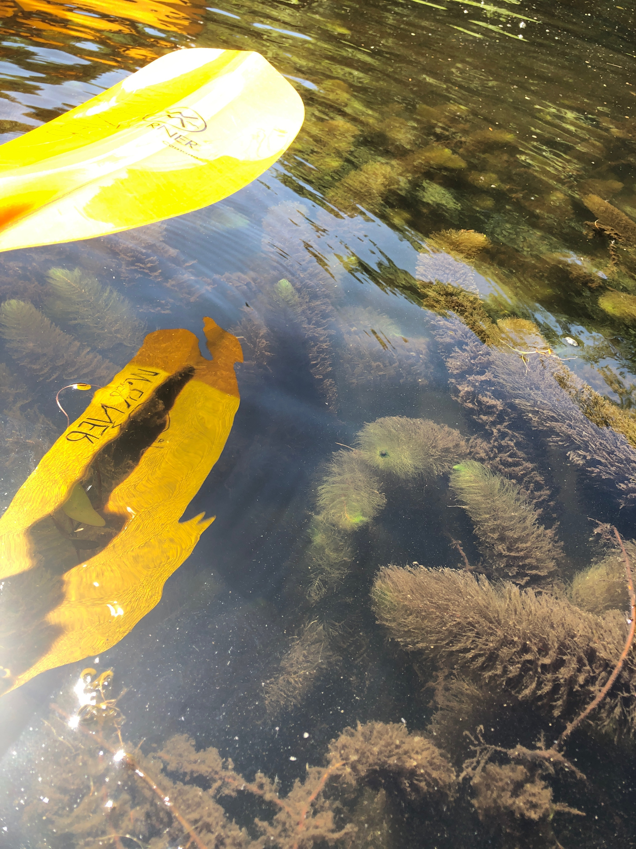

Estimated Polygons Drawn in iMap Invasives of Variable Watermilfoil;

Broadleaf Watermilfoil *Myriophyllum heterophyllum in purple.*

Curly-leaved Pondweed; *Potamogeton crispus* in green.

The shallow water bays with soft sediments are reaching a

high density of infestation and bordering on a monoculture.

*Approximately 3-4 acers in total surface area.*

iMap Presence Id of top right polygon for reference

Presence #1051005

Watermilfoil *Myriophyllum heterophyllum*

**Section 2: Survey Result Summary**

|  |  |  |  |  |  |  |  |  |
| --- | --- | --- | --- | --- | --- | --- | --- | --- |
| **Common Name** | **Scientific Name** | **Location (GPS)** | **Growth Type** | **Phenology** | **Abundance** | **iMap User** | **iMap Presence ID** | **PRISM** |
| Variable Watermilfoil; Broadleaf Watermilfoil | Myriophyllum heterophyllum | 43.06735 -74.4981 | Submerged/Rooted | Emergent Growth | Dense | Kristopher Williams | 1050912 | APIPP |
| Variable Watermilfoil; Broadleaf Watermilfoil | Myriophyllum heterophyllum | 43.06529 -74.4916 | Submerged/Rooted | Emergent Growth | Dense | Kristopher Williams | 1050917 | Capital |
| Variable Watermilfoil; Broadleaf Watermilfoil | Myriophyllum heterophyllum | 43.06762 -74.4963 | Submerged/Rooted | Emergent Growth | Dense | Nicole Campbell | 1050843 | Capital |
| Eurasian Water-milfoil; European Water-milfoil | Myriophyllum spicatum | 43.06518 -74.5064 | Submerged/Rooted | Emergent Growth | Sparse | Kristopher Williams | 1050922 | APIPP |
| Variable Watermilfoil; Broadleaf Watermilfoil | Myriophyllum heterophyllum | 43.06542 -74.4932 | Submerged/Rooted | Emergent Growth | Dense | Lauren Henderson | 1051012 | Capital |
| Variable Watermilfoil; Broadleaf Watermilfoil | Myriophyllum heterophyllum | 43.06565 -74.4933 | Submerged/Rooted | Emergent Growth | Dense | Lauren Henderson | 1051013 | Capital |
| Variable Watermilfoil; Broadleaf Watermilfoil | Myriophyllum heterophyllum | 43.06542 -74.4933 | Submerged/Rooted | Emergent Growth | Dense | Lauren Henderson | 1051011 | Capital |
| Eurasian Water-milfoil; European Water-milfoil | Myriophyllum spicatum | 43.06599 -74.5066 | Submerged/Rooted | Emergent Growth | Sparse | Kristopher Williams | 1050924 | APIPP |
| Eurasian Water-milfoil; European Water-milfoil | Myriophyllum spicatum | 43.06589 -74.5065 | Submerged/Rooted | Emergent Growth | Sparse | Kristopher Williams | 1050925 | APIPP |
| Eurasian Water-milfoil; European Water-milfoil | Myriophyllum spicatum | 43.06554 -74.5072 | Submerged/Rooted | Emergent Growth | Sparse | Kristopher Williams | 1050923 | APIPP |
| Variable Watermilfoil; Broadleaf Watermilfoil | Myriophyllum heterophyllum | 43.06724 -74.4981 | Submerged/Rooted | Emergent Growth | Dense | Lauren Henderson | 1051008 | APIPP |
| Variable Watermilfoil; Broadleaf Watermilfoil | Myriophyllum heterophyllum | 43.06735 -74.4981 | Submerged/Rooted | Emergent Growth | Dense | Kristopher Williams | 1050913 | APIPP |
| Variable Watermilfoil; Broadleaf Watermilfoil | Myriophyllum heterophyllum | 43.06783 -74.5024 | Submerged/Rooted | Emergent Growth | Dense | Kristopher Williams | 1050910 | APIPP |
| Variable Watermilfoil; Broadleaf Watermilfoil | Myriophyllum heterophyllum | 43.06573 -74.4934 | Submerged/Rooted | Emergent Growth | Dense | Kristopher Williams | 1050914 | Capital |
| Variable Watermilfoil; Broadleaf Watermilfoil | Myriophyllum heterophyllum | 43.06741 -74.4963 | Submerged/Rooted | Emergent Growth | Dense | Lauren Henderson | 1051009 | Capita |
| Eurasian Water-milfoil; European Water-milfoil | Myriophyllum spicatum | 43.0646 -74.5019 | Submerged/Rooted | Emergent Growth | Sparse | Nicole Campbell | 1050847 | Capita |
| Variable Watermilfoil; Broadleaf Watermilfoil | Myriophyllum heterophyllum | 43.06732 -74.4981 | Submerged/Rooted | Emergent Growth | Dense | Lauren Henderson | 1051007 | APIPP |
| Curly Pondweed; Curly-leaved Pondweed | Potamogeton crispus | 43.06547 -74.4934 | Submerged/Rooted | Emergent Growth | Sparse | Lauren Henderson | 1051010 | Capita |
| Curly Pondweed; Curly-leaved Pondweed | Potamogeton crispus | 43.06425 -74.4974 | Submerged/Rooted | Emergent Growth | Sparse | Kristopher Williams | 1050918 | Capital |
| Variable Watermilfoil; Broadleaf Watermilfoil | Myriophyllum heterophyllum | 43.06562 -74.4906 | Submerged/Rooted | Emergent Growth | Dense | Nicole Campbell | 1050844 | Capital |
| Variable Watermilfoil; Broadleaf Watermilfoil | Myriophyllum heterophyllum | 43.06562 -74.4906 | Submerged/Rooted | Emergent Growth | Dense | Nicole Campbell | 1050845 | Capital |
| Variable Watermilfoil; Broadleaf Watermilfoil | Myriophyllum heterophyllum | 43.06566 -74.4935 | Submerged/Rooted | Emergent Growth | Dense | Kristopher Williams | 1050915 | Capital |
| Variable Watermilfoil; Broadleaf Watermilfoil | Myriophyllum heterophyllum | 43.06549 -74.4906 | Submerged/Rooted | Emergent Growth | Dense | Kristopher Williams | 1050916 | Capital |
| Variable Watermilfoil; Broadleaf Watermilfoil | Myriophyllum heterophyllum | 43.06778 -74.5027 | Submerged/Rooted | Emergent Growth | Dense | Kristopher Williams | 1050911 | APIPP |
| Curly Pondweed; Curly-leaved Pondweed | Potamogeton crispus | 43.0643 -74.4975 | Submerged/Rooted | Emergent Growth | Dense | Kristopher Williams | 1050919 | Capita |
| Eurasian Water-milfoil; European Water-milfoil | Myriophyllum spicatum | 43.06468 -74.5009 | Submerged/Rooted | Emergent Growth | Sparse | Kristopher Williams | 1050921 | Capital |
| Curly Pondweed; Curly-leaved Pondweed | Potamogeton crispus | 43.06422 -74.4977 | Submerged/Rooted | Emergent Growth | Sparse | Kristopher Williams | 1050920 | Capital |

**Section 3: Summary of Recommendations**

This page provides recommendations of any treatment methods, monitoring methods, and restoration efforts based on the survey.

**Treatment:** *Describe briefly any recommendations for future treatment methods, why they are recommended, and any alternatives to consider. Please use abundance and site-specific factors in your treatment recommendation. Optional: Attach or reference BMP guidance document*

* Construct a focus group meeting with APPIP to discuss options.
* Is the water body worth managing?
* Water Level Manipulation
* Benthic Matts
* Chemical Treatment as the infestation is large

Basic Fact Sheet

<https://extension.umaine.edu/publications/wp-content/uploads/sites/52/2015/04/2530.pdf>

Example control plan

<https://bownh.gov/DocumentCenter/View/366/Long-Term-Management-Plan---Variable-Milfoil-in-Turee-Pond-PDF>

**Post- Survey Monitoring:** *Briefly explain the monitoring procedure, when it will occur, and who will complete it. Consider the phenology of species when suggesting time-lines. If a separate management or monitoring plan was developed or to be completed, attach or describe here*.  
  
Due to poor reception a whole lake polygon in Survey 123 /Collector App should be installed before reaching the site. The leading edge of the infestation could then be mapped out for more accurate calculation of infested acres.   
  
Will post-treatment management be handled by another person/entity? Not Applicable at this time.  
If yes- please provide the contact information:

Will an Invasive Species Management Plan be created? Not Applicable at this time.



*The New York State Department of Environmental Conservation provides financial support to The Capital Region PRISM via the Environmental Protection Fund*