Rockwood State Forest Hemlock Woolly Adelgid Follow-Up Survey 2019

Spencer Barrett

Introduction: In May of 2019, the Terrestrial Invasive Species Coordinator, Spencer Barrett, worked with two interns, from Siena College, to look for early detection invasive species throughout the Capital-Mohawk PRISM. The Siena interns, Anna Kuhne and Kelsey Stevens, focused on terrestrial invasive plant surveys at highly susceptible and valuable habitats throughout the PRISM region. The following is an abridged summary of some of the findings of the survey throughout Rockwood State Forest. The PRISM works throughout 11 counties around the capital region to detect, prevent, and control invasive species.

Project Description: Following up on the initial detection of HWA at Rockwood State Forest, the team went out to see if they could locate other infested trees on state land immediately surrounding the parking lot. Terrestrial invasive plant points were also taken on site.
Dates: 5/29/19
Participants: Spencer Barrett, Kelsey Stevens, Anna Kuhne, DEC Forest Health Survey Team
Point of Contact: Jason Denham (Jason.denham@dec.ny.gov)
County: Montgomery

Locations and Species Identified:
Rockwood State Forest (DEC): At Rockwood, the team first surveyed immediately around the parking lot area, where no additional HWA was found. The team then crossed the street, surveying around the cemetery, where an extremely large patch of Vinca minor was found infiltrating the forest understory. Upon returning to the parking lot, Spencer spoke to a pair of DEC Forest Health Interns who pointed the team further up the hill to the initial detection point of HWA. The rest of the time before lunch was spent surveying the immediate area around that tree, where one additional ovisac and infested tree was found within 50 yards of the initial detection point.
After lunch the team started back up by going to one of the few iMap Invasives reports for Russian Olive in the state, which happened to be less than two miles to the south on Murray Hill Road. When the location was further surveyed, only Autumn Olive was found, which led Spencer to believe that this point was a misidentification. These findings were later forwarded to Jennifer Dean at iMap. No autumn olive record was taken at this site due to the population being completely on private property.
After checking the olive record, the team did a trail survey consisting of terrestrial invasive plants, elongate hemlock scale, and hemlock woolly adelgid. From the main parking lot, the team walked on the main northbound trail, which eventually turned west and led to a primitive campsite. At the campsite, the team turned around and headed back, taking additional roadside records of Bishop’s Goutweed, Common Periwinkle, Moneywort, and Japanese Knotweed before going back to the office to finish the day.

Invasive Species Present at and around Rockwood State Forest:
Common Name | Scientific Name | Locations (GPS) | Growth Type | Phenology
Japanese Knotweed | Reynoutria japonica | 43.0556, -74.4916 | Herbaceous | Vegetative
Moneywort | Lysimachia nummularia | 43.0556, -74.4903 | Vine | Vegetative
Colt’s Foot | Tussilago farfara | 43.0549, -74.4886 | Herbaceous | Vegetative
Narrowleaf Bittercress | Cardamine impatiens | 43.0548, -74.4889 | Herbaceous | Flowering/Immature Fruit
Honeysuckle spp. | Lonicera spp. | 43.0555, -74.4904 | Shrub | Flowering
Garlic Mustard | Allaria petiolata | 43.0619, -74.4912 | Herbaceous | Flowering
Multiflora Rose | Rosa multiflora | 43.0619, -74.4976 | Shrub | Vegitative
Bishop’s Goutweed | Aegopodium podagraria | 43.0561, -74.4924 | Herbaceous | Vegetative
Common Periwinkle | Vinca minor | 43.0556, -74.4902 | Herbaceous | Flowering
Japanese Barberry | Berberis thunbergii | 43.0597, -74.4876 | Shrub | Vegetative
Wild Parsnip | Pastinaca sativa | 43.0552, -74.4898 | Herbaceous | Vegetative
Elongate Hemlock Scale | Fiorinia externa | 43.0623, -74.4895 | - | -
Hemlock Woolly Adelgid | Adelges tsugae | 43.0539, -74.4856 | - | In old wool?

Native Community Types: Hemlock-Northern Hardwood Forest, some wetland areas
Recommendations for the Future: Further surveying and prioritization of hemlock stands is needed at this site if any treatment for the HWA present is planned. Invasive plants present were surveyed to provide information about what species could further colonize the area in case of gradual hemlock decline.

Contact Spencer Barrett at spncrbrrtt@gmail.com for any questions regarding this report.

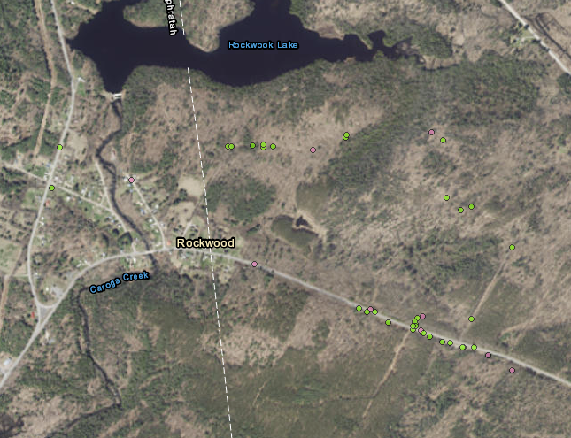

Figure 1: Map of area surveyed immediately around Rockwood State Forest. Terrestrial plant records were reviewed and confirmed and show in green and forest pest records are shown in pink as unconfirmed species. Route 20 bisects the two main parcels of state managed land. The yellow star designates the new point of Hemlock Woolly Adelgid found.

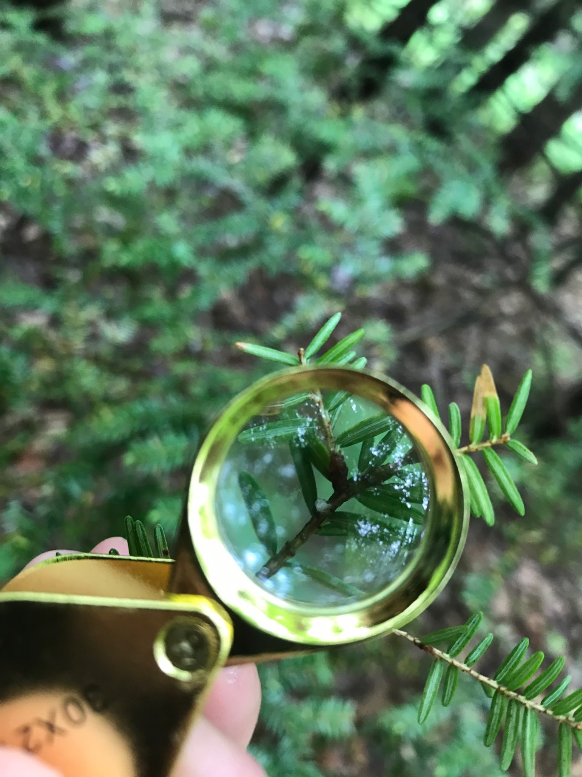
Figure 2: Possible Hemlock Woolly Adelgid ovisac found close to the infested tree. This was found on a medium tree around eight feet tall which is in physical contact with a similarly sized tree. Both trees are less than twenty feet from the edge of the right-of-way surrounding Rte. 20.

