Capital Region PRISM Cornell Cooperative Extension Saratoga County
Partnership for Regional 50 West High St. Invasive Species Management Ballston Spa, NY 12020
www.capitalregionprism.org (518) 885-8995

Page 1

Capital Region PRISM Survey Report: Rush Pond

Purpose:
The Invasive Species Survey Report will provide an overview and help guide invasive species treatments, baseline site composition, post-monitoring, and restoration at a specific site over time. A single survey report should not be written for an entire site, but a specific project. A site could have multiple reports. If there are multiple reports within a site, consult with the Capital Region PRISM about potentially preparing a more robust survey report.

To be submitted to Capital Region PRISM following the completion of partner, individual, or PRISM-led survey for review. This form can be found online as "Field Survey Report Template" at www.capitalregionprism.org/reports.html or with a request. Please consult the Capital Region PRISM if there are any questions at (518)-885-8995. Please capture and collect data using iMapInvasives: www.nyimapinvasives.org. The online software platform and associated mobile application is free and open sourced.

Section 1: Survey Summary
This section provides an overview of the site, contact information, etc. Once complete, save your report and submit the form via email to a member of the Capital Region PRISM team. Feel free to include supporting documents in your submission.

To determine site value, we recommend using the iMapInvasives Prioritization Model which can be found on the PRISM website at https://www.capitalregionprism.org/ny-invasive-species-prioritization-map.html The prioritization model will allow you to assess your sites ecologic value based on a few factors. Evaluate the comprehensive score or the ecological score to determine if your site is a high priority site that will will help us determine if the location and infestation falls into our priority objectives for future management. If it is not a high priority site, we still encourage you to complete invasive species surveying as the site maybe culturally and socially of value to the public.

Section 2: Survey Result Summary
The survey summaries section will contain the tables and maps generated from your survey efforts. The biologic surveys will assist the Capital Region PRISM in our efforts to identify emerging species to be able to more effectively manage infestations and the spread of populations. Please fill out the provided table and insert screen shots of iMapInvasives maps.

Section 3: Summary of Recommendations
The recommendation section contains treatment calendars and post-season summaries. Most sites need to be revisited annually to document successes/failures, identify any changes needed, and update future treatment calendars.

Section 1: Survey Summary
Date: 9/23/21
Site Name Address: Rush Pond/Recreation Area
County: Warren
Latitude and Longitude: 43.358782, -73.706757
Property Owner Contact: Queensbury Parks & Recreation
Lead Contact for Survey: Sam Schultz & Lauren Henderson
Phone and Email: 315-200-4952, ss986@cornell.edu; 518-885-8995 ext. 2215, ljh257@cornell.edu
Team Member(s): Hannah Coppola
Overall Site Size: 2.6 miles

Site Description: Rush Pond/Recreation Area, in Queensbury, NY contains 3 miles of trails one way. The preserve is considered an Oak-Pine Eastern Adirondack Forest with interspersed segments of hemlock trees. This trail is a highly used multipurpose trail for hikers, runners and skiers alike.

Rush Pond is a freshwater pond and class II wetland. The pond is approximately 46 acres and the wetland is 81.3 acres. The waterbody substrate is comprised of muck with a bottom cover of macrophytes, leaf pack, and woody debris.

Survey Techniques: Survey was completed for both terrestrial and aquatic invasive species. Terrestrial species were detected along the trail while a shoreline survey was complete for aquatic invasive species when access to the pond was possible.

Did you identify this site through the iMapInvasives Prioritization Model? Yes, an area nearby scores very high for both ecological and comprehensive value and the pond trail is rated medium-high.

Section 2: Survey Result Summary
Common Name | Scientific Name | GPS Location | Growth Type | Phenology | Distribution Abundance
Oriental Bittersweet | Celastrus orbiculatus | Multiple locations- iMap | Vine | Fruit ripening | Dense Patches
Burning Bush | Euonymus alatus | Multiple locations- iMap | Shrub | Vegetative | Single plant
Japanese Barberry | Berberis thunbergii | Multiple locations- iMap | Shrub | Fruit ripening | Single plant
Mugwort | Artemisia vulgaris | Multiple locations- iMap | Herbaceous | Vegetative | Single clump
Honeysuckle spp. | Lonicera spp. | Multiple locations- iMap | Shrub | Vegetative | Single plant
Multiflora Rose | Rosa multiflora | Multiple locations- iMap | Shrub | In seed | Single plant
Common Reed | Phragmites | Multiple locations | Wetland | In seed | Monoculture
Hemlock Wooly Adelgid | Adelges tsugae | N/A | N/A | N/A | Not present
Growth Type: (T)Tree, Shrub, Vine, Ground Cover, Herbaceous, Riparian, Pest, Animal (A)Submerged, Floating, Emergent, Pest, Animal
Phenology: Flowering, Leaf unfolding, fruit ripening, leaf color change, dormant, swarming, spawning, emergence (insects), migrating, in seed
Distribution/Abundance: Sparse, Dense Patches, Dominant, Single Clump, Single Plant

Map: Develop a map of the survey area that has any iMapInvasives points and/or searched, polygons to delineate infestation extent. Multiple maps may be added for multiple species or locations. Different mapping formats are welcome but iMap Invasive delineations are preferred,

- Insert Survey Map(s):

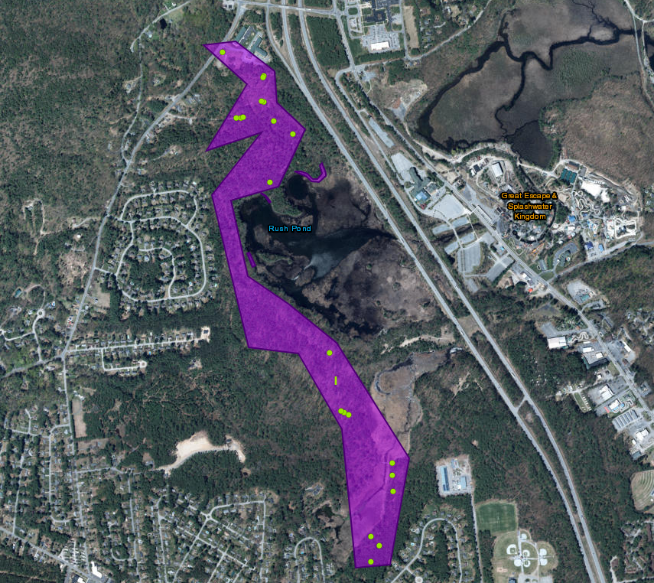

Section 3: Summary of Recommendations
This page provides recommendations of any treatment methods, monitoring methods, and restoration efforts based on the survey.

Treatment: Describe briefly any recommendations for future treatment methods, why they are recommended, and any alternatives to consider. Please use abundance and site-specific factors in your treatment recommendation. Optional: Attach or reference BMP guidance document. Consider state and local permitting requirements.

No treatment is planned to manage the invasive species at this location since these are tier 3 and 4 species that are widespread across the PRISM.

Post- Survey Monitoring: Briefly explain the monitoring procedure, when it will occur, and who will complete it. Consider the phenology of species when suggesting time-lines. If a control such as eradication, suppression, and exclusion is selected will a management plan be drafted? If a plan is needed please contact the CR-PRISM Office for a template of post treatment Invasive Species Management Plan.

There is no post-survey monitoring planned for this site.

