Saratoga PLAN Preserves Scouting Findings 2018:

Capital / Mohawk PRISM

"Detect, prevent, and control invasive species, through direct action and education to protect biodiversity, the natural environment, economy, and quality of life."
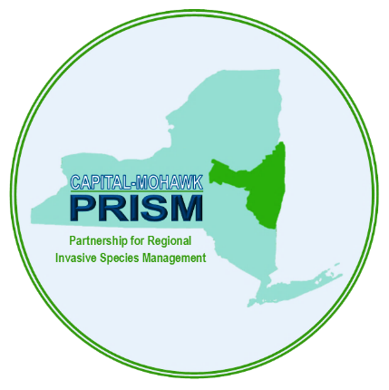

Capital Mohawk PRISM Partnership for Regional
Invasive Species Management
Cornell Cooperative Extension Saratoga
50 West High St.
Ballston Spa, NY 12020

518.885.8995

The New York State Department of Environmental Conservation provides financial support to The Capital Mohawk PRISM via the Environmental Protection Fund
Saratoga PLAN Preserves Summer Scouting Findings 2018:
Prepared by Spencer Barrett and Gwendolyn Temple

This summer, the Terrestrial Invasive Species Coordinator worked with two interns, one from SUNY Environmental Science and Forestry and one from Cornell, to look for Early Detection invasive species throughout the Capital-Mohawk PRISM. The ESF Intern, Elizabeth-Anne Jamison, focused on terrestrial plant species while the Cornell Intern, Lilly-Anne Trainor, worked with the New York State Hemlock Initiative to determine the spread of Hemlock Woolly Adelgid throughout the Capital Region. The team in total visited 50 sites throughout the CapMo PRISM including five Saratoga PLAN preserves. The following is an abridged summary of some of the findings of the summer throughout Saratoga County as well as recommendations of future invasive species related endeavors for the various affected stakeholders. The PRISM works throughout 11 counties around the Capital Region to detect, prevent, and control invasive species.

Locations (With Property Owners) and Species:
Note: The absence of any species from a preserve does not guarantee the absence of the species at the site. This is intended as an informal guiding document to inform future management.
- Anchor Diamond Park (Town of Ballston): Anchor Diamond Park was one of the first locations visited by the summer field team. On May 25th, the team spent half of the day in the office in Ballston Spa and then went to Anchor Diamond Park in the afternoon to practice making invasive species entries via the OAT software as well as practicing hemlock identification and surveying techniques. The team found a number of invasive plants on their way to the hemlock trail which they went over identification characteristics for, but the real surprise of the day was finding Hemlock Woolly Adelgid infesting three understory trees near the fireplace. Eventually, the contact person with the town of Ballston was tracked down and all proper parties became informed of the infestation. It was unknown at the time of surveying that this property was associated with Saratoga PLAN as the kiosk had not been constructed.
  - Invasive Species Present: Hemlock Woolly Adelgid, Norway Maple, Multiflora Rose, Black Locust, Privet, Japanese Barberry, Garlic Mustard, Bush Honeysuckle, Common Buckthorn, February Daphne, Burning Bush.

- Ora Phelps Preserve (Saratoga PLAN): The team spent a lot of the earlier months of the season in the southern counties of the PRISM for phenological reasons, as well as a lack of current data collected in those counties. At the start of August, a renewed focus was placed on Saratoga County, and the team spent a half day on 8/10/18 at the Ora Phelps Preserve doing a full trail survey. While many of the invasives present were present in small numbers, two things stuck out; White Poplar (Populus alba) in a small clearing to the south-eastern corner of the preserve and a large curtain of Porcelainberry (Ampelopsis brevipedunculata) next to the road. These species are in low numbers in Saratoga County, and the Porcelainberry was the first report in the county at-large. For this reason, it has jumped the list to be one of the PRISM’s species of highest concern in the county.
  - Invasive Species Present: White Poplar, Porcelainberry, Garlic Mustard, Wild Parsnip, Bush Honeysuckle, Common Periwinkle, Autumn Olive, Japanese Barberry, Multiflora Rose

- Galway Nature Preserve (Saratoga PLAN): Lily and EJ took a day late in the season to work specifically on Saratoga PLAN preserves in the vicinity of the office. In that day they covered three preserves: Galway, Coldbrook, and LeVine. Galway appears to be the site of a prior iMap Invasives training as there are many records present on the online map. The only new species that was added from this year was Common Periwinkle, a widespread, evergreen groundcover with no real easy management options available.
  - Invasive Species Present: Black Locust, Bush Honeysuckle, Common Periwinkle, Multiflora Rose, Autumn Olive, Oriental Bittersweet, Common Buckthorn, Purple Loosestrife, Phragmites, Norway Maple

- Coldbrook Preserve (Saratoga PLAN): The second PLAN preserve from that day was the Coldbrook Preserve. The town of Northumberland overall has been less surveyed in Saratoga County, so this should be considered a higher priority town in the region to map out invasive species. That being said, the team did not find much interesting in terms of species, as only two species were recorded, some of the most common in this type of ecosystem.
  - Invasive Species Present: Bush Honeysuckle, Multiflora Rose

- LeVine Nature Preserve (Saratoga PLAN): LeVine parallels Coldbrook Preserve in terms of being in a town in the county where not much surveying has occurred and not having much in terms of species that were found. The only note from LeVine was the presence of Spotted Knapweed, another low priority species due to its widespread nature.
  - Invasive Species Present: Spotted Knapweed

Other Activities:
  - In addition to the normal scouting schedule that was designed at the start of the summer, the PRISM team was on hand for a Water Chestnut Pull event in partnership with Saratoga PLAN and the Kayak Shak that had 36 attendees. Many of the pictures from this report come from that event, where European Frogbit populations in Fish Creek were noted. This species is of high priority to the aquatics program as it is a Tier 2 species still at the point where we can eradicate it from the region. Another Water Chestnut Pull was scheduled and had to be cancelled due to weather.

Recommendations for the Future:
Saratoga PLAN: Saratoga PLAN has a rich history in Saratoga County of working as a balancing force to the ever increasing development which threatens such important habitat pathways such as the Palmertown Range. Thankfully, Saratoga County, while indeed invaded, is in a completely different stage of invasion than further south in Columbia, Greene, Ulster, etc. Saratoga PLAN has been able to focus on bringing new preserves into existence, knowing that relatively stable and resilient habitat will be made in the process. However, as we all know, many invasive species are marching north due to changing climatic conditions, further fragmentation of primarily undeveloped land, and traveling via human-assisted means. This means that protecting that habitat resilience will become more and more important as new threats spread through the areas surrounding these protected lands.
While I personally have not been to Coldbrook or LeVine preserves, these locations have been reported to be relatively clear of invasive species. The species reported at LeVine does not have excellent manual removal methods available, unlike Coldbrook, where both reported species can be removed by hand. If Saratoga PLAN is interested, I would be open to leading an invasive species removal workday at the Coldbrook Preserve where we could go over best management practices regarding these two species as well as phenology and disposal. Likewise, I would like to further survey these preserves more thoroughly in order to access if there are other species present, though this could be tied into a workday. PLAN and the PRISM have enjoyed a productive partnership on the aquatic side of things and I see no reason why this should not continue on the terrestrial end in terms of HWA monitoring and invasive plant removal opportunities. It is recommended that water chestnut pulls continue to keep the pressure on the population at Fish Creek and hopefully start to combat the European Frogbit population in the same area.

Capital/Mohawk PRISM: The PRISM is hosted out of a county office building in Saratoga County, which logistically makes this the easiest county to work out of. Fortunately, Saratoga County is also in a relatively uninvaded scenario where many common invasive species are present, but many of the threatening emerging species have yet to make an appearance. Individual populations of plants, however, have been discovered during the Saratoga County surveying work this summer. Porcelainberry, Japanese Angelica Tree, and Shrubby Bushclover have one appearance in Saratoga County and should be removed as soon as possible to prevent these species from proliferating. Some species, such as Porcelainberry, represent a challenge that may have to be contracted out to a certified pesticide applicator if PLAN would be willing to sign off on a treatment. Others, such as Japanese Angelica Tree, are present in small populations that could be dealt with easily were the PRISM to obtain a pesticide business license and work with the town of Ballston Spa to deal with this minor population. Then there are those that have a variety of solutions available such as the bushclover, which is a formidable manual removal due to its high density. Manual methods could be used to shrink the patch of this plant in Daketown while future treatment options are considered.

Species of focus for Saratoga County for all stakeholders at this point in the surveying and prioritization process include Porcelainberry (found at Ora Phelps Preserve), Japanese Stiltgrass (two new locations in Saratoga County this year), Hemlock Woolly Adelgid (new to county this year), Japanese Angelica Tree (new to PRISM and County) and Tree of Heaven. The PRISM is actively seeking records of all these species, if you have seen them in Schenectady, contact Spencer Barrett at sb685@cornell.edu or submit a report via iMap Invasives or on the reporting form at capitalmohawkprism.org.

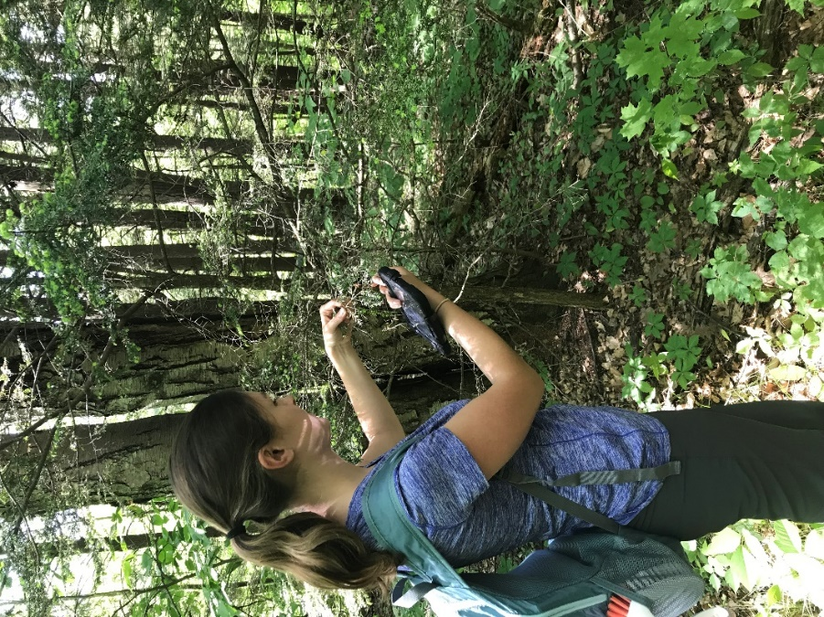
Figure 1: New York State Hemlock Initiative Intern Lily Trainor with the tree that HWA was discovered on in Anchor Diamond Park in May. Future surveying revealed three more infested trees in the immediate area as well as one approximately 200 feet away.

Figure 2: Event participants at the Water Chestnut Pull on Saratoga Lake with PRISM Coordinator Kris Williams and Saratoga PLAN Stewardship Coordinator Greg Redling.

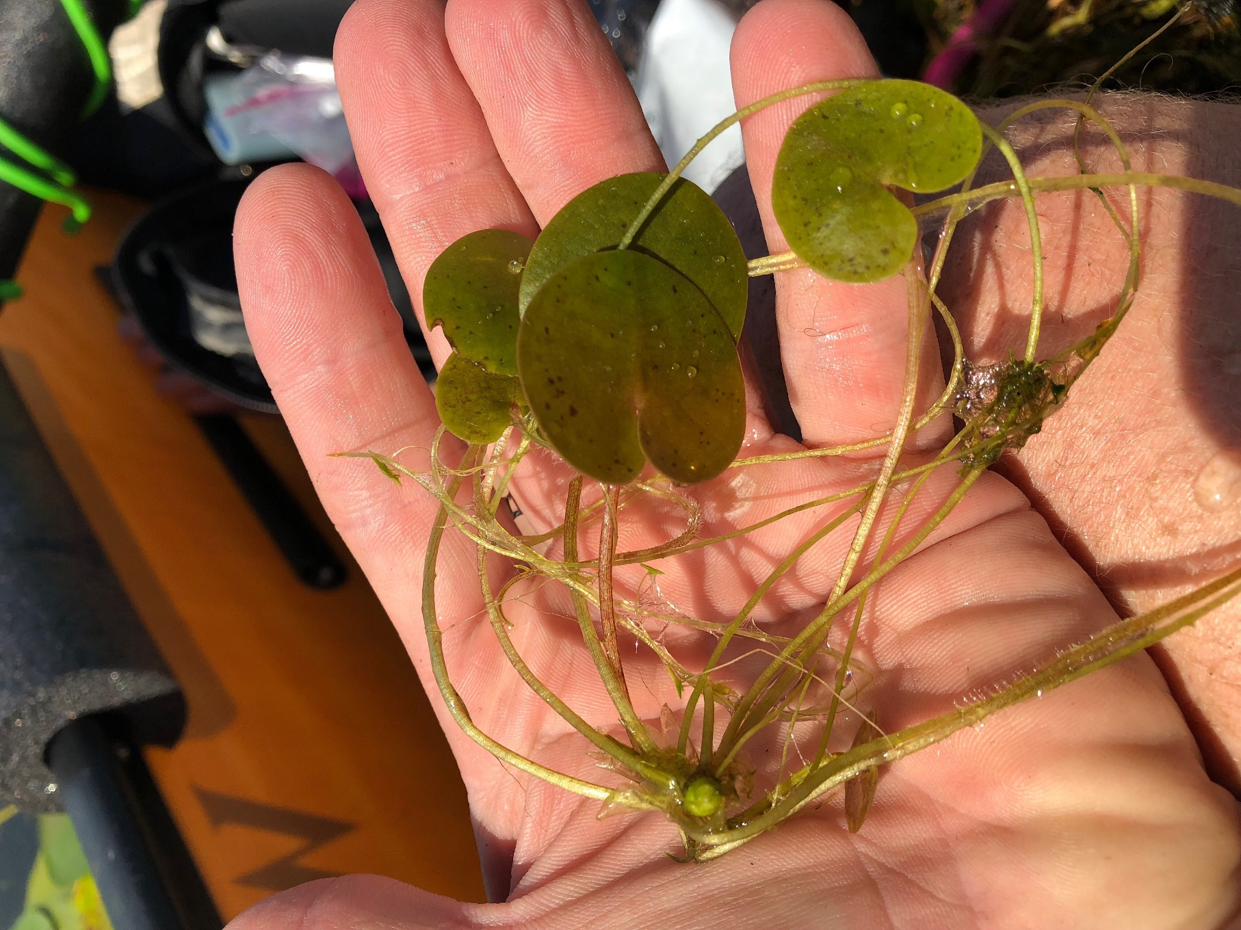
Figure 3: European Frogbit found during the Water Chestnut Pull on Saratoga Lake. This is currently a Tier 2 or emerging species on the PRISMs invasivity tier list.
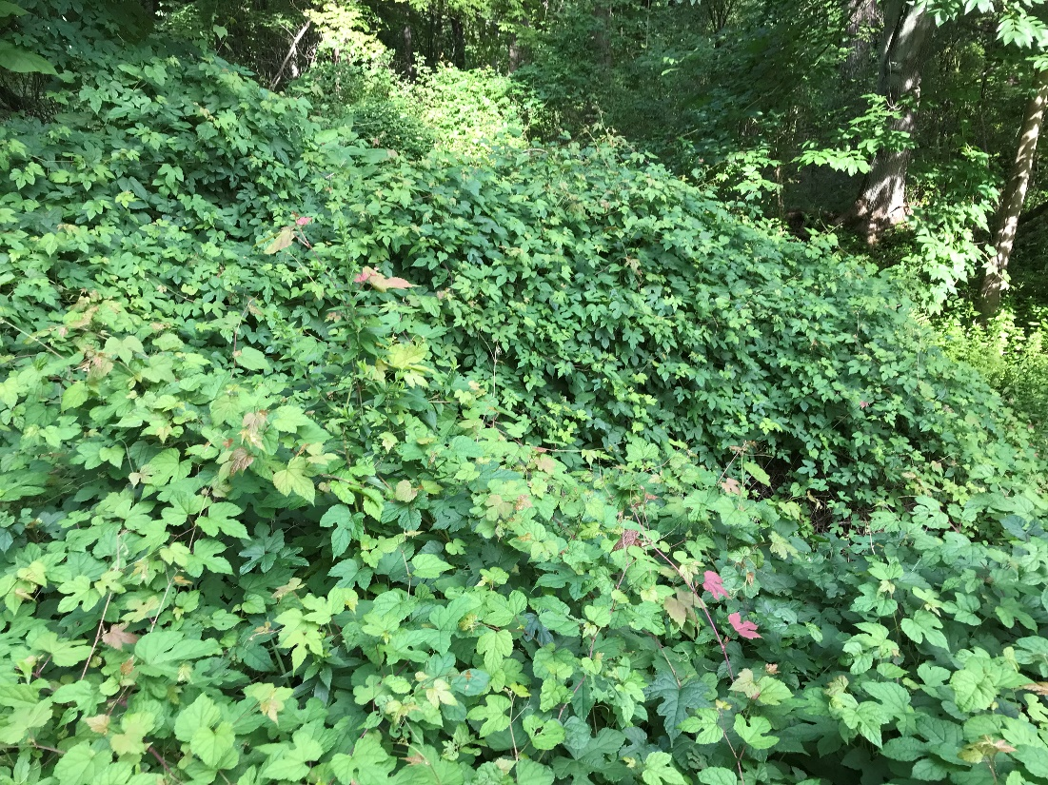
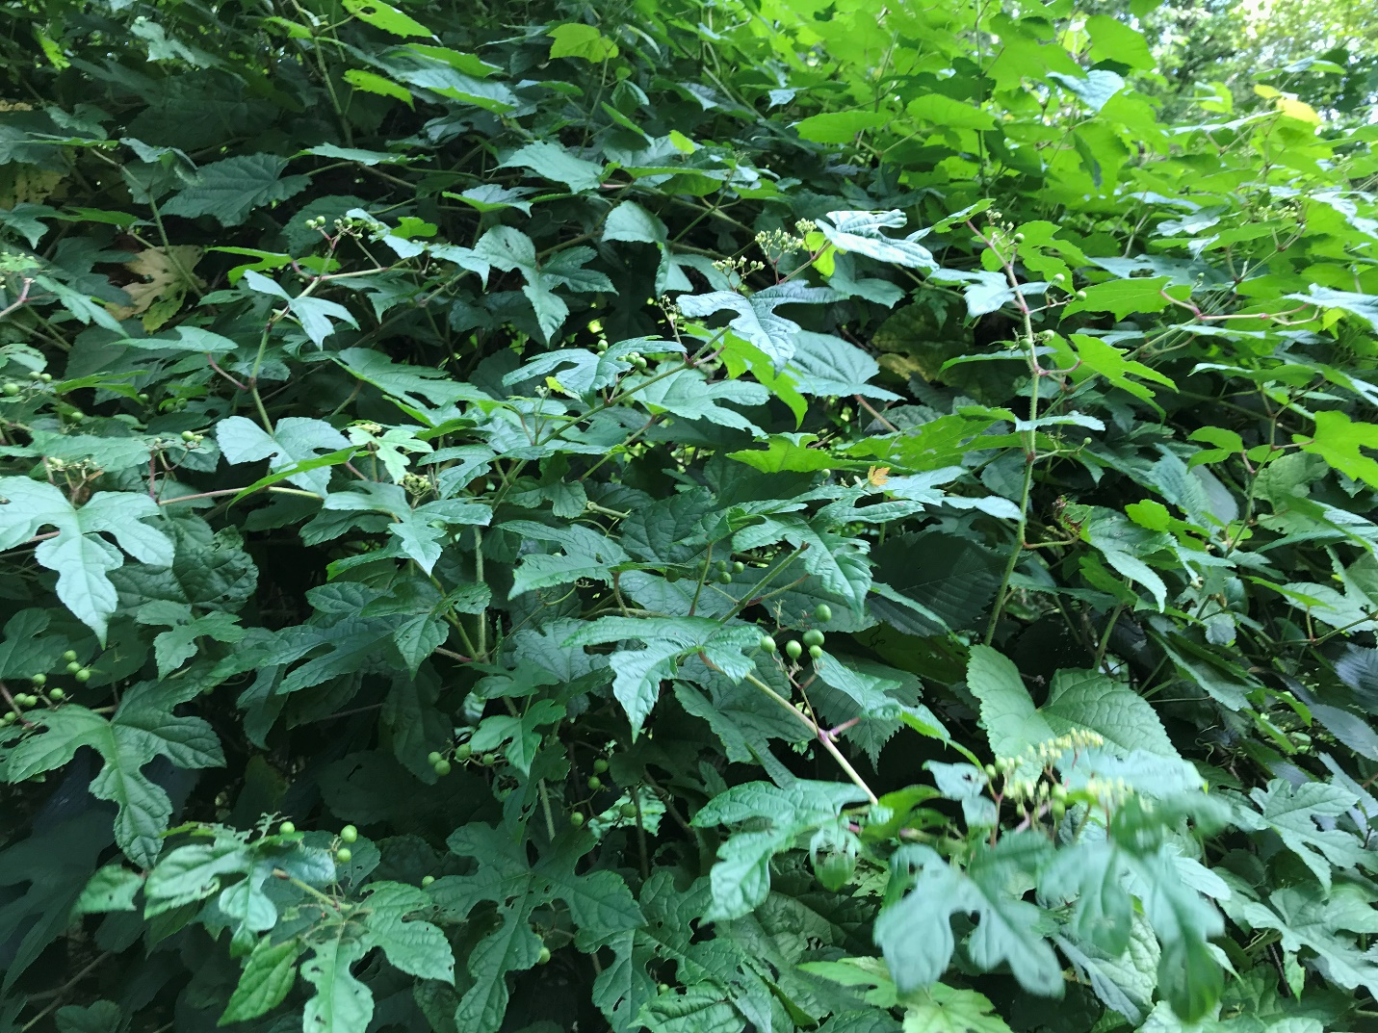
Figures 4 and 5: The Porcelainberry infestation at the Ora Phelps Preserve. Identifying characteristics of this plant include an upturned fruit cluster which can be seen in the bottom picture as well as a (sometimes) sharply segmented leaf shape.

