SARATOGA SANDPLAINS SPECIES SURVEY 2019:

Anna Kuhne, Lauren Mercier, and Kelsey Stevens

Introduction: : In July of 2019, the Terrestrial Invasive Species interns, from Siena College, and the education and outreach coordinator went to look for early detection invasive species throughout the Capital-Mohawk PRISM. The Siena interns, Anna Kuhne and Kelsey Stevens, focused on terrestrial invasive plant surveys at highly susceptible and valuable habitats throughout the PRISM region. The following is an abridged summary of some of the findings of the survey throughout the Saratoga Sandplains of the Wilton Wild Preserve. The PRISM works throughout 11 counties around the capital region to detect, prevent, and control invasive species.

Project Description: Surveying terrestrial invasive plants in the park
Dates: June 28th^{th}, 2019
Participants: Capital Mohawk Prism, Cornell Cooperative Extension, and NYS DEC
Point of Contact: Info.R5@dec.ny.gov
County: Saratoga County
Locations and Species Identified:
Hudson Crossings (NYS DEC Region 5 Brook Office): Scouting was done on the trails throughout the Saratoga Sandplains / Wilton Wildlife Preserve.

Invasive Species Present at (SARATOGA SANDPLAINS)
Common Name | Scientific Name | Locations (GPS) | Growth Type | Phenology
Garlic Mustard | Alliaria petiolata | 43.15483 -73.69801 | Herbaceous | Gone to Seed
Japanese Knotweed | Reynoutria japonica | 43.15378 -73.69932 | Herbaceous | Vegetative
Spotted Knapweed | Centaurea stoebe | 43.15692 -73.69523 | Herbaceous | Vegetative
Oriental Bittersweet | Celastrus orbiculatus | 43.15426 -73.70199 | Vine | Vegetative
Black Locust | Robinia pseudoacacia | 43.1578 -73.69535 | Tree | Vegetative
Honeysuckle | Lonicera spp | 43.15462 -73.69831 | Shrub | In Seed
Common Reed | Phragmites australis | 43.154 -73.70012 | Herbaceous | Vegetative
Water Chestnut | Trapa natans | 43.15373 -73.69926 | Aquatic | Vegetative
Great Mullein | Verbascum thaspus | 43.1548 -73.69806 | Herbaceous | Vegetative
Crown Vetch | Coronilla varia | 43.15378 -73.69591 | Herbaceous | Flowering
Japanese Hops | Humulus japonicus | 43.15466 -73.6983 | Herbaceous | Vegetative
Birdfoot Deervetch | Lotus corniculatus | 43.15353 -73.6959 | Herbaceous | Flowering

Dominant Native Plants: Sugar maple, blueberries, hemlocks, princess pines, ground cedars, lupine, and ferns
Native Community Types: Forest and sandy plains
Treatment Method: N/A

Summary of Work Completed:
  - Scouting and surveying for invasive terrestrial plants
Recommendations for the Future:

Contact Anna Kuhne at av13kuhn@siena.edu, Lauren Mercier at lnm47@cornell.edu, or Kelsey Stevens at kao04stev@siena.edu for any questions regarding this report.
Figure 1. Map of points taken during scouting and surveying of invasive terrestrial plants at the Saratoga Sandplains of the Wilton Wildlife Preserve in Saratoga County.
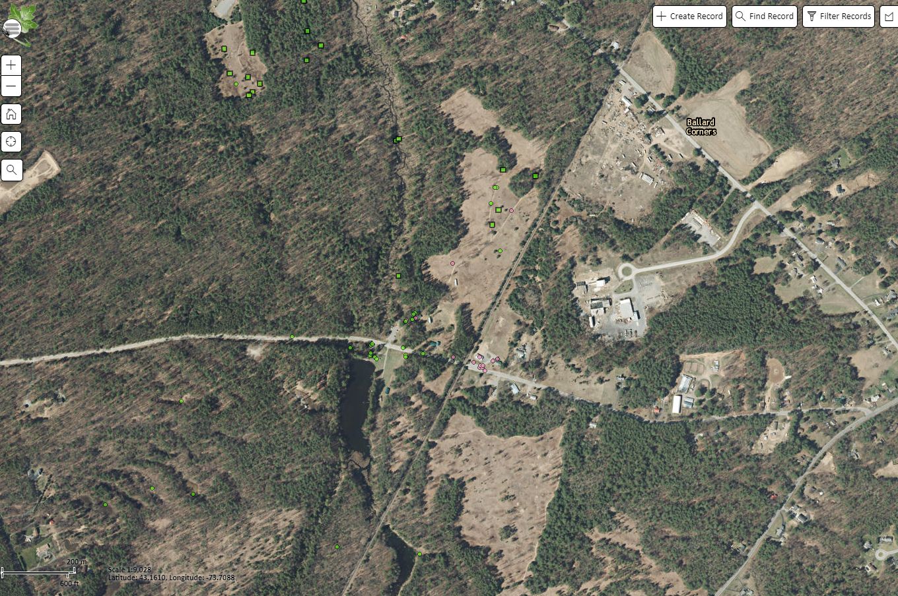

Figure 2. Oriental Bittersweet at the Saratoga Sandplains of the Wilton Wildlife Preserve
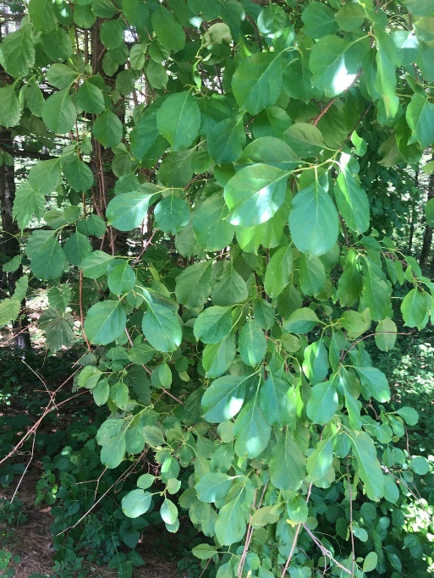

Figure 3. Great Mullein / Common Mullein at the Saratoga Sandplains of Wilton Wildlife Preserve
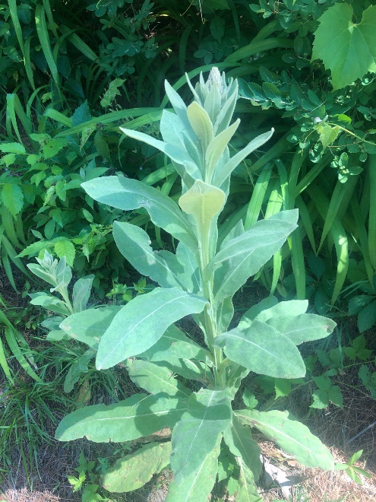

The New York State Department of Environmental Conservation provides financial support
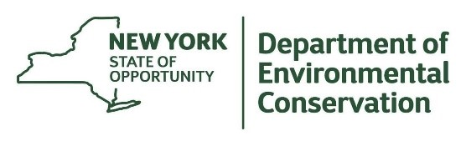
to The Capital Mohawk PRISM via the Environmental Protection Fund

