Saratoga State Forests Scouting Findings 2018:

Capital / Mohawk PRISM

"Detect, prevent, and control invasive species, through direct action and education to protect biodiversity, the natural environment, economy, and quality of life."
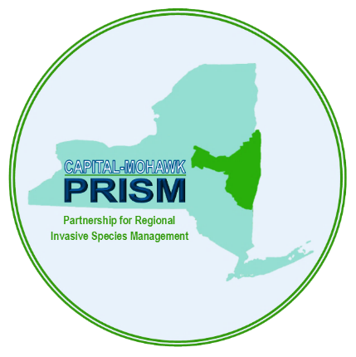

Capital Mohawk PRISM Partnership for Regional
Invasive Species Management
Cornell Cooperative Extension Saratoga
50 West High St.
Ballston Spa, NY 12020

518.885.8995

The New York State Department of Environmental Conservation provides financial support to The Capital Mohawk PRISM via the Environmental Protection Fund
Saratoga State Forest Summer Scouting Findings 2018:
Prepared by Spencer Barrett

This summer, the Terrestrial Invasive Species Coordinator worked with two interns, one from SUNY Environmental Science and Forestry and one from Cornell, to look for Early Detection invasive species throughout the Capital-Mohawk PRISM. The ESF Intern, Elizabeth-Anne Jamison, focused on terrestrial plant species while the Cornell Intern, Lilly-Anne Trainor, worked with the New York State Hemlock Initiative to determine the spread of Hemlock Woolly Adelgid throughout the Capital Region. The team in total visited 50 sites throughout the CapMo PRISM including four Saratoga County State Forests. The following is an abridged summary of some of the findings of the summer throughout Saratoga County as well as recommendations of future invasive species related endeavors for the various affected stakeholders. The PRISM works throughout 11 counties around the Capital Region to detect, prevent, and control invasive species.

Locations (With Property Owners) and Species:
Note: The absence of any species from a preserve does not guarantee the absence of the species at the site. This is intended as an informal guiding document to inform future management.
- Daniel’s Road State Forest (DEC): Daniel’s Road State Forest was the first Saratoga County State Forest to get surveyed during the week when EJ was on vacation. The high number of hemlocks there lent itself to HWA surveys, and there were a few terrestrial plants that were noted for the record that are of regional importance. Japanese Stiltgrass, which before this season was not known to occur anywhere in Saratoga County, was found in the parking lot and up and down the access road to the site, where other various invasives are present as well. The stiltgrass also spreads off onto adjacent properties, further complicating treatment options for this population. The easement property next to the state land has a different variety of invasive species but is still relatively uninvaded compared to other places within the county.
  - Invasive Species Present: Japanese Stiltgrass, Japanese Knotweed, Phragmites, Purple Loosestrife.
  - Invasive Species Present in nearby easement: Bishop’s Goutweed, Burning Bush, Japanese Barberry.

- Usher’s Road State Forest (DEC): Usher’s Road State Forest was another day of scouting that was targeted at Hemlock Woolly Adelgid but involved taking a few records of terrestrial plant species (though this forest is also relatively intact and uninvaded). The whole loop trail running through the center of the forest was surveyed and no HWA was found, though follow-up surveying at this site should be attempted due to the relative proximity of the HWA infestation found at Anchor Diamond Park in the town of Ballston. Additional invasive species reports are present on the Zim Smith Trail, which has a path which connects to Usher’s Road State Forest, so species that are present on the nearby trail should be monitored to ensure they do not move into the DEC land. The most notable plant of interest found was Tree of Heaven, which does not have many populations in Saratoga County. This plant is directly adjacent to the parking area and, while not quite six inches in DBH at this point, could represent a future site to monitor for Spotted Lanternfly in the future unless the tree is removed.
  - Invasive Species Present: Tree of Heaven, Glossy Buckthorn, Multiflora Rose, Bush Honeysuckle.

- Lincoln Mountain State Forest (DEC): Lincoln Mountain State Forest scouting was started with Rich McDermott present, who giving the terrestrial team an overview of the forest and talked with us about projects to potentially partner on in the near future. We discussed the Japanese Stiltgrass that was found at Daniels Road State Forest and agreed on a manual removal date range for starting to chip away at the issue there. After viewing the patch of Japanese Knotweed which had infiltrated a suspicious distance into the forest, the team travelled along the foot trails within the woodland as well as surveying along Lincoln Mountain Road, where a majority of their records were taken. Most of these species are not as aggressive as the Knotweed, and/or are more widespread throughout the county, so at this site the Knotweed at this time is the highest priority species present in the state forest.
  - Invasive Species Present: Japanese Knotweed, Mugwort, St. John’s Wort, Coltsfoot, Spotted Knapweed, Wild Parsnip, Common Tansy, Tufted Vetch, Moneywort, Canada Thistle, Purple Loosestrife, Phragmites, Bird’s Foot Trefoil, Multiflora Rose.

- Daketown State Forest (DEC): The last state forest surveyed in the county turned out to be one of the most significant locations of the field season. The habitat at this property is under a lot of pressure from invasive species, including a species that is new to PRISM and has no prior reports in New York State. Shrubby Bushclover (Lespedeza bicolor) has shown invasive potential in the south and has been planted in the past as quail forage, which may explain its presence in Daketown. This species has been reported to rapidly invade open areas in warmer regions, which should be of concern in New York and Pennsylvania as the climate warms.
  - Invasive Species Present: Shrubby Bushclover, Bush Honeysuckle, Multiflora Rose, Autumn Olive, St. John’s Wort, Canada Thistle, Bull Thistle, Common Periwinkle, Japanese-Spurge, Wintercreeper, Common Buckthorn, Coltsfoot, Bishop’s Goutweed, Garlic Mustard, Oriental Bittersweet, Spotted Knapweed.

Other Activities:
  - In addition to the normal scouting schedule that was designed at the start of the summer, the PRISM team participated in a Japanese Stiltgrass and Purple Loosestrife removal project with Rich McDermott, State Forester, at Daniels Road State Forest in the wetland directly adjacent to the parking lot. The positive side is that by beginning management this year, hopefully the chance of complete eradication at this location goes up in the future. The negative side is that the removal took place about two weeks too early. Management recommendations suggested that the time to attempt removal of this species was August-September and since this species is rarely spotted so far north, time was still available for the grass to flower and set seed. It is recommended that future efforts focusing on Stiltgrass in Saratoga County take place in late August instead of early August.
  - Further investigation of Shrubby Bushclover in the region’s state forests is needed. Is there a running list of species that were once planted for wildlife forage and restoration and where those plants were used? Are there other known occurrences of this plant in Saratoga County State Forests? Can management of this species be started now or should more information be gathered before attempting treatment? There are more questions than answers at this point in the process. It does seem that this species is fire resistant, which presents complications for the Moreau and Albany area where the open habitat of the Karner Blue might be threatened by this species.

Recommendations for the Future:
Saratoga State Forests: Thankfully, Saratoga County, while indeed invaded, is in a completely different stage of invasion than further south in Columbia, Greene, Ulster, etc. The majority of State Forests that were surveyed were in fairly good ecological health from an invasive species standpoint, and based off of that fact, a few populations that would make good removal targets stick out. The Japanese Knotweed, which Rich first brought to our attention, would be a great target to practice stem injection on in order to further understand the effectiveness of the technique. The population is relatively secure and undisturbed and would make an interesting pilot project assuming that the proper permits are secured and filled. There are a number of other populations that would also make good management targets inside of Saratoga County State Forests including the Shrubby Bushclover, Tree of Heaven and Glossy Buckthorn.

Capital/Mohawk PRISM: The PRISM is hosted out of a county office building in Saratoga County, which logistically makes this the easiest county to work out of. Fortunately, Saratoga County is also in a relatively uninvaded scenario where many common invasive species are present, but many of the threatening emerging species have yet to make an appearance. Individual populations of plants, however, have been discovered during the Saratoga County surveying work this summer. Porcelainberry, Japanese Angelica Tree, and Shrubby Bushclover have one appearance in Saratoga County and should be removed as soon as possible to prevent these species from proliferating. Some species, such as Porcelainberry, represent a challenge that may have to be contracted out to a certified pesticide applicator unless additional capabilities are obtained by the PRISM. Others, such as Japanese Angelica Tree, are present in small populations that could be dealt with easily were the PRISM to obtain a pesticide business license and work with the town of Ballston Spa to deal with this minor population. Then there are those that have a variety of solutions available such as the bushclover, which is a formidable manual removal due to its high density. Manual methods could be used to shrink the patch of this plant in Daketown while future treatment options are considered.
In addition, if Moreau Lake State Park is confirmed as an Invasive Species Prevention Zone (ISPZ), Lincoln Mountain State Forest represents a relatively secure, uninvaded parcel that could be added onto that zone in coming years.

Species of focus for Saratoga County for all stakeholders at this point in the surveying and prioritization process include Porcelainberry (found at Ora Phelps Preserve), Japanese Stiltgrass (two new locations in Saratoga County this year), Hemlock Woolly Adelgid (new to county this year), Japanese Angelica Tree (new to PRISM and County) and Tree of Heaven. The PRISM is actively seeking records of all these species, if you have seen them in Schenectady, contact Spencer Barrett at sb685@cornell.edu or submit a report via iMap Invasives or on the reporting form at capitalmohawkprism.org.

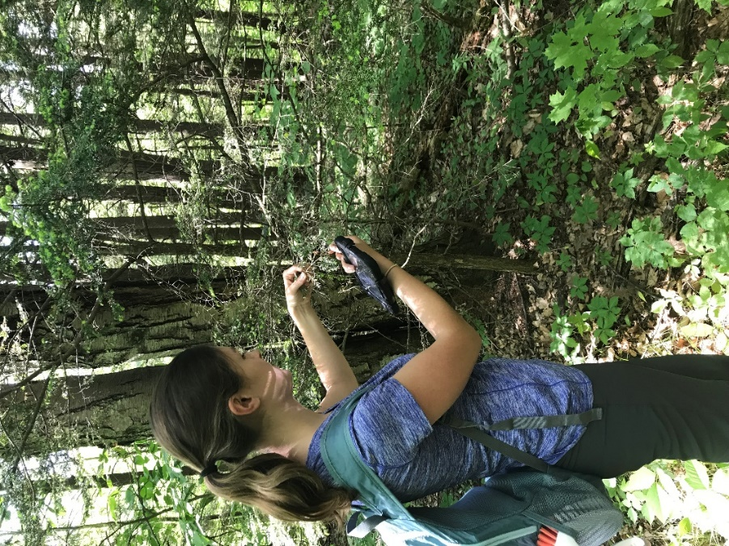
Figure 1: New York State Hemlock Initiative Intern Lily Trainor with the tree that HWA was discovered on in Anchor Diamond Park in May. Future surveying over Saratoga County will be of extreme regional importance for continued forest health of this county and the Adirondacks.
Figure 2: The reported occurrences of Shrubby Bushclover nationwide according to EDDMaps. Notably, Saratoga County is not shaded. The same is true for the EDDmaps distribution of Japanese Stiltgrass, which was newly reported in Saratoga County.

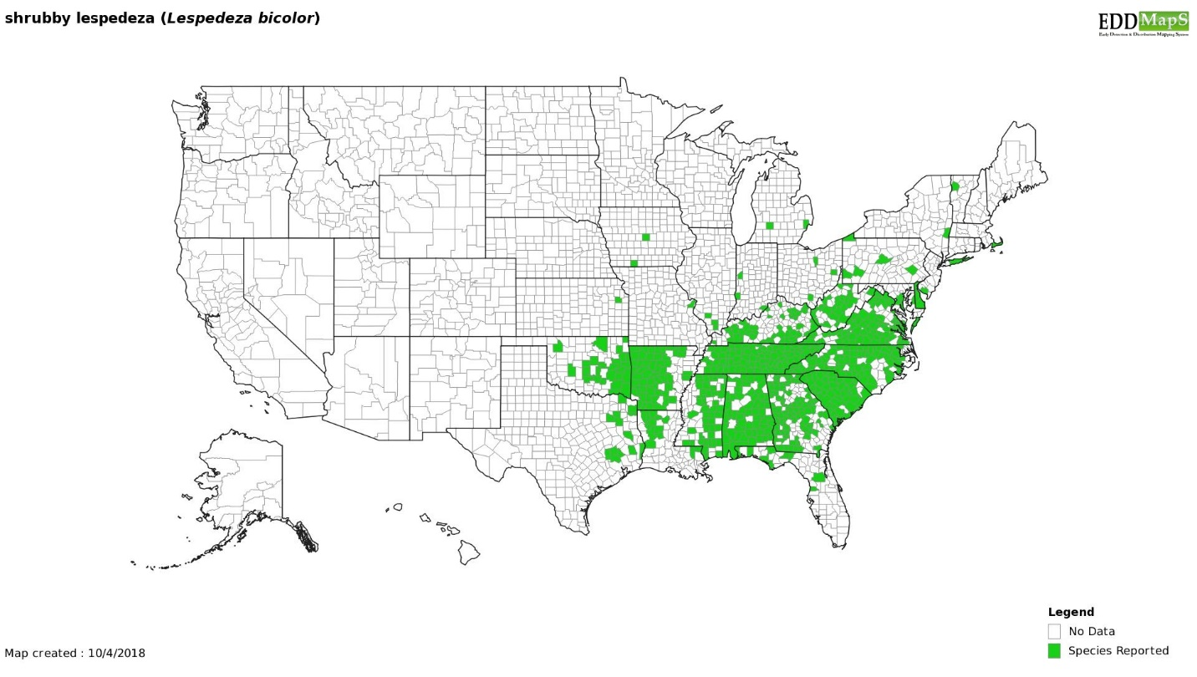
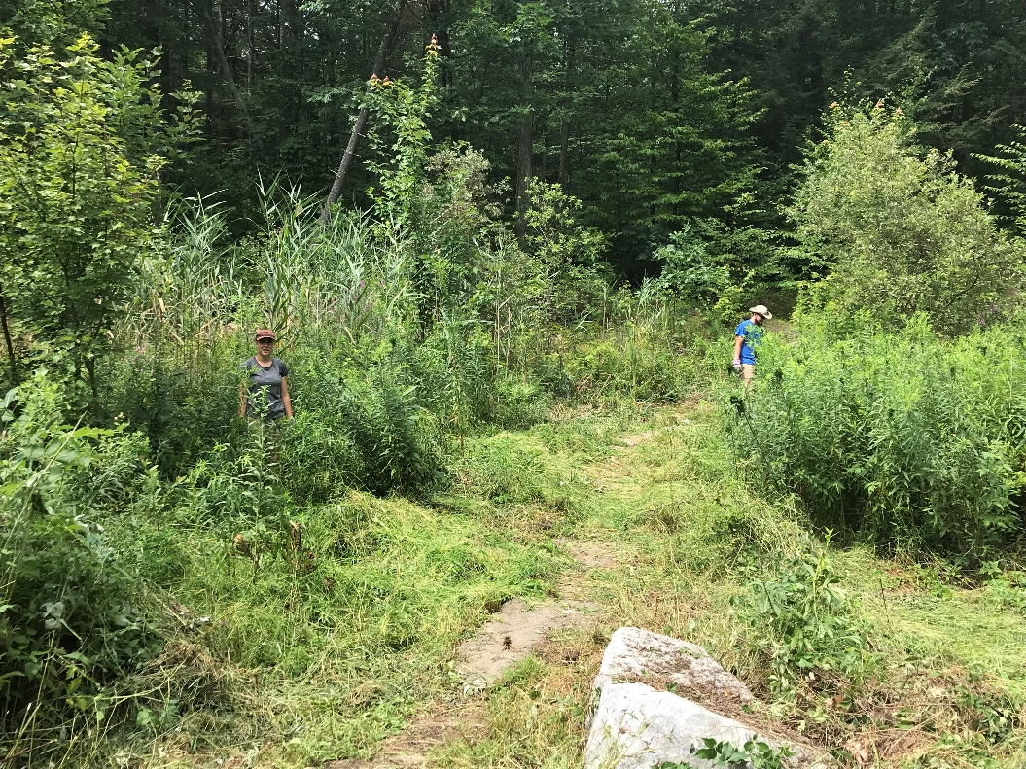
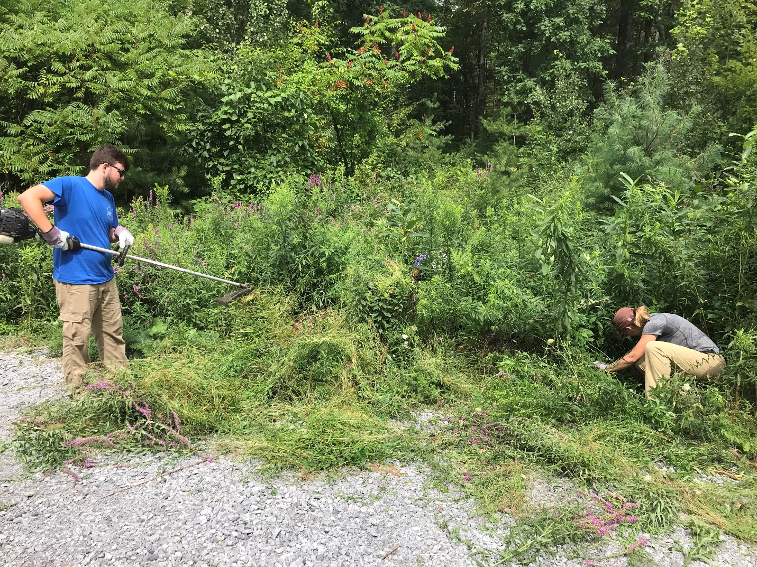
Figure 3: Terrestrial Scouting Intern, Elizabeth Jamison, and CapMo PRISM Boat Steward, Declan Daly, try different methods of manual removal on Japanese Stiltgrass at Daniel’s Road State Forest.
Figure 4: The work area at Daniel’s Road State Forest midway through the work day. The work was focused around the entrance path in order to prevent the spread of stiltgrass into the forest.
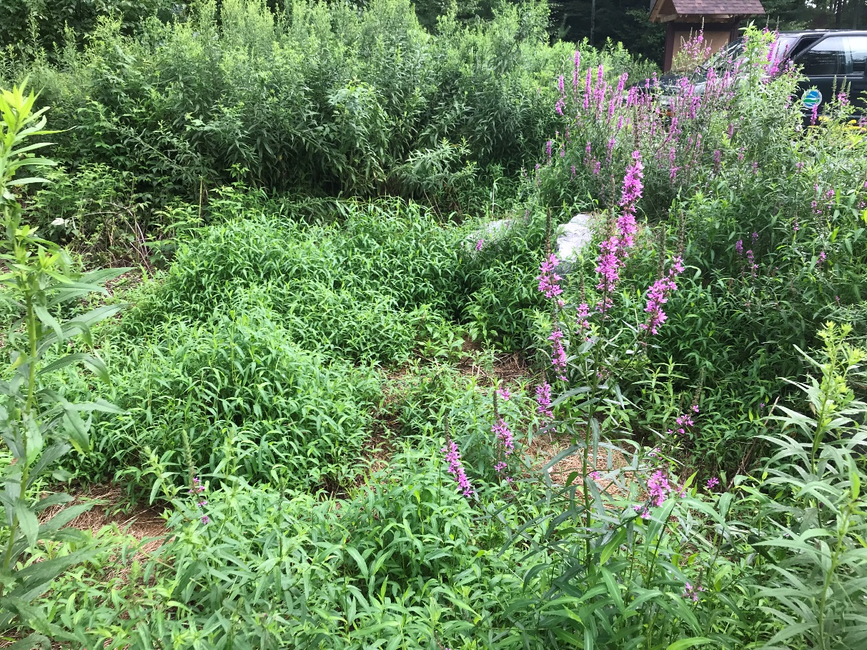
Figures 5: Before and after pictures of the parking area after removal of Japanese Stiltgrass and Purple Loosestrife.

