Schenectady County Summer Scouting Findings 2018:

Capital / Mohawk PRISM

"Detect, prevent, and control invasive species, through direct action and education to protect biodiversity, the natural environment, economy, and quality of life."
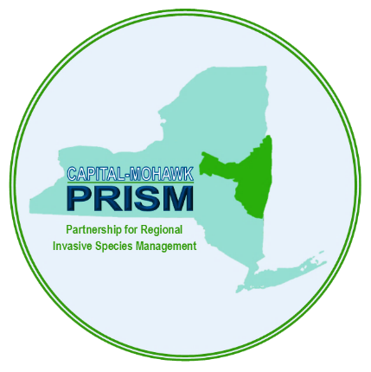

Capital Mohawk PRISM Partnership for Regional
Invasive Species Management
Cornell Cooperative Extension Saratoga
50 West High St.
Ballston Spa, NY 12020

518.885.8995

The New York State Department of Environmental Conservation provides financial support to The Capital Mohawk PRISM via the Environmental Protection Fund
Schenectady County Summer Scouting Findings 2018:
Prepared by Spencer Barrett

This summer, the Terrestrial Invasive Species Coordinator worked with two interns, one from SUNY Environmental Science and Forestry and one from Cornell, to look for Early Detection invasive species throughout the Capital-Mohawk PRISM. The ESF Intern, Elizabeth-Anne Jamison, focused on terrestrial plant species while the Cornell Intern, Lilly-Anne Trainor, worked with the New York State Hemlock Initiative to determine the spread of Hemlock Woolly Adelgid throughout the Capital region. The team in total visited 50 sites throughout the CapMo PRISM, seven of which were located in Schenectady County. The following is an abridged summary of some of the findings of the summer throughout Schenectady County as well as recommendations of future invasive species related endeavors for the various affected stakeholders. The PRISM works throughout 11 counties around the Capital Region to detect, prevent, and control invasive species.

Locations (With Property Owners) and Species:
Note: The absence of any species from a preserve does not guarantee the absence of the species at the site. This is intended as an informal guiding document to inform future management.
- Indian Kill (Schenectady County) and Hemlock Hollow (Town of Glenville): Lily-Anne and Elizabeth were sent to Indian Kill and the town of Glenville’s Hemlock Hollow to access HWA density and spread in the past year as well as categorize invasive plant species present in the preserve. The entire blue trail of Indian Kill was scouted for Hemlock Woolly Adelgid along with the blue trail of Hemlock Hollow. No HWA was detected in Hemlock Hollow, though follow-up surveys should be attempted during the peak season. The level of invasion in the Indian Kill is quite variable, with some slopes containing nothing but native vegetation and other sections being close to an invasive monoculture. There are a number of species pushing in at the edges of the preserve that are not located in the central sections, though as the HWA progresses and trees begin to suffer, more edge habitat will be opened up inside the preserve unless treatment is attempted.
  - Invasive Species Present: Japanese Barberry, Bush Honeysuckle, Burning Bush, Elongate Hemlock Scale, Norway Maple, Common Buckthorn, Black Locust, Multiflora Rose, Oriental Bittersweet, Japanese Knotweed, Coltsfoot, Moneywort, Narrowleaf Bittercress, Climbing Nightshade, Hemlock Woolly Adelgid, Common Barberry, Garlic Mustard.

- The Schenectady County Forest (Schenectady County): Two events focused in on the Schenectady County Forest to examine the invasive species present there. The first day occurred in spring, when Spencer went on Earth Day to participate in the County Forest Cleanup with volunteers and speak shortly on invasive species in the preserve and survey for HWA. The second day occurred during Invasive Species Awareness Week (ISAW), when Lily Trainor, joined by Mary Werner of SCISC and Dustin Lewis from Saratoga Soil and Water Conservation District re-visited the area to search for HWA. In addition to being visited twice to look for HWA, Spencer took records of invasive plants present on site during the first day, though since the focus was on HWA, it is nowhere near a comprehensive survey.
  - Invasive Species Present: Honeysuckle and Common Buckthorn.

- Featherstonhaugh State Forest (DEC): The same date that Lily took Mary and Dustin to the County Forest, there was another group focusing in on terrestrial plant species in Featherstonhaugh State Forest. A large area was surveyed that day with the help of volunteers from SCISC and the community. Most of the main trails were surveyed, though the Long Path could use more work. Many of the species in the State Forest could be manually removed during workdays, though there are some that would prove difficult.
  - Invasive Species Present: Garlic Mustard, Common Buckthorn, Honeysuckle, Multiflora Rose, Phragmites, Tartarian and Morrow’s Honeysuckle, Bittersweet Nightshade, Black Locust, Chicory, White Sweetclover, Narrowleaf Bittercress, Japanese Barberry, Norway Maple, Poison Hemlock, Coltsfoot, Purple Loosestrife, Wild Parsnip, Autumn Olive.

- Lock 7 Park and Trail (OPRHP): A half day of surveying was performed at the Lock 7 Park along the Mohawk River to access if the site had been infested with Hemlock Woolly Adelgid due to the site’s proximity to the known infestation at Lisha Kill. While no HWA was found, Pine Bark Adelgid was found in small amounts, which is another pest that the Hemlock Initiative is looking into as a food source for their silverfly biocontrol insects. While the Forest Pest Survey was ongoing, terrestrial plant records were also taken. As the area was close to the Mohawk River, a brief aquatic survey was also attempted. European Alder was found at the site; the species has been observed spreading down the Mohawk River into the Hudson.
  - Invasive Species Present:
    - Terrestrial- Common Buckthorn, Norway Maple, Morrow’s Honeysuckle, Multiflora Rose, Narrowleaf Bittercress, Spotted Knapweed, Canada Thistle, Garlic Mustard, Black Locust, Bittersweet Nightshade, White Mulberry, Japanese Barberry, Bull Thistle, European Alder, Tree of Heaven.
    - Aquatic- Water Chestnut, Curly-leaved Pondweed, Chinese Mysterysnail, Zebra Mussel.

- Christman Sanctuary (The Nature Conservancy): Elizabeth Jamison and Lily Trainor spent time in Christman Sanctuary with an intern from the iMap Invasives team scouting out the sanctuary for HWA and terrestrial plant species. Many invasive species records were obtained during this scouting trip, which covered the majority of the property.
  - Invasive Species Present: Multiflora Rose, Common Buckthorn, Bush Honeysuckle, Spotted Knapweed, Wild Parsnip, Black Locust, Moneywort, Canada Thistle, Purple Loosestrife, Oriental Bittersweet.

- The Woodlawn Preserve (The City of Schenectady): Spencer Barrett led a walk at the Woodlawn Preserve in the spring with Jeff Kehoe, a local forester, to provide an introduction to invasive species and how they affect the ecosystem. The team led one workday in Schenectady County at the Woodlawn Preserve where a boat launch was cleared and signage from ECOS regarding invasive species was put up. Many invasive species such as common buckthorn, multiflora rose, and oriental bittersweet was removed manually. Around thirty buckthorn bags were put on stumps in the work area, these should be checked to evaluate their effectiveness. Steve Young, the State Botanist, has done surveys throughout the Sanctuary in the past to access the flora present, so in-depth surveying efforts were deemed redundant at this location for this summer.
  - Invasive Species Present in work area: Black Locust, Common Buckthorn, Phragmites, Oriental Bittersweet, Bush Honeysuckle, White Mulberry, Purple Loosestrife, Mugwort, Multiflora Rose, Spotted Knapweed, Garlic Mustard.

- Jeff Blatnick Park (The Town of Niskayuna): A brief survey was performed at this location by Spencer Barrett and Elizabeth Jamison with the intention of looking along the Mohawk for European Alder and Yellow Garden Loosestrife. There was no water access, so instead the team took one record for each invasive species noted to provide a snapshot of what the site is like to better plan any future efforts that might take place there.
  - Invasive Species Present: Bush Honeysuckle, Autumn Olive, Oriental Bittersweet, Purple Loosestrife, Phragmites, Tufted Vetch, Mugwort, Bull Thistle, Spotted Knapweed, Wild Parsnip, Multiflora Rose, Common Buckthorn.

- The Plotterkill Preserve (Schenectady County): The PRISM helped to set up and provide guidance to an invasive species removal at the Plotterkill Preserve on the last weekend of September. The event was hosted with the assistance of The Schenectady County Invasive Species Committee, the Environmental Clearinghouse of Schenectady, The Union College Sustainability Committee, The Schenectady Soil and Water Conservation District, and the Schenectady County Environmental Advisory Committee. During this workday, species of focus for removal at Plotterkill were Bush Honeysuckle, Common Buckthorn, Multiflora Rose, and Oriental Bittersweet. Participants were trained in the identification of these common species and manual removal techniques. There were 27 attendees at the event and the removal work focused primarily on the Yellow Trail just past the bridge.

Other Activities:
  - In addition to the normal scouting schedule that was designed at the start of the summer, the Terrestrial team participated in a number of public education events in Schenectady including Spencer’s Invasive Species Overview talk at Union College, the Earth Day Cleanup at the Community Forest, the Schenectady County 4H Environmental Field Day, and organizing a volunteer survey of Featherstonhaugh State Forest for Invasive Species Awareness Week. At these events, the team talked to 190 Schenectady County residents about the impact of Invasive Species and how they can assist the PRISM and SCISC’s goals for Schenectady County and the region at large.
  - Schenectady County was also the site for two Spotted Lanternfly traps, one monitored by Spencer Barrett, the other monitored by Elizabeth Jamison. No Spotted Lanternfly was found during the 2018 Field Season. Schenectady County is bordered on the north side by the Mohawk River which is an important pathway for invasive species. Schenectady County is also home to Tree of Heaven populations which may act as hosts for the Spotted Lanternfly during its spread in New York.
  - The PRISM awarded a grant written by the Invasives Committee to put up boot brush stations at three county preserves (Plotterkill, Indian Kill, and the County Forest) to assist with preventing the spread of invasive species as well as educating the public about the dangers that they pose to the ecosystem. Boot Brush stations will be present at all these preserves by the end of the year.

Recommendations for the Future:
SCISC: The Schenectady County Invasives Committee has been working diligently on a number of important facets of invasive species control. The formal implementation of the hemlock plan should continue to be a goal of the committee. Having this plan in place will help with acquiring assistance from DEC and other organizations to combat HWA at a county-wide level. The work at Plotterkill and the Lisha Kill has brought attention to this important forest pest and the boot brush stations that will be put up will help to prevent the spread of invasive species throughout the county-run preserves. The Invasive Species committee should double-down on the preserves where the boot brush stations are being constructed, working to remove and prevent invasive species from spreading throughout. This should be attempted at the areas that are in the best shape first, the Plotterkill and Indian Kill, with the intention of moving onto the Community Forest at a later date. Management plans should be authored for those two locations with the goal of reducing invasive species on location and promoting the restoration of native species; the PRISM could assist in the authoring of these plans. The committee should continue to act as an outreach source for invasive species research and news to the county at large, possibly ramping up monitoring for Spotted Lanternfly as the pest approaches the region. Treekeeper is a great source of potential trap trees for this monitoring as Davey gathered data on Tree-of-Heaven as well as their DBH.
Woodlawn Preserve: Likewise, the Woodlawn Preserve has been working on addressing invasive species over the 135 acres located on the edge of Schenectady and Albany County. Volunteer events in the past there have attempted to remove and bag Common Buckthorn, cut back Oriental Bittersweet, and educate the public about the threat that invasive species can pose, which is quite visually evident at the preserve. It is the recommendation of the author that more signage around the preserve that would assist with visual identification of invasive species would go a long way. As with many volunteer land-management organizations, recruiting recurring volunteers is important. Right now, there is not an easily accessible volunteer sign-up page that can be found for the group online, which would potentially help with projects moving forward. The link with the Pine Bush seems to be strengthening, which absolutely will help with volunteer efforts before they come in for more comprehensive management, but there is no reason to wait on that to occur if improvements can be made in the meantime.
Capital/Mohawk PRISM: The PRISM has a strong link to Schenectady County both in the history of Laurel’s work in the county and the renewed work that Spencer, Kris, and now Gwendolyn Temple have been achieving in the county. Geographically, it makes sense for CapMo to have a strong link to Schenectady due to proximity and in the number of environmental groups that currently work with the PRISM in the county. The PRISM is working to incorporate a partnership with ECOS, which will start with a training for members of that organization as well as working to be involved with TNCs efforts at the Lisha Kill to address the HWA located there. It’s recommended that the PRISM assist with the HWA populations in Lisha Kill, Indian Kill, and reapplication at Plotterkill as these important natural areas are key for the spread of this pest north into Saratoga County and then into APIPP. The PRISM should continue to assist with SCISC and Woodlawn, while working with other land management groups in the county, such as the Mohawk-Hudson Land Conservancy, TNC, and others. Renewing old partnerships and forging new partnerships will always be a key to the PRISMs goals and Schenectady County is a sensible place to attempt this, though as always, resources of the PRISM have to be spread out among 11 counties. For further surveying efforts, it’s recommended that the Mohawk Hudson Bikeway be surveyed for emerging invasive species such as Yellow Garden Loosestrife and attempts to measure the spread of Flowering Rush and European Alder along the Mohawk be undertaken.

Species of focus for Schenectady County for all stakeholders at this point in the surveying and prioritization process include Black and Pale Swallowwort (primarily Black, found along the Crosstown Connection), Hemlock Woolly Adelgid, Japanese Hops (found at Scotia Collins Park), European Alder, Japanese Stiltgrass (undetected but present in Albany and Saratoga Counties), Yellow Garden Loosestrife, and Tree of Heaven. The PRISM is actively seeking records of all these species, if you have seen them in Schenectady, contact Spencer Barrett at sb685@cornell.edu or submit a report via iMap Invsives or on the reporting form on capitalmohawkprism.org.

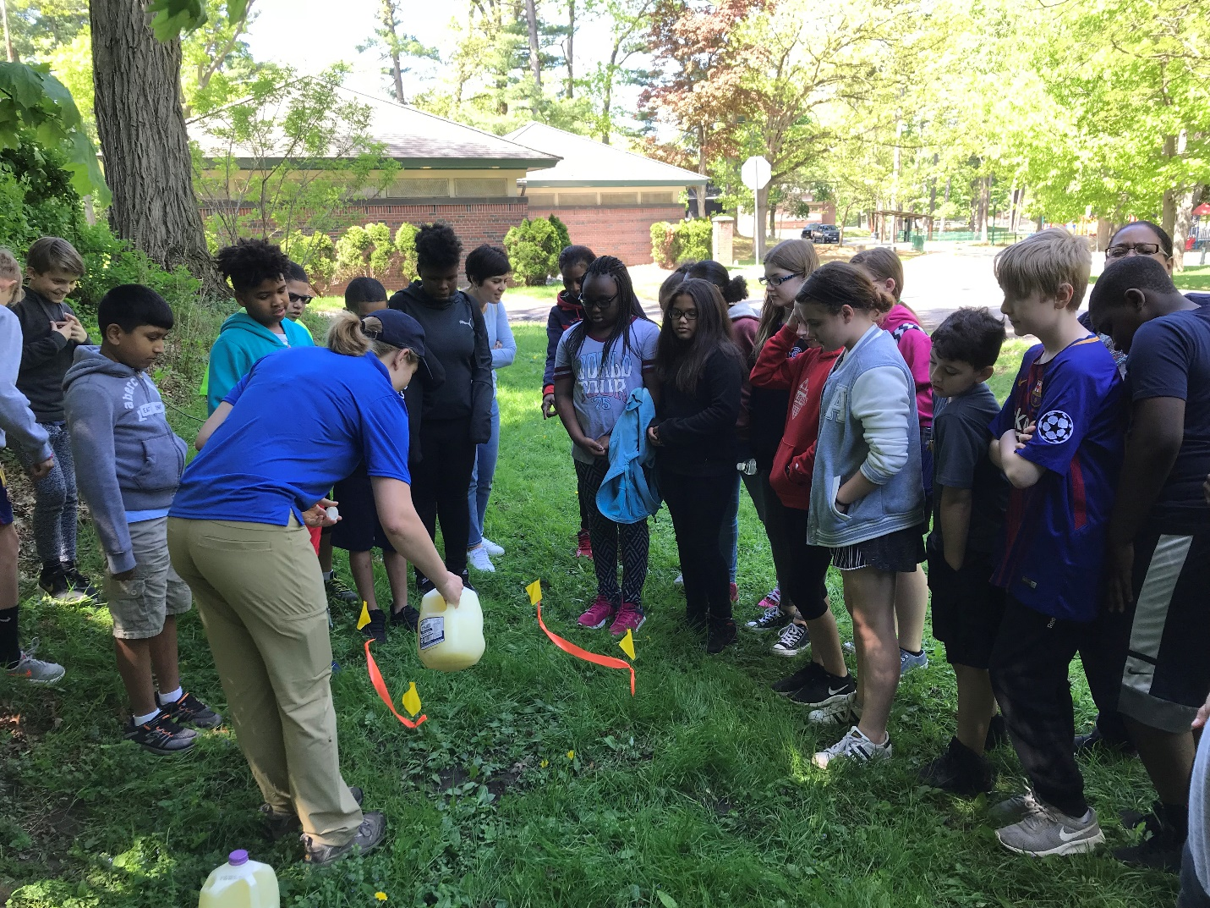
Figure 1: Elizabeth Jamison demonstrating mustard-seed’s effect on earthworms while checking Central Park in Schenectady for the invasive Amynthas earthworm during the 4H Environmental Field Day.
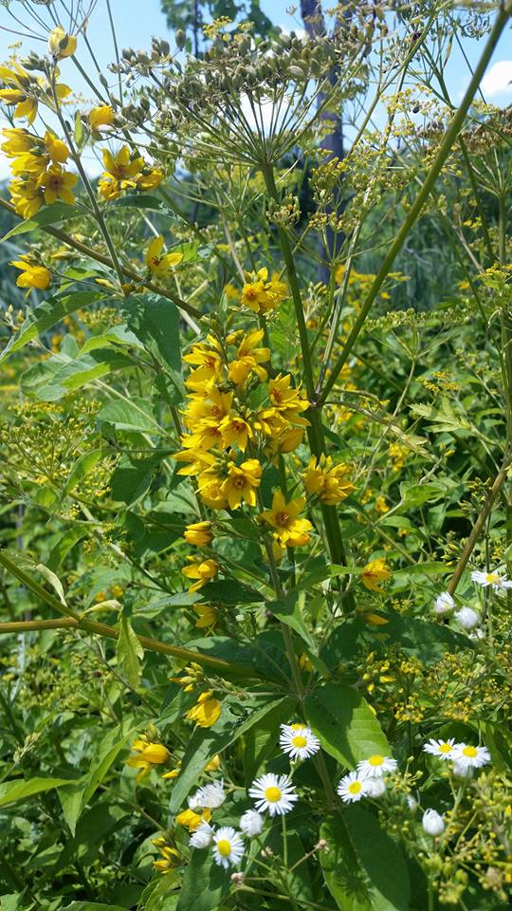
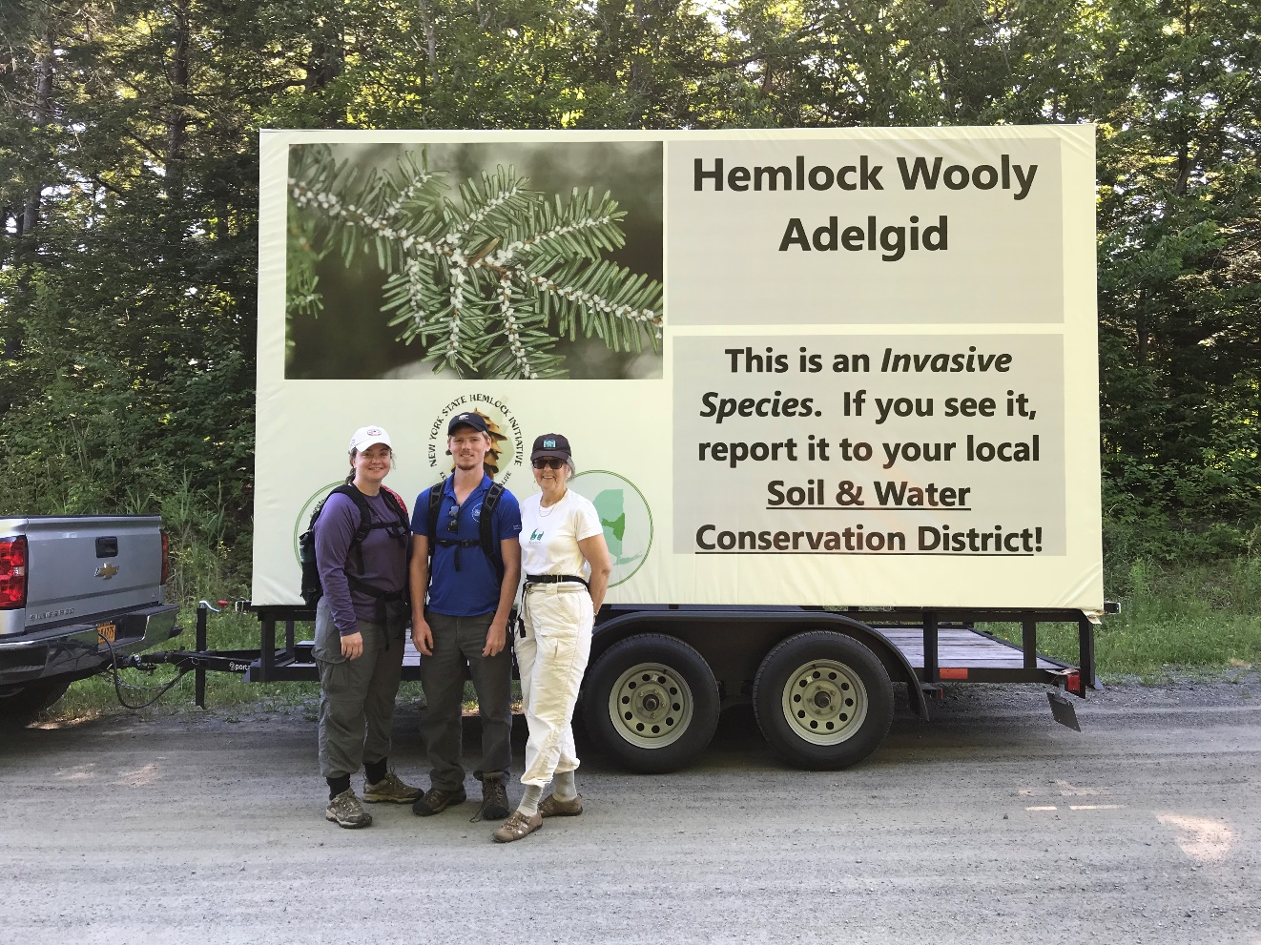
Figure 2: Spencer Barrett, Loretta McNamee, and Mary Werner of the Schenectady County Invasives Committee pose with the mobile billboard purchased by the PRISM through a contract with the Saratoga Soil and Water Conservation District before surveying Featherstonhaugh during Invasive Species Awareness Week.

Figure 3: Yellow Garden Loosestrife (Lysimachia vulgaris) is an underreported invasive species that has been found in Visher’s Ferry, Cohoes, and Troy. It likely has unreported populations in Schenectady County as well along the Mohawk River.

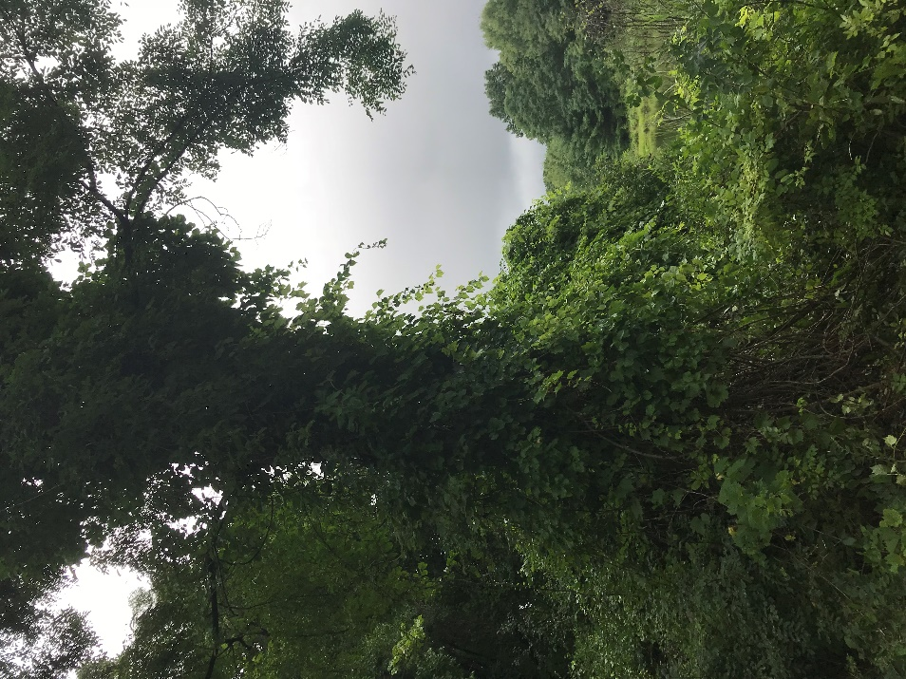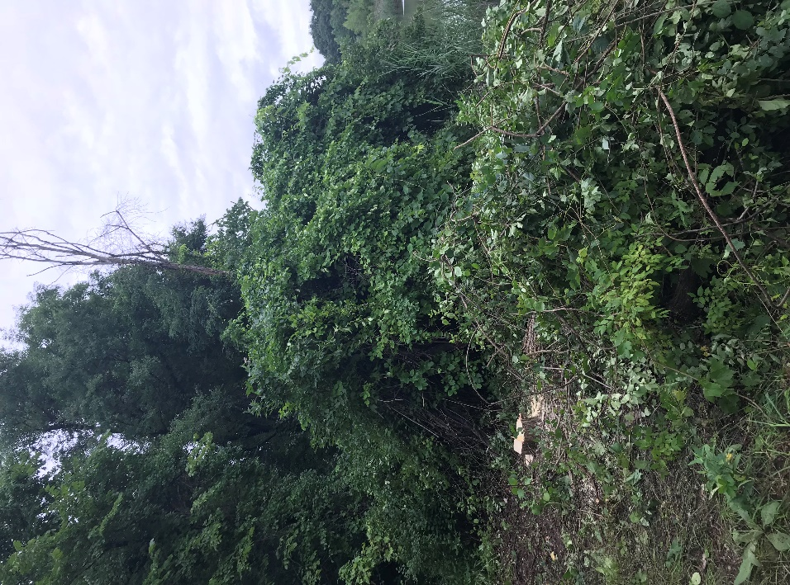
Figure 4: Before and After- Removing a large Black Locust (Robinia pseudoacacia) as well as Oriental Bittersweet (Celastrus orbiculatus) at the Woodlawn Preserve to clear room for a canoe launch.
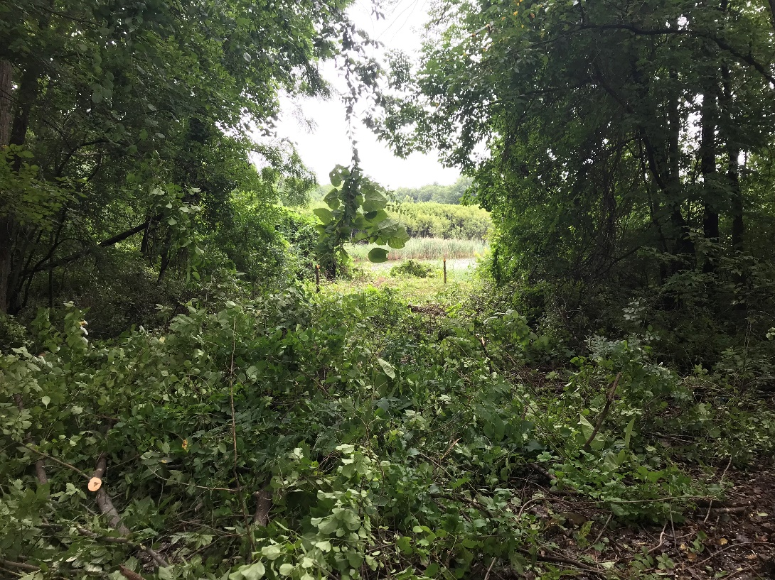
Figure 5: Path cleared in the Woodlawn Preserve during the workday.

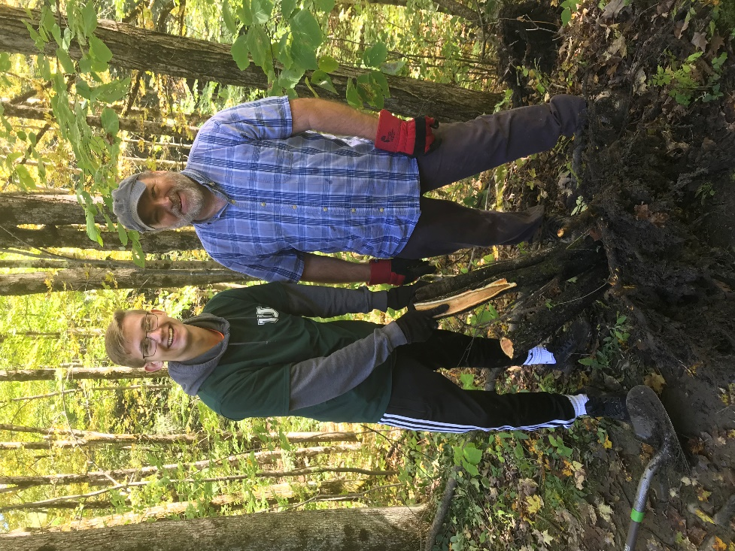
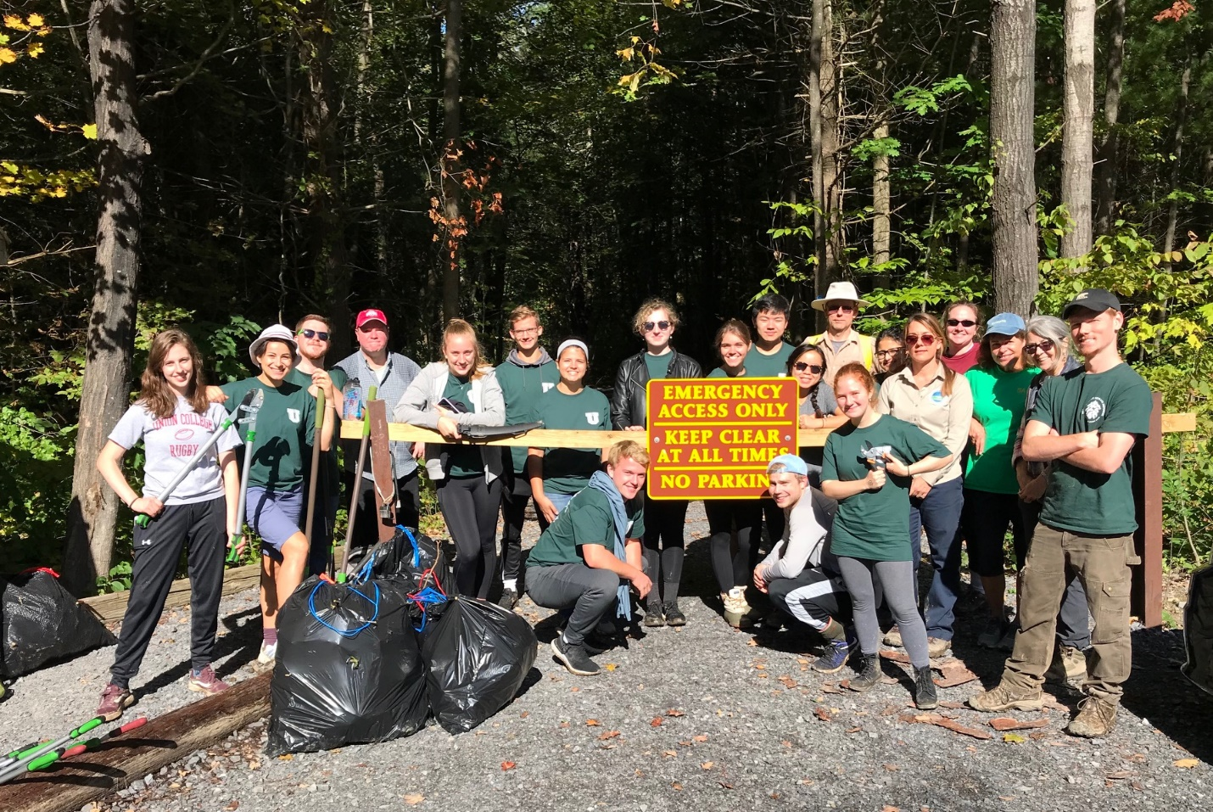
Figure 6: Group photo taken of the volunteer group for the 9/29 Plotterkill IS Workday including members of the Invasive Committee, the Union College student group, and CapMo PRISM.
Figure 7: Volunteers pose with a large Common Buckthorn (Rhamnus cathartica) stump after it has been removed from the ground.

