Siebold’s Viburnum Treatment, Spring 2019: Glenville, Schenectady County
Prepared by Spencer Barrett
Siebold’s Viburnum (Viburnum sieboldii) was a Tier 1 species in the Capital Mohawk PRISM and now has a single population reported in the Town of Glenville at their Hemlock Hollow town preserve. This species is a serious threat in the Lower Hudson PRISM as well as Pennsylvania and New Jersey, and has been popping up in new PRISMs in recent years. This plant, much like the previous findings of Mile-A-Minute Vine and Japanese Angelica Tree, appeared more than 50 miles from the next closest reported location in Dutchess County. (a closer estimate is 75 miles) After discovery on 5/1/19, the two individuals were removed the next day. The following is a summary of that work.
Associated iMap Invasives Records: (Obs: #1013303, Treatment: #14198)

Two relatively mature Sieboldii were located by Spencer Barrett on a recreational hike at the Hemlock Hollow preserve in Glenville. Having previous contact with Vicki Hillis, who is the primary contact for town preserves, he contacted her over email and permission for removal was obtained. He then went back to the site the next day, removing both plants with the weed wrench. Some burning bush shrubs were also removed for site access. At one point a neighbor that Spencer had previously met with came out to ask what was being done at the preserve and the invasive nature of burning bush was explained. (Omitting the viburnums for simplification.) That landowner had previously contacted the PRISM for consultation on Hemlock Woolly Adelgid.
Totals: In one visit, Spencer removed two stems of Siebold’s Viburnum over an area of approximately 8,500 square feet. In addition to the removal of this pest, an additional 30 stems of smaller burning bush shrubs were removed for access to these plants. Removed plants were piled for desiccation on-site.

Suggestions for the Future:
This area of the preserve still needs some work. While understanding that the area borders a residential neighborhood, there are a number of species spreading from the neighborhood into the preserve from this exact location. Japanese Pachysandra, Burning Bush, Siebold’s Viburnum, among other species, clearly spread from the neighborhood itself. There is also a potential Linden Viburnum shrub next to the treatment area, though the heavy serration of the leaves rather than scalloping suggests that it could be a native arrowwood. This provides additional incentive for post-treatment monitoring, along with the simple fact that all treatments of any kind need to be monitored for success. If treatment was successful, keep Sieboldii at a Tier 1 species. If other points are located, move this species to Tier 2.

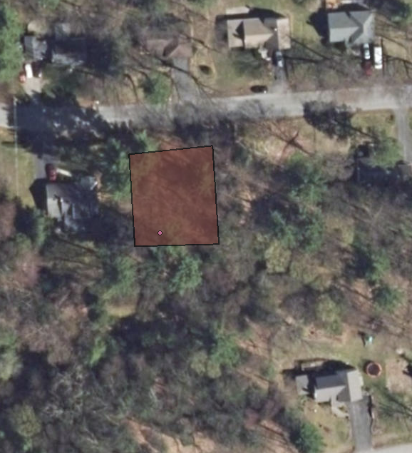
Figure 1: The infestation polygon from iMap Invasives. Plants were located at the pink presence point on the side of the trail. The street visible on the map is Birch Lane. There are two main entrances to the Hollow, the polygon is over the western entrance.

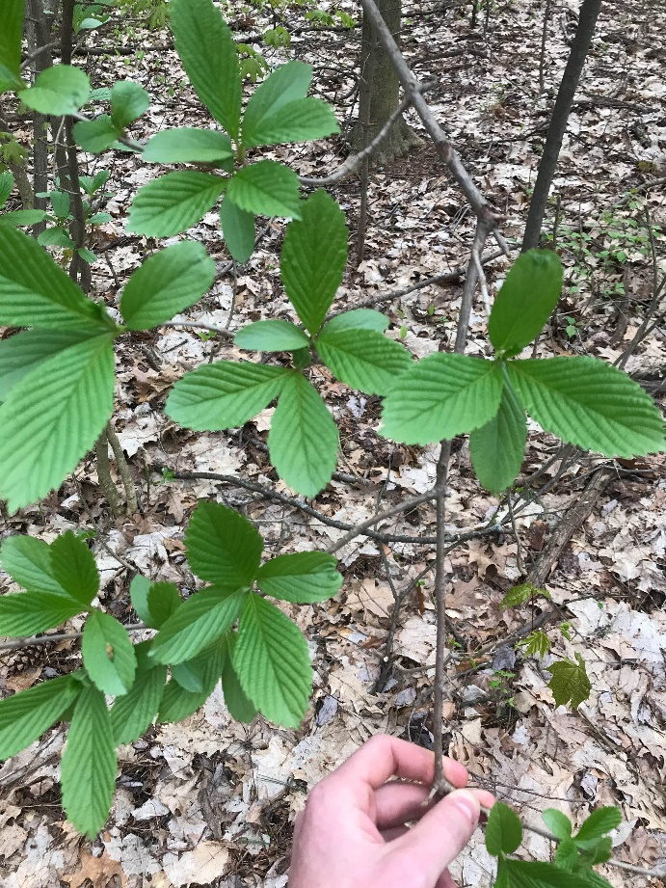
Figure 2 and 3: Siebold’s Viburnum can be identified by its ovate, opposite leaves with deep venation, but by far the most identifying characteristic of this plant is the smell of the leaves which has been likened to anything from green peppers to burning plastic. Its growth form ranges from shrub to a full tree, growing up to 20 feet tall.

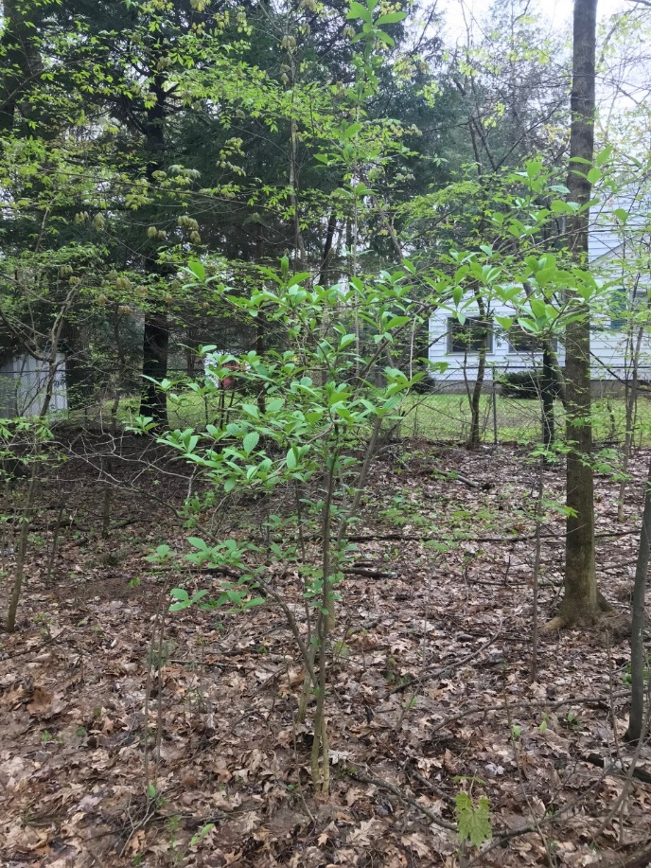

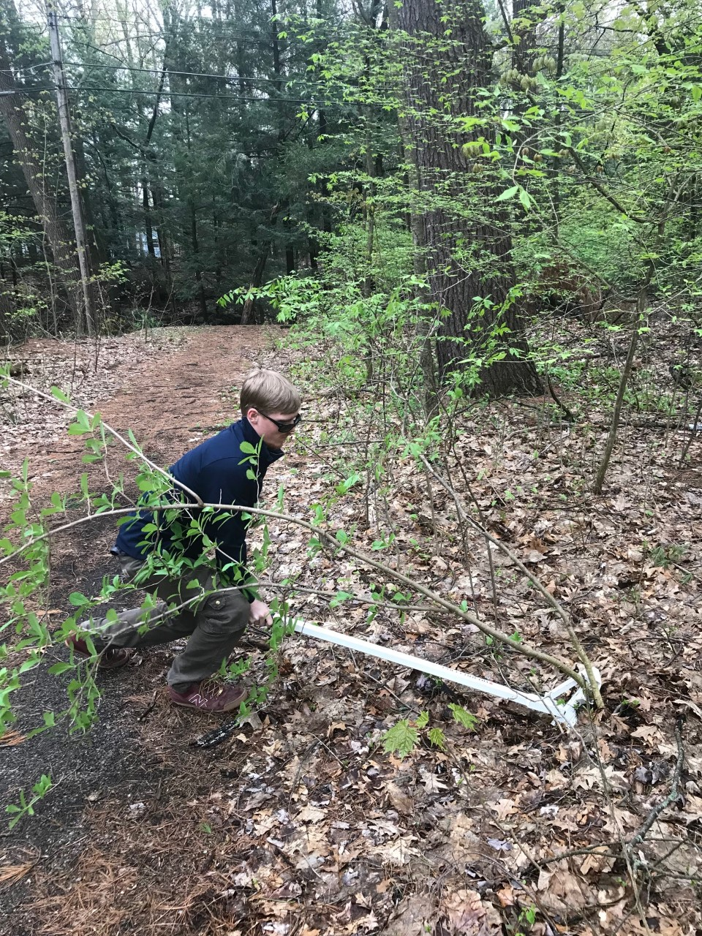
Figure 4: Removal of these plants required use of the weed wrench. The proximity of the plant to the trail can be seen in the picture below.

