SIX MILES WATERWORKS PARK INVASIVE SPECIES SURVEY 2019:

Emily Caboot, Anna Kuhne, Lauren Mercier, and Kelsey Stevens

Introduction: In July of 2019, the Terrestrial Invasive Species interns, from Siena College, and the education and outreach coordinator went to look for early detection invasive species throughout the Capital-Mohawk PRISM. The Siena interns, Anna Kuhne and Kelsey Stevens, focused on terrestrial invasive plant surveys at highly susceptible and valuable habitats throughout the PRISM region. The following is an abridged summary of some of the findings of the survey throughout the Six Miles Water Works Park. The PRISM works throughout 11 counties around the capital region to detect, prevent, and control invasive species.

Project Description: Surveying terrestrial invasive plants in the park
Dates: July 17th, 2019
Participants: Capital Mohawk Prism, Cornell Cooperative Extension, NYS DEC, and Albany Pine Bush Preserve
Point of Contact: info@albnaypinebush.org
County: Albany County

Locations and Species Identified:
Six Miles Waterworks Park (infor@albnaypinebush.org): Surveying was done around the parking lots and on the trails of the Six Miles Waterworks Park.
Invasive Species Present at Six Miles Waterworks Park: This table presents species that have been identified in the area in the past and present including both terrestrial and aquatic invasive species.
Common Name | Scientific Name | Locations (GPS) | Growth Type | Phenology
Common Reed | Phragmites australis | 42.69854  -73.83571 | Herbaceous | Vegetative
Norway Maple | Acer platanoides | 42.69662  -73.82951 | Tree | Vegetative
Japanese Barberry | Berberis thunbergii |  | Shrub
Oriental Bittersweet | Celastrus orbiculatus | 42.69626  -73.83098 | Vine | In Seed
Black Locust | Robinia pseudoacacia | 42.69859  -73.83722 | Tree | Vegetative
Honeysuckle | Lonicera spp | 42.69863  -73.83543 | Shrub | In Seed
Multiflora Rose | Rosa multiflora | 42.69661  -73.8343 | Shrub | Vegetative
European Barberry | Berberis vulgaris | 42.69659  -73.83428 | Shrub | Vegetative
Spotted Knapweed | Centurea stoebe | 42.69754  -73.83552 | Herbaceous | Flowering
Tree – of – Heaven | Ailanthus altissima | 42.69837  -73.83694 | Herbaceous | Flowering
European Lily of the Valley | Convallaria majalis | 42.69663  -73.8296 | Herbaceous | In Seed
Garlic Mustard | Alliaria petiolata | 42.69667  -73.82959 | Herbaceous | In Seed
Canada Thistle | Cirsum arvense | 42.69631  -73.83159 | Herbaceous | Flowering
Bull Thistle | Cirsium vulgare | 42.6983  -73.83615 | Herbaceous | Flowering
Wild Carrot, Queen Anne’s Lace | Daucus carota | 42.69615  -73.83232 | Herbaceous | Flowering
Cypress Spurge | Euphoria cyparissias | 42.69847  -73.83726 | Herbaceous | Vegetative
Knotweed | Reynoutria spp | 42.69843  -73.83733 | Herbaceous | Vegetative
Glossy Buckthorn | Frangula alnus | 42.6981  -73.83341 | Tree | Vegetative
Ground Ivy | Glechoma hederacea | 42.69669  -73.82956 | Herbaceous | Vegetative
Birdfoot Deervetch | Lotus corniculatus | 42.69598  -73.83283 | Herbaceous | Flowering
Purple Loosestrife | Lythrum salicaria | 42.69606  -73.83254 | Herbaceous | Flowering
White Mulberry | Morus alba | 42.69717  -73.83502 | Tree | Vegetative
Eurasian Water-milfoil | Myriophyllum spicatum | 42.69635  -73.83168 | Aquatic | Vegetative
Japanese Knotweed | Reynoutria japonica | 42.69781  -73.83593 | Herbaceous | Vegetative
Curly Pondweed | Potamogeton crispus | 42.69734  -73.83131 | Aquatic | Vegetative
Common Buckthorn | Rhamnus cathartica | 42.69612  -73.83086 | Tree | Vegetative
Climbing Nightshade | Solanum dulcamara | 42.69842  -73.83687 | Vine | Flowering
Coltsfoot | Tussilago farfara | 42.6961  -73.83255 | Vine | Vegetative
Great Mullein | Verbascum thapsus | 42.69588  -73.8303 | Herbaceous | Flowering

Dominant Native Plants: Oak, sugar maple
Native Community Types: Forest, wetland (pond)
Treatment Method: N/A

Summary of Work Completed:
  - Surveying for invasive terrestrial species
Recommendations for the Future: Continue surveying
Contact the Capital Mohawk Prism, find the website at http://www.capitalmohawkprism.org/

Figure 1. Map of points taken at Six Miles Water Works in Albany County.

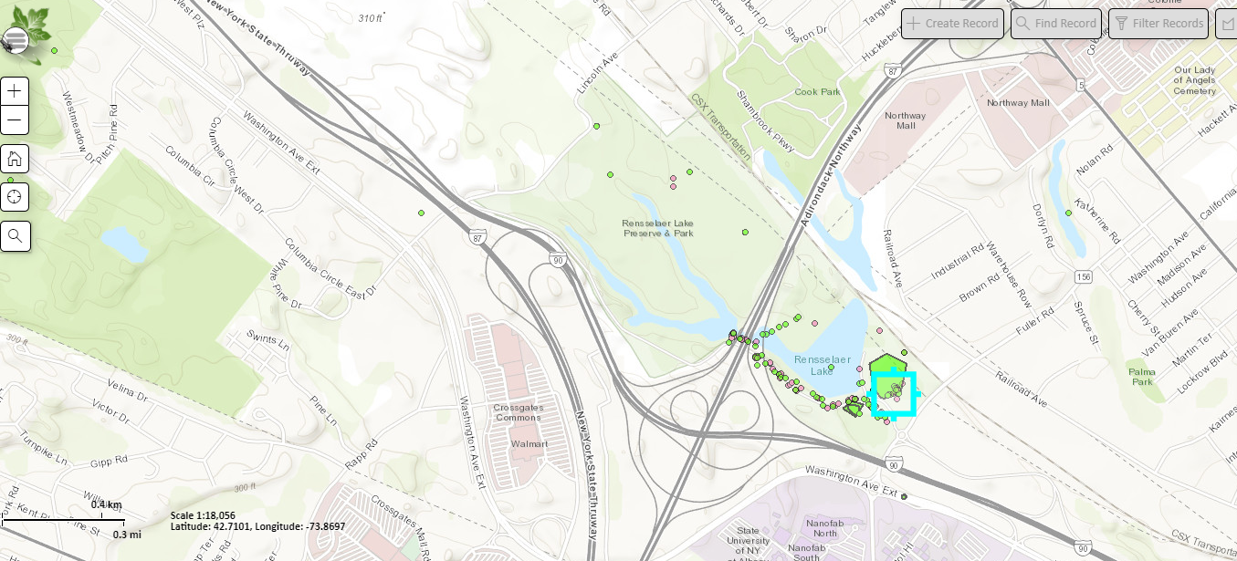

Figure 2. Black Locust (Robinia pseudoacacia) under the highway in Six Miles Waterworks Park
