Aquatic Invasive Species Survey: South Bay on Lake Champlain (2019)

Prepared By Gwendolyn Temple, Aquatic Invasive Species Coordinator

This survey was performed in conjunction with a shoreline hemlock woolly adelgid survey.

Date: June 12, 2019

Survey Team: Gwendolyn Temple and Kristopher Williams

Point of Contact: Capital Mohawk PRISM

County: Washington

Location: DEC Launch 23 Co Rd 7A, Whitehall, NY 12887 (Just Off Route 22 when crossing the South Bay Bridge)

Common Name | Scientific Name | Locations (GPS) | Survey Type
Hemlock Woolly Adelgid (HWA) | Adelges tsugae | 43.5753, -73.4369 | Early Detection  HWA Boat Survey | No Detection
Water chestnut | Trapa natans | 43.5681628, -73.4363637 | AIS Survey | Detected
Yellow flag iris | Iris pseudacorus | 43.5493371, -73.4470996 | AIS Survey | Detected
Eurasian watermilfoil | Myriophyllum spicatum | 43.5715587, -73.4287602 | AIS Survey | Detected
Variable leaf watermilfoil | Myriophyllum heterophyllum | 43.5715587, -73.4287602 | AIS Survey | Detected

Findings and Recommendations: No detection of HWA as of June 12th, 2019; detection of intense patches of water chestnut, Eurasian watermilfoil, variable leaf watermilfoil, and scattered patches of yellow
South Bay: Approximately 7 miles of shoreline were surveyed on June 12th for aquatic invasive species while surveying for hemlock wooly adelgid, an invasive forest pest. This waterbody was a great location to search for aquatic invasives, but not a good location for HWA lake surveys as hemlock trees accounted for less than 5% of the forest composition. A round-trip loop in this section is approximately 7-8 miles and the survey itself was completed in less than 3 hours.
Native Community Types: Pine-Oak forest
Treatment Method: None
Summary of Work Completed:
- Surveyed for invasive aquatic species, particularly plants.
- Found numerous locations of both Eurasian watermilfoil and variable leaf watermilfoil intermixing. Most was found just south of route 22 past the bridge.
- Found patches of yellow flag iris in various locations along the shoreline.
- Found extensive patch of water chestnut that cannot be manually removed. Patch was already uploaded to iMapInvasives upon review back at the office. Patch can be seen south of route 7A.

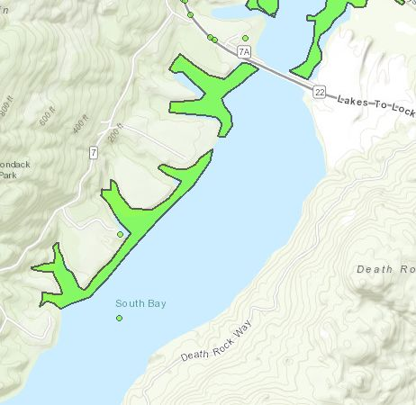
Recommendations:
- The yellow flag iris is very patchy, suggesting that it is being transported by water to numerous locations when it goes to seed. Removal should be considered in order to reduce the potential for spread of this species. This can be performed either by hiking the shoreline (which may be difficult in some locations and could abut private property) or by landing a kayak/canoe along the shore and disembarking to remove the species.
- The water chestnut patch below route 7A needs to be managed in some capacity. Without management, this patch will continue to grow and could lead to the spread of this species into other uninvaded waterbodies throughout Vermont and the Adirondacks. Mechanical harvesting is the most time effective method, but may not be cost-effective. Volunteer removal efforts may be possible, but would need to be performed in conjunction with some other removal method in order to actively manage the population.
- On-going monitoring of this waterbody should be performed as it is a location that has significance to two states (New York and Vermont) and two countries (United States and Canada). It is also a location where numerous species can spread from as there are numerous entry and exit points along the lake itself.

Please contact Gwendolyn Temple at ggt25@cornell.edu for any questions regarding this report.

Figure 1: Water chestnut found south of route 7A. Patch extends far beyond what the photo shows.
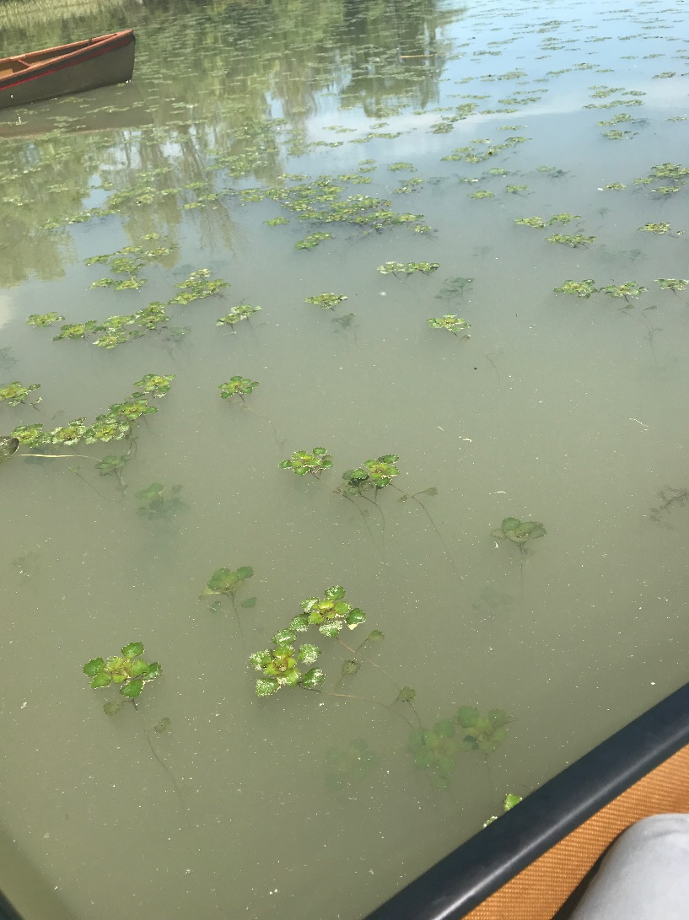
Figure 2: Photo of South Bay.
