STOCKPORT FLATS INVASIVE SPECIES SURVEY 2019:
Anna Kuhne, Lauren Mercier, and Kelsey Stevens

Type of Work Performed: Survey for terrestrial invasive species

Date: August 8th, 2019

Address: Stockport Creek, Stockport, NY 12173
County: Columbia
Latitude and Longitude: 42.310956, -73.771416
Website: https://www.dec.ny.gov/lands/92355.html

Lead Contact Information for Project: Lauren Mercier

Site Owner Contact Information: NYS DEC 845-889-4745

Project Description: A terrestrial invasive species survey was done at Stockport Creek and the surrounding and related areas to get a full idea of the present invasive species.

Invasive Species Present at Stockport Flats:
Common Name | Scientific Name | Locations (GPS) | Growth Type | Phenology | Distribution/ Abundance
Tree of Heaven | Ailanthus altissima | 42.35723  -73.78931 | Tree | In flower | Record from 2018
Japanese Barberry | Berberis thunbergii |  | Shrub
Oriental Bittersweet | Celastrus orbiculatus | 42.35841  -73.78756 | Vine | Vegetative | Dense
Black Locust | Robinia pseudoacacia |  | Tree
Privet | Ligustrum spp | 42.35856  -73.7888 | Shrub | Record from 2018 | Record from 2018
Amur Honeysuckle | Lonicera maackii | 42.3602  -73.7861 | Shrub | In Seed | Record from 2017
Multifora Rose | Rosa multflora | 42.35705  -73.78765 | Shrub | Vegetative | Dense
Water Chestnut
Siberian Elm | Ulmus pulima | 42.35977  -73.78822 | Tree | Vegetative | Record from 2018
Mugwort | Artemisia vulgaris | 42.35777  -73.78908 | Herbaceous | Vegetative | Dense
Spotted Starthistle | Centaurea stoebe | 42.35838  -73.78744 | Herbaceous | In flower | Dense
Brown Starthistle | Centaurea jacea | 42.35849  -73.78734 | Herbaceous | In flower | Dense in parking lot
Field Bindweed | Convolvulus arvensis | 42.35843  -73.78735 | Vine | In flower | Dense in parking lot
Black Swallow-wart | Vincetoxicum louiseae | 42.35804  -7378865 | Herbaceous | In flower | Single clump
Wild Carrot | Daucus carota | 42.35837  -73.78758 | Herbaceous | In flower | Dense
Cypress Spurge | Euphorbia cyparissias | 42.3582  -73.78819 | Herbaceous | Vegetative | Single clump
Ground Ivy | Glechoma hederacea | 42.35718  -73.7878 | Herbaceous | Vegetative | Dense along trail
Purple Loosestrife | Lythrum salicaria | 42.35818  -73.78731 | Herbaceous | In flower | Dense
Honeysuckle | Lonicera spp | 42.35807  -73.78747 | Shrub | In seed | Dense
Japanese Stiltgrass | Microstegium vimineum | 42.35813  -73.78874 | Herbaceous | Vegetative | Single patch
Common Buckthorn | Rhamnus cathartica | 42.35832-73.78762 | Tree | In seed | Dense
Black Locust | Robinia pseudoacacia | 42.35844  -73.7873 | Tree | Vegetative | Dense
Stringy Stonecrop | Sedum sarmentosum | 42.35781  -73.78904 | Herbaceous | Vegetative | Single patch
Chicory | Cichorium intybus | 42.32645  -73.7629 | Herbaceous | In flower | Dense
Birdfoot Deervetch | Lotus corniculatus | 42.32673  -73.76294 | Herbaceous | In flower | Dense
Emerald Ash Borer | Agrilus planipennis | 42.30929  -73.77183 | Pest | N/A | Record from 2018
Garlic Mustard | Alliaria petiolate | 42.30999  -73.77078 | Herbaceous | Record from June 2018 | Record from 2018
White Mulberry | Morus alba | 42.31064  -73.77214 | Tree | Vegetative | Dense
Knapweed | Centaurea | 42.31096  -73.77227 | Herbaceous | Record from 2018 | Record from 2018
Canada Thistle | Cirsium arvense | 42.31017  -73.7711 | Herbaceous | Record from June 2018 | Record from 2018
Dame’s Rocket | Hesperis matronalis | 42.31025  -73.77044 | Herbaceous | In flower | Record from June 2018
Privet | Ligustrum spp | 42.30996  -73.77166 | Shrub | In seed | Record from June 2018
Reed Canarygrass | Phalaris arundinacea | 42.31027  -73.77098 | Herbaceous | In seed | Record from June 2018
Tufted Vetch | Vicia cracca | 42.31023  -73.77019 | Herbaceous | Vegetative | Record from June 2018
Water Chestnut | Trapa natans | 42.31081  -73.77221 | Aquatic | In Seed | Dense

Capital Mohawk PRISM Strongly Recommends Uploading Points into https://www.imapinvasives.org/
Native Community Types: Wetland
Dominant Native Plants Present: Sugar maple and oak trees
Summary of Work Completed:
  - Survey throughout Stockport Flats for terrestrial invasive plant species.
Recommendations for the Future: continue to survey for and document terrestrial invasive plant species
Contact the Capital Mohawk Prism http://www.capitalmohawkprism.org/

Figure 1. Map of Stockport Flats which is in Columbia County, data points were entered at Nutton Hook, Brickyard WMA and Stockport Creek
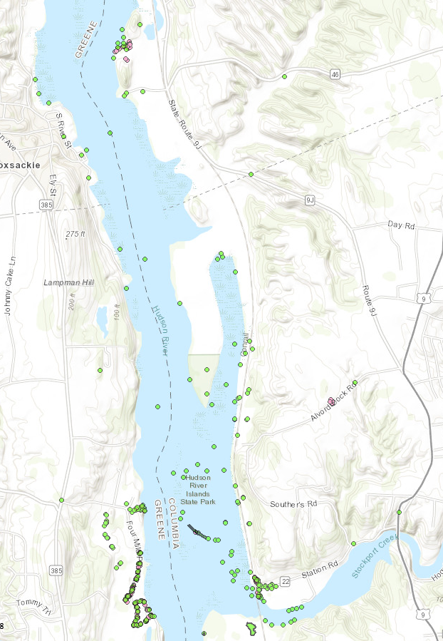

Figure 2, 3, 4. Figure 2 is a White Mulberry at Stockport Creek on the Stockport Flats property. Figure 3 is Chicory at the Brickyard WMA on the Stockport Flats property. Figure 4 is Stringy Stone Crop at Nutton Hook on the Stockport flats Property.
Fig 4
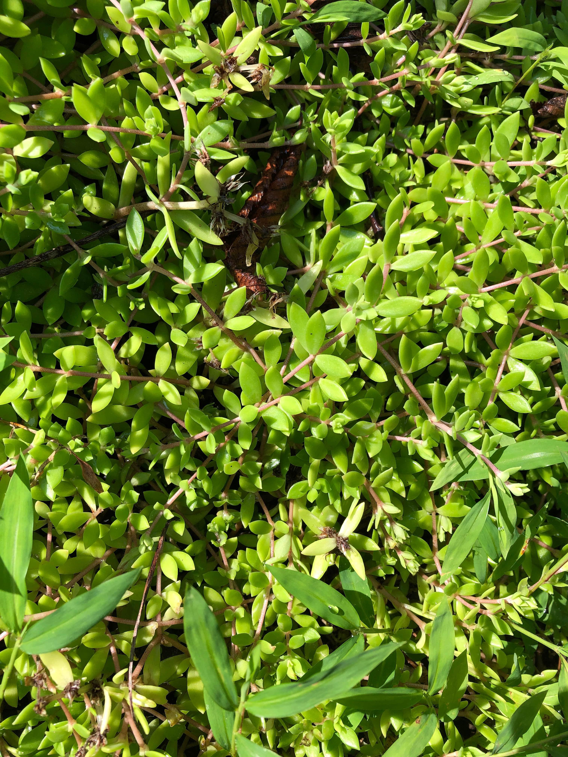

Fig 2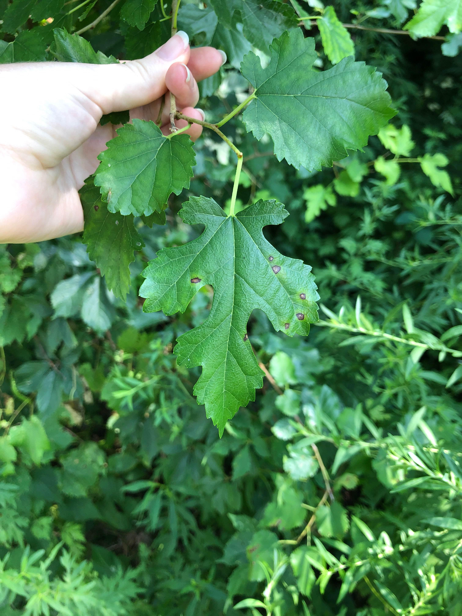
Fig 3 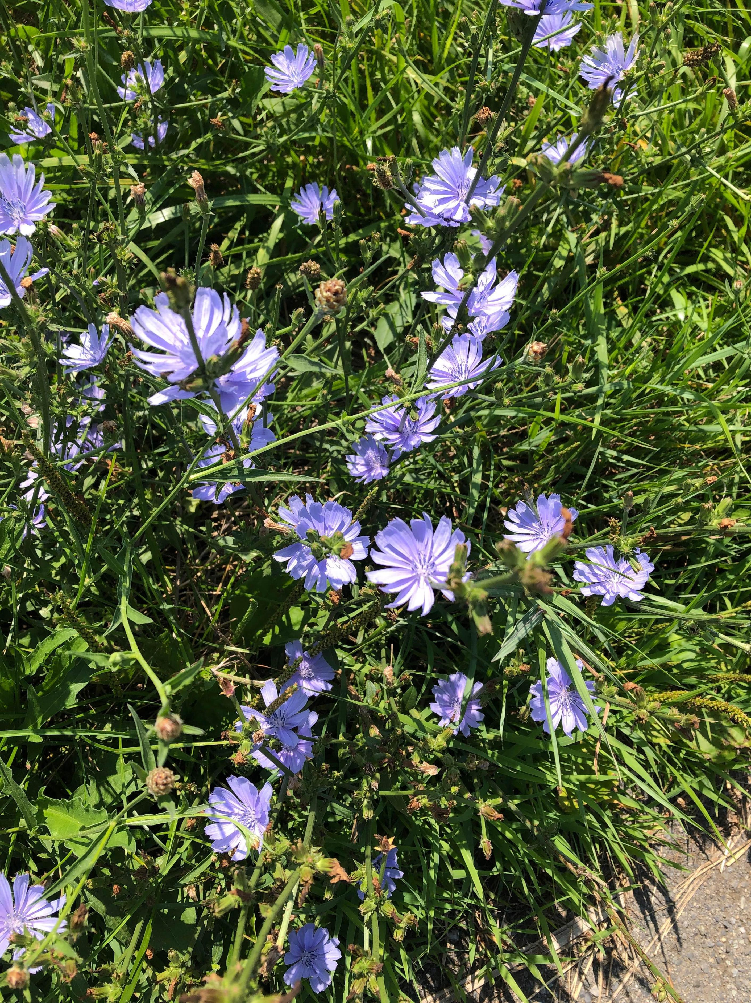

The New York State Department of Environmental Conservation provides financial
support to The Capital Mohawk PRISM via the Environmental Protection Fund.

