Thompson’s Lake Aquatic Invasive Species Shoreline Survey (2019)
Gwendolyn Temple
Introduction: This survey was performed at the request of Thompson’s Lake Association after providing an Aquatic Invasive Species Identification Workshop on June 21st, 2019.

Type of Work Performed: Shoreline survey

Date: August 20, 2019

Address: Thompson’s Lake, NY 12059
County: Albany
Latitude and Longitude: 42.649257; -74.042319

Lead Contact Information for Project: Gwendolyn Temple, ggt25@cornell.edu

Project Description: Thompson’s Lake is a lake that has, historically, been relatively uninvaded by aquatic invasive plant species. Aside from Eurasian watermilfoil and purple loosestrife, Thompson’s Lake is relatively aquatic invasive plant species free. However, Thompson’s Lake Association was concerned with the possible threat of hydrilla (which was later determined to be unfounded as there was a misidentification of native elodea) and asked that the Capital Mohawk PRISM survey the lake in full. An initial site assessment was made through a shoreline survey and a full lake survey was intended with a member of the Thompson’s Lake Association. Unfortunately, the weather was inappropriate for a full lake survey during the time it was scheduled and the full survey was tabled for next year.

Invasive Species Present at Thompson’s Lake:
Common Name | Scientific Name | Locations (GPS) | Growth Type | Phenology | Distribution/ Abundance
Eurasian Watermilfoil | Myriophyllum spicatum | 42.6522; -74.0435 | Submerged aquatic plant | Perennial | Extensive population along shoreline
Native Community Types: Freshwater lake
Dominant Native Plants Present: Coontail, native pondweeds
Summary of Work Completed:
  - Shoreline survey of Thompson’s Lake completed
Recommendations for the Future: Return to Thompson’s Lake and survey the lake in full with a member of the Thompson’s Lake Association. Reach out to Gabriella Cebada-Mora from the NYS Office of Parks, Recreation, and Historic Preservation to partner on an aquatic survey of the lake. Without a full lake survey, it is impossible to say what new aquatic invasive plant species have made their home in Thompson’s Lake.Two feasible access points exist on the lake for surveying along the shoreline or in a boat: a DEC fishing access site, and an access point within the Thompson’s Lake State Campground. Boat rentals are offered at the state campground in the event that a Thompson’s Lake Association member is unable to provide transportation across the lake. It is free to launch at the DEC fishing access site if you have your own kayak or canoe.
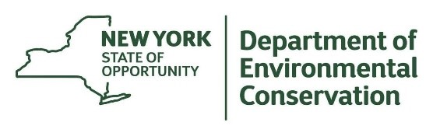
The New York State Department of Environmental Conservation provides financial
support to The Capital Mohawk PRISM via the Environmental Protection Fund.

