WASHINGTON COUNTY GRASSLANDS INVASIVE SPECIES SURVEY 2019:
Anna Kuhne, Lauren Mercier, and Kelsey Stevens

Type of Work Performed: Terrestrial invasive species surveying was done on the trail within the property

Date: August 1, 2019

Address: 390 Black Horse Rd, Fort Edward, NY 12828
County: Washington County, NY
Latitude and Longitude: 43.245657, -73.559227
Website: http://www.dec.ny.gov/outdoor/97661.html

Lead Contact Information for Project: Lauren Mercier, Capital Mohawk PRISM

Site Owner Contact Information: DEC Region 5 Ray Brook Office

Project Description: Surveying for terrestrial invasive species was done and points for the species were uploaded on to iMapInvasives.

Invasive Species Present at Wahsington County Grasslands:
Common Name | Scientific Name | Locations (GPS) | Growth Type | Phenology | Distribution/ Abundance
Chicory | Cichorium intybus | 43.2428  -73.55672 | Herbaceous | Flowering | Sparse
Bull Thistle | Cirsium vulgare | 43.24088  -73.55564 | Herbaceous | Flowering | Linearly Scattered
Wild Carrot | Daucus carota | 43.24261  -73.5662 | Herbaceous | Flowering | Linearly Scattered
Honeysuckle | Lonicera spp | 43.24276  -73.55669 | Shrub | In Seed | Linearly Scattered
Birdfoot Deervetch | Lotus corniculatus | 43.23969  -73.55561 | Herbaceous | Flowering | Linearly Scattered
Purple Loosestrife | Lythrum salicaria | 43.24004  -73.55523 | Herbaceous | Flowering | Sparse
Yellow Sweet Clover | Melilotus officinalis | 43.2438  -73.55732 | Herbaceous | Flowering | Sparse
Wild Parsnip | Pastinaca sativa | 43.23966  -73.55567 | Herbaceous | In Seed | Linearly Scattered
Reed Canarygrass | Phalaris arundinacea | 43.245  -73.5587 | Herbaceous | In Seed | Monoculture (whole park)
Common Buckthorn | Rhmanus cathartica | 43.24278  -73.55669 | Tree | In Seed | Linearly Scattered
Tufted Vetch | Vicia cracca spp | 43.23895  -73.55621 | Herbaceous | Flowering | Linearly Scattered

Capital Mohawk PRISM Strongly Recommends Uploading Points into https://www.imapinvasives.org/
Native Community Types: Grasslands
Dominant Native Plants Present: Raspberry, oak
Summary of Work Completed:
  - Survey for terrestrial invasive species
Recommendations for the Future: Continue surveying to make sure that the invasive species do not disturb the endangered short – eared owl present at the Washington County Grasslands.
Contact the Capital Mohawk Prism http://www.capitalmohawkprism.org/

Figure 1. Map of points taken at the Washington County Grasslands in fort Edward, New York
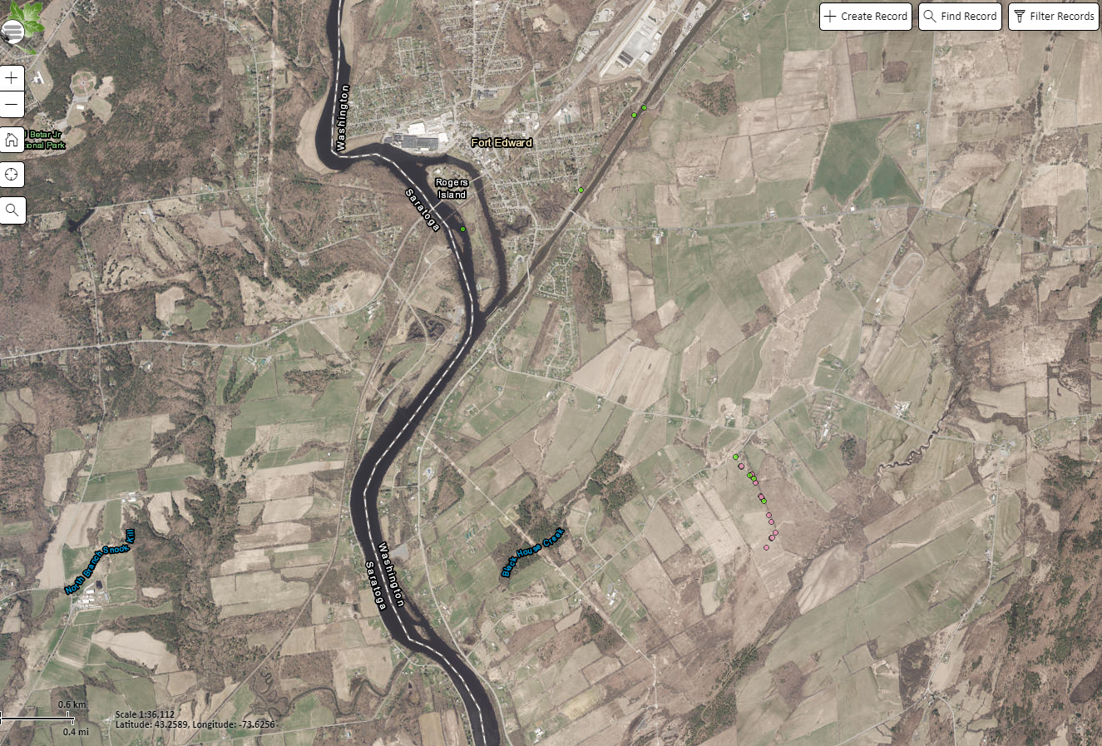

Figure 2. Honeysuckle along the trail of the Washington County Grasslands In Fort Edward, New York.

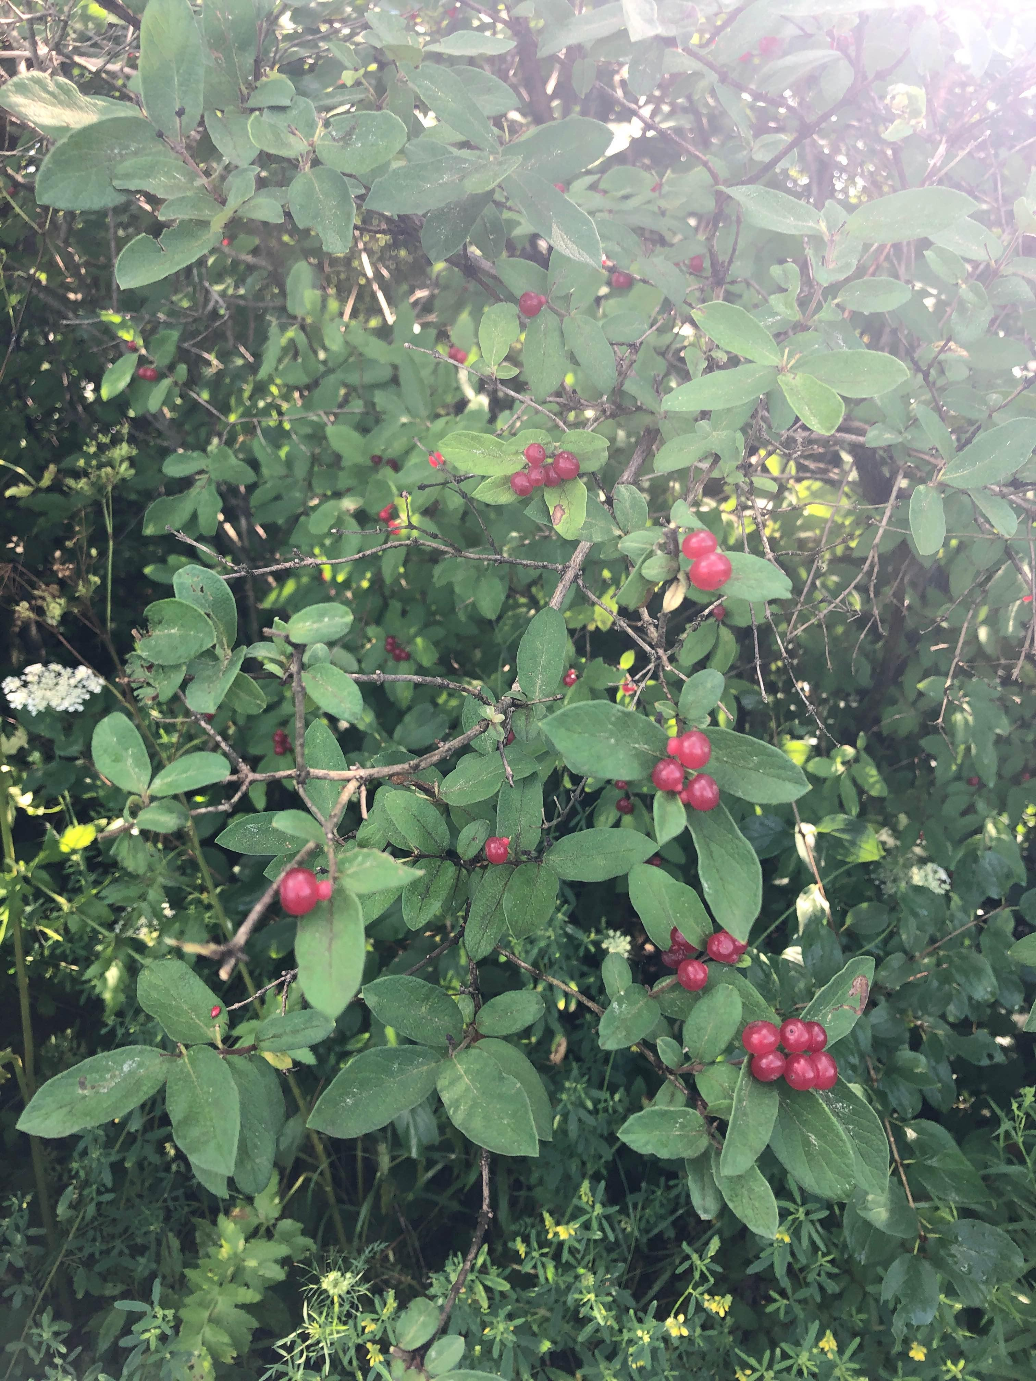

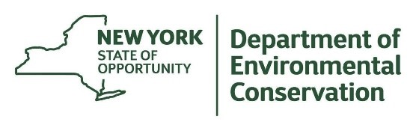
The New York State Department of Environmental Conservation provides financial
support to The Capital Mohawk PRISM via the Environmental Protection Fund.

