Water Chestnut Pull on Cossayuna Lake with Cossayuna Lake Improvement Association (2019)
Introduction: On July 1, 2019 at 10:00 a.m., 10 volunteers gathered by the western cove on Cossayuna Lake to remove water chestnut. This removal has been performed for a number of years in order to reduce the potential for the species to spread to other parts of the lake. Removals are performed in conjunction with the use of an aquatic harvester to remove larger patches in different parts of the lake.

Type of Work Performed: Removal

Date: July 1, 2019

Address: 314 East Lake Road, Cossayuna, NY 12823
County: Washington
Latitude and Longitude: 43.203241, -73.418371

Lead Contact Information for Project: Cossayuna Lake Improvement Association, cossayunalakeny@gmail.com

Project Description: No prior scouting on part of the Capital Mohawk PRISM was performed before the event took place. Volunteer Gene Henry and his wife identified patch locations, noting that the western cove was the primary location that was managed each year. Determining that the best course of action would be to continue managing that location, Gene gathered volunteers to help remove the water chestnut that had historically been a problem within the cove.

Despite two hours of extensive searching, the volunteer group only pulled up enough material to fill two 5 gallon buckets, showing that the yearly management had been effective in reducing the population size.

Invasive Species Present at Cossayuna Lake:
Common Name | Scientific Name | Locations (GPS) | Growth Type | Phenology | Distribution/ Abundance
Water Chestnut | Trapa natans | 43.211948, -73.424617 | Herbaceous | Vegetative | Sparse

Capital Mohawk PRISM strongly recommends uploading points to https://www.imapinvasives.org/.
Dominant Native Plants Present: Water lilies (nymphaeaceae)
Summary of Work Completed:
- Education and outreach: Identification of water chestnut and best methods for removal discussion occurred briefly before the event took place
- Invasive species removal
  - 10 direct contacts/participants
  - Two 5 gallon buckets worth of water chestnut removed

Recommendations for the Future:
Due to the fact that there was not an extensive amount of water chestnut found, it is safe to say that yearly management of the species is significantly reducing the population size. However, monitoring should still take place in order to ensure that the species does not continue to grow unmanaged. Ensuring that no new plants have emerged between when the pull occurred and when the plants begin to drop their seeds in the fall will help reduce the population size for next year’s event.
For any questions regarding this report, please reach out to Gwendolyn Temple, Aquatic Invasive Species Coordinator, at ggt25@cornell.edu.
Figure 1: The weather was very appropriate for the water chestnut pull with little wind.
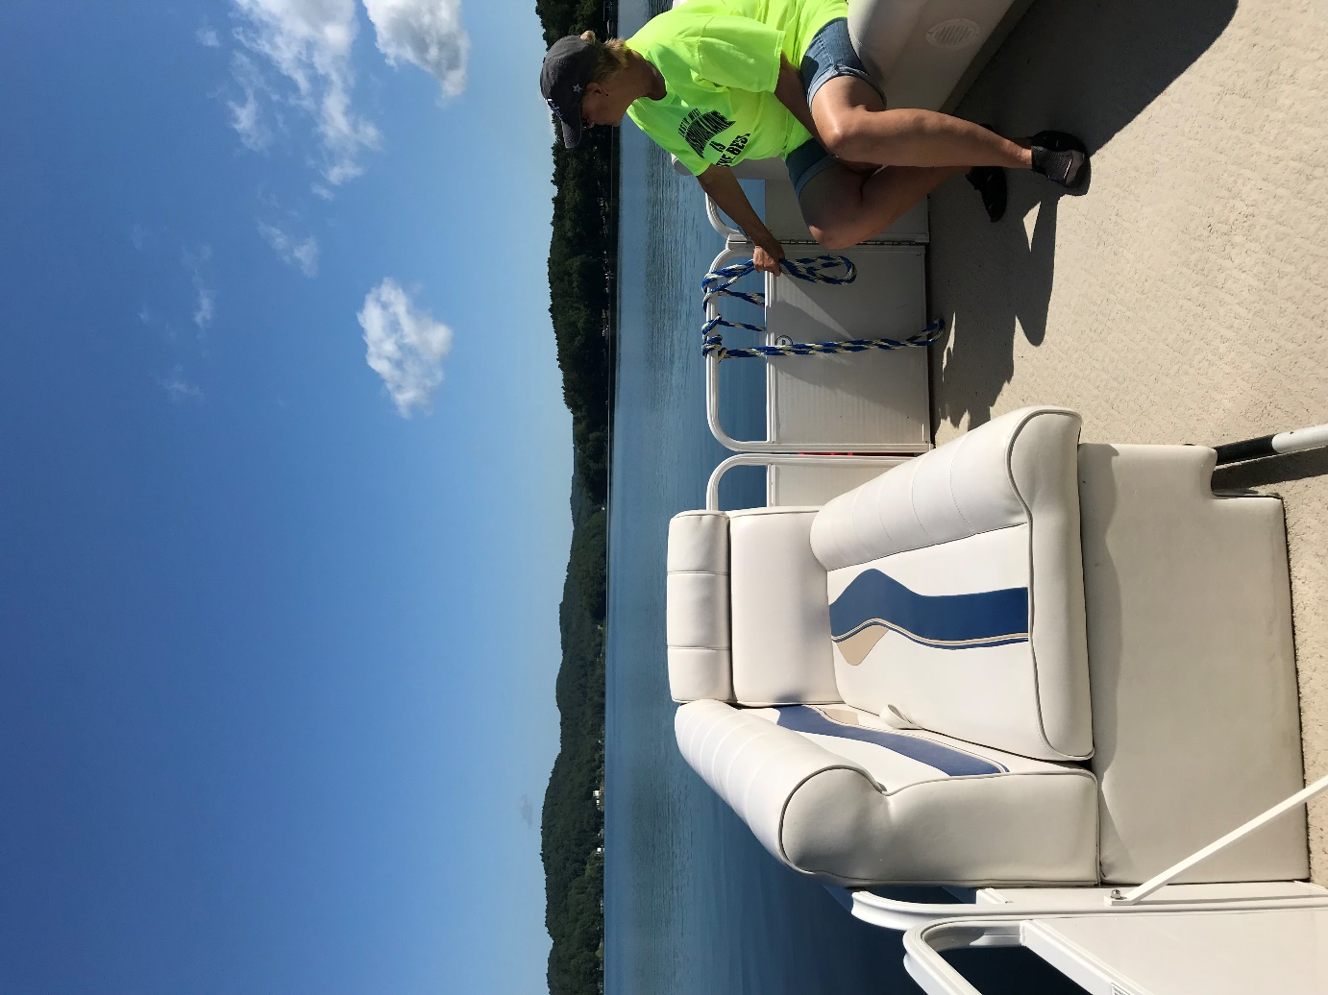
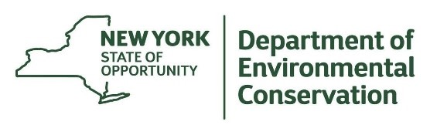
The New York State Department of Environmental Conservation provides financial
support to The Capital Mohawk PRISM via the Environmental Protection Fund.

