Wild Parsnip
Pastinaca sativa
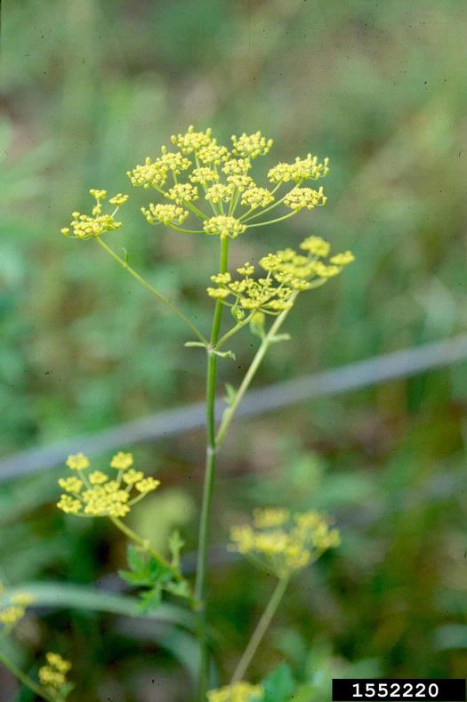

Identification
Wild parsnip has a green, grooved, and hollow stem that can grow up to 5ft tall. The plant has serrated compound leaves with between 3 and 5 leaflets. Both the stem and the leaves resemble celery which is non-native but does not have the same invasive characteristics as wild parsnip. During the first year of growth, the wild parsnip exists as a rosette of ovate compound pinnate leaves that end with toothed leaflets. The leaflets grow in an opposite fashion along the stem.

Reproduction
During its second year of growth, wild parsnip will go into flower around June. An umbel of small yellow flowers will form at the top of the stem and will last for about a month. After flowering, the plant will release flat and oval shaped seeds that are brown and slightly winged for wind dispersal. Most of the seeds are non-viable, but those that are can remain viable in the soil for up to 4 years.
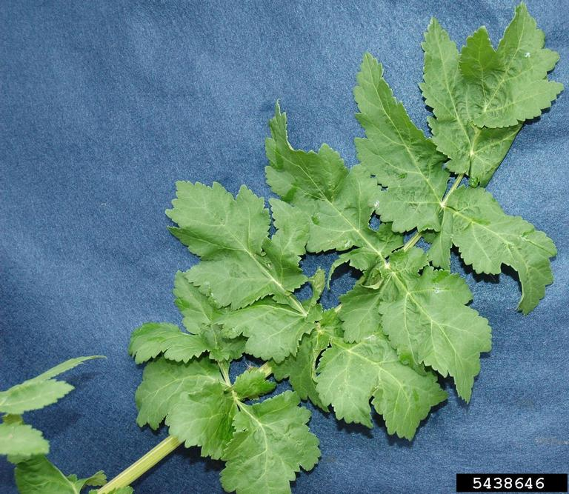

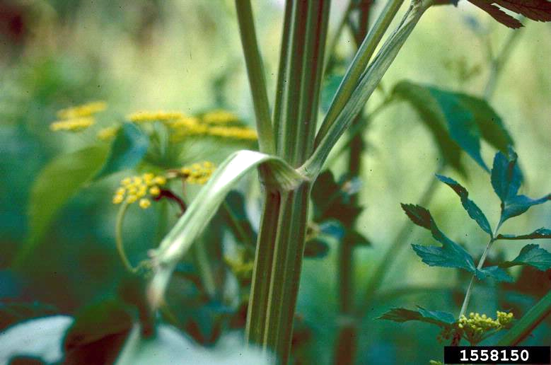

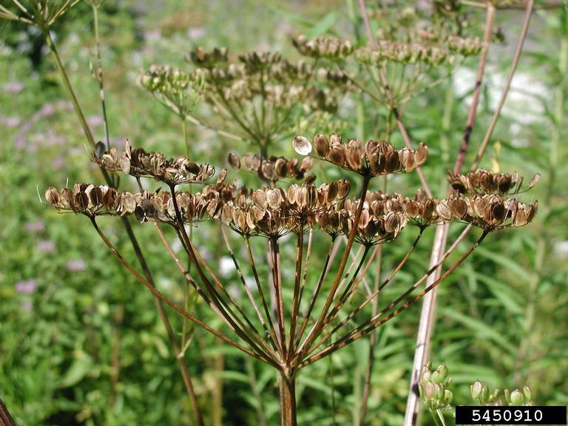

Habitat
Wild parsnip has the ability to grow in many different soil conditions. It thrives in riparian areas that are rich and moist but is also very common along roadsides and pastures.

Threat
Wild parsnip contains a sap that is harmful to human skin and can cause chemical burns that are activated by sun light. Seek medical attention immediately after contact.
The plant can also invade high quality meadow or field habitat which could impact biodiversity and habitat quality.

Integrated Pest Management for

Wild Parsnip
Due to the threat of wild parsnip to human health and the local ecosystems, it is important to reduce the size and limit the spread of existing populations. Invasive species are controlled through prevention, eradication, containment and suppression. An integrated pest management (IPM) approach should be adopted to control unwanted species. The integrated approach is a combination of manual, mechanical, biological and chemical controls. IPM requires post treatment monitoring and treatment over a period of several years, leading to more successful outcomes (https://nysipm.cornell.edu/about/defining-ipm/).

Practices to Avoid
- DO NOT HANDLE WILD PARSNIP WITHOUT PERSONAL PROTECTIVE EQUIPMENT. The plant produces a compound in its leaves, stems, flowers, and fruits that causes intense, localized burning, rash, severe blistering, and discoloration on contact with the skin on sunny days. The condition, known as phytophotodermatitis, is caused by furanocoumarin contained in the sap. This is not an allergic reaction, it is a chemical burn.
- DO NOT LEAVE THE SEED HEADS ON THE GROUND. When cutting this plant, it is important to place the seed head in a plastic bag and allow it to solarize for at least three weeks before disposal. If it is not disposed of correctly, the seeds can spread and form new populations or add to existing ones.
- DO NOT MOW WHEN IT IS IN SEED. Mowing while it is in seed can increase the spread of the seeds to new populations on the mowing equipment.

Manual and Mechanical Control
Pulling or digging out young plants is an effective way to remove small populations of wild parsnip. Mowing and cutting after flowering but before the plant goes into seed will help control larger populations. However, it is important to wear protective gear such as gloves and even a form of face protection to avoid contact with the sap.

Biological Control
There are currently no approved or effective methods of biological control for the wild parsnip.

Herbicide Control
Herbicide treatment is often considered a last resort when it comes to treating infestations due to the cost and the adverse effects on the environment. For wild parsnip it is a fairly useful technique though because it limits the contact with the sap and is effective at controlling populations and preventing new growth. However, it is important to be aware of the type of chemicals to use and when to apply them to have lasting impact on infestations of wild parsnip. Please consult an expert or certified applicator when applying herbicides. Read and follow herbicide product labels as required by law. Seek out proper local, state, and federal permitting when applying herbicides.

Herbicide Treatment for Homeowners/Private landowners

Time of Year: April-June, Follow up September-November

Example Chemical(s) to Use: Read all Product Labels as Required By Law
Product names are listed as examples, and not as endorsement or recommendation. The suitability and details for specific use of these products are provided through their labels.
Chemical  (Products containing) | Timing | Application Technique | Notes
Glyphosate (Roundup, Glyphomate) | April-June  (Before flowering) | Foliar Spray | - Non-selective  - Best to apply to rosettes  - Follow-up treatments in the fall
Triclopyr (Garlon 3A, Garlon 4) | April-June | Foliar Spray | - More selective  - Best to apply to rosettes  - Follow-up treatments in the fall
If there is water present near the infestation, a permit from the DEC is required. For more information regarding aquatic pesticide permitting, please contact the nearest DEC Regional Office: Division of Environmental Permits at (518) 357-2069 or visit: http://www.dec.ny.gov/permits/209.html.

Timeline of Action

CAUTION: DO NOT HANDLE WILD PARSNIP WITHOUT PERSONAL PROTECTIVE EQUIPMENT.

For More Information Seek out the Cornell Guidelines for Pesticide Use:
The Cornell Guidelines offer the latest information on topics such as pest management, crop production, and landscape plant maintenance. Each title in the series is updated by Cornell University researchers and Extension specialists and is designed as a practical guides. https://www.cornellstore.com/books/cornell-cooperative-ext-pmep-guidelines
CAUTION: DO NOT HANDLE WILD PARSNIP WITHOUT PERSONAL PROTECTIVE EQUIPMENT.

Native Replacements
After removing or treating wild parsnip, it is important to reseed or plant the disturbed soils with native species common in the geographic area. Replanting will help restore the ecosystem and prevent old infestations from re-establishing. Consider using stress tolerant plants in harsh environments that are best suited to a given site. If pre-existing native plants are present on site, protect these species from harm, during management. The surrounding native species can then be used to aid in the heathy reestablishment of the area. More information about native plants, shrubs and trees can be found:

Alternatives to Ornamental Invasive Plants “A Sustainable Solution for New York State”
- https://nysipm.cornell.edu/sites/nysipm.cornell.edu/files/shared/documents/NYSIPM-alt-inv.pdf

NYSDEC Native Plant Factsheets
- https://www.dec.ny.gov/docs/lands_forests_pdf/factnatives.pdf

Lady Bird Johnson Native Flower Database
- https://www.wildflower.org/plants/

Westchester Community College Native Plant Center
- https://www.sunywcc.edu/about/npc/

Definitions:
Manual Control: a technique to remove small infestations. Some examples of manual control is hand-pulling, mulching, burning, digging, and removal of the entire plant, portions of a plant, nests, egg masses, or other life stages. This type of control is only economically feasible for small infestations.
Herbicide Control: a technique which uses chemicals to remove or decrease the population of a species. Herbicides are usually one of the last choices for control as they are usually expensive and have adverse effects to the environment. There are different methods to apply an herbicide. Some examples are: foliar spray, basal bark, bundle and cut, and cut-stump treatment.
Biological Control: a technique where an animal, insect, fungi or disease is used to manage a large invasive species population. This control species is studied intensively to see if there could be any negative effects for native species.
Foliar Spray: method of herbicide control where the chemical is sprayed directly on the leaves. Sprayers can be hand held, on a backpack or mounted on a vehicle. If a plant has a waxy surface, a surfactant may be needed to allow the herbicide to work.
Selective herbicides: a type of herbicide which kills specific groups of plants but not others. For examples, a selective herbicide may kill broadleaf plants, like dandelions, but not grasses.
Non-selective herbicides: a type of herbicide which kills all types of plants. When using this herbicide, any plant that is sprayed will be effected.
DISCLAIMER
Please note that neither Cornell Cooperative Extension of Saratoga County nor any representative thereof makes any representation of any warranty, express or implied, of any particular result or application of the information provided by us or regarding any product. If a product is involved it is the sole responsibility of the User to read and follow all product labeling instructions and to check with the manufacturer or supplier for the most recent information. Nothing contained in this information should be interpreted as an express or implied endorsement of any particular product or criticism of unnamed products. With respect to any information on pest management the User is responsible for obtaining the most up-to-date pest management information. The information we provide is no substitute for pesticide labeling. The User is solely responsible for reading and following manufacturer’s labeling and instructions.

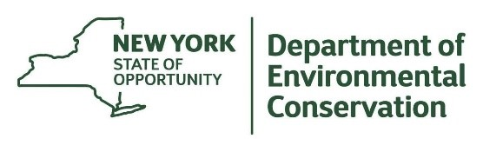
The New York State Department of Environmental Conservation provides financial support
to The Capital Mohawk PRISM via the Environmental Protection Fund.

