NEILMANN PARCEL JAPANESE STILTGRASS REMOVAL 2019:
Anna Kuhne, Lauren Mercier, Kelsey Stevens, and Kristopher Williams
Type of Work Performed: Manual removal of Japanese Stiltgrass

Date: August 16th, 2019

Address: 248 Ruggles Rd, Saratoga Springs, NY 12866
County: Saratoga County
Latitude and Longitude: 43.133274, -73.681978
Website: https://www.wiltonpreserve.org/the-lands/neilmann-parcel

Lead Contact Information for Project: Kristopher Williams

Site Owner Contact Information: Executive Director: Margo Bloom Olson (518) 450 – 0321 mbolson@wiltonpreserve.org

iMap Searched Area Record: #1044054
iMap Presence Record:#1026433
iMap Treatment Record:#16295

Project Description: Japanese Stiltgrass was removed at two main sites, to get to the first patch on the yellow loop the team headed left at the fork by the trail head sign. This patch was on the left side of the trail. The Second patch was at the beginning of the orange loop. The patch began to get dense closest to a patch of ferns. The Stiltgrass infestation was on both sides of the trail. The infestation continued down the trail where it was to the right of the fork. All Stiltgrass in these areas was removed. Stiltgrass is an annual and should be removed before going to seed by manual , mechanical or fire.

Invasive Species Present at Neilmann Parcel:
Common Name | Scientific Name | Locations (GPS) | Growth Type | Phenology | Distribution/ Abundance
Japanese Stiltgrass | Microstegium vimineum | 43.13123  -73.68787 | Herbaceous | In seed | Two Dense Patches

Capital Mohawk PRISM Strongly Recommends Uploading Points into https://www.imapinvasives.org/
Native Community Types: Maple Oak Beech Forest. / Wetland
Dominant Native Plants Present:
Ground Cedar, princess pine, other club mosses, pine trees, ferns, blackberries, raspberries

Summary of Work Completed: Manual removal of Japanese Stiltgrass
Recommendations for the Future: Future surveying and monitoring of the site for new growth of infestation. If future removal is needed, when removing, double bag the trash bags if heavy. Bring wheel barrel, gorilla cart, and/or wagon to carry out heavy trash bags. Signs should be made for the beginning at the trail head at the individual infestation sites. These signs should warn the public of the issue at hand and suggest brushing off bottoms of boots and fur on pets as to not spread seeds to any other parcels in the Saratoga County. Treatment year 2 of 7 based on seed viability.
Contact the Capital Mohawk Prism http://www.capitalmohawkprism.org/

Figure 1. Map of Neilmann Parcel

Figure 2. Image of Japanese Stiltgrass at Neilmann Parcel.
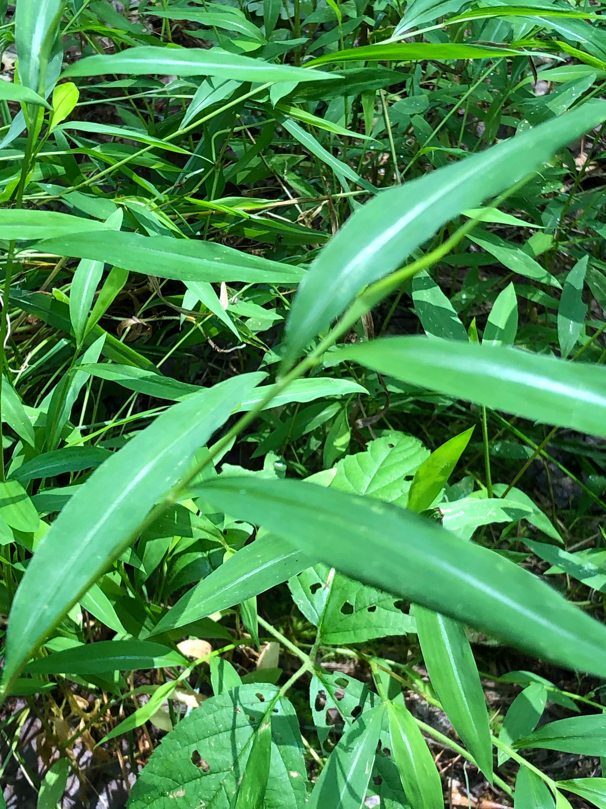

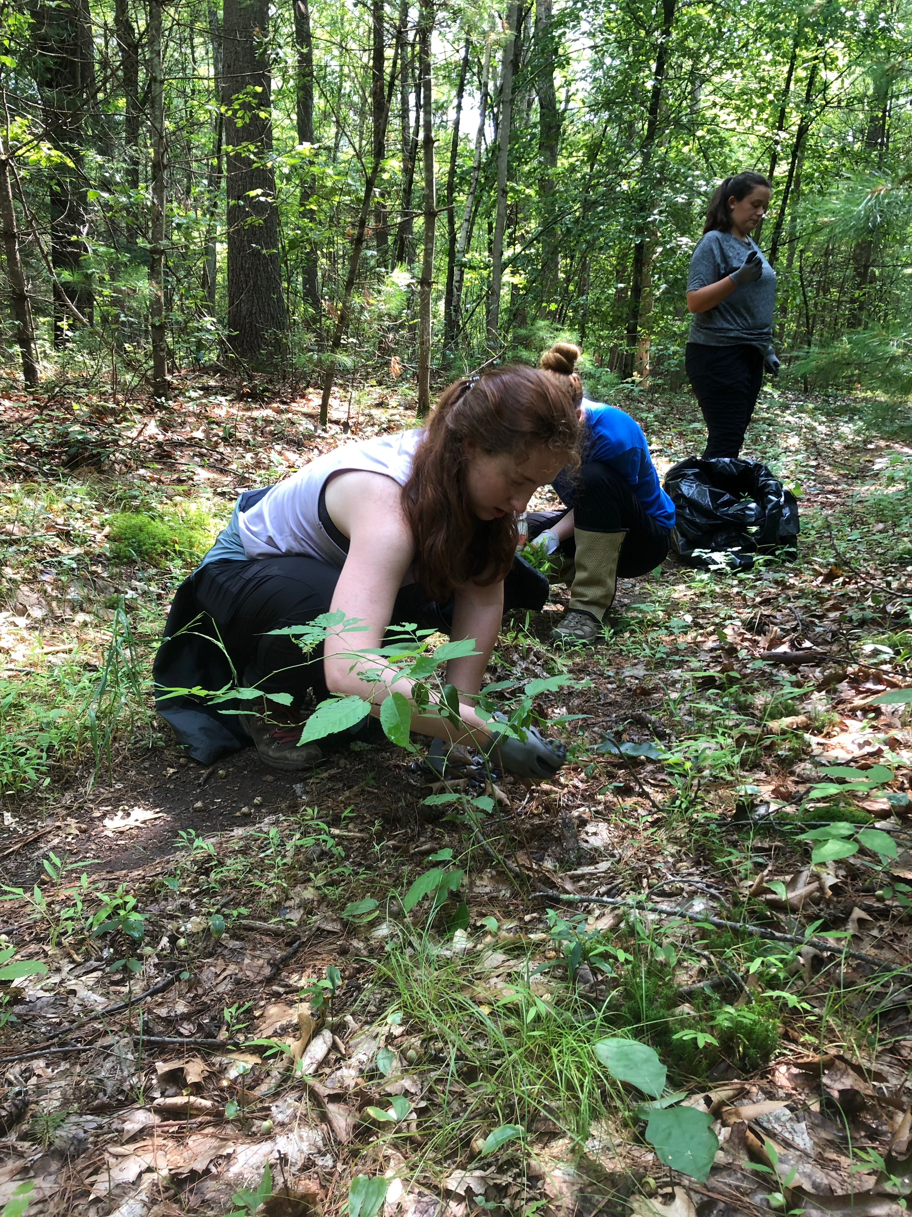
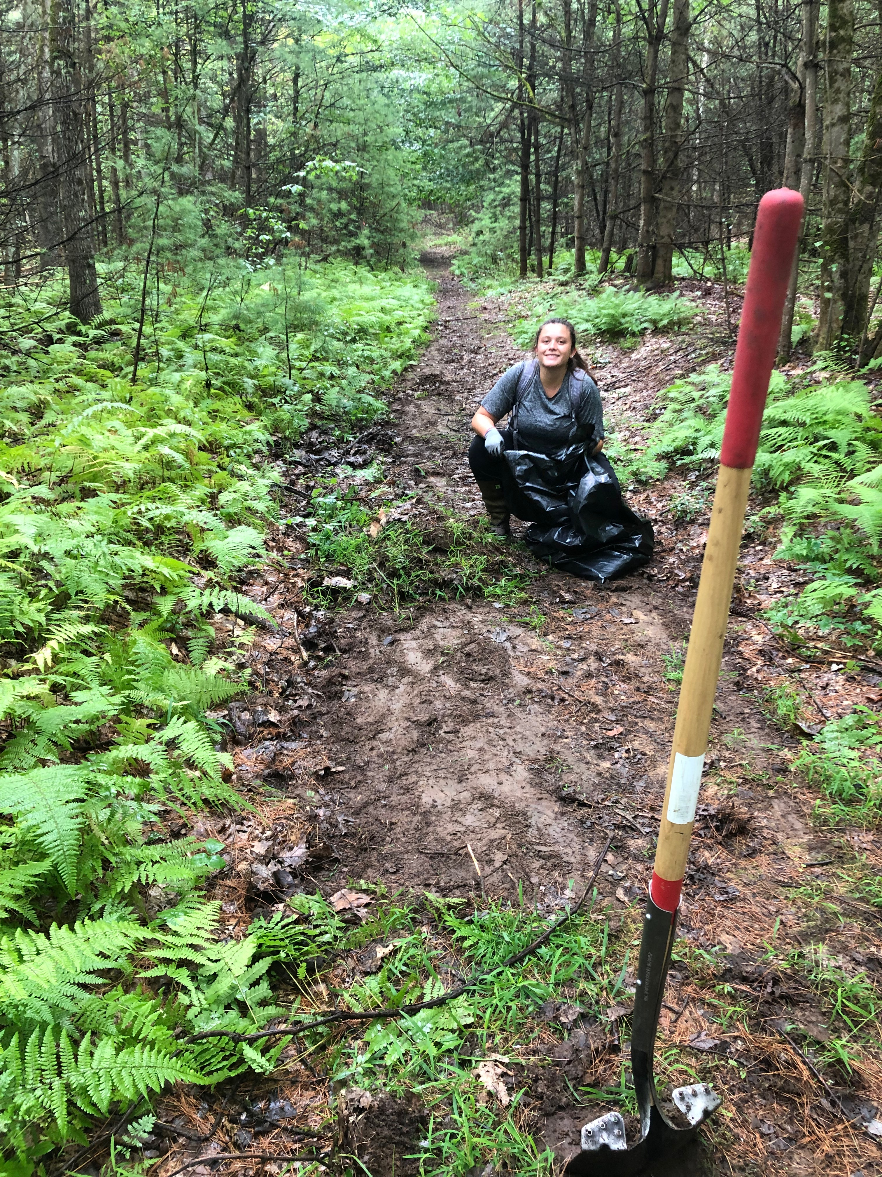

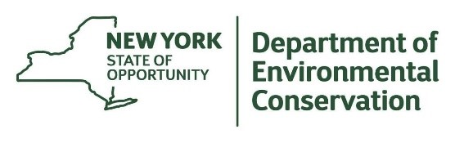
The New York State Department of Environmental Conservation provides financial
support to The Capital Mohawk PRISM via the Environmental Protection Fund.

