WOODLAWN PRESERVE INVASIVE SPECIES SURVEY AND REMOVAL 2019:

Anna Kuhne, Lauren Mercier, and Kelsey Stevens

Introduction: In July of 2019, the Terrestrial Invasive Species interns, from Siena College, and the education and outreach coordinator went to look for early detection invasive species throughout the Capital-Mohawk PRISM. The Siena interns, Anna Kuhne and Kelsey Stevens, focused on terrestrial invasive plant surveys at highly susceptible and valuable habitats throughout the PRISM region. The following is an abridged summary of some of the findings of the survey throughout the Woodlawn Preserve. The PRISM works throughout 11 counties around the capital region to detect, prevent, and control invasive species.

Project Description: Surveying terrestrial invasive plants in the park
Dates: July 13th, 2019
Participants: Capital Mohawk Prism, Cornell Cooperative Extension, and NYS DEC
Point of Contact: Steve Young, DEC
County: Schenectady County
Locations and Species Identified:
Woodlawn Preserve ((518) 346 – 6775): Removal of Yellow Iris and Cyprus Spurge was done on the trail on the woodlawn preserve property.
Invasive Species Present at Woodlawn Preserve: This table presents species that have been identified in the area in the past and present
Common Name | Scientific Name | Locations (GPS) | Growth Type | Phenology
Common Reed | Phragmites australis | 42.76431  -73.90651 | Herbaceous | Vegetative
Norway Maple | Acer platanoides | 42.76721  -73.90652 | Tree | Vegetative
Oriental Bittersweet | Celastrus orbiculatus | 42.76775  -73.91038 | Vine | Vegetative
Multiflora Rose | Rosa multiflora | 42.76699  -73.91057 | Shrub | Vegetative
Spotted Knapweed | Centurea stoebe | 42.76603  -73.90939 | Herbaceous | Vegetative
Garlic Mustard | Alliaria petiolate | 42.76617  -73.90659 | Herbaceous | In Seed
Mugwort | Artemisis vulgaris | 42.76738  -73.91075 | Herbaceous | Vegetative
Queen Anne’s Lace | Daucus carota | 42.76408  -73.90444 | Herbaceous | Flowering
Smooth Crabgrass | Digitaria ischaemum | 42.76408  -73.90444 | Herbaceous | Vegetative
Honeysuckle | Lonicera spp | 42.76649  -73.90477 | Shrub | In Seed
Purple Loosestrife | Lythrum salicaria | 42.76764  -73.91089 | Herbaceous | Vegetative
Japanese Spurge | Pachysandra terminalis | 42.76562  -73.90344 | Herbaceous | Vegetative
Japanese knotweed | Reynoutria japonica | 42.76723  -73.90939 | Herbaceous | Vegetative
Curly Pondweed | Potamogeton crispus | 42.76523  -73.90653 | Herbaceous | Vegetative
Common Buckthorn | Rhamnus cathartica | 42.76847  -73.90387 | Tree | Vegetative
Black Locust | Robinia  Pseudoacacia | 42.76585  -73.90922 | Tree | Vegetative
Cyprus Spurge | Euphorbia cyparissias | 42.76416  -73.90441 | Herbaceous | Vegetative
Yellow Iris | Iris pseudacorus | 42.76643  -73.90587 | Herbaceous | Vegetative

Dominant Native Plants: Sugar maple, red oak trees
Native Community Types: Meadow, forest, lake
Treatment Method: Manual Removal of yellow iris and Cyprus spurge

Summary of Work Completed:
  - Removal of yellow iris and Cyprus spurge
Recommendations for the Future: Continue to monitor yellow iris and Cyprus spurge for new growth at the removal sites.
Contact Anna Kuhne at av13kuhn@siena.edu, Lauren Mercier at lnm47@cornell.edu, or Kelsey Stevens at kao04stev@siena.edu for any questions regarding this report.

Figure 1: Map of Woodlawn Preserve. The removal areas are the brown polygons. The yellow iris removal site is the point and polygon in the northern are of the map and the cyprus spurge removal site is the point and polygon in the southern area of the map.

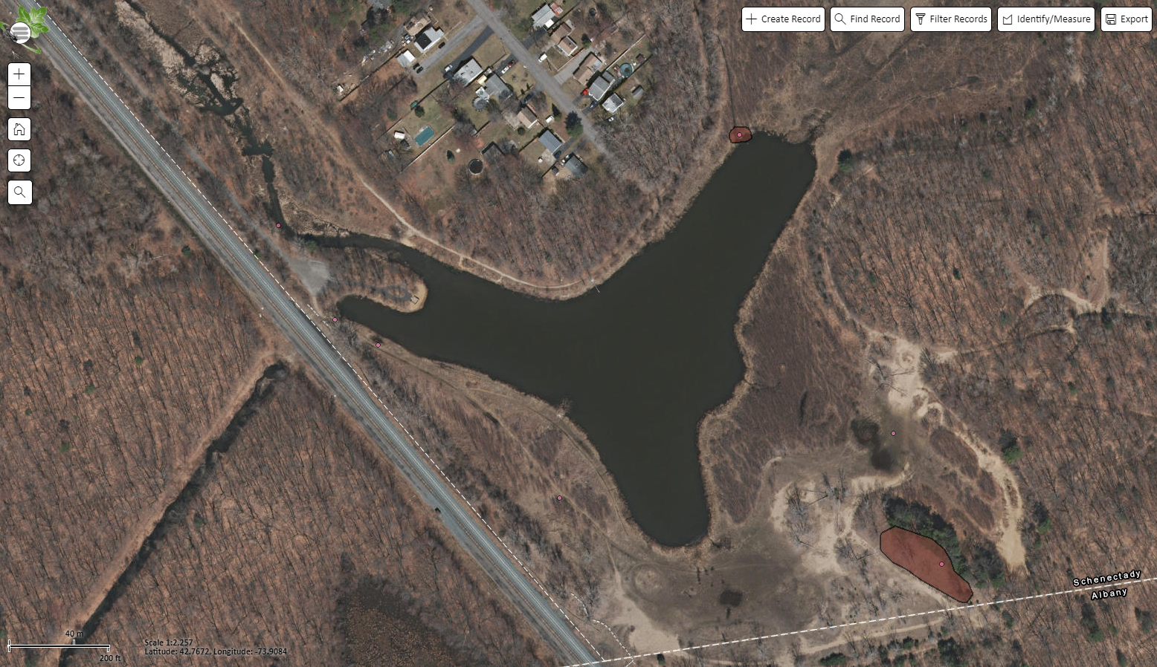

Figure 2. A bunch of cyprus spurge (Euphorbia cyparissias) that was removed manually by hand at Woodlawn Preserve
